**Validation**

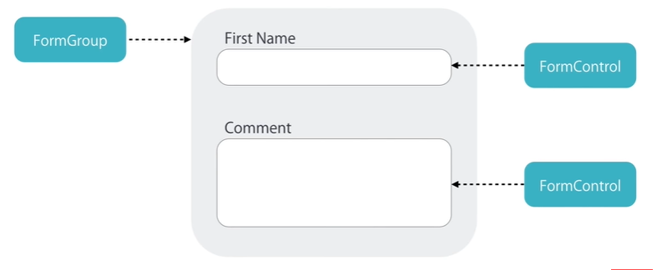

**FormControl class**

We can see the current value

If the input field touched/ untouched

If it is dirty (meaning changed) or pristine (its value not changed)

If it is valid or not (what errors, if not validated)

Ex) firstName

**FormGroup class**

Ex) a form incl. firstName and lastName

**Creating Controls**

Directives => Template-driven

Code

|  |  |
| --- | --- |
| Reactive | Template-Driven |
| More control over validation logic  Good for complex forms  Unit testable | Good for simple forms  Simple validation  Easier to create  Less code  Ex) ngModel ngModel name="firstName" |