***IWSLT 2023* - End User Agreement**

**INSTRUCTIONS for COMPILATION**

Please fill in, print, and sign the end-user agreement, scan it and send it **by email** to [mapelli@elda.org](mailto:mapelli@elda.org).

Each page of the agreement should also be initialled (the person signing the agreement should put his/her initials on each and all pages).

The End-User named must be a legal entity, or a department or section of a named legal entity, not an individual nor a project - the person signing this Agreement has to be duly authorized by the institution for such signatures (e.g. Department or Administrative Head or similar) and shall be liable for such authorization.

In Article 2, you must insert the address of the location where the data will be used.

If, due to circumstances beyond your control, you are unable to complete the task, you shall inform us as soon as possible.

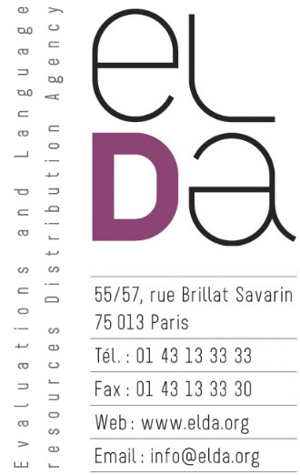

**EVALUATION PACKAGES**

**END-USER AGREEMENT**

(Agreement Ref. No. LC/ELDA/EVAL/IWSLT2023)

**This agreement is made by and between:**

**,** (hereinafter called **END-USER**), having its principal place of business at:

AND

**ELDA S.A.S.**, (hereinafter called **DISTRIBUTOR**), having its principal place of business at: 9 rue des Cordelières - 75013 Paris, FRANCE

registered at the Tribunal de commerce de Paris:

RCS Paris B 402 781 876 (95b147 95)

Definition:

**“Evaluation Packages”** referred to in this agreement are described as follows:

– Pashto => French dataset.

**whereby it is agreed as follows:**

1. The Distributor grants, free of charge, to the END-USER the non-transferable, non-exclusive rights to reuse the Evaluation Packages, exclusively for the purposes of evaluating their Human Language Technologies within IWSLT 2023’s Shared Task. This transfer shall not grant End-User any ownership, rights or title in all or any parts of the **Evaluation Packages**.
2. The site of use of the **Evaluation Packages** shall be the following:

The **Evaluation Packages** shall not be transferred to or accessed from any other site.

1. End-User is not permitted to reproduce the **Evaluation Packages** for commercial or distribution purposes and to commercialise (or distribute for free) in any form or by any means the **Evaluation Packages** or any derivative product or services based on all or a substantial part of it. Summaries, analyses and interpretations of the linguistic properties of the information may be derived and published, provided it is not possible to reconstruct the information from these summaries. Small excerpts of the information may be displayed to others or published in a scientific or technical context, solely for the purpose of describing the research and development and related issues. Any such use shall not infringe on the rights of any third party including, but limited to, the authors and publishers of the excerpts.
2. Distributor grants End-User the right to reproduce the **Evaluation Packages** temporarily or permanently, to translate, adapt, arrange and modify by any means the **Evaluation Packages**, if one or all of these acts are necessary to access and make the agreed use of the contents of the **Evaluation Packages**. End-User is permitted to make a copy of the **Evaluation Packages** for purposes of archiving only. These rights are granted only in relation to participation in IWSLT 2023. After participation has ended, END-USER agrees to delete the Data from any computer or media onto which it has been copied and to return all **Evaluation Packages** to DISTRIBUTOR.
3. End-User may include limited excerpts from the **Evaluation Packages** and shall give appropriate references to Distributor, as well as to the name and reference of the **Evaluation Packages** in scholarly literature whenever the **Evaluation Packages** are mentioned. The required acknowledgement will be provided to END-USER when IWSLT 2023’s Shared Task is completed.
4. The Evaluation Package is provided “as-is” and the DISTRIBUTOR does not warrant the accuracy, completeness, currentness, merchantability or fitness for a particular purpose of the Evaluation Packages. Both parties exclude all liability of whatsoever nature for direct, consequential or indirect loss or damage suffered by the other.
5. END-USER will maintain and post a list of people with current and recently-terminated access to the LR. END-USER shall maintain such appropriate records and DISTRIBUTOR shall have the right to audit such records upon reasonable prior notice using an independent auditor of its choice (the “Auditor”). The Auditor shall be bound to keep confidential the details of the business affairs of END-USER.
6. END-USER agrees not to disclose nor communicate to anyone any information concerning or contained in technical or commercial documents relating to the Language Resources placed at END-USER’s disposal by DISTRIBUTOR, except to its officers, directors or employees on a “need-to-know” basis.
7. This Agreement is subject to, construed and interpreted in accordance with the Law of France. Should it not be possible to settle amicably differences of interpretation out of this Agreement, then the case shall be brought before the regular courts of law for a decision. The "Tribunal de commerce de Paris" shall be the only competent court.

The entire Agreement is composed of the 9 articles herein.

In witness whereof, intending to be bound, the parties hereto have executed this AGREEMENT by their duly authorized officers.

AUTHORISED BINDING SIGNATURES:

________________ ________________

On behalf of On behalf of ELDA

Name: Name: Khalid CHOUKRI

Position: Position: Managing Director

Date: Date: