**Part II**

**Impact of manoeuvrability on decision making**

*We rarely recognize how wonderful it is that a person can traverse an entire lifetime without making a single really serious mistake. Like putting a fork in one’s eye or using a window instead of a door.*

– Marvin Minsky [Minsky et al. (1991)]

23

25

The previous part describes the context of this research and showed steps towards autonomous shipping, which are relevant to this research. This part will focus on the effect of manoeuvrability on the decision-making process. The steps taken to get to the right decision are similar to steps shown in the model of chapter 2. The insights acquired from the effect of the manoeuvrability on the decision process can be used to determine manoeuvrability requirements and answer the following question:

*How do ship manoeuvrability characteristics influence the domain for decision making, to ensure that the chosen strategy will result in a closest point of approach which does not require communication?*

The first phase of the decision process is the observation phase. This phase starts by updating the mental model and is followed by a phase where different chunks of information are connected. An operator or system uses this to identify situations and scenarios. This identification is the start of the decision making process in which different trees are used to identify potential hazards and problems which will result in strategies. These strategies are finally narrowed down to the actions. The various nodes and trees are discussed in chapter 3.

The next chapter discusses more detailed descriptions of the different phases within the decision-making process. First, the identification of the situation and scenario is addressed in chapter 4. Which branch to take in the decision trees, is determined by evaluating criteria. These criteria define if there are hazards and which manoeuvers are feasible, which works in two ways: An operator can use these criteria during operation to determine the right strategy, while a ship designer can use these criteria to ensure a ship can navigate safely in specific situations. The criteria to evaluate what kind of problem there is, are described in chapter 5. The criteria used to assess if strategies are feasible for critical situations are described in chapter 6. In chapter 6 is also described how designers can use these manoeuvers to determine the manoeuvring requirements for safe operation. Manoeuvers are simulated to evaluate if these criteria are useful. With the tool as described in appendix B. These are also used to test several scenarios and see how these criteria affect the decision-making process.

The result of this part is an overview, which can be used by designers to determine the effect of manoeuvring capabilities on the moment decisions have to be made, which is done for some common critical manoeuvrers, showing the minimal time and distance needed to make decisions to have a safe distance between vessels. This matrix depends on the manoeuvring characteristics, speed and type of manoeuvrer.

26

# *|* Decision-making process

A rule-based time-domain decision model is used, to acquire more insight into the decision- making process. Using this model can be answered what the situation is, what problems might occur, and how to act to operate safely. A decision tree is used to answer this in a structured way. Tags describe the nodes. This generalised model can be optimised in later stages to create a fully functional decision algorithm for autonomous and unmanned ships. The final algorithm is created using advanced modelling techniques and machine learning algorithms, as the decision algorithm becomes too complicated to draw decision trees by hand. First, the decision phases are described, followed by lists of nodes used to identify scenarios and situations. Combining this with the COLREGs will result in a functional decision model. Also, the criteria necessary to go through the steps are discussed. This decision model aims to gain insight into the decision process. To show which situations are critical when the goal is to avoid communication.

## Decision phases

The decision making process has different phases. As shown in chapter 2. A simplified version of the decision model is shown in figure 3.1. These different phases are described in table 3.1.

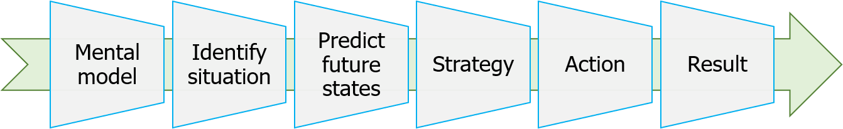

Figure 3.1: Decision process

Class

Mental model Situation identification

Predict future states Strategy

Action Result

Description

Acquire knowledge about the situation

Identify the encountered situation, to determine which criteria are relevant, based on waterway lay-out and other ships.

Predict if a problem will occur, as there is only a change in strategy needed when this is the case.

If there is a problem, a new strategy should be chosen, this is based on the evaluation of criteria.

From this strategy, different actions will follow.

Finally the result is evaluated, using the same criteria to determine a problem in future states.

Table 3.1: Description of phases in decision process 27

28 *CHAPTER 3. DECISION-MAKING PROCESS*

## Nodes in decision-making tree

Short keywords are used to describe the nodes within the decision tree. These describe in short what kind of situation, problem, strategy, action or result there is. This section gives definitions for those keywords.

#### Identify situations

Identification of encountered situations is the first step to limit the number of strategies which are relevant to evaluate. The nodes within the identification process are described in table 3.2, more details on how this is determined are described in section 4.1.

Tag

Passing

Crossing Over-taking Merge

Description

The paths of both ships are in the opposite direction, and do not cross.

The final direction of both ships differ, but they do cross. The paths of both ships are the same but at different speeds. The starting direction of both ships differ, but the final direction is the same.

Table 3.2: Tags for different situations

#### Predict future states

Different criteria are evaluated, to identify is a problem will occur. These criteria are described in chapter 5. In table 3.3 the nodes within the decision tree are discussed to evaluate if there is a problem, and which evaluations are possible for these criteria.

Tag

Closest point of approach Crossing point

Crossing distance Passing position Relative speed

Evaluation

Good; Too close In front; Behind Good; Too close

Port side; Starboard side Faster; Same speed; slower

Table 3.3: Criteria and result of evaluation to identify a problem

#### Possible strategies

Using the identification of the situation and the prediction of future states. A limited number of strategies might be possible. The strategies will result in actions but can be categorised in

* 1. *NODES IN DECISION-MAKING TREE* 29

the groups. Table 3.4 describes this and shows the possible actions per strategy. The distance and time which is left to avoid a problem is evaluated to determine if an action is necessary and possible. These criteria are described in table 3.5.

Tag Actions

Follow planned path Continue without change

Increase CPA by yourself Evasive manoeuvrer; Adjust speed Increase crossing distance by yourself Evasive manoeuvrer; Adjust speed

Work together with others Communicate; Evasive manoeuvrer; Adjust speed Emergency Emergency stop; Communicate

Table 3.4: Tags for different strategies

Tag

Time till problem Distance till problem

Evaluation

... seconds

... meter

Table 3.5: Criteria to determine if action is possible

#### Possible actions

From the chosen strategy, actions will follow. These action are a combination of an action type, and a moment to execute action. In table 3.6 and 3.7 these are described. These actions consist of different smaller sub-actions such as: ”rudder 35 degrees to port-side”.

Tag

Continue without change Evasive manoeuvrer Adjust speed

Emergency stop Communicate

Description

Do not change speed or rudder

Steer to starboard or port side first and end at same course Reduce speed or speed-up

Turn ship side-ways and set propulsion in reverse Discuss required actions with other vessel(s)

Table 3.6: Types of actions

Tag

Now

In ... minutes/seconds After action ...

Description

When action can be undertaken as soon as possible Wait to ensure action is necessary

Wait with action till you or other has done another action

Table 3.7: Time-domain for action

30 *CHAPTER 3. DECISION-MAKING PROCESS*

#### Result

Using the criteria from the action phase, can the chosen action be evaluated. Herein is the human factor on board of other vessels taken into account, in the form of perceived risk. This perceived risk is linked to the safety domains [Szlapczynski and Szlapczynska (2017b)]. The used safety domain at open sea is described by Coldwell [Coldwell (1983)]. Figure 3.2 shows that this domain is based on an ellipse, which is not centred at the location of the vessel. This safety domain takes into account that ships rather pass on port-side and behind. In this model, the safety domain only depends on the length of the ship. In busy areas, such as harbours and coastal area’s, it is not always possible to use this safety domain. Based on expert reviews for the port of Rotterdam, is a closest point of approach used in these regions of 2 cables, which is equal to 370 meters.

Evaluations and criteria are shown in table 3.8. The evaluation of these criteria determines if problems can be avoided.

Tag

CPA

Perceived risk Safe situation

Evaluation

Good; Too close

Safe; Uncomfortable; Close encounter; Too close Yes; Uncomfortable; No

Table 3.8: Tags for safe situation criteria

## Critical paths in decision trees

When combining the nodes as described in the previous section, huge decision trees are obtained. The decision tree for specific situations and scenarios is much smaller than a tree covering all possibilities. Based on the previously described nodes, a generalised model of the tree can be drawn. Figure 3.3 shows this model, where the orange blocks show evaluation criteria and the white blocks are choices. Thereby should be considered that the actions are evaluated similarly compared to predicting future states.

*In the next chapters* will the decision tree be used to identify critical paths. These paths will be evaluated for critical situations. When all possible paths are considered, this will result in a massive decision tree and many critical situations. All these paths do not result in more insight into a solution to avoid communication. Using identification and evaluation criteria several common critical paths can be identified which are used to define manoeuvrability criteria.

* 1. *CRITICAL PATHS IN DECISION TREES* 31

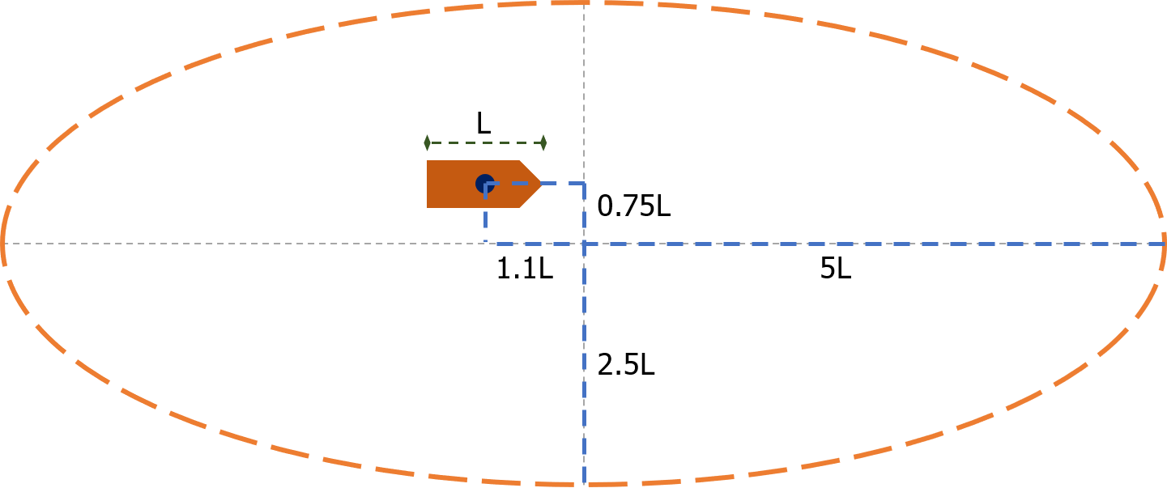

Figure 3.2: Model for safety domain by Coldwell

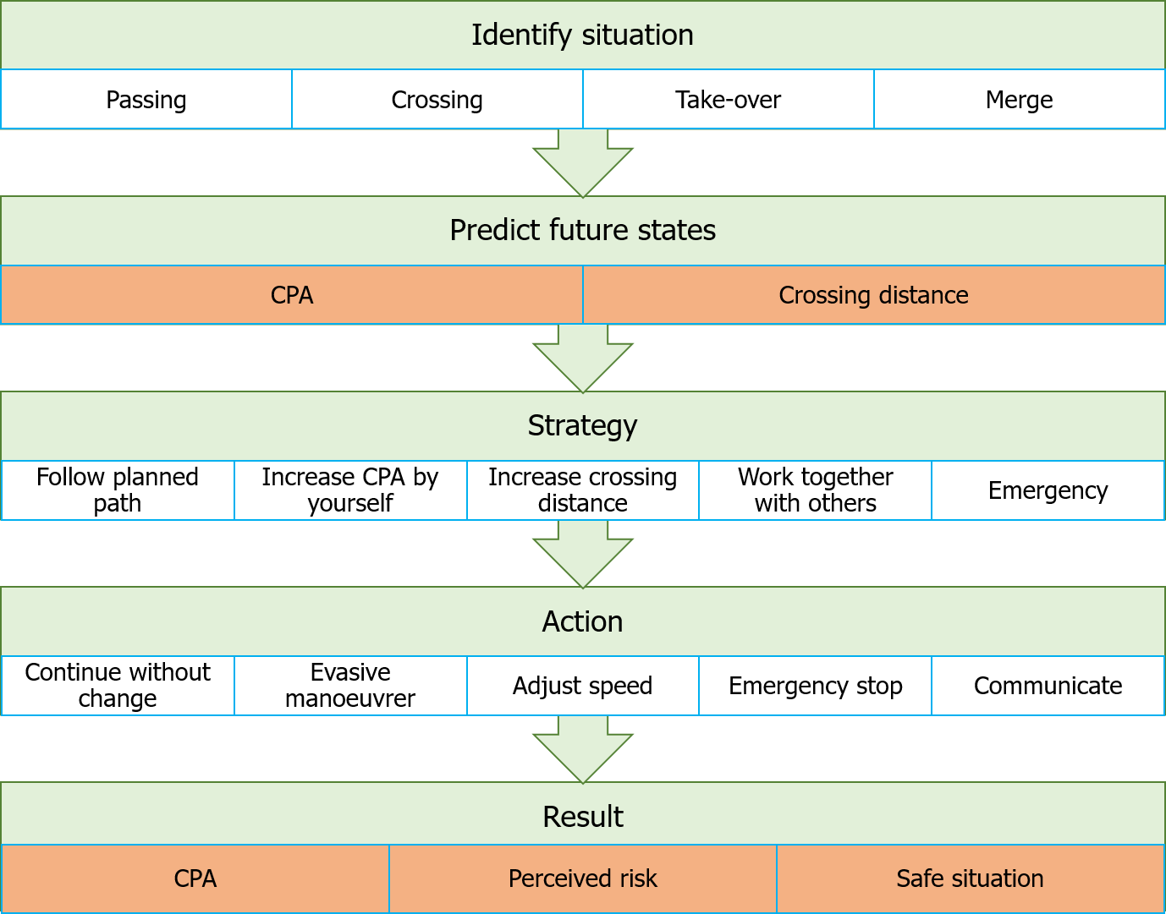

Figure 3.3: Generalized model for decision tree

32 *CHAPTER 3. DECISION-MAKING PROCESS*

# *|* Identification of situation and scenarios

After forming a mental model of the situation, starts the decision process with the identification of the situation and scenario. Where the decision tree from chapter 3, will help to identify common critical situations. The identification of these situations aims to narrow down possible strategies in the next phases of the decision-making process. This chapter discusses the first steps of classifying the situation. Followed by the steps taken in the orientation phase to narrow down the possible strategies. Which will help to determine which paths are common and critical, thus are good to be used while evaluating manoeuvring criteria.

## Situation identification

Situations can be classified into four types. These are also discussed in chapter 3, as these are the same nodes as in the decision tree. Table 4.1 shows these situations:

Situations Description

Passing The paths of both ships are in the opposite direction, and do not cross. Crossing The final direction of both ships differ, but they do cross.

Over-taking The paths of both ships are the same but at different speeds.

Merge The starting direction of both ships differ, but the final direction is the same.

Table 4.1: Tags for different situations

It depends on the waterway lay-out which situation is likely. Traffic separation schemes, forbidden zones or land masses influence this layout. A classification of paths is used to determine the situation. Paths are based on figure 4.1 and can be written as: [current position, direction].

The paths are considered to classify a situation where two vessels encounter each other. Key is to determine the angle between those paths. This way it is possible to classify them using table 4.2 and figure 4.1.

The boundaries to determine if the other ship comes from direction A, B, C or D are based on COLREGs [IMO (1972)]. Direction A is between 112.5 and 247.5 degrees, as shown with the dotted line in figure 4.1. While sailing this angle can be observed using the mast-head lights. Which are seen as red when the vessel comes from B, green when from D and green and red from C. While from direction A the colour of the light will be white. When in doubt if it is a head-on situation or a crossing situation. Always assume a head-on situation, as this stated in rule 14 [IMO (1972)].

33

34 *CHAPTER 4. IDENTIFICATION OF SITUATION AND SCENARIOS*

|  |  |  |
| --- | --- | --- |
| Own ship | Other ships | Situation |
| [A,D] | [D,C] [D,B] [D,A] [C,B] [C,A] [B,A] [B,C] | Passing |
| [A,C] | [C,A] [C,B] [B,A] | Passing |
| [A,B] | [D,C] [C,D] [B,A] | Passing |
| [A,C] | [D,B] [D,A] [C,D] [B,D] | Crossing |
| [A,B] | [D,A] [C,A] [B,D] [B,D] | Crossing |
| [A,D] | [C,D] [B,D] | Merge |
| [A,C] | [D,C] [B,C] | Merge |
| [A,B] | [D,B] [C,B] | Merge |
| [A,D] | [A,D] | Over-taking |
| [A,C] | [A,C] | Over-taking |
| [A,B] | [A,B] | Over-taking |

Table 4.2: Path definitions for different situations

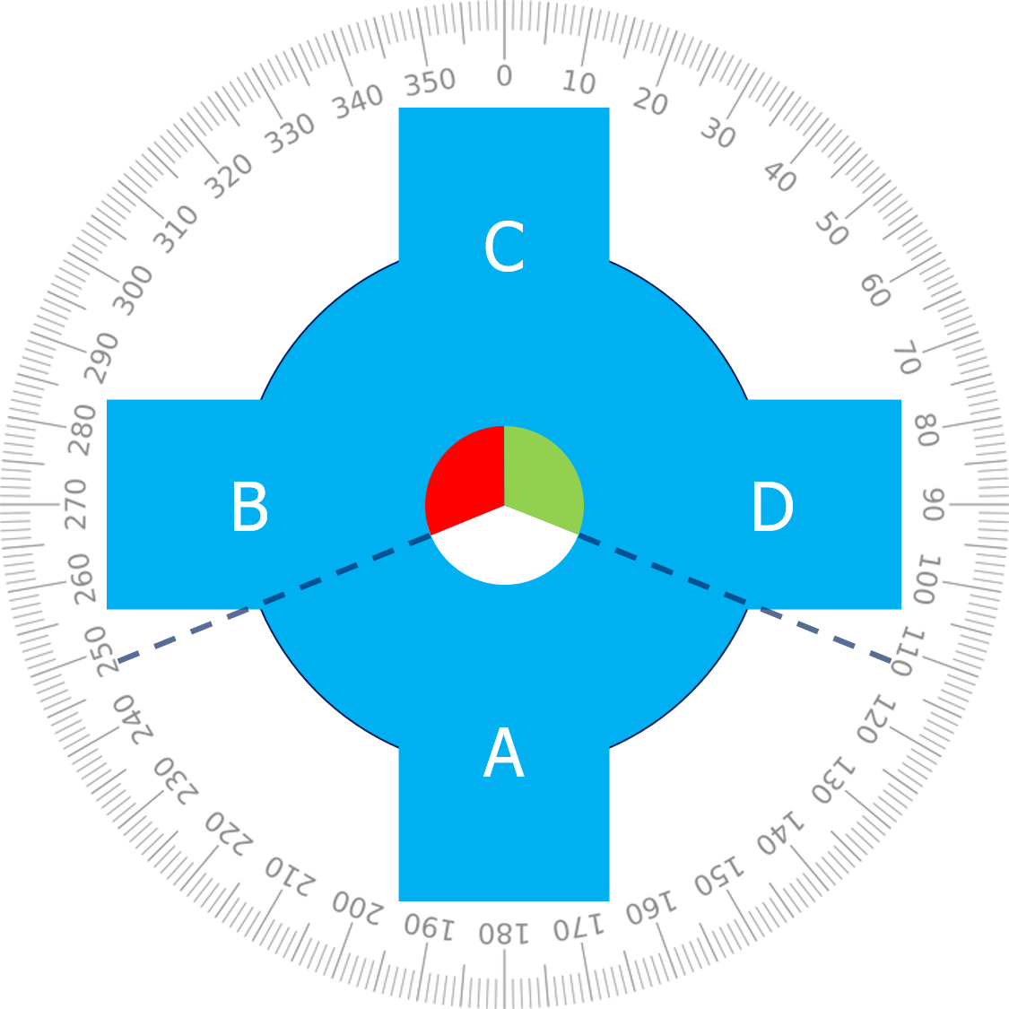

Figure 4.1: Path description for situation identification

*4.2. SITUATIONS WHICH LIMIT POSSIBLE STRATEGIES* 35

## Situations which limit possible strategies

Beside this first identification of the situation. More details must be taken into account to eventually form the right strategy, as these details might limit the possible strategies. Below the effect of the waterway and actors are discussed on possible strategies.

### Waterway properties

To limit the strategies which have to be evaluated by a system or operator, are they filtered based on the physical properties of the waterway, as this might restrict the area where can be sailed or does behaviour differ. It is common to over-take ships in open-water on the starboard side. While on restricted waterways ships will sail as far as possible to starboard already. This means that the ship which is over-taking will have to pass on the port side of the other vessel, at the centre of the waterway.

In the next step, other static hazards are considered to check if the chosen strategy does not lead to a collision, or if there are specific regulation frameworks for this waterway. These are however not part of the first iteration of the decision model, as this will introduce much more complexity, without improving the result in most cases. Future iterations of the model should evaluate static hazards, such as buoys, forbidden zones, bridges, quays, port mouths or shallow waters. In those cases are possibilities for over-taking or evasive manoeuvres limited, which means the strategies are limited.

Another limiting factor related to waterways are the difference in regulations between waterways. Most noticeable are traffic separation schemes or other road marks such as signs which forbid to over-take or meet. But others are for example to not create wash or no turning, thus limiting the options to manoeuvre. Or more directive signs on obligated directions or speed limits. These signs are most relevant for coastal and inland waterways.

### Dynamic objects

The second major step is the identification of dynamic objects. Those are all relevant moving objects. Most obvious are other ships, which come close. But in future developments of the decision model, objects which are not under any control of a human should also be considered, such as floating containers, this is however not within the scope of this research. The major difference between static hazards is that the ’forbidden zone’ around the dynamic object changes over time. This means more complex evaluation methods are needed to determine

36 *CHAPTER 4. IDENTIFICATION OF SITUATION AND SCENARIOS*

if there is no perceived risk, and thus a safe situation. The path itself is relevant for the evaluation of different criteria, as will be discussed in chapter 5 with different algorithms.

These complex evaluation methods will have to predict the path. To do this, first, the general information about the object should be acquired. Such as manoeuvrability, speed, course, type of object, under control, etc. Thereby, might it be possible in future developments to take into account the human factor, to improve the path prediction. This prediction uses the experience of the crew, availability of a pilot or if the vessel is unmanned.

Examples of such dynamic objects which limit the possible strategies, are for instance: Fishery vessels, as they might have long nets behind them during operation. Ferries in inland waters which have priority over other shipping traffic. Ships with limited manoeuvrability or forbidden zones around them.

## Scenarios

The scenario can is identified by using the information about the properties of the waterway and actors, where the situation is based on observations and describes the current state. Do the scenarios take into account the possible future strategies of those actors and thus describe what the future states could be. Based on the scenarios, can be determined which rules to apply and what their implications are on the possible strategies. The same goes for the estimated path of dynamic objects. These both might narrow down the possible strategies.

Using the information as mentioned above in the decision model, the strategies can be narrowed down. This information can be used to simplify the decision tree and select the right criteria to evaluate. Different scenarios for the same situation could be that the ship turns to port or starboard. For both does a probability exist. Using a probability index for the decision of other vessels will, in this case, improve the final decision making. This index can be taken into account by the safe motion parameters and safety domains as described by Szlapczynski [Szlapczynski and Szlapczynska (2017a)][Szlapczynski and Szlapczynska (2017b)].

*In the next chapter* the criteria are defined to evaluate the situations and scenarios. This evaluation shows if a problem might occur. These criteria are eventually used to determine the most critical common situations.

# *|* Definition of criteria for evaluation of situation

To determine if a problem might occur in the situations and scenarios as identified in the previous chapter, are different criteria evaluated. The current systems calculate most of these criteria, such as ECDIS and ARPA. However, they do use linearised algorithms. These do not predict the CPA and crossing distance correctly while turning, often resulting in many dismissed alarms. This chapter describes different criteria, followed by the calculation needed to evaluate them. This description and calculation are given for both the linearised algorithms and proposed algorithms. Later in the process, these criteria can be used again, to ensure that the chosen strategies ensure safe operation with low perceived risk.

## Calculations based on current systems

Within ARPA and ECDIS, different calculations are made, which can be used to evaluate if there is a problem in the current scenario. These calculations often use linearised algorithms, which results are not correct when turning. Humans can easily dismiss the false alarms given due to these wrong results. Computers do not handle these false positives well. The advantage, however, is that the calculations can be done very fast. Below these calculations are discussed for the closest point of approach (CPA) and crossing position.

### Closest point of approach

The CPA refers to the positions at which two dynamically moving objects reach their closest possible distance, which is an important calculation for collision avoidance. A linearised form uses two points moving at fixed speed and fixed direction. Figure 5.1 shows an example, where P and Q are the moving points, with corresponding direction vectors *u* and *v*, which include the speed and direction.

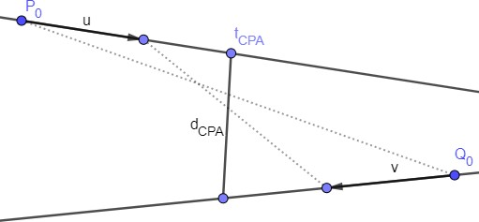

Figure 5.1: Example for closest point of approach (CPA) 37

38 *CHAPTER 5. DEFINITION OF CRITERIA FOR EVALUATION OF SITUATION*

A formula can be derived for the closest point of approach. With the motion equations for *P* and *Q*, the distance can be calculated. Where *P*0 and *Q*0 are the current positions, and *u* and *v* are the corresponding speed vectors:

*P* (*t*) = *P*0 + *t · u*; *Q*(*t*) = *Q*0 + *t · v* (5.1)

*d*(*t*) = *|P* (*t*) *− Q*(*t*)*|* = *|P*0 *− Q*0 + *t*(*u − v*)*|* (5.2)

Since d(t) is a minimum when *D*(*t*) = *d*(*t*)2 is a minimum, this is the case when the derivative is equal to 0:

*D*(*t*) = *d*(*t*)2 = (*u − v*) *•* (*u − v*)*t*2 + 2(*P*0 *− Q*0) *•* (*u − v*)*t* + (*P*0 *− Q*0) *•* (*P*0 *− Q*0) (5.3)

*dD*(*t*)

= 0 = 2*t*[(*u − v*) *•* (*u − v*)] + 2(*P*0 *− Q*0) *•* (*u − v*) (5.4)

*dt*

This equation can be solved for t, to calculate the moment where CPA is the smallest:

*tCP A*

= *−*(*P*0 *− Q*0) *•* (*u − v*)

*|u − v|*2

(5.5)

*dCP A*

(*tCP A*

) = *|P*0

*− Q*0

+ *−*(*P*0 *− Q*0) *•* (*u − v*) (*u v*) (5.6)

*|u − v|*2

* *− |*

If *tCP A* is smaller than 0, the CPA is in the past. If *tCP A* is equal to 0, the CPA is right now, else it is in the future. If *u* and *v* are the same, the denominator of equation 5.5 is equal to

0. This means that the CPA is constant.

### Crossing distance

The crossing distance is the distance between two ships if they pass each others path. The position of another vessel can be both in front or behind a vessel. This distance is mostly relevant for how safe a crossing situation feels. The crew on manned ships do not want to have ships too close in front of them, as they can’t do an evasive manoeuvrer in those situations. The same motion equation as for CPA can be used (equation 5.1).

In figure 5.2 the distance is calculated between two points at a certain moment in time. The first step is to calculate the crossing point (cp) of the two lines:

*P* (*tcp,p*) = *Q*(*tcp,q*) *→ P*0 + *tcp,p · u* = *Q*0 + *tcp,q · v* (5.7)

*tcp,P*

= (*Q*0 *− P*0) *× v*

*u × v*

(5.8)

*5.2. PROPOSED ALGORITHM BASED ON PLANNED PATH* 39

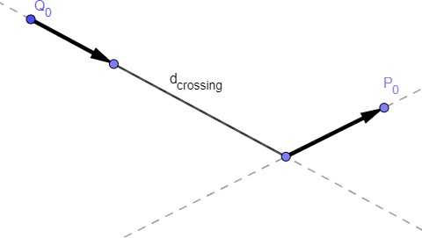

Figure 5.2: Example for crossing point and distance

*tcp,Q*

= (*P*0 *− Q*0) *× u*

*v × u*

l *·*

l *·*

(5.9)

*cp* = *P*0

+ (*Q*0 *− P*0) *× v u* = *Q*

*u × v*

0

+ (*P*0 *− Q*0) *× u v* (5.10)

*v × u*

The next step is to determine where each vessel is when the other vessel is at the crossing point. To determine finally what the crossing distance is:

*P* (*t*

*cp,Q*

) = *P*0

+ (*Q*0 *− P*0) *× v u* (5.11)

*u × v*

l *·*

*Q*(*t*

*cp,P*

) = *Q*0

+ (*P*0 *− Q*0) *× u v* (5.12)

*v × u*

l *·*

*d*(*t*) = *|P* (*t*) *− Q*(*t*)*|* (5.13)

The crossing distance (cd) for when P crosses Q and vice versa, can be calculated using the following formulas:

*dcd,P Q*(*tcp,P* ) = *|P* (*tcp,P* ) *− Q*(*tcp,P* )*|* (5.14)

*dcd,QP* (*tcp,Q*) = *|P* (*tcp,Q*) *− Q*(*tcp,Q*)*|* (5.15)

## 5.2 Proposed algorithm based on planned path

Better non-linearised methods are necessary for the calculation of the CPA and crossing point, to improve the evaluation of criteria. By predicting the likely path of a vessel, better estimations can be made. Which first uses a first-order change, based on the rate of turn and course. This prediction can be extended with a combination of expected location and the probability that another ship is choosing a specific strategy.

Although it will result in better evaluations, the disadvantage is that much heavier computations are needed, while also introducing uncertainty with the numerical solver. The first step will be

40 *CHAPTER 5. DEFINITION OF CRITERIA FOR EVALUATION OF SITUATION*

to make a combination of both the linearised and non-linearised methods. The calculations have to be done for every combination of ships.

The B´ezier curve is used to describe the paths in a non-linearised manner. This section first defines a B´ezier curve. Followed by the same criteria as in the previous section: closest point of approach (CPA) and crossing distance. This time describing the algorithm using to calculate it in a non-linearised manner.

### B´ezier curve

The first iteration of the algorithm is semi-linearised, where the path of own ship is represented by a B´ezier curve, based on its waypoints and strategy. Points have to be fitted along the planned path to describe the B´ezier curve. This method is similar to the method as described by Taams [Taams (2018)]. The path prediction for the other ship is still linearised, new systems and protocols have to be introduced to gather enough information on the strategy and waypoints.

For the calculation does the distance function not change. This is still *d*(*t*) = *|P* (*t*) *− Q*(*t*)*|*. However is P taken as own ship and gets a new formula using the B´ezier curve. This curve has a degree of *n*, which depends on the way-points and can be described using the following equations:

, *·*

*n*

*P* (*t*) = *bi,n*(*t*) *Pi and* (5.16)

*i*=0

*b* (*t*) =  *n*  *ti*(1 *− t*)*n−i, i* = 0*, . . . , n* (5.17)

*i,n*

 *i* 

### Closest point of approach

The numerical algorithm used to calculate the CPA is shown below. Herein is the path of own vessel represented by a B´ezier curve. While other vessels are represented with a linearised function as described in section 5.1. This results in the following algorithm:

* + - 1. Check if situation (course, speed, other vessels) has changed since last calculation:
         1. No, break
         2. Yes, continue
      2. Use waypoints to determine expected path for own ship (B´ezier curve).
      3. Use path to determine the location for each time-step.

*5.2. PROPOSED ALGORITHM BASED ON PLANNED PATH* 41

* + - 1. Use course and speed other ships to determine their location for each time-step
      2. Calculate distance between ships for each time-step:
         1. If smaller than stored CPA, update stored CPA with calculated CPA
         2. If larger than stored CPA, do not update
      3. Return CPA

### Crossing distance

The algorithm to calculate the crossing distance will require much less computational power, as not all time-steps have to be calculated. Just the ones where the paths cross. The following algorithm can be used. It should be noted that some calculations from the CPA calculation can be reused.

* + - 1. Check if something has changed since last calculation:
         1. No, break
         2. Yes, continue
      2. Use waypoints to determine expected path for own ship (B´ezier curve).
      3. Determine crossing point(s) between linear path and B´ezier curve.
      4. Check if crossing points exist:
         1. No, break
         2. Yes, determine location for crossing point(s)
      5. Calculate time when ships are at crossing point(s).
      6. Calculate distance between ships at time of crossing.
      7. Return crossing distances.

*In the next chapter* we will describe criteria which depend on the manoeuvrability characteristics of a ship. Using the CPA and crossing distance can be determined if the chosen strategy without communication will result in safe operation. Where the algorithms as discussed in this chapter, will give more exact results.

42 *CHAPTER 5. DEFINITION OF CRITERIA FOR EVALUATION OF SITUATION*

# *|* Manoeuvres for validation and testing

The criteria as described in chapter 5 aim to evaluate if there is a problem. In case there is a problem, different actions can be undertaken to mitigate the risk. Other criteria are used to determine which manoeuvres are feasible. As the simulation of all possible manoeuvres can’t be done in real-time, due to the endless number of possibilities and the continuously changing environment. Therefore will a look-up table be used. This look-up table has data for different manoeuvres and ship types. Every matrix shows how much the CPA can be improved at different speeds and for different decision domains (both time and distance). Simulations are performed for different ships and scenarios to gather enough data to fill these matrices. In this chapter is described which manoeuvre is most critical and will be tested in the simulation environment. These tests are a start to gather enough information. The information is also used to determine relations between different input values, which will show if an action is possible. Thus in this chapter is information gathered about the time and distance needed for a manoeuvrer. Followed by an evaluation of the impact that a common critical manoeuvrer has on the CPA.

## Manoeuvre descriptions

Strategies often result in actions which are categorised in different types of manoeuvers. Most common to avoid critical situations are evasive manoeuvers. The time needed to do an evasive manoeuver depends on the manoeuvring characteristics of the ship. Manoeuvers from sea- trials are used to ensure that the results from simulations are correct. These manoeuvers are used to validate if the manoeuvrability of a vessel is similar to the real-life situation. Examples of these manoeuvers are the zig-zag test and turning circle test. This section describes the manoeuvers from sea-trials and the critical evasive manoeuvrer.

### Sea-trial

Manoeuvring capabilities of a ship are determined during the sea-trials. Using the same manoeuvring tests and metrics as currently used by ship designers, will ensure that the results of other tests are reliable. Different tests are performed to ensure the vessel complies with regulations and its contract on manoeuvring capability. The manoeuvers used to determine this, are the turning circle and zig-zag test. This section will describe these manoeuvers. Next will section 6.2 discuss the resulting metrics. These metrics are used to validate how well

43

44 *CHAPTER 6. MANOEUVRES FOR VALIDATION AND TESTING*

the manoeuvring model works, compared to existing sea-trials with the same ship. Using, for example, the trial database of Damen Shipyards.

#### Turning circle manoeuvrer

The first test is to determine the turning circle of the vessel. The rudder is given a maximum angle of 35 degrees. The ship will start turning. After some time the ship will turn at a steady speed and course change. The results of this test are an advance distance, which is the distance from starting to give rudder until the ship has turned 90 degrees. The tactical diameter, which is the distance between the starting point and maximum distance the ship travelled to the side. And finally the steady turning diameter, which is the diameter of the turning circle when speed and course change are constant. An example is shown in figure 6.1. Showing the changes in the rudder angle, and how this affects the speed, acceleration and drift angle (*β*) for a 140-meter cargo-ship.

#### Zig-zag test

The second test is the zig-zag test. Herein is the initial turning time, yaw checking time and overshoot tested. The rudder is put at an angle of 10 or 20 degrees to the port side, till the course change is also 10 or 20 degrees, then the rudder is changed to the starboard side. These changes are repeated several times to get a good measurement of the overshoot. Measurements of the course changes determine this overshoot. In figure 6.2 the zig-zag test is shown. Figure 6.2b shows the rudder, course and heading changes during a zig-zag test. The measured overshoot is a key metric for the manoeuvrability of a vessel, as it shows how easy it is to rotate the vessel. The overshoot is the maximum course change minus the test angle. This test angle is also the maximum change of rudder (20 degrees in figure 6.2b). The larger the overshoot, the better the yaw checking ability, but this will result in a lower path changing-ability.

* 1. *MANOEUVRE DESCRIPTIONS* 45

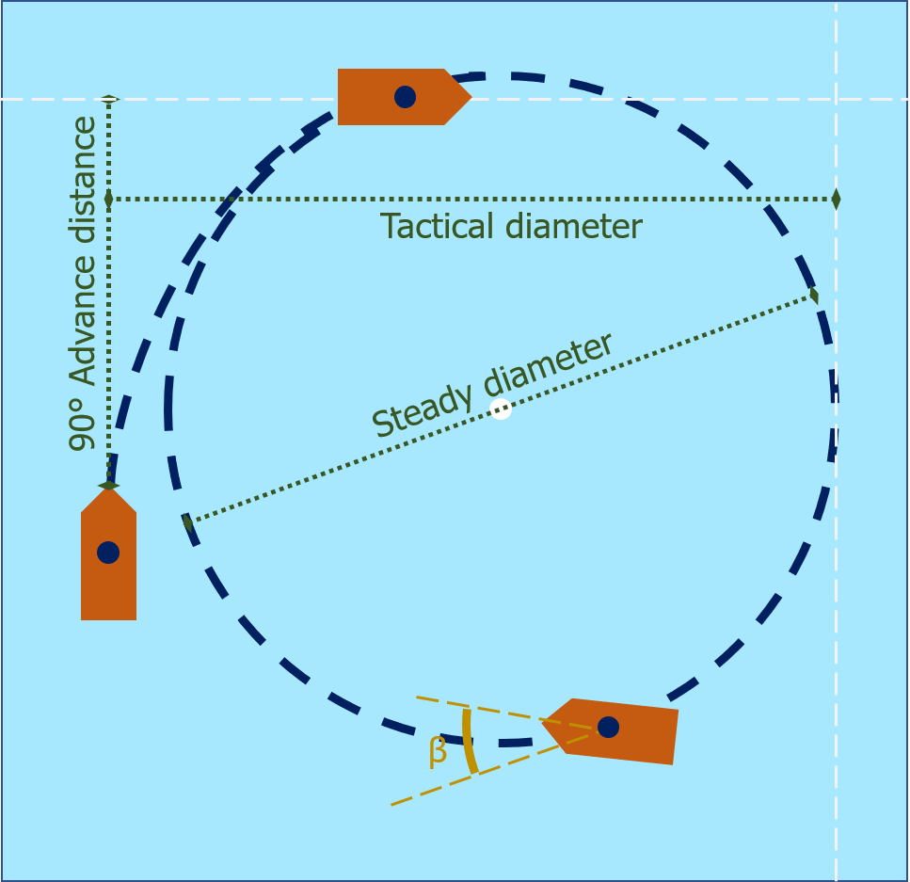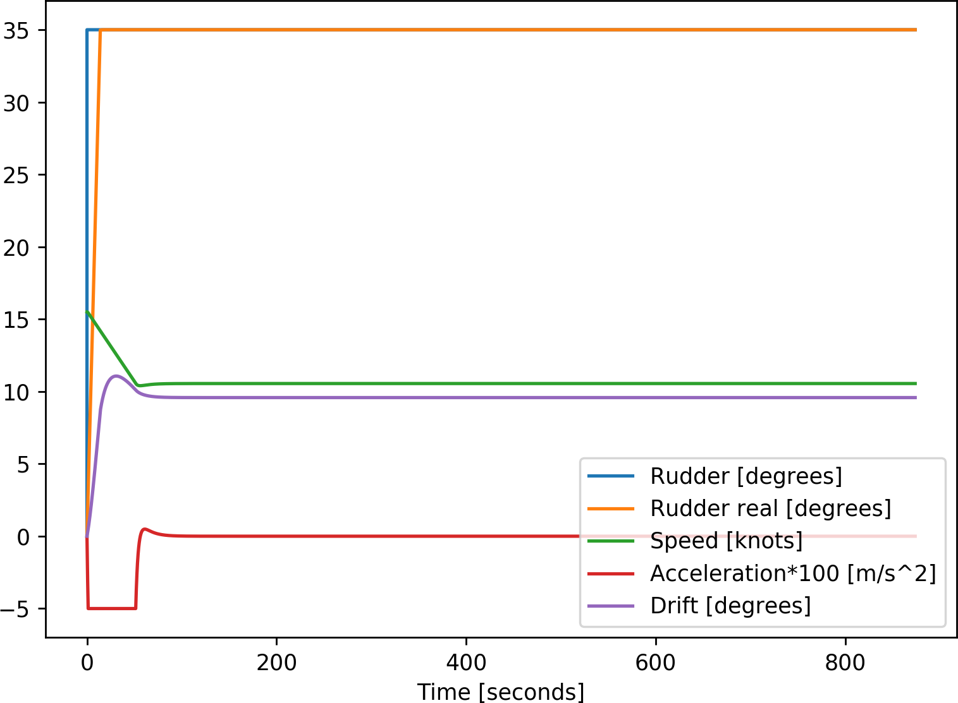

* + 1. Illustrative path (b) 15kn with 140m cargoship

Figure 6.1: Turning circle test

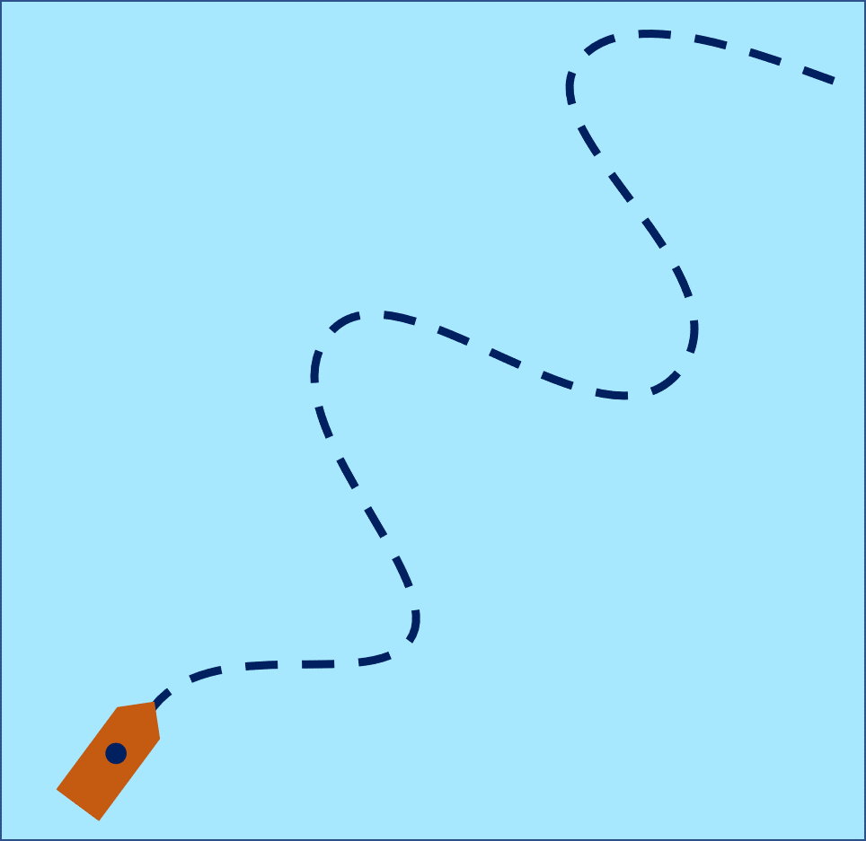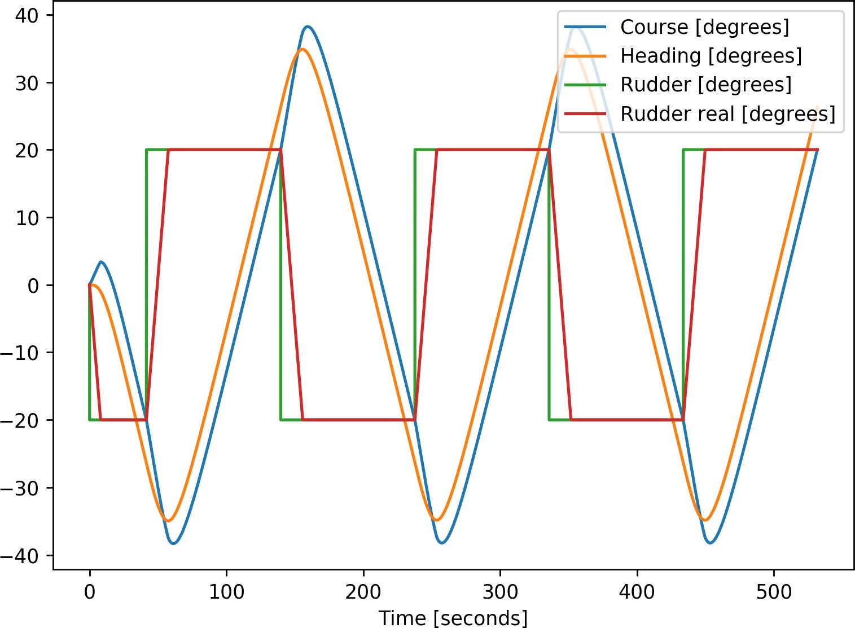

(a) Illustrative path (b) Zig-zag 20:20 test at 15kn with 140m cargoship

Figure 6.2: Zig-zag test

46 *CHAPTER 6. MANOEUVRES FOR VALIDATION AND TESTING*

### Critical evasive manoeuvrer

The critical evasive manoeuvrer aims to increase the closest point of approach (CPA) as much as possible and return to the original course. Using the least amount of time and advance distance. Based on COLREGs is there a stand-on and give-way vessel. The stand-on vessel is supposed to keep course and speed the same, while the give-way vessel is supposed to manoeuvrer. A ship can do an evasive manoeuvrer in many ways. However, the most critical situation is when the ships are on a collision course, where maximum rudder is given to avoid another vessel of which the course is perpendicular. Thereby is the aim of the give-away vessel to end the manoeuvrer at its initial course. Figure 6.3 shows an example of such manoeuvrer. *θ* is the maximum course change. *X* is the distance until a ship reaches the initial CPA, which is in the most critical situation, the collision point. Figure 6.3b shows how the vessel uses its rudder during the evasive manoeuvrer. Also is seen that the speed reduces, mostly due to the drift angle. The manoeuvrer is simulated for different start speeds and with different maximum course changes.

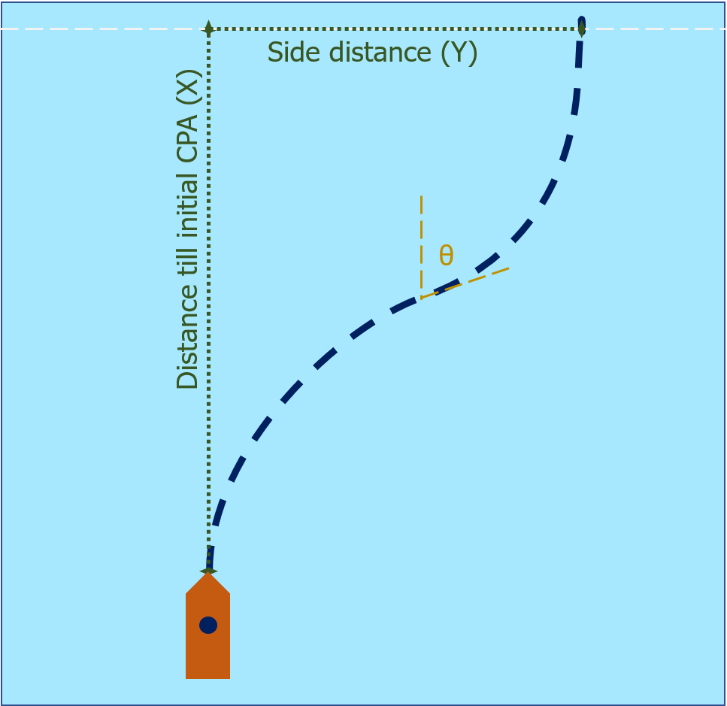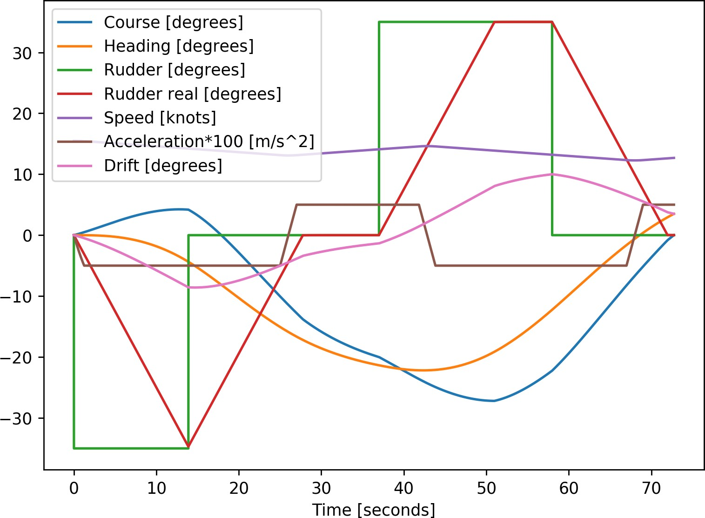

* + - 1. Illustrative path (b) 20 degrees at 15kn with 140m cargoship

Figure 6.3: Evasive manoeuvrer

* 1. *TOOL VALIDATION* 47

## Tool validation

To validate if the results will be as expected, do we use the same manoeuvers as in the sea-trials. Thereby are different input settings tested for the evasive manoeuvrer, to improve the final result. The previous section describes these manoeuvers. This section will discuss the validation of the tool, which is presented in appendix B. This validation is first done for the used hydrodynamic model. And then for the evasive manoeuvrer which will be used to determine the dependence of the decision domain on manoeuvrability.

### Validation of hydrodynamic model

Section B.2.3 and the paper by Artyszuk [Artyszuk (2016)] explain the used hydrodynamic model. This linear dynamic higher-order model is based on the 2*nd* order Nomoto model

[Nomoto and Taguchi (1957)], where different derivations are made to incorporate ship characteristics.

The model is validated using the sea-trial database from Damen Shipyards, criteria as described

by IMO resolution A751(18) [Quadvlieg and van Coevorden (2003)], similar simulator comparisons [Tjøswold (2012)] and results presented at MARSIM ’96 [MARSIM (1996)]. Combining these sources will give ranges in which the metrics from the sea-trials are expected. By using the same vessels and manoeuvers as are stored in the database, the quality of the hydrodynamic model is validated. This validation is done by comparing the resulting metrics from the simulation model to expected metrics, which are based on the database and regulations.

The overshoot measured during the zig-zag test has a larger spread compared to other metrics, as it depends much more on weather conditions and human factor. But the overshoot gives insight if the input characteristics result in behaviour which can be expected. For example, a tug should have a larger overshoot, compared to a cargo vessel, as the course keeping characteristics are very different. The results for the turning circle test give more definitive answers on the quality of the model. The model is accepted when the results of these tests are close to the expected results. For the simulation are not all input coefficients optimised for each ship to behave as realistic as possible, as the optimisation of these coefficients is not within the scope of this research. In table 6.1, the expected results are compared with the results from the manoeuvring model for different ship types and sizes. The overshoot is based on a 10 degrees zig-zag test, so a change of course at 10 degrees and for a rudder angle of 10 degrees. The turning circle test starts by giving the maximum amount of rudder. Both tests begin when sailing at design speed. For the small tugboat, the results are not within the expected range. The overshoot and advance distance are for the other vessels within the predicted range. The tactical diameter is however relatively too large. This difference between

48 *CHAPTER 6. MANOEUVRES FOR VALIDATION AND TESTING*

expected results and simulation results is seen more often [Tjøswold (2012)]. This difference has been identified as an error with non-linear damping. The critical evasive manoeuvrer is much more similar to the first part of the turning circle test in which the advance distance will be determined. Therefore the inputs for the manoeuvring model will not be changed to improve the tactical diameter. Thus when testing the critical evasive manoeuvrer, it should be considered that the model works better for larger cargo vessels and manoeuvers which do not go further than 90 degrees.

|  |  |  |  |  |
| --- | --- | --- | --- | --- |
| Ship type | Metric | Unit | Expected result | Model result |
| Tug | Overshoot | seconds | 8 - 45 | 29 |
| 28 meter | Advance | meter | 60 - 66 | 81 |
| 13 knots | Tactical diameter | meter | 35 - 41 | 68 |
|  | Final speed | knots | 6 - 7 | 4.4 |
| Cargo vessel | Overshoot | seconds | 4 - 10 | 8.6 |
| 115 meter | Advance | meter | 265 - 320 | 315 |
| 13 knots | Tactical diameter | meter | 280 - 365 | 362 |
|  | Final speed | knots | 7.9 - 10.5 | 8.7 |
| Cargo vessel | Overshoot | seconds | 4 - 10 | 8.4 |
| 145 meter | Advance | meter | 350 - 420 | 397 |
| 15 knots | Tactical diameter | meter | 340 - 450 | 475 |
|  | Final speed | knots | 5 - 11 | 9.6 |
| Tanker | Overshoot | seconds | 3 - 7 | 4.2 |
| 250 meter | Advance | meter | 600 - 650 | 609 |
| 10.5 knots | Tactical diameter | meter | 650 - 800 | 870 |
|  | Final speed | knots | 7 - 9 | 8.9 |

Table 6.1: Validation of manoeuvring model

*6.2. TOOL VALIDATION* 49

### Input for critical evasive manoeuvrer

Section 6.1.2 describes the critical evasive manoeuvrer. During the manoeuvrer, there are several actions: give rudder, give rudder to opposite direction, steer straight. The timing of these steps determines the overshoot. The maximum turning rate of the rudder should thereby be taken into account. During the simulation different steps are taken:

* + - 1. Start of manoeuvrer. Rudder angle: 35 degrees to initial direction.
      2. Few seconds before reaching desired course change. Rudder angle: 0 degrees.
      3. At desired course change. Rudder angle: 35 degrees to opposite direction.
      4. Few seconds before reaching original course. Rudder angle: 0 degrees.

These steps will result in a path which has a bit of overshoot but is comparable to the decision taken by an officer of watch (human or autonomous). 35 degrees is the maximum angle to which a rudder turns for most vessels. Figure 6.4 shows how the initial rudder direction should be, depending on the location and direction of the crossing vessel. To improve the CPA, you should steer away from the other’s path, which means that if the other ship is in the green area, you should steer to starboard. When the other ship is in a red area, your initial direction should be to port. The orange cross represents the initial collision location in the figure. The critical evasive manoeuvrer aims to increase the CPA as much as possible and return to the original course. Two factors determine the increase in CPA. The first is the distance which the ship moves to the side. The second factor is the reduction in speed due to the course changes. The passing distance and closest point of approach are calculated using the algorithms from chapter 5

50 *CHAPTER 6. MANOEUVRES FOR VALIDATION AND TESTING*

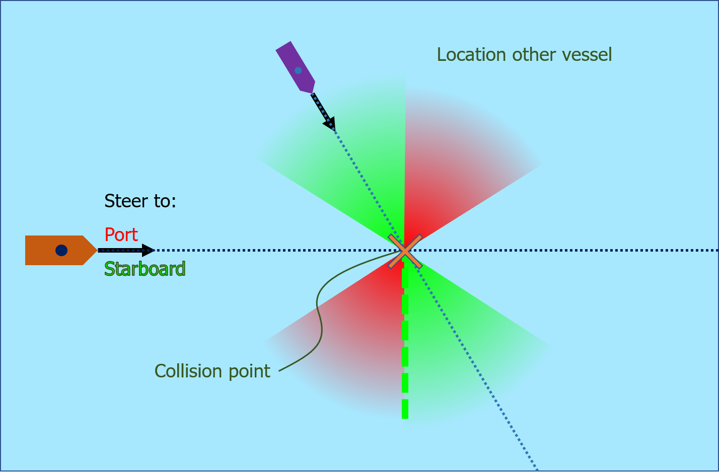

Figure 6.4: Direction for evasive manoeuvrer in crossing situation

# 7 *|* Evaluation of critical evasive manoeuvre

In the previous chapters are steps taken to identify common critical situations. Enough clearance is key to avoid communication. Ships can acquire this clearance by making the right decision well in advance. This chapter will take a look at the relation between the manoeuvrability of the vessel and this clearance. Section 7.1 shows the relation between manoeuvring characteristics and criteria for safe operation. Using the simulation environment is looked into the effect of varying manoeuvring characteristics, including the advance distances from the turning circle test. These relations are used to evaluate the effect of improvements to the advance distance by increasing the manoeuvrability of a vessel on the possibility to avoid communication. This increase in manoeuvrability should result in less critical situations and therewith the amount of communication. This will on its turn show how the passing distance can be improved by changing manoeuvrability characteristics, and how this should be taken into account in the design and decision process of ships. A use case is thereby used to support this. The method to find this relation for the critical evasive manoeuvre and effect on the decision and design process can be used to give a general answer to the question if it is possible to ensure that a chosen strategy will result in an approach distance which does not require communication.

## 7.1 Trial results for critical evasive manoeuvre

The first step is to find the relations between manoeuvring characteristics and criteria for the operation which do not require communication. The tests from section 6.1 are used in the simulation environment to acquire these relations. The criteria herein are the CPA and crossing distance. The primary input for the results depend on the ship manoeuvrability and starting speed of the vessel. The speed of another vessel and crossing angle should be taken into account to eventually calculate the closest point of approach and passing distance for the most critical situation. The metrics to evaluate the above mentioned criteria are described in table 7.1 and shown in figure 6.3a.

The reason to use the evasive manoeuvre is that when two ships are parallel, the situation becomes a head-on or take-over situation. These situations are less critical and more easy to cope with than a crossing situation. A ship has to alter its course to go from a crossing situation to another situation. In case the crossing angle is 90 degrees, the ship has to alter its course the most. This is deduced from figure 6.4. Therefore is the crossing angle for the most critical evasive manoeuvre 90 degrees.

51

52 *CHAPTER 7. EVALUATION OF CRITICAL EVASIVE MANOEUVRE*

Metric Description

Time needed for manoeuvre Time from first rudder change, until the ship returned to its

original course

Distance till initial CPA (X) Distance travelled forward in the direction of the original

course to the point where the ship had the smallest CPA Side distance (Y) Distance travelled perpendicular to original course

Extra time Time needed for manoeuvre, minus the time it would have taken to travel the same distance forward

Passing distance Adding the distance to the side to the extra time times the

speed of the other vessel

CPA Closest point of approach during the manoeuvre

Table 7.1: Metrics for evasive manoeuvrer

### Passing distance

The passing distance is the first criteria which will be evaluated, as this is often used by seafarers to determine if they pass correctly. A simplified calculation for the passing distance can be used due to the perpendicular crossing situation. Figure 7.1 shows the results of trials revealing the relation between passing distance, distance till initial CPA and starting speed.

#### Results of simulations

The *passing distance* = *side distance* + *speed other × extra time*. For the simulation is the speed of the other vessel kept constant at 14 knots, as the effect of the speed of another vessel is relatively small. For the same passing distance will the distance till CPA vary with less than 50 meters. 14 knots is a typical speed for large cargo vessels at open-sea. The possible passing distance for lower speeds is smaller for the same distance till CPA.

The wedges in figure 7.1 are used to determine the distance till initial CPA. For the Gulf Valour at 13 knots, and a collision course with a vessel sailing at 14 knots. Does it mean that the Gulf Valour has to start acting at least 860 meters before the collision point, to end up with a CPA of 500 meters. When the Emma Maersk sails 13 knots and has 1150 meter left to act before a collision. Does it mean that the passing distance can be at most 500 meters.

In figure 7.1d are the wedges combined, to show the relative size of these wedges. The location of the curves within the wedges depend on the start speed, which influences the advance distance. There exist a maximum at a distance for every ship and speed. This distance is equal to the distance needed to do an evasive manoeuvre with a maximum course change of 90 degrees. The ship becomes parallel to the other vessel with this course change, which means it’s not a crossing situation anymore.

* 1. *TRIAL RESULTS FOR CRITICAL EVASIVE MANOEUVRE* 53

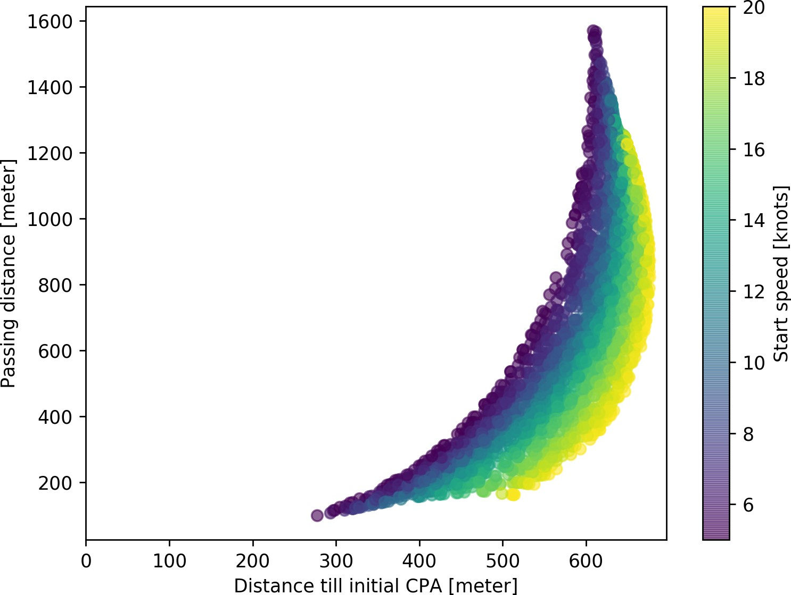

* + 1. Astrorunner (140m - 9500 ton - General cargo)

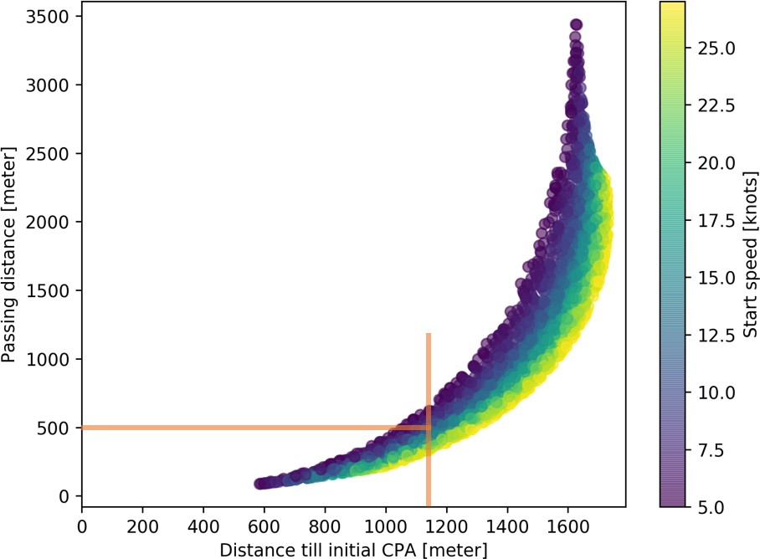

* + 1. Emma Maersk (400m - 157000 ton - Containers)

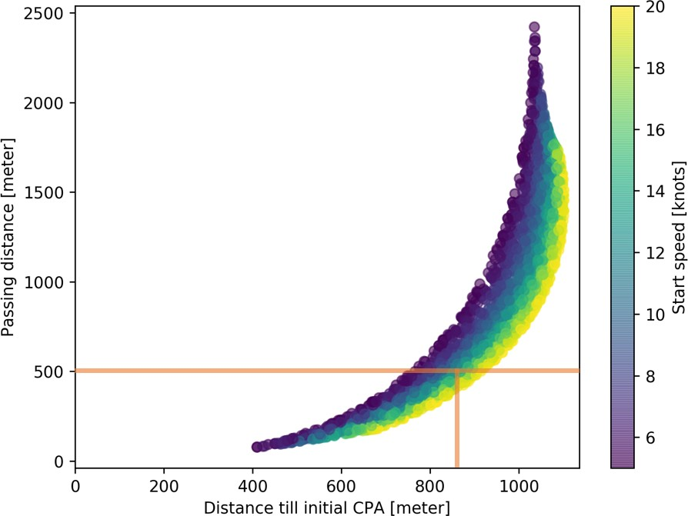 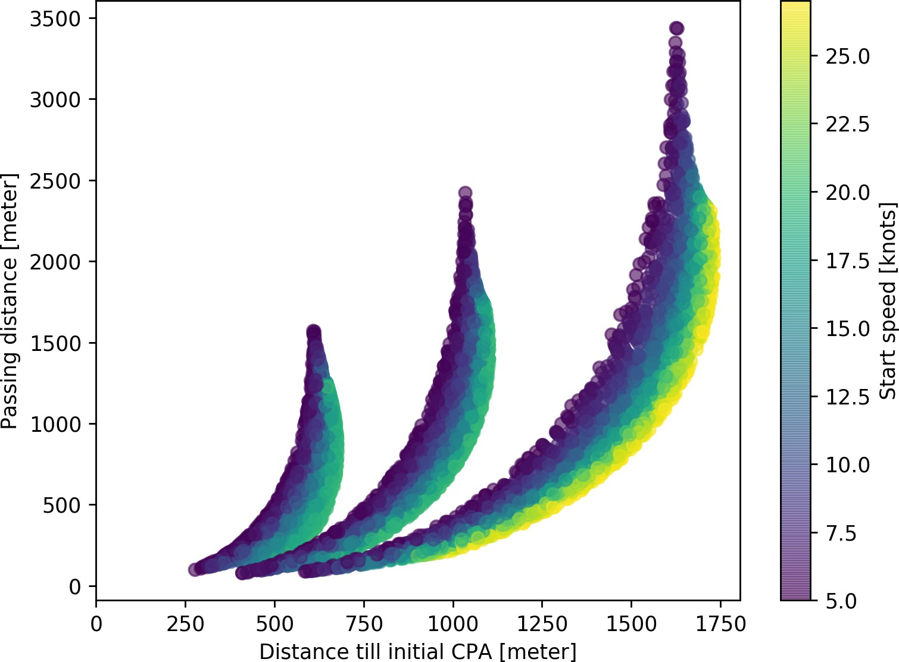

* + 1. Gulf Valour (250m - 115000 ton - Tanker) (d) Combined relations for vessels

Figure 7.1: Relation between passing distance, distance till CPA and start speed

54 *CHAPTER 7. EVALUATION OF CRITICAL EVASIVE MANOEUVRE*

#### Relation between the passing distance and advance distance

From the results above is clear that there is a relation between start speed and the results of the critical evasive manoeuvrer. This start speed influences the key manoeuvrability characteristic relevant to the critical evasive manoeuvrer: Advance distance. This is measured during the turning circle test. To show the relation between the advance distance, distance till initial CPA and passing distance, are trial results as shown in figure 7.1 combined. Many more ships are however needed to create a continuous graph which can be used to show relations over a wider range. More ships are created using a mocking strategy, where beside the start speed and course change, also the input for the manoeuvring model is varied. This creates fake ships which do not exist in reality but will give results comparable to existing ships. The empirical amplification factor of the rudder force is varied, which means that the rudder is more or less effective. Vessels acquire this change by changing the size of the rudder or adding rudders. Due to non-linearities can’t be said that a doubling of this factor is the same as adding an extra rudder. However, it will give a requirement for the advance distance.

Figure 7.2 shows how the relation between distance till CPA and the final passing distance depends on the advance distance. Where the advance distance depends on three factors, the ship (140m cargo ship, 250m tanker or 400m container ship), the start-speed and the empirical rudder amplification factor. Using the different graphs per ship as shown in appendix D is a continuous graph created. The curves deducted from this graph can be used during the design process or while operating a vessel to determine the required advance distance for a specific situation. This can be used on its turn to define vessel dependent speed limits or manoeuvrability requirements for specific areas and situations.

#### Generalized relation for passing distance

Figure 7.3 shows the generalised form for the relation between distance till initial CPA and passing distance. Going left or right on this general curve, relates to the maximum course change (*θ*). The position of the curve depends on two factors, the advance distance and speed of another vessel. Where the speed of another vessel has a relatively small impact, as the bandwidth of these curves is small. By comparing different curves, is seen that an increase of 1 knot, will result in a maximum change of 1% of the distance till CPA when the passing distance is kept constant. This change means for a 400-meter container ship with the desired passing distance of 1000 meter that the distance till initial CPA varies between 960 and 1070 meters when the speed of the other vessel varies between 0 and 18 knots.

*7.1. TRIAL RESULTS FOR CRITICAL EVASIVE MANOEUVRE* 55

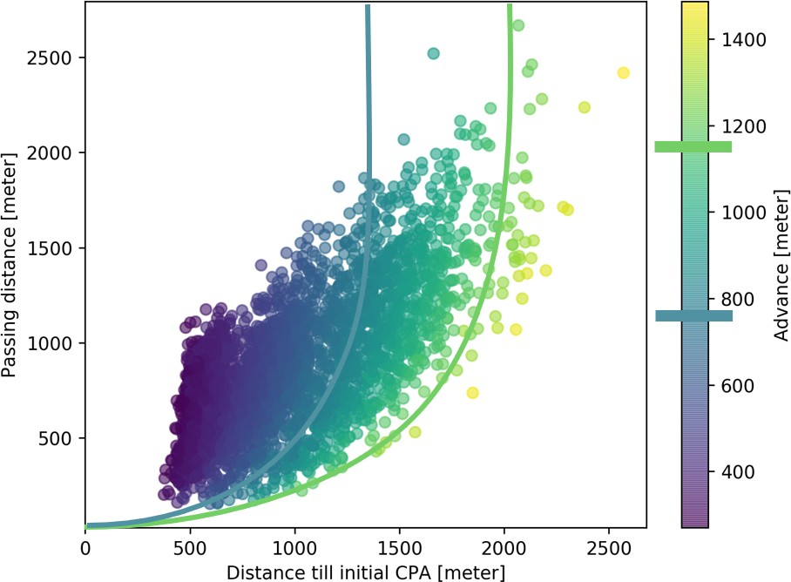

Figure 7.2: Combined plots for different advance distances, showing the relation between distance till CPA, passing distance and advance distance by varying start speed and rudder amplification factor. Including example advance distance iso-curves

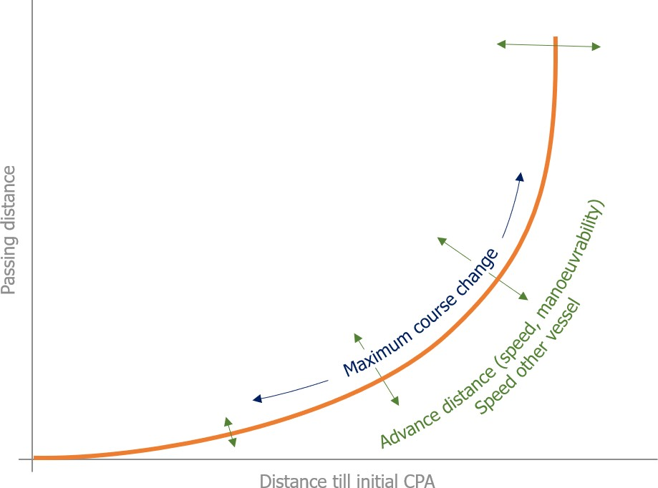

Figure 7.3: General curve for relation between distance till initial CPA and passing distance

56 *CHAPTER 7. EVALUATION OF CRITICAL EVASIVE MANOEUVRE*

The advance distance is however much more relevant for increasing the ability of unmanned vessels to ensure safe operation in critical situations. In case of an evasive manoeuvrer does a reduction of 1% of the advance distance, result in a 1% reduction of the distance till initial CPA. Liu [Liu et al. (2015)] has shown that a reduction of 10 % in advance distance can already be acquired by using different rudder profiles, compared to commonly used profiles. Similar results are acquired by using a high-lift rudder [Zaky et al. (2018)]. For a 250 meter tanker at 12 knots, with the desired passing distance of 1000 meter, this would mean a reduction of 100 meters on the distance till initial CPA. This reduction will on its turn mean that 100 meters less is required to ensure that the chosen strategy will result in a passing distance which does not require communication.

### Closest point of approach

The more critical measure is the CPA, as this tells what the minimal distance is between two vessels. For this criteria is a more complex calculation necessary. The algorithm from section 5.2.2 is used to calculate the CPA. In case of the critical evasive manoeuvre is the CPA smaller than the passing distance. The moment of the CPA is often earlier than the initial CPA, as the first step in a crossing situation is to steer towards the other vessel. Using the knowledge from the passing distance is again looked at the influence of the advance distance on the CPA.

#### Results of simulations of the relation between the CPA and advance distance

The minimum for the distance between another ship and own ship at every timestep is the CPA. To find the general relations are for this simulation different inputs varied again. Varying these inputs will give insight into how these affect the decision and design process. Inputs which are also varied for to find the general relation for the passing distance are the ships, the maximum course change, the start speed, and the rudder amplification factor. The speed of the other vessel is 14 knots again for the same reasons as described in the previous section.

Figure 7.4a shows a clear maximum for the CPA at every distance till the initial CPA. Thereby can be seen that this depends on the advance distance. This relation has a different generalised curve than figure 7.3. Figure 7.4b shows the generalised curve for the CPA, where the advance distance is constant for each of the different curves. The advance distance for these curves is 397, 609 and 1140 meter.

* 1. *TRIAL RESULTS FOR CRITICAL EVASIVE MANOEUVRE* 57

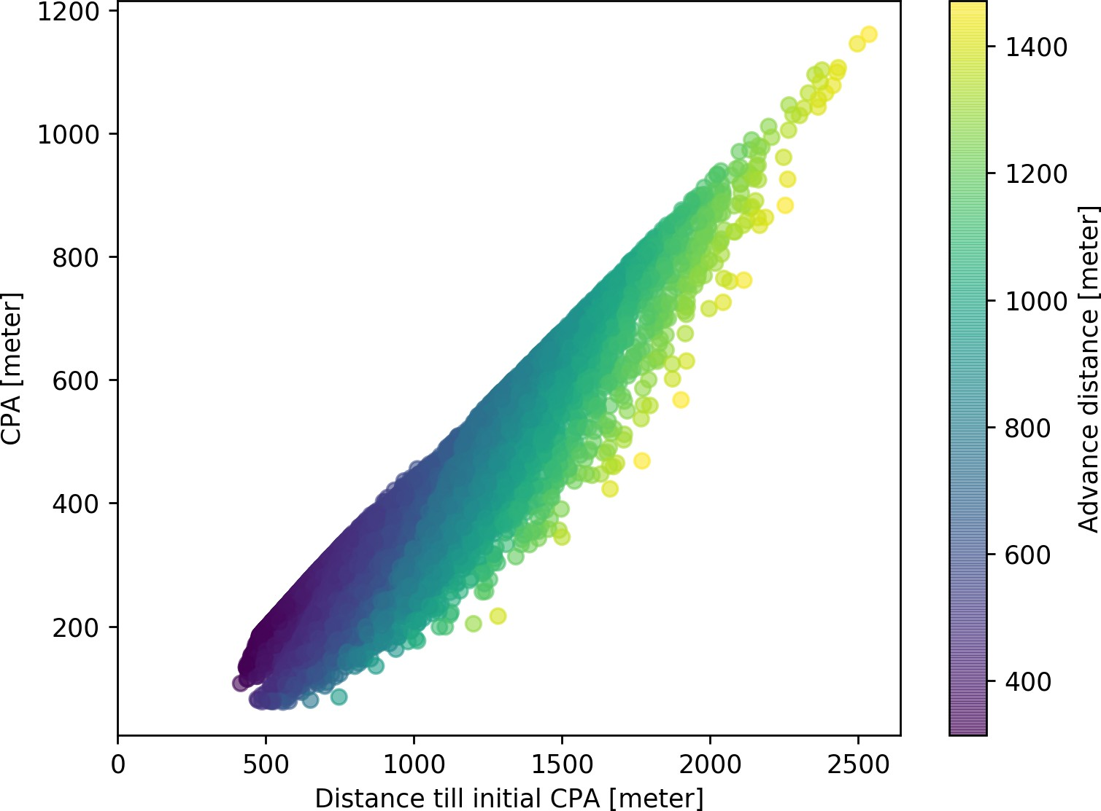

* + 1. Combined plot for the resulting CPA at different advance distances

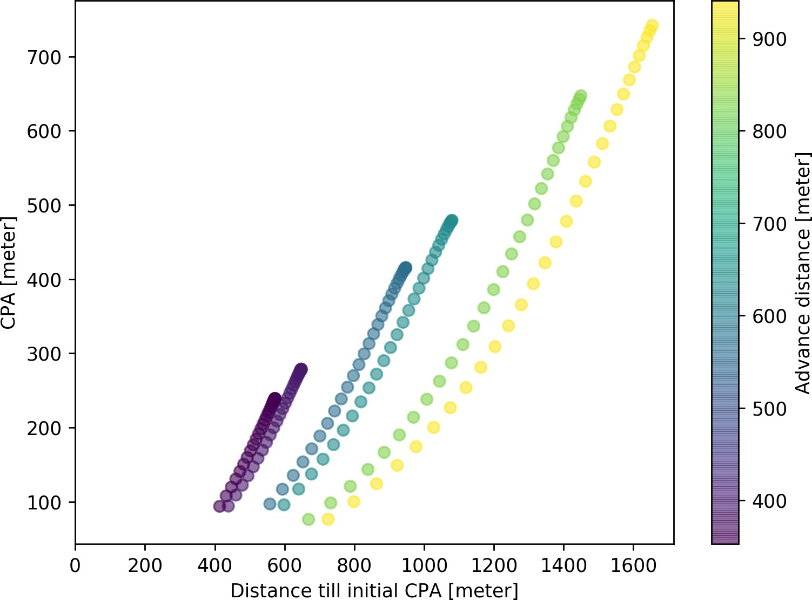

* + 1. Example iso-curves for different speeds and manoeuvring characteristics, as used in use case

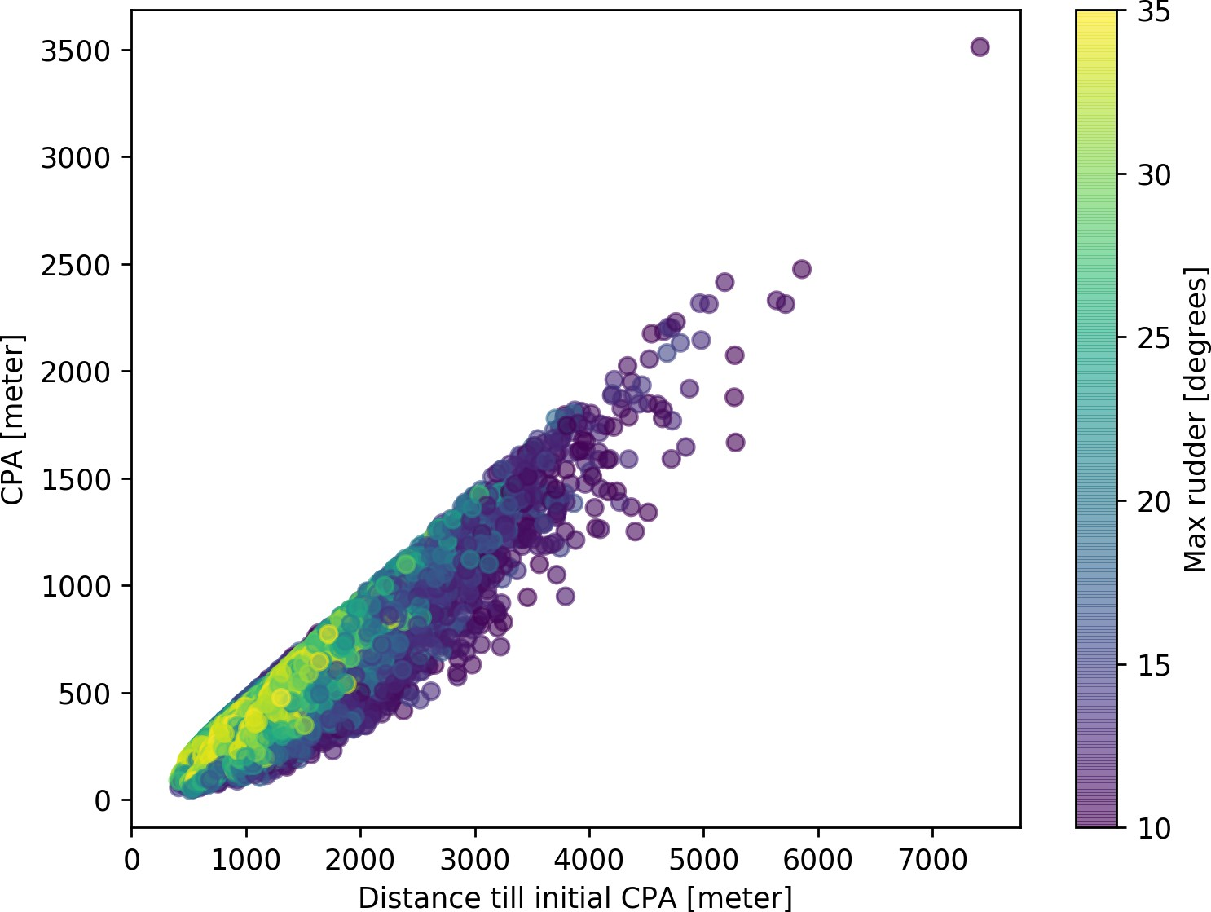

* + 1. For different maximum rudder angles

Figure 7.4: Relation between distance till CPA and CPA

58 *CHAPTER 7. EVALUATION OF CRITICAL EVASIVE MANOEUVRE*

The maximum rudder angle during the evasive manoeuvre is an extra factor influenced to find the relation between CPA and advance distance. For calculating the CPA is the shape of the curve during the evasive manoeuvre relevant, as the CPA takes often place somewhere in this bend. Varying this input will give results for a larger range of CPAs. Figure 7.4c shows how this changes the relation between distance till initial CPA, CPA and the advance distance.

#### General relation for CPA

In the previous section are results shown for the impact of the advance distance. The manoeuvring characteristics and start speed of the vessel determine the advance distance, thereby is shown how these affect the CPA in a critical evasive manoeuvre. Conclusions can be drawn on the effect of the manoeuvring characteristics on the decision process, by taking the general curves for these relations. These are also taken into account during the design process of a ship or traffic schemes.

One of the most interesting characteristics from the results, is the maximum value for CPA at different distances till initial CPA. Thus the almost linear line showing the maximum CPA reachable for each distance till a collision would occur. This line can be explained by the trajectories of the ships and the shape of the safety domain. The exact trajectory of the ship depends on the manoeuvrability characteristics, such as overshoot and turning ability. But the most important factor for the shape is the advance distance.

The point where the CPA is reached is at a similar location in the manoeuvre when normalized by the advance distance and time for the situation where the maximum course change is 90 degrees. This point is exactly where the ship has turned 90 degrees. This point is exactly the same as the point where the advance distance in the turning circle test is measured. Which means there is a direct correlation between the advance distance and the point where the CPA is reached. As the speed of the other vessel is kept the same due to its limited impact, will this result in a linear line for the relation between CPA and distance till initial CPA.

## Use case

Examples are given to show how the relations for common critical evasive manoeuvres can be used in the decision and design process. These show how the relations can be used to define vessel dependent speed limits or manoeuvrability requirements for specific situations. The common critical situation used is a crossing of a traffic lane. This is similar to the situation as used in part III during the experiment. The situation is described first, next the

* 1. *USE CASE* 59

manoeuvrability characteristics are varied to show how this influences the decision process. This is concluded by a discussion on the requirements for different vessels in such a situation.

A crossing situation at the North-Sea is used. This situation is also described in section 11.1.2.

The situation is based on the accident between MV ARTADI and MV ST-GERMAIN (appendix C.2). Three vessels are included in this use case: a 250-meter tanker (GULF VALOUR), a 140- meter cargo vessel (ASTRORUNNER) and a 400-meter container vessel (EMMA MAERSK).

Different screenshots of the situation are shown in figure 7.5 and 7.6 over time, at the end of this chapter. The relevant information for the ships is given in table 7.2.

|  |  |  |  |  |
| --- | --- | --- | --- | --- |
|  | GULF VALOUR | ASTRORUNNER | EMMA MAERSK |  |
| Length | 249.0 | 141.6 | 397.7 | m |
| Width | 48.0 | 20.6 | 56.4 | m |
| Draft | 13.2 | 6.5 | 12.6 | m |
| Deadweight | 114900 | 9543 | 156907 | ton |
| Type | Oil tanker | General cargo vessel | Container vessel |  |
| Colour | Green | Orange | Blue |  |
| Start position | [-100, -100] | [3250, 0] | [2800, 3400] | m |
| Speed | 15.0 | 14.7 | 12.0 | knots |
| Course | 45 | 315 | 225 | degrees |
| Advance distance | 633 | 393 | 940 | m |

Table 7.2: Relevant information for crossing situation at North-Sea

The ASTRORUNNER sails perpendicular to the courses of both GULF VALOUR and EMMA MAERSK. The first interaction is between GULF VALOUR and ASTRORUNNER. The GULF VALOUR has to give-way in this situation. Based on the results from the previous section and considering a minimal CPA of 370 meters (two cables). The experts from the experiment in chapter 11 confirmed that this a realistic CPA in busy areas. This CPA forces the GULF VALOUR to start the evasive manoeuvre 968 meter before the initial collision point.

As the ASTRORUNNER is the stand-on vessel, it has to hold course and speed till the GULF VALOUR has passed. But also considering the results from the previous section and a minimal CPA of 370 meters, this does mean that the ASTRORUNNER has to change its course 739 meters before colliding with the EMMA MAERSK. The GULF VALOUR has passed the ASTRORUNNER 1060 meter before the initial collision point with the EMMA MAERSK, which means that the ASTRORUNNER has plenty of time to avoid a collision with the EMMA MAERSK

If the GULF VALOUR would have been in the same situation as the ASTRORUNNER will it still be possible to manoeuvre in time. As the CPA of 370 meters can be reached by changing its course 968 meter before. This is less than the 1060 meter which is left after becoming

60 *CHAPTER 7. EVALUATION OF CRITICAL EVASIVE MANOEUVRE*

the give-way vessel. The EMMA MAERSK would get into problems, as she has to start the evasive manoeuvre 1285 meters before the collision, while the distance at which the vessels changes from stand-on to give-way vessel is only 1060 meters from the collision point. In that case is it for the EMMA MAERSK only possible to increase the CPA to 218 meters.

Small adoptions are for vessels with the size of the EMMA MAERSK not sufficient, such as an improvement of the rudder properties or reducing speed. These changes will result in a maximum decrease for the distance till initial CPA to 1180 meters. For the GULF VALOUR will changing the rudder profile reduce the advance distance with 10% as described before in section 7.1.1. This reduction will result in an distance till initial CPA of 897 meters, instead of 968 meters for the same desired CPA of 370 meters.

Tables 7.3 and 7.4 show the results of substituting the ASTRORUNNER by the EMMA MAERSK or GULF VALOUR in the use case. This shows that the EMMA MAERSK can’t act in this situation, the GULF VALOUR is limited by its manoeuvrability characteristics to improve the CPA, while the ASTRORUNNER would not benefit due to it’s high manoeuvrability.

## Effect of advance distance on decision and design process

In this research is the critical evasive manoeuvre evaluated. By evaluating more different manoeuvres and situations, will it be possible to create many more common use cases, which can subsequently be used to define more requirements for the advance distance in those situations. This advance distance is an input for the design process of a ship. On the other hand is it possible to use these results to make vessel and situation dependent speed limits. This will ensure that ships can operate safely without communication.

For the critical evasive manoeuvre there are three possible results. There is not sufficient distance left till the initial CPA to improve the CPA to a satisfying distance. For the EMMA MAERSK this is true in the use case. In those situations it is necessary to communicate. The second result is when the manoeuvrability characteristics are limiting the possible CPA. In that case is a ship not able to turn 90 degrees, but has enough distance left till the collision to improve the CPA to the desired CPA. This is the case for the GULF VALOUR when no adaptions are made. The last possibility is that there is sufficient distance to go from a crossing situation to a situation where the courses of both ships are parallel. The maximum possible CPA can exceed in those cases the required CPA. For every extra meter distance till initial CPA, does the CPA also increase one meter. This is the case for the improved GULF VALOUR and the ASTRORUNNER.

* 1. *EFFECT OF ADVANCE DISTANCE ON DECISION AND DESIGN PROCESS* 61

|  |  |  |  |  |
| --- | --- | --- | --- | --- |
|  | GULF VALOUR | ASTRORUNNER | EMMA MAERSK |  |
| Advance distance | 633 | 393 | 940 | m |
| Distance till initial CPA | 1060 | 1060 | 1060 | m |
| Possible CPA  Accepted CPA (370 m) | 462  ,/ | 691  ,/ | 218 | m |
| Advance distance | 633 | 393 | 940 | m |
| Distance till initial CPA | 968 | 739 | 1285 | m |
| Possible CPA  Sufficient distance (1060 m) | 370  ,/ | 370  ,/ | 370 | m |

Table 7.3: Results for double crossing situation with original advance distance

|  |  |  |  |  |
| --- | --- | --- | --- | --- |
|  | GULF VALOUR | ASTRORUNNER | EMMA MAERSK |  |
| Advance distance | 570 | 354 | 846 | m |
| Distance till initial CPA | 1060 | 1060 | 1060 | m |
| Possible CPA  Accepted CPA (370 m) | 527  ,/ | 762  ,/ | 274 | m |
| Advance distance | 570 | 354 | 846 | m |
| Distance till initial CPA | 897 | 704 | 1180 | m |
| Possible CPA  Sufficient distance (1060 m) | 370  ,/ | 370  ,/ | 370 | m |

Table 7.4: Results for double crossing situation with improved advance distance

62 *CHAPTER 7. EVALUATION OF CRITICAL EVASIVE MANOEUVRE*

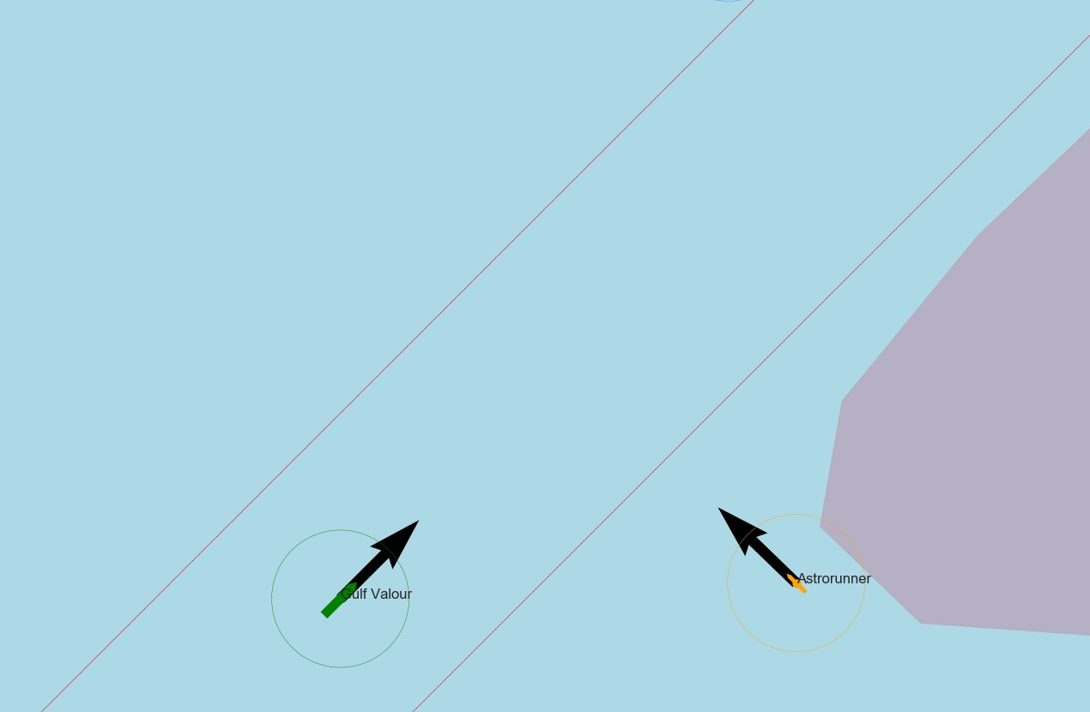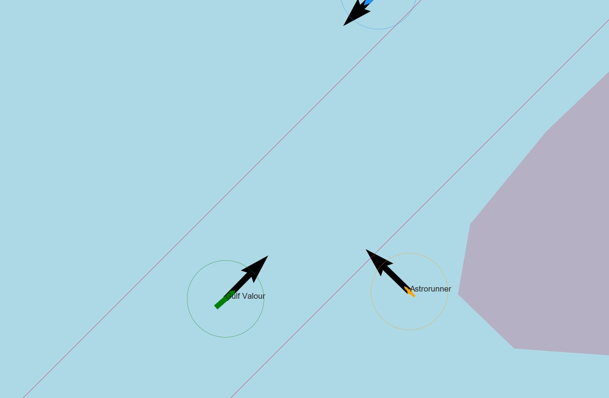

1. Time: 0 (b) Time: 65

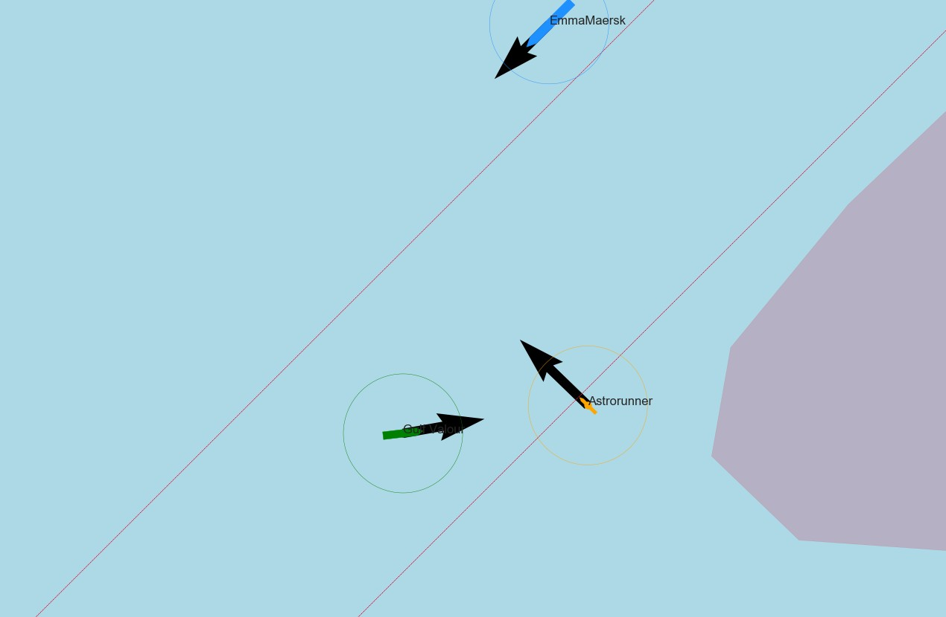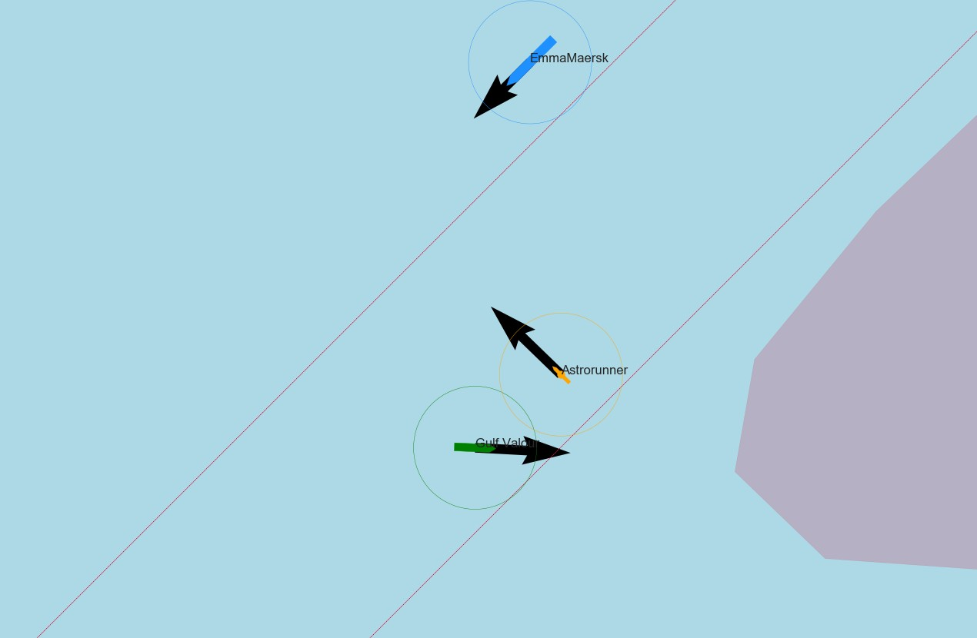

(c) Time: 120 (d) Time: 170

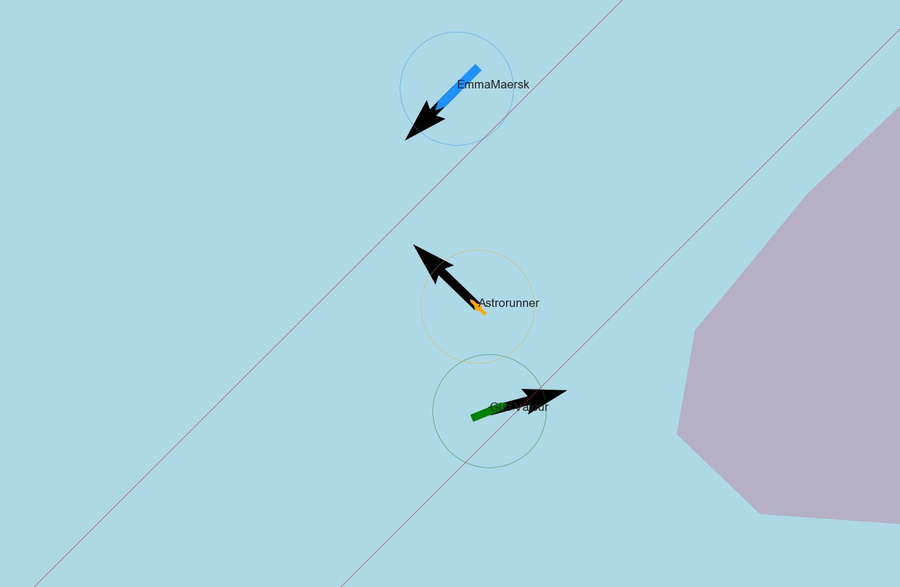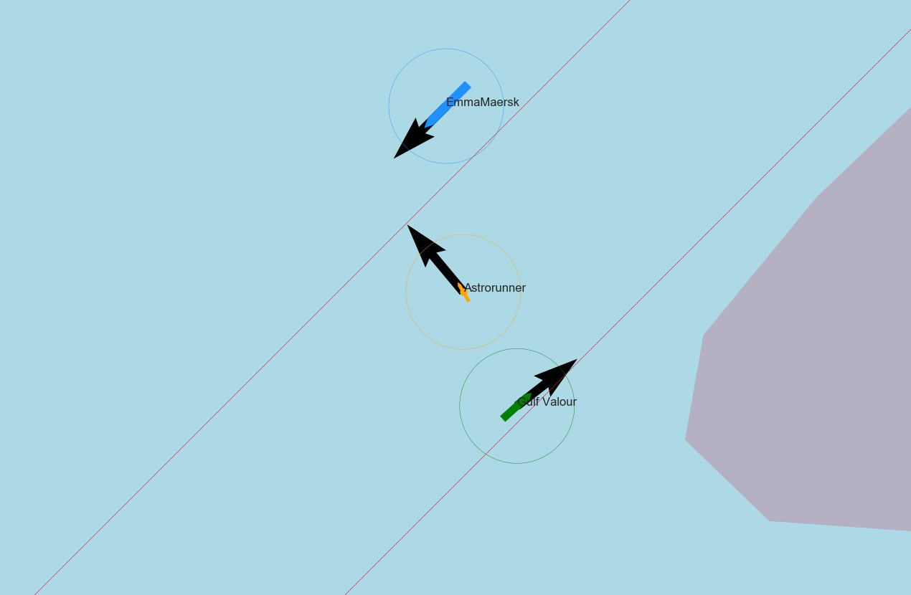

(e) Time: 220 (f) Time: 240

Figure 7.5: Situation sketch for crossing situation at North-Sea part 1

* 1. *EFFECT OF ADVANCE DISTANCE ON DECISION AND DESIGN PROCESS* 63

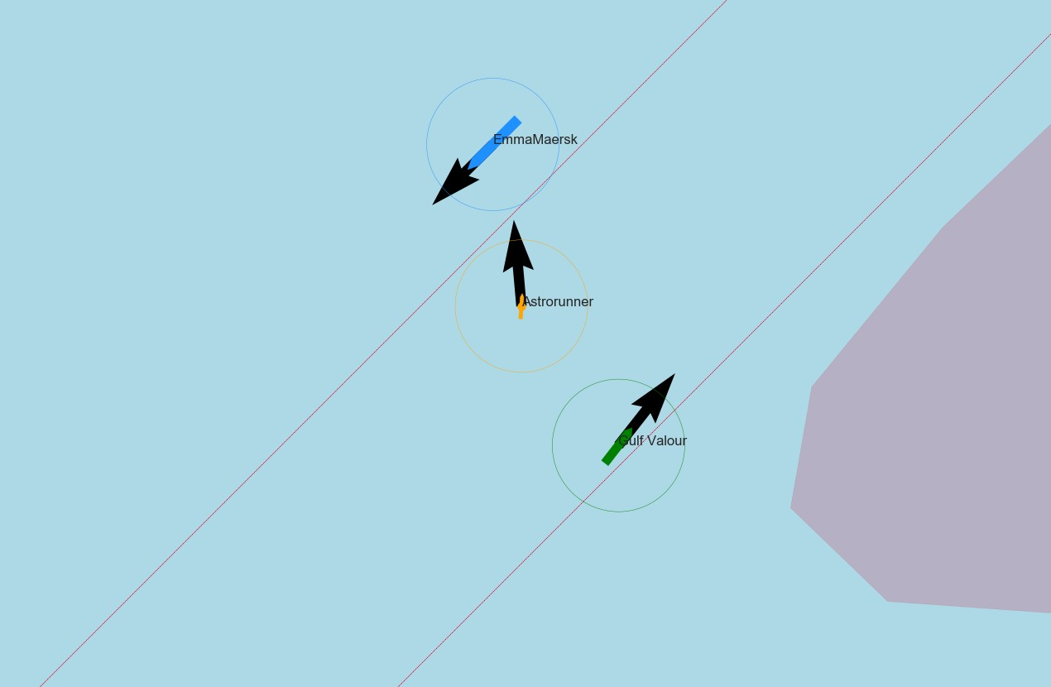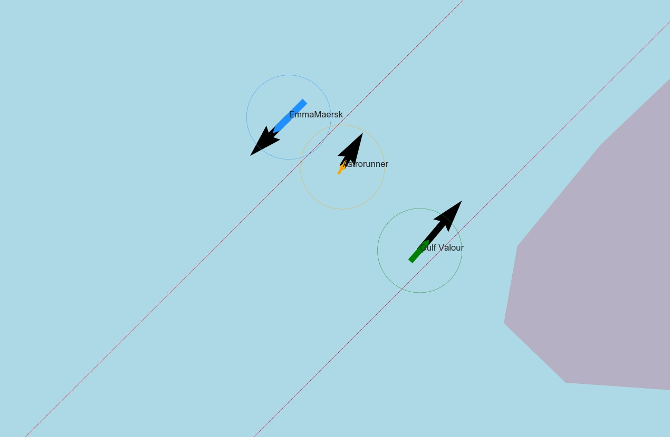

* + 1. Time: 270 (b) Time: 320

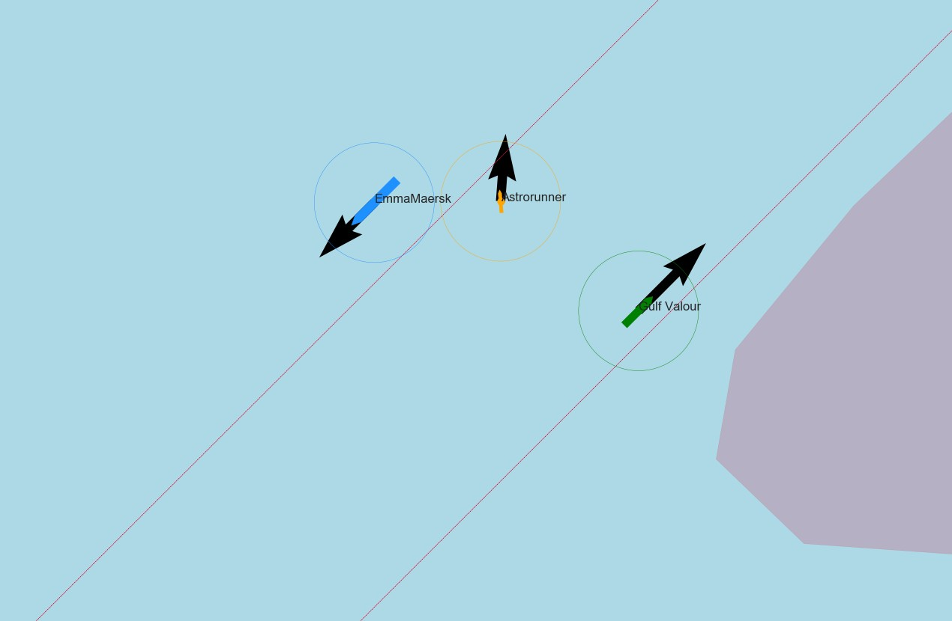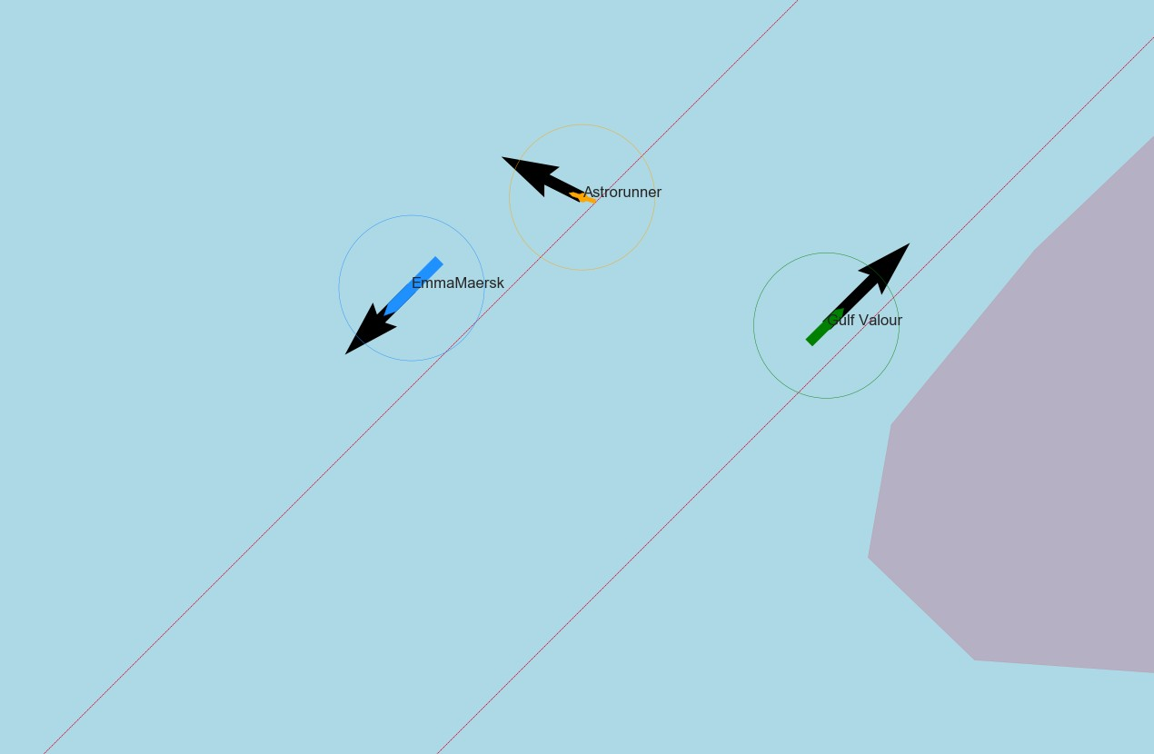

(c) Time: 370 (d) Time: 420

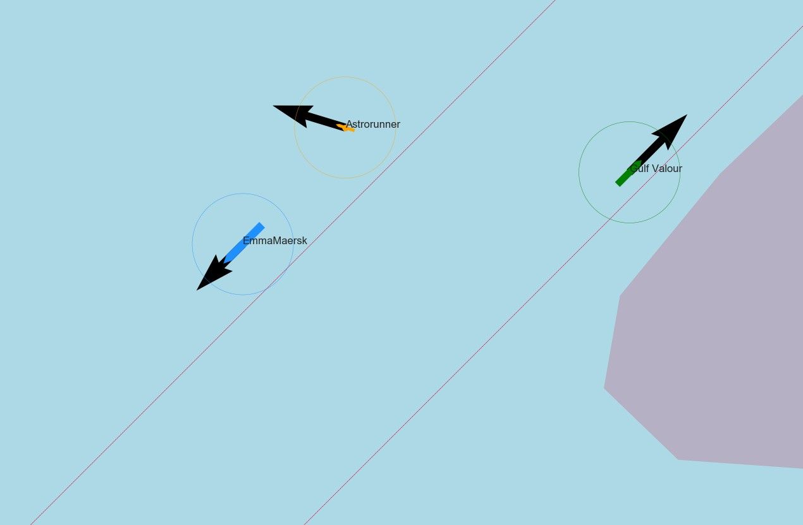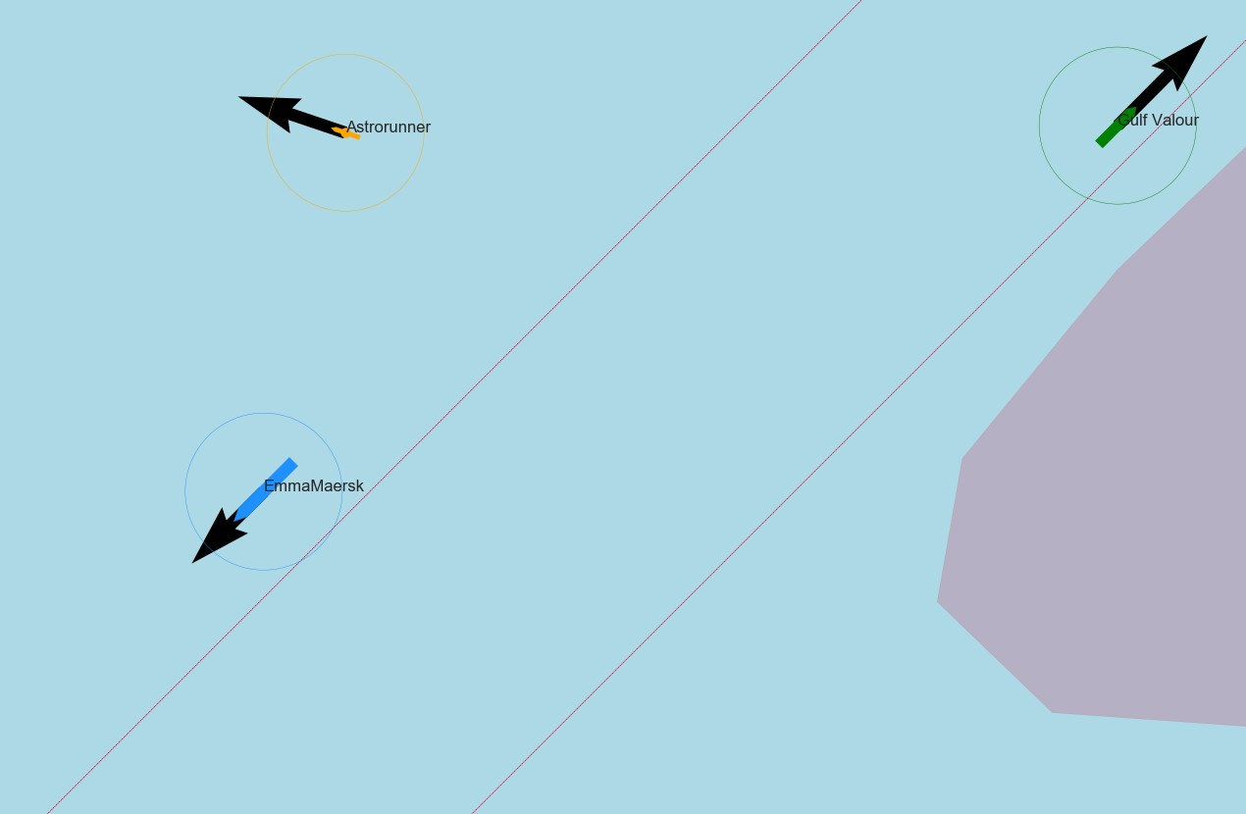

(e) Time: 500 (f) Time: 620

Figure 7.6: Situation sketch for crossing situation at North-Sea part 2

64 *CHAPTER 7. EVALUATION OF CRITICAL EVASIVE MANOEUVRE*

# 8 *|* Conclusion

In this part are different steps taken to show the influence of manoeuvring characteristics on the decision making process, to ensure safe operation. The first step gave insight into the decision making process in different situations. To select criteria which are relevant to make decisions. Based on this analysis are different manoeuvres described, which are used to determine the manoeuvring characteristics. These characteristics are used to evaluate the criteria and determine the right action using the decision trees. The evasive manoeuvre is than selected to test the evaluation method in more detail, as the evasive manoeuvre is both common and critical. This means that the manoeuvre is very suitable to test the method which uses a simulation environment to determine what the relation is between manoeuvrability characteristics and safe operation. This is used to answer the following question:

*How do ship manoeuvrability characteristics influence the domain for decision making, to ensure that the chosen strategy will result in a closest point of approach which does not require communication?*

For a specific situation which requires an evasive manoeuvre is determined that the key manoeuvring characteristics is the advance distance, which is tested during the turning circle test. A relation is found between this advance distance and decision criteria. The relevant decision criteria during a common critical evasive manoeuvre are the closest point of approach (CPA) and passing distance. When these criteria are met, no communication is needed.

The found relations shows that in case the required CPA is 370 meter, the distance till initial CPA should be at least 835 meter. One of the conclusions which can be drawn from this is that the distance between two traffic lanes should be at least 806 meters to ensure that crossing ships have enough space to react, and can avoid communication. The maximum advance distance in this case is 400 meter. Higher advance distances will result in higher distances till initial CPA and thus will need even more space between traffic lanes. The advance distance can be improved by adding rudders or changing the rudder profile. One of these changes could already result in an improvement of 10% on the advance distance, which results in a reduction of 10% on the distance required to react. But this distance can’t be smaller than the mentioned 806 meters, when only using the evasive manoeuvre. By sailing parallel this distance can be increased, but this means it is no crossing situation anymore.

The method used to validate if a ship with certain manoeuvring characteristics is able to act safely and avoid communication can also be used for different situations. Creating a set of these situations will make it possible to evaluate for any ship. If they ensure that the chosen strategy will result in an approach distance which does not require communication. Starboard-

65

66 *CHAPTER 8. CONCLUSION*

starboard passing while turning and the moment when two ships merge are examples for these situations. More research and mostly number crunching are thereby needed to determine what an acceptable CPA and passing distance should be to avoid communication.