COMP9334 Computing clusters

1 Probability distribution

The probability distribution of inter-arrival time
The value of each inter-arrival time is obtained by multiplying an exponentially distributed random number with a uniformly distributed random number,.The implementation of Python3 code is shown in Figure 1.1. Here, 10000 generation tests are conducted using the parameters provided in test case 4, and a distribution histogram of the generated data is plotted, as shown in the Figure 1.2.
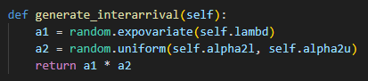
Figure 1.1
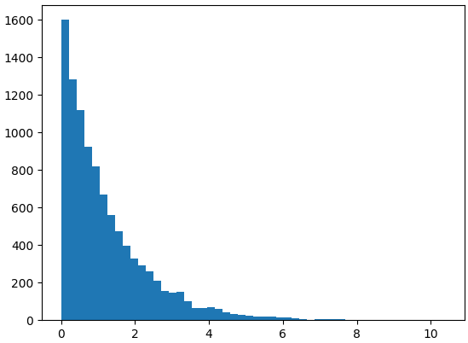
Figure 1.2

The probability of service group
The test case provides a p₀ parameter, which determines the probability of group being 0, so the probability of group to 1 is (1-p₀). Here, the p₀ value from test case 4 was used for testing, with a total of 10000 iterations. Finally, the proportion of group 0 was calculated, as shown in Figure 1.3. Therefore, the result is 0.6967, which is almost the same as the probability of 0.7 specified in test case 4.
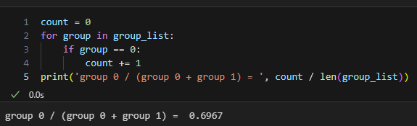
Figure 1.3

The probability distribution of service time
I used the Inverse Transform Method here to generate a service time that conforms to the given probability density function(PDF). We mainly rely on the SymPy module in Python 3 to derive the Cumulative Density Function(CDF), and further derive the inverse function(ICDF). The specific code implementation and derivation results of the inverse distribution functions of g0 and g1 are shown in Figures 1.4 and 1.5.
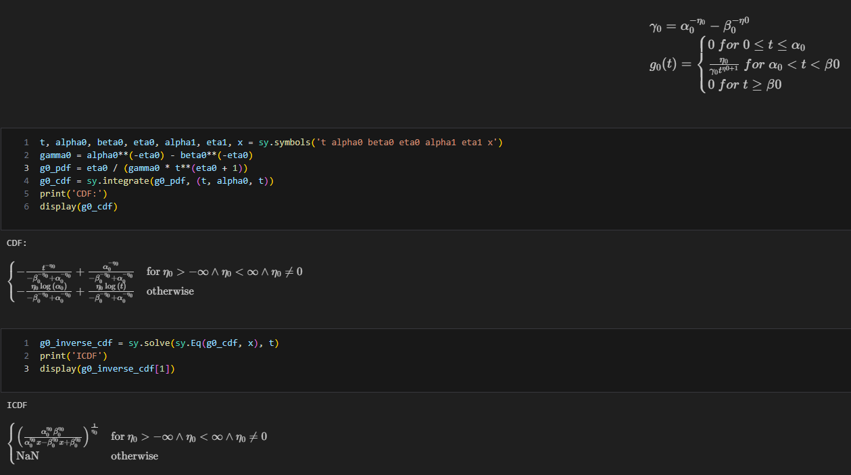
Figure 1.4
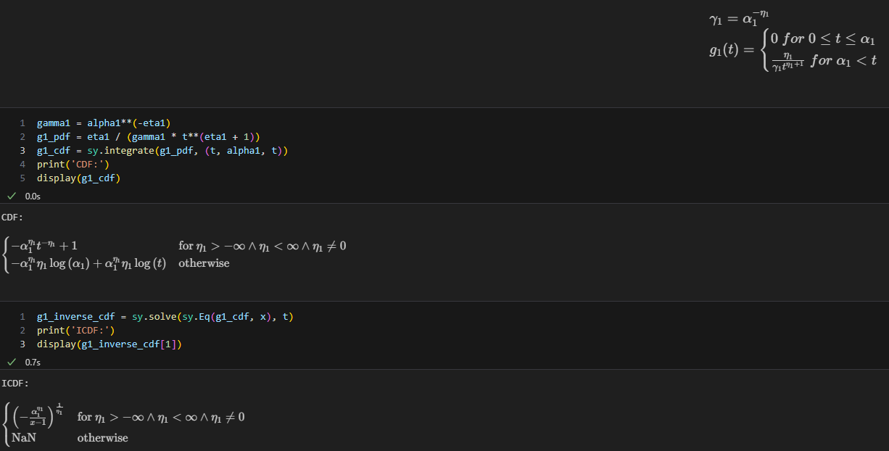
Figure 1.5
At this point, generating service time transforms into generating a random number with a uniform distribution of 0 to 1. The generated random number is substituted into the value obtained by ICDF, which is a random number that conforms to the probability distribution function. The code implementation is shown in Figure 1.6.
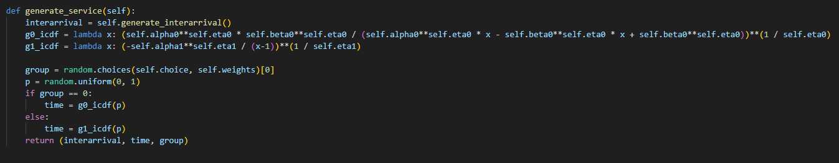
Figure 1.6
Based on the parameters provided in test case 4, generate 10000 times and draw the distribution histograms of service time generated by group 0 and group 1, respectively, as shown in Figures 1.7 and 1.8.
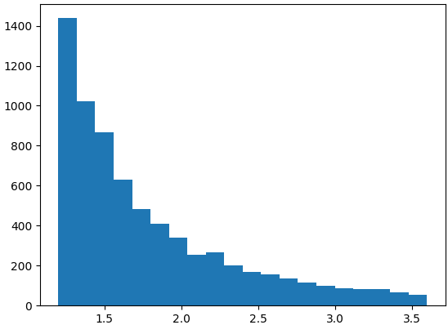
Figure 1.7
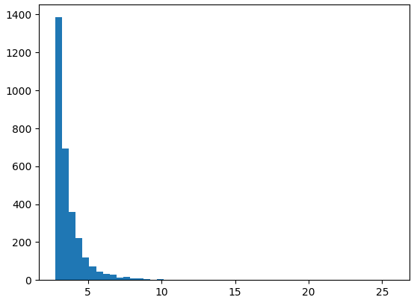
Figure 1.8

Verifying the correctness of the simulation program
In order to verify the correctness of the simulation program, I used 7 test cases provided by lecturer to simulate and run them separately. Finally, I used cf_output_with_ref.py for verification, and the verification output results are shown in the following Figure 2.1.
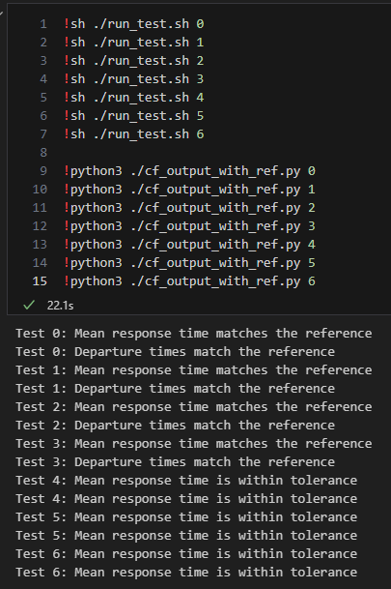
Figure 2.1

3 Simulation reproducible
To ensure that my simulation experiment is reproducible, I used a fixed random number method. Here, the parameters of test case 4 will be used for 100 repeated simulation tests, and the mean response time for each experiment will be recorded. Draw an image based on the mean response time of each experiment as shown in the figure 3.1.
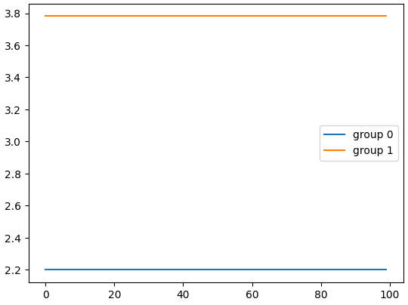
Figure 3.1

4 Determine a suitable value of n₀

4.1 Running the simulation once and present the results
The main purpose of simulation is to determine the optimal value of n₀, and to achieve this goal, it is necessary to ensure that the data is reliable. Here, we will mainly test using the parameters provided by test case 4, and set time_end to 10000, n to 10, and n₀ to 5, and then investigate transient behavior.
Set time_end to 10000 here to ensure that there is enough data to exhibit steady behavior. After conducting simulation tests, it was found that both group 0 and group 1 can maintain a steady mean response time after 1300 data points, as shown in the figure 4.1 below. Based on the probabilities of group 0 and group occurrence being 0.7 and 0.3, respectively (test case 4), the estimated minimum time_end value for steady behavior occurrence is 4333. The time_end value used here is 10000, which can provide sufficient data for the experiment.
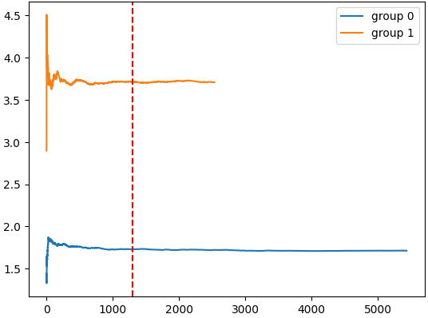
Figure 4.1
In further experiments, the first 1300 data points for group 0 and group 1 will be removed, and the mean response time will be calculated. Directly calculating the mean response times of group 0 and group 1 are 1.7131 and 3.7074, respectively. After removing the transient, the calculated average values are 1.7073 and 3.7029, respectively.

4.2 Take different n₀ value and compare different systems
To determine the optimal value of n₀, we need to calculate confidence intervals separately.
Firstly, we need to calculate the sample mean using the following formula,
$$\hat{T}=\frac{\sum_{i=1}^{n}{T\left(i\right)}}{n}$$
The code implementation is shown in the figure 4.2,
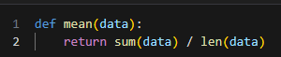
Figure 4.2
Then the sample standard deviation is,
$$\hat{S}=\sqrt{\frac{\sum_{i=1}^{n}{{\left(\hat{T}-T\left(i\right)\right)}^{2}}}{n-1}}$$
The code implementation is shown in the figure 4.3,
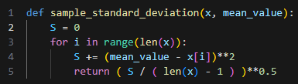
Figure 4.3
There is a probability 95% that the mean response time that I want to estimate lies in the area of
$$\left[\hat{T}-t_{n-1,1-\frac{α}{2}}\frac{\hat{S}}{\sqrt{n}},\hat{T}+t_{n-1,1-\frac{α}{2}}\frac{\hat{S}}{\sqrt{n}}\right]$$
The code implementation is shown in the figure 4.4,
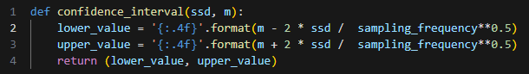
Figure 4.4
In the experiment, two mean response times, group 0 and group 1, will be generated. The lecturer provides the following formula for calculation,
$${weighted_mean_response_time=ω}_{0}T_{0}+ω_{1}T_{1}$$
w_{i} is a ratio, the numerator is the proportion of the i-th (0,1) group in the total amount of the two groups, and the denominator representing the average service time of the i-th group.
After each simulation program execution, two sets of response times and the service time of the task itself are written to the file. Then read and calculate the values of w₀ and w₁ corresponding to each simulation data, calculate the mean response time for both sets, and then calculate the weighted mean response time, as shown in Figure 4.5,

Figure 4.5
In order to minimize the error of the simulation experiment as much as possible, we will adopt a method of repeating the experiment multiple times. At the same time, we need to consider the reproducibility of the experimental site, so we will use multiple fixed random seeds for the experiment. When n is set to 10, n₀ will test values from 1 to 9. After each value of n₀, 20 repeated experiments will be conducted, with random seed values ranging from 1001 to 1020.
Finally, the confidence interval of the data obtained from simulating the 9 values of n0 is calculated, as shown in Figure 4.6,
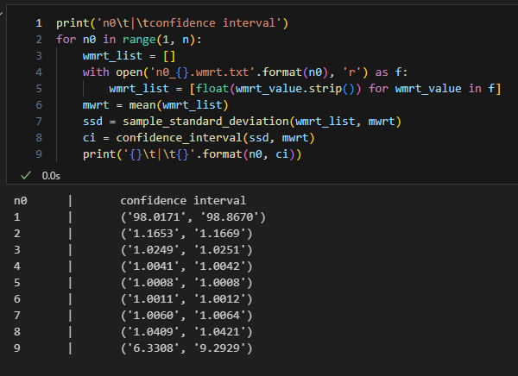
Figure 4.6

The confidence interval data obtained after completing the simulation test are shown in Table 4.1.
n₀ | Confidence Interval
1 | (98.0171,98.8670)
2 | (1.1653,1.1669)
3 | (1.0249,1.0251)
4 | (1.0041,1.0042)
5 | (1.0008,1.0008)
6 | (1.0011,1.0012)
7 | (1.0060,1.0064)
8 | (1.0409,1.0421)
9 | (6.3308,9.2929)
Table 4.1
It can be observed that when n₀ = 5, the minimum confidence interval can be obtained.

