CHAPTER 1
INDRODUCTION

1.1 INTRODUCTION
In the constantly changing realm of consumer behavior, understanding the preference of youth demographic is supreme, especially in the context of sports goods. This study aims to explore the complex network of brand preference among the youth, illuminating preference of the youth demographic is supreme, especially in the context of sports goods. This study aims their preference in the realm of sports related products. Despite the growing importance of understanding consumer behavior, there remains a lack of localized research focusing on brand preference of youths, particularly within the context of sports goods. This study seeks to fill the gap by delving in to the intricacies of youth’s preferences, considering factors such as cultural influences, socio-economic backgrounds, and local market dynamics. The sports goods industry, incorporating a diverse range of products from athletic footwear to specialized equipment, is not only a reflection of individual preferences but also a field where brand loyalty and innovation intersect. This study finds the proper reasons behind the youth preference towards particular brands, considering aspects such as quality, pricing, brand image and the impact of marketing efforts. This study not only aims to contribute valuable insight to the field of consumer behavior but also provide actionable data for local businesses and stakeholders. Understanding the youths brand preferences is not only a key to market success but also a route for increasing a deeper connection between brands and their youthful consumers.

1.2 STATEMENT OF THE PROBLEM
The sports goods market is a dynamic and competitive industry influenced by various factors including consumer preferences, brand loyalty, and marketing strategies. Understanding the brand preferences of youths towards sports goods is a crucial for business to effectively target and engage with this key demographic. However, there is a significant gap in our understanding of the specific brand preferences of youths within the context of sports goods market. The study is on “A STUDY ON YOUTHS BRAND PREFERENCE TOWARDS SPORTS GOODS WITH SPECIAL REFERENE TO MALAPPURAM DISTRICT”.

1.3 OBJECTIVES OF THE STUDY
- To assess the level of brand awareness among the youth regarding sports goods.
- To identify factors influencing brand preference.
- To examine variation in brand preference across different sports categories.
- To understand brand loyalty and switching behavior of customers.
- To understand demographic influences in brand preferences.

1.4 SCOPE OF THE STUDY
This study is mainly focused on the youth brand preference towards sports goods within the unique context of Malappuram district. Specially targeting the demographic aged between 15 to 35 years. This study helps to find out the factors influencing the youth of Malappuram on selecting a particular brand of sports goods. By analyzing factors such as brand reputation, quality, price, endorsements by athletes, and marketing strategies. The study aims to identify the most preferred brands and understand the underlying reasons for their popularity among youths in Malappuram.

1.5 SIGNIFICANCE OF THE STUDY

This study helps to understand the customer attitude, brand preference and shopping behavior towards sports goods and will also contribute valuable insights to sports goods manufacturers, marketers, policymakers, aiding them in understanding and catering to the specific preference of youth in Malappuram district. By gaining insights into the brand preference of youth in Malappuram, companies can tailor their marketing strategies, product offerings, and pricing strategies to better meet the needs and preferences of the local youth population. Moreover, the study can contribute to academic knowledge by adding to the body of research on consumer behavior and brand preferences, particularly within localized markets such as Malappuram district.

1.6 RESEARCH METHODOLOGY
Research methodology means the scientific methods and techniques used for conducting a research. It is the research design which can be selected for conducting a study according to nature and scope of the research problem.

1.6.A RESEARCH DESIGN

Research design is the plan structure and strategy under which the research work is conducted. It is purely and simply the framework or plan for a study that guides the collections and analysis of data. It is the blueprint that is followed in completing the study. Fundamental to the success of any research project is a sound research design. Descriptive research design has been used for conducting this study. This design helps to describe characteristics of a particular population or phenomena and study in depth the characteristics concerning individual group and situation.
1.6.B SOURCES OF DATA

For this study primary and secondary data are used.

i. PRIMARY DATA

The primary data are those collected by the investigator himself for the first time and these are original character. They are collected for a particular purpose. The data are collected through the questionnaire.

ii. SECONDARY DATA
Secondary data are those which already have been collected by some other persons for his purpose and published. The relevant information for this project has been collected from books, report, journals and internet.

1.6.C SAMPLING DESIGN

Sampling design is a design or a working plan that specifies the population frame, sample size, sample selection, and estimation method in detail. Objective of the sampling design is to know the characteristics of the population.

i. POPULATION

Population means the aggregate of all elements under study having one or more common characteristics. Population for the study is MALAPPURAM DISTRICT.

ii. SAMPLE SIZE

Number of sampling units selected from the population is called sample size for the study is 50 persons.

iii. SAMPLING TECHNIQUE

Sampling technique is the procedure for selecting the sample members from a population. The study completed by using convenience sampling, a nonprobability sampling technique, where subject is selected because their convenience accessibility and proximity to the researcher.

1.6.D TOOLS USED FOR THE STUDY

Questionnaire prepared is used by the researcher to get needed information from respondent.
i. TOOLS FOR DATA COLLECTION

Questionnaire is used for primary data collection.

ii. TOOLS FOR DATAANALYSIS

In this research, simple percentage analysis is used for analysis primary data.

• Percentage

iii. TOOLS FOR DATA PRESENTATION

In this research, tables, diagrams, charts are used for presenting data.

- Table
- Chart
- Graph

1.6.E PERIOD OF STUDY

The period of study is limited to 21 December 2024 to 10 January 2025.

1.7 LIMITATION OF THE STUDY

- The study focuses specifically on Malappuram district and may not be entirely representative of broader regional or national trends.
- The research relies on self-reported data, which may be subject to respondent bias.
- The respondents where less interested in answering the questions, as they felt it was interruption to their regular work.
- Brand preferences and market dynamics could evolve over time, so it faces limitation regarding the time-bound nature.
- The study is conducted only Malappuram district.
- This study only take short term to complete.

CHAPTER 2
REVIEW OF LITERATURE

Kirkpatrick,Nathan(2000). Fan identification often leads to emotional attachment and buying behavior in sports fans. The purpose of this study was to identify the relationship between fan identification and collegiate athletic apparel brand preference among an array of sports consumers. Three research questions are presented, and a web based survey was used to gather data to address these questions of interest. The survey was conducted through amazon’s mechanical Turk market, and, after data refinement. 394 respondents remained for analysis. Significant result showed:70.8 percent of respondent could accurately recall the sponsor of their favorite team’s uniforms. 66.5 percent state they are more likely to buy apparel from the sponsoring brand of their favorite team. 43.5 percent of respondents believed they would buy less of their favorite team’s present sponsoring brand I their team changed its apparel sponsor. As future spending intentions were significant for fan identification but not team loyalty, we conclude that identification is the more influential factor for sponsoring brands to consider in their branding and promotion strategies.

Yayati Shinde&Sadaf khan(2002)This paper is based on the study of various factors which influence the habitual buying behavior of consumers while buying branded apparels. Habitual behavior represents the repeat purchase made by the customers, based on habits or routines that are developed in order to simplify the decision-making process. The paper considers the influence of various marketing and demographic factors on consumer’s habitual behavior towards branded sports apparels. A conceptual model is proposed, and factor analysis, along with chi-square etc. is used to analyze the data taken on a random basis. The study tries to reflect the influence of various marketing factors such as brand awareness, quality, price, durability, etc. This study will help companies to select effective models for targeting customers with an aim to retain them.

Mariej.Lachance(2003).Wearing clothes with prestigious brand names seems to be very important for adolescents. This phenomenon was studied in the context of consumer socialization by examining the influence of three socialization agents, namely parents, peers and TV, on the development of French Canadian adolescents’ brand sensitivity and their relative importance. Controlling for socio-economic variables, multiple regression analyses were conducted separately for boys and for girls. For both genders brand sensitivity is related to peers’ influence. Girls” brand sensitivity is related to the importance fathers give to clothing brands. TV exposure is not related to adolescents” brand sensitivity. For boys and girls, peers represent the most important predictor of this consumer socialization. The results are discussed in the light of social and economic pressures and family relationships.

Miller,John(2009)The purpose of the study was to identify the decision-making styles of college students for sports apparel. Modifying the Customer Style Inventory (CSI) developed by Sproles and Kendall (1986), a quantitative research design was developed to analyze the effect of seven factors. Eight-hundred and twenty-two subjects composed of 376 male and 446 female college students enrolled at three public universities. The results indicated that male and female college aged consumers had different decision making styles in relation to fashion, impulse, and brand consciousness. There were, however, no statistically significant differences between college classifications or interactions between gender and college classifications.
Daehee Kwak,Joon-Ho Kang(2009)The purpose of this paper is to discuss the notion of “symbolic purchase” which has long been documented in the management and marketing literature. In particular, self-congruity theory has been examined in various domains of consumer behavior. However, little attention has been paid to the area of sport. In sport business, licensed-merchandise (i.e. team apparel) has become an increasingly important revenue source and it strengthens fan identity and brand loyalty. Therefore, based on the selfcongruity theory, the aim is to investigate the effect of self-image congruence on sport team licensed-merchandise evaluation and purchase

Sam Fullertone and G.russell Merz(2010)
Despite its acknowledged contribution to local, national, and global economies, there is no consensus as to exactly what is meant by the term sports marketing. This conceptual paper attempts to address this deficiency via the development of a new framework that is based upon two key dimensions: type of product and level of sports integration. By categorizing goods and services as either sports products or no sports products and by differentiating between traditional strategies and sponsorship-based strategies, four sports marketing domains are identified. They are the theme based, product-based, alignment based, and sports based strategic domain. The underlying principles for developing the framework are delineated in this article, and many examples for each strategic domain are provided as a means of illustrating their conceptual differences and how they are implemented.

Chiyong Kim,bob Heere(2012)While consumers within emerging markets are the largest growth market for global sport apparel brands, relatively little is known about how they perceive these brands. These emerging markets have recently become consumer markets for western brands, yet they initially served as producing nations. This study examined how this transition affected consumer perceptions on global sport apparel brands. Consumer behavior theories, such as the brand as “western status symbol”, ethnocentrism, the country of origin effect, and the country of manufacturing effect were all incorporated within this exploration. Fifteen interviews were held with young adult consumers from both India and China. In contrast to previous studies, we suggest that these respondents view western sport apparel brands favourable because they are seen as an instrument to express a global citizenship. Additionally, the international labour practices did not seem to directly harm the global brands, but they did diminish some of the utilitarian advantages the western brands possessed.

Deborah Fowler(2015)Sports apparel has changed the way Americans dress, thereby affecting the apparel design and retailing industry. The state of the industry is described using four sources of data: a national study, a convenience study of college students, a telephone survey of merchandise managers, and a focus group female college coaches in the South Easter United States. Cross usage of apparel by athletes and non-athletes, the demographic profile of the consumers, and performance and aesthetic characteristics of apparel sought by purchasers are discussed. Recommendations are made for the apparel designer and merchandiser to better satisfy the desires of the consumers.

Pattisonk(2016)Social media represents a revolutionary new trend that has introduced a substantial change in the way communication takes place. Marketers are therefore converting to consumer-generated content (CGC) to act as an advertising tool in creating awareness and promoting their brands. Although a number of studies have explored this subject, few studies have looked at this topic among the youth in Johannesburg with a focus on sports apparel brands. By means of a conceptual model, brand exposure (to CGC) is the predictor variable, while consumer purchase intention is the outcome variable, and the mediating variables are brand familiarity, brand preference, brand attitude and brand knowledge. The article undertook a quantitative approach in which 150 self-administered surveys were distributed among students from the University of the Witwatersrand. The findings indicated that eight of the nine hypotheses are supported. The finding from the article contributes to both academic literatures by adding to theory in the field of marketing which is a rapidly growing field of interest. From a practical perspective, it will provide marketers with insight in to the effectiveness of CGC as an advertising platform.

CHAPTER 3
THEORETICAL FRAMEWORK

INTRODUCTION

Theoretical framework means a study own perception about the coped and structure of a problem, the literature review provides others ideas and work in areas close to that under study.

SPORTS GOODS

Sports equipment, sporting equipment, also called as sporting goods, are the tools, materials, apparel, and gear used to compete in a sport and varies depending on the sport. The equipment ranges from balls, nets, and protective gear like helmets.
WHY ARE SPORTS GOODS IMPORTANT?

Without the right equipment, athletes can be put at risk of injury or may not be able to perform at their highest level. Sports gear also helps protect athletes from the elements and provides them with necessary support and protection they need to safely participate in a sport.

BRAND

A brand is a name, term, design, symbol or any other feature that identifies one seller’s goods or service as distinct from those other sellers. Brands are used in business, marketing, advertising. Name brands are sometimes distinguished from generic or store brand.

BRANDING

By definition, it is a marketing practice in which a company creates a name, symbol or design that is easily identifiable as belonging to the company. This helps to identify a product and distinguish it from other product and services. Branding is important because not only is it what makes a memorable impression on consumers but allows your customers and clients to know what to expect from your company. It is a way of distinguishing yourself from the competitors and clarifying what it is a you offer that makes you the better choice. Your brand is built to be a true representation of who you are as a business, and how you wish to be perceived. There are many areas that are used to develop a brand including advertising, customer service, promotional merchandise, reputation and logo. All of these elements work together to create one unique and (hopefully) attention-grabbing professional profile.
WHY IS BRANDING IMPORTANT?

Branding is absolutely critical to a business because of the overall impact it makes on your company. Branding can change how people perceive your brand, it can drive new business and increase brand awareness.

BRANDING GETS RECOGNITION

The most important reason branding is important to a business is because it is how a company gets recognition and becomes known to the consumers. The logo is the most important element of branding, especially where this factor is concerned, as it is essentially the face of the company. This is why a professional logo design should be powerful and easily memorable, making an impression on a person at first glance.
Printed promotional products are a way of getting this across.

BRANDING INCREASES BUSINESS VALUE

Branding is important when trying to generate future business and a strongly established brand can increase a business value by giving the company more leverage in the industry. This makes it a more appealing investment opportunity because of its firmly established place in the marketplace.

BRANDING GENERATES NEW CUSTOMERS

A good brand will have no trouble drumming up referral business. Strong branding generally means there is a positive impression of the company amongst consumers, and they are likely to do business with you because of the familiarity and assumed dependability of using a name they can trust. Once a brand has been well established, word of mouth will be the company’s best and most effective advertising technique.

IMPROVES EMPLOYEE PRIDE AND SATISFACTION

When an employee works for a strongly branded company and truly stands behind the brand, they will be more satisfied with their job and have a higher degree of pride in the work that they do. Working for a brand that is reputable and help in high regard amongst the public makes working for that company more enjoyable and fulfilling. Having a branded office, which can often help employees feel more satisfied and have a sense of belonging to the company, can be achieved through using promotional merchandise for your desktop.

CREATS TRUST WITHIN THE MARKETPLACE

A professional appearance and well-strategized branding will help the company build trust with consumers, potential clients and customers. People are more likely to do business with a company that has a polished and professional portrayal. Being properly branded gives the impression of being industry experts and makes the public feels as though they can trust your company, the products and services it offers, and the way it handles its business.

BRANDING IS ALLABOUT ADVERTISING

Advertising is another component to branding, and advertising strategies will directly reflect the brand and its desired portrayal. Advertising techniques such as the use of promotional products from trusted companies such as Outstanding Branding make it easy to create a cohesive and appealing advertising strategy that plays well into your branding goals.

LEADS TO MONOPOLY

It leads to some kind of monopoly known as brand monopoly. It is created by gradually creating brand loyalty and image of the product and the manufacturer in the minds of consumers.

CREATE CONFUSION

Consumers are often confused in product selection on account of the methods of plethora offered in the market. The situation becomes more difficult when all brands carry as assurance of similar quality and value satisfaction.

COMMANDS PREMIUM

The popularity of brands renders them out of the common man’s reach because they command premium prices, such as Hercules cycles, Crompton fans, etc.

SUBSTANDARD GOODS

When the brand name becomes popular, manufacturers sometimes place in inferior and substandard goods in the market. Brand imposes responsibility for maintaining consistent quality and delivering proclaimed value satisfaction.

SOME PRODUCTS DO NOT LEND THEMSELVES TO BRANDING

Some products, such as raw materials, pins, fruits, and vegetables, do not lend themselves to branding on account of their very nature.

SWITCH TO ANOTHER PRODUCT

If the quality deteriorates or supply of adulterated goods is increased due to brand popularity, the customer may switch over to other similar product.

EXPENSIVE

Building up brand reorganization and loyalty is very expensive. Particularly, small sized companies cannot afford it.

INCREASE COST

Branding needs heavy and widespread advertising, attractive packaging and effective sales promotion.

OPPOSITION OF MIDDLEMAN

The retailers and the wholesalers may not be willing to stock the goods if the brand is not popular. On the contrary, if the brand is very popular, they may refuse to stock and sell the goods on the ground that their margin of profit has been reduced considerably due to an increase in competition. They even prepare to sell adulterated and inferior goods at a lower price. On the basis of the above criticism, it will be entirely wrong to conclude that brands are socially undesirable. If we honestly compare the overall advantages with the disadvantages of branding, we may conclude that it is advantages and much more powerful. If certain more legislative measures are undertaken to improve the situation, such as strict enforcement of Consumers Protection Act, trademark act, etc. the brand name may prove more useful to consumers, distributions and the producers alike.
TYPES OF BRANDING

PRODUCT BRANDING

The concept of product branding is quite different from the corporate branding as here the main aim of the company is to promote the newly launched product in the market in the minds of the consumers creating an emotional connection so that the weekly, monthly, quarterly, and yearly sales targets are accomplished. The company indulges into the various marketing activities such as advertisements in the television, newspapers, magazines, periodicals, social media, hoardings, signage’s, and host of other above the line and below the line campaigns are under taken to create awareness in the market amidst the cut-throat competition. Various FMCG and retail companies take the route of product branding to promote their products that are fast moving and have a limited shelf life.

CORPORATE BRANDING

The concept of corporate branding can be described as when the company is new in the industry and wants to promote itself as a corporate firm with its values, objectives, fundamentals, business ethos, and objectives to curate a distinctive identity in the market and an industry as a whole. It has a direct benefit to the sales of the products and services offered by the company as once the objectives of corporate branding are established, the consumers will definitely wish to try out the offerings by the company. For the successful corporate branding, sponsoring various events related to the brand, social media promotions, and PR exercises are a must for the company. The concept is also applicable to established companies as well that want to rebrand themselves in the market due to the changing business dynamics, evolving tastes of the consumers, and the growing competition.

PERSONAL BRANDING

The concept of personal branding is usually opted and followed by the politicians, movie stars, sportsmen, socialites, and any person who has and enjoys a celebrity status in the market.
Right from the presence on the social media channels such as Facebook, Instagram, Linked In, Twitter, and along with the right measures by the PR firms is quiet necessary to create a successful personal branding. Once the celebrity is successful with his or her personal branding, he or she gets signed up as a brand ambassador for the various successful brands representing their company, products, and services.

CHAPTER-4
DATA ANALYSIS AND INTERPRETATION

1.GENDER OF RESPONDENTS

respondents Table 4.1
Particulars | Number respondents | of | Percentage respondents | of
Male | 45 |  | 90 %
Female | 5 |  | 10 %
Total | 50 |  | 100 %

Chart 4.1 Percentage of Gender of Respondents


10

%

90

%

Male

Female

Interpretation

The table shows that out of 50 respondents, the majority are male (45 respondents, 90%), while only 5 respondents (10%) are female. This indicates that the sample is heavily male-dominated, with very limited female representation in the survey.

4.2 Age of respondents

Table 4.2
Particulars | Number respondents | of | Percentage respondents | of
15 – 18 Years | 6 |  | 12 %
19 - 21 Years | 18 |  | 36 %
22 - 24 Years | 13 |  | 26 %
Above 24 Year | 13 |  | 26 %
Total | 50 |  | 100%

Chart 4.2 Age of Respondents
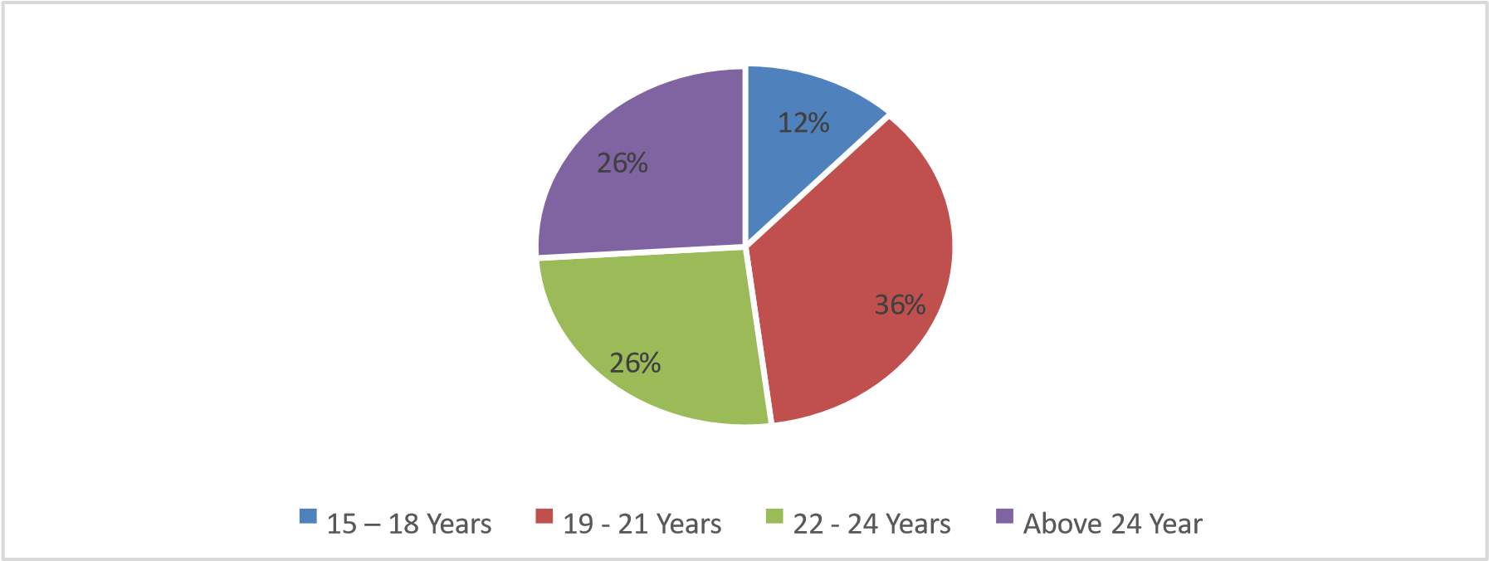

Interpretation

The table shows that the majority of respondents are aged 19–21 years (36%), followed by 22–24 years and above 24 years (26% each). Only 12% are in the 15–18 years group. This indicates that most respondents are young adults between 19 and 24 years.

4.3 EDUCATIONAL QUALIFICATION

Table 4.3
Particulars | Number respondents |  | of | Percentage respondents | of
Higher | 17 |  |  | 34 %
Secondary Undergraduate | 23 |  |  | 46 %
Postgraduate | 20 |  |  | 10 %
Total | 60 |  |  | 100 %

Figure 4.3 Education qualification


10

%

34

%

46

%

Higher

Secondary

Undergraduate

postgraduate

Interpretation

The table shows that most respondents are Undergraduates (46%), followed by those with Higher education (34%). Only 10% are Postgraduates. This indicates that the majority of respondents have an undergraduate level of education.

4.4 INCOME WISE CLASSIFICATION

Table 4.4
Particulars | Number of respondents | Percentage respondents | of
Below ₹5,000 | 18 | 16%
₹5,001 – ₹10,000 | 12 | 24%
₹10,001 – ₹20,000 | 16 | 32%
Above ₹20,000 | 14 | 28%
Total | 50 | 100 %

Figure 4.4 Income Wise Classification
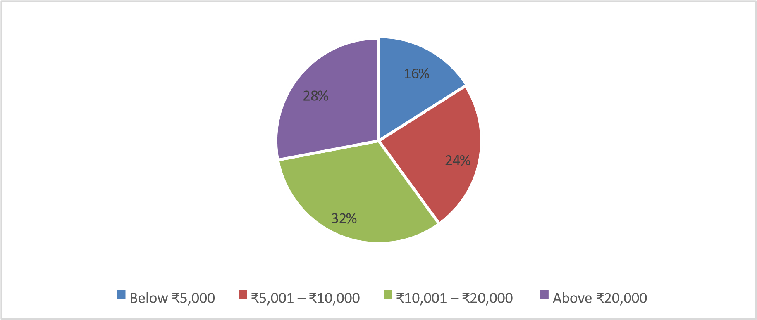

Interpretation

The table shows that the highest proportion of respondents (32%) earn between ₹10,001–₹20,000 per month, followed by 28% earning above ₹20,000. About 24% earn ₹5,001–₹10,000, while the smallest group (16%) earns below ₹5,000.
This indicates that most respondents fall within the middle-income range.

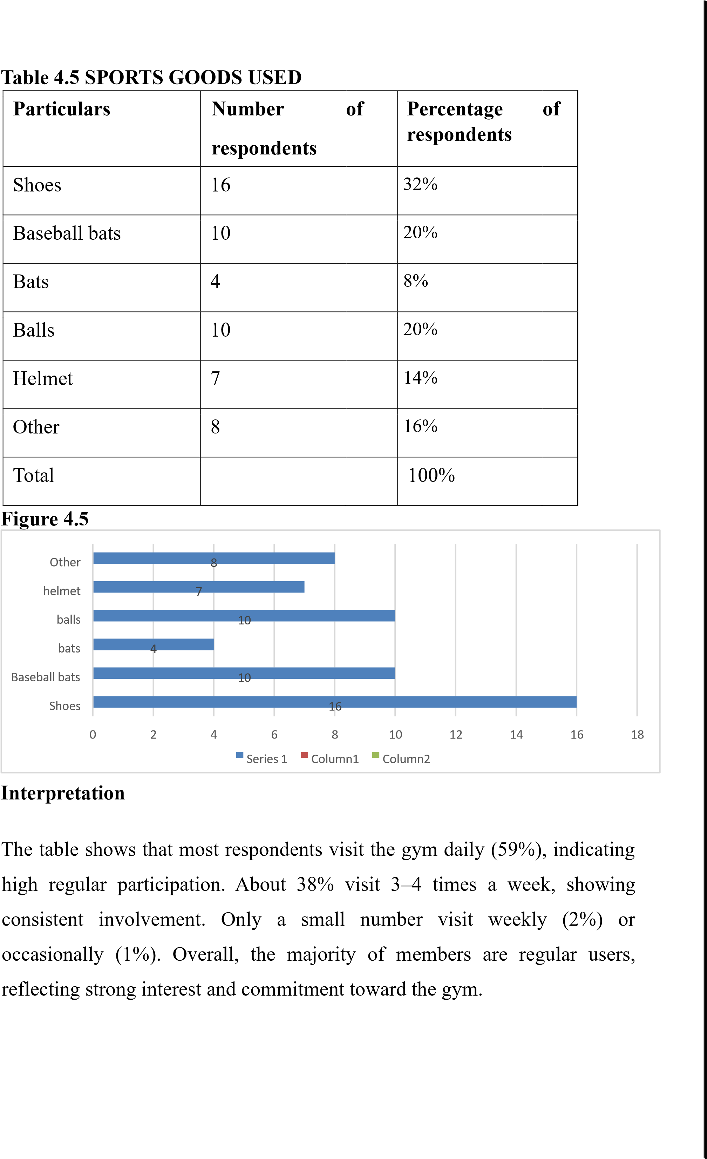

Table 4.6 PURCHASE SOURCE

Particulars | No. of respondents | Percentage of respondents
Online platforms | 10 | 20%
local sports stores | 20 | 40%
Shopping malls | 17 | 34%
Brand Showroom | 3 | 6%
Total | 50 | 100

Figure 4.6 PURCHASE SOURCE
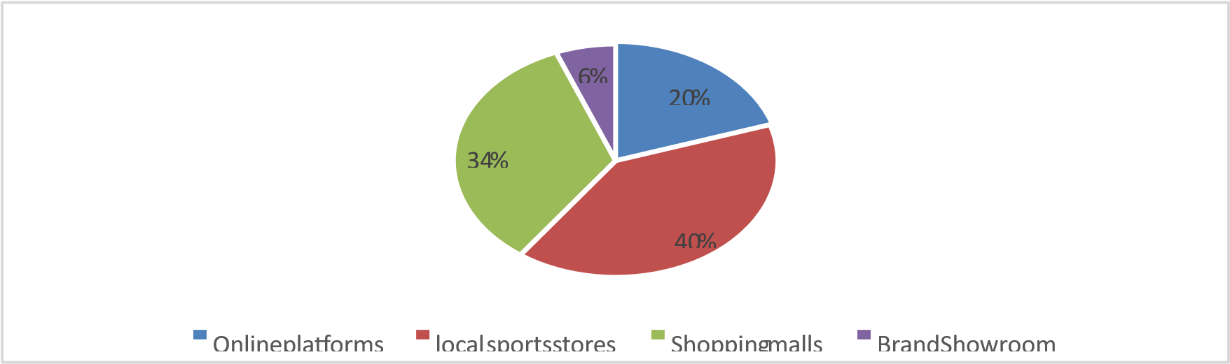

Interpretation

The table shows that most respondents are influenced by local sports stores (40%), followed by shopping malls (34%). Online platforms influence 20% of respondents, while brand showrooms have the least influence (6%). This indicates that physical retail stores play a major role in influencing purchase decision Table 4.7 BRAND PREFERENCE

Particulars | No. of respondents | Percentage respondents | of
International brands | 10 | 20%
National brands | 19 | 38 %
Local brands | 14 | 28 %
No Specific Preference | 7 | 14%
Total | 509 | 100 %

Figure 4.7 BRAND PREFERENCE
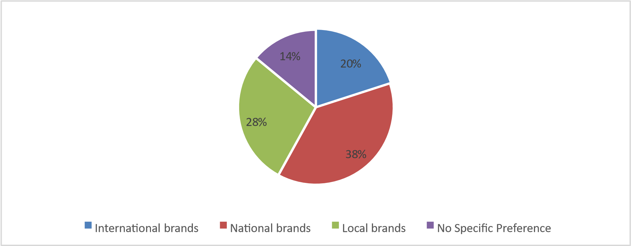

Interpretation

The table shows that most respondents prefer national brands (38%), followed by local brands (28%). International brands are preferred by 20% of respondents, while 14% have no specific preference. This indicates that national brands are the most popular choice among respondents.

Table 4.8 ANNUAL PURCHASE FREQUENCY

 | Particulars | No. of respondents | Percentage respondents | of
 | never | 8 | 16%
 | occasionally | 20 | 40%
 | weekly | 9 | 18%
 | Daily | 6 | 12%
 | monthly | 7 | 14%
 | Total | 50 | 100%

figure 4.8 ANNUAL PURCHASE FREQUENCY


%

16

40

%

18

%

%

12

%

14

never

occasionally

weekly

Daily

monthly

Interpretation

The table shows that most respondents purchase occasionally (40%), followed by weekly purchases daily. This indicates that occasional purchasing is the most common behaviour among respondents. (18%). About 16% never purchase, 14% purchase monthly, and 12% purchase

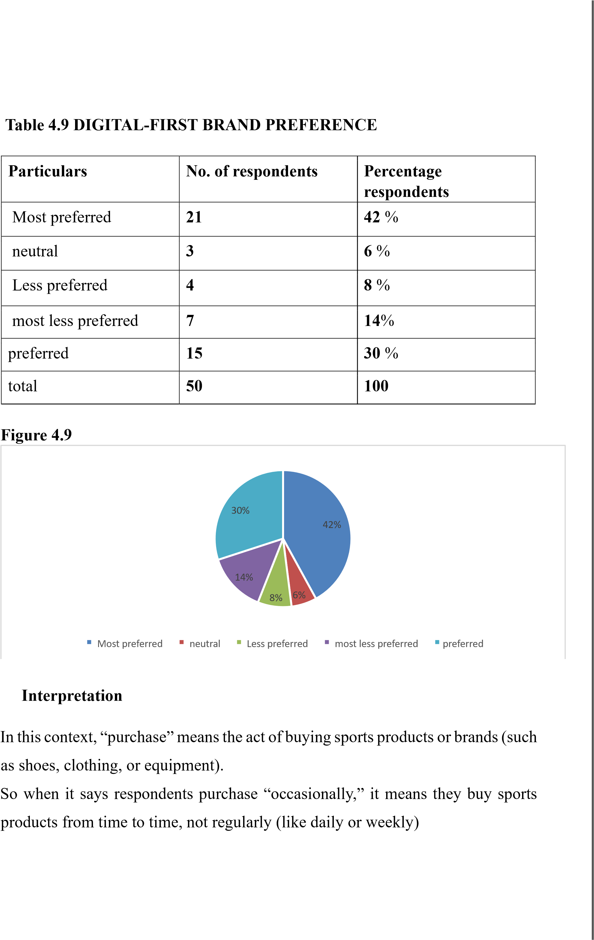
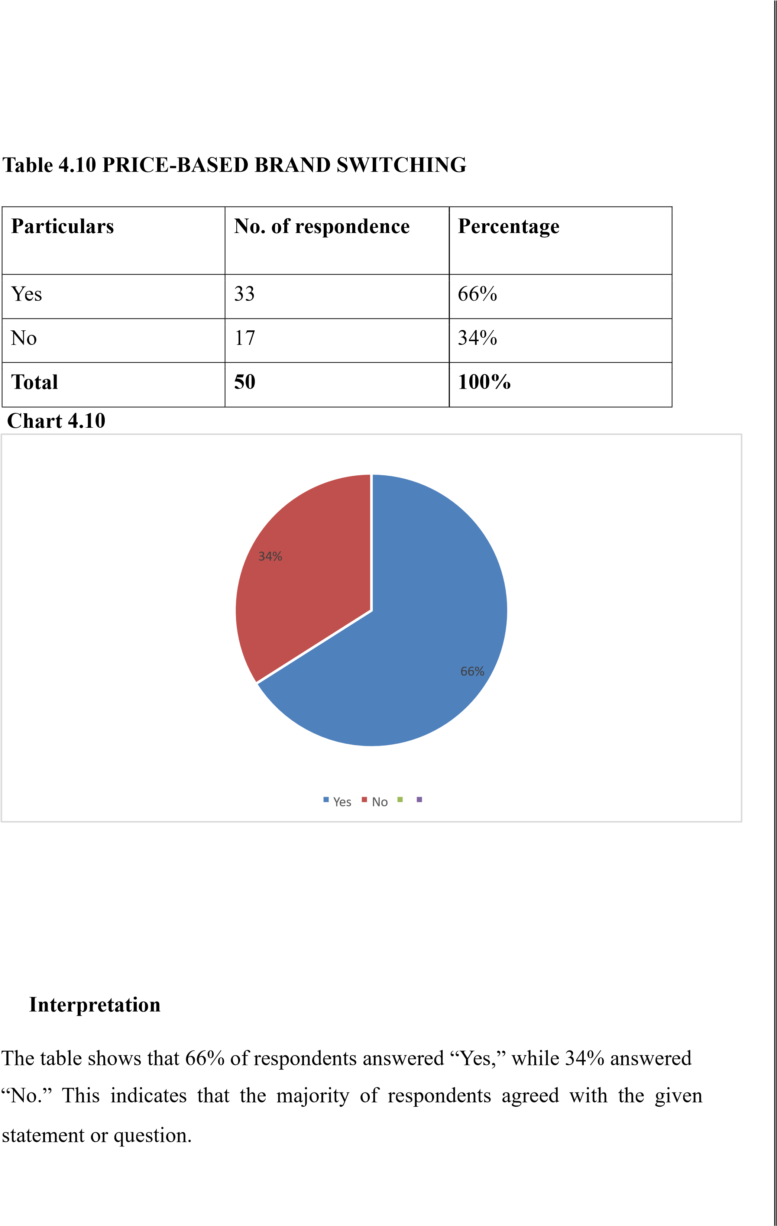

Table 4.11 ADVERTISING INFLUENCE ON PURCHASE DECISION

Particulars | No. of response | Percentage
Yes | 39 | 78%
No | 11 | 11%
Total | 50 | 100%

Chart 4.11 ADVERTISING INFLUENCE ON PURCHASE DECISION


78

%

11

%

Yes

no

Interpretation

The table shows that 78% of respondents (39 out of 50) believe that advertising influences their sports brand purchase decisions, while only 11% responded “No.” This clearly indicates that advertising plays a significant role in influencing the majority of consumers’ buying decisions

4.12. FRIEND INFLUENCE ON TRYING NEW SPORTS BRANDS

Table 4.12
Particulars | No. of response | Percentage
Yes | 25 | 50%
No | 20 | 40%
maybe | 5 | 10%
Total | 50 | 100%

Chart



50

%

40

%

10

%

1.2

yes

No

maybe

4

th Qtr

Interpterion

50% of respondents are willing to try a new sports brand based on a friend’s recommendation, showing strong influence. However, 40% are not willing, and
10% are unsure. Overall, word-of-mouth plays an important role in
decisionmaking work,

4.13. BRAND AWARENESS & PERCEPTION OF INTERNATIONAL SPORTS BRANDS
Table 4.13
Statement | Strongly  disagree  (1) | Disagree  (2) | Neutral | Agree | Strongl y agree | Weight | Rank
I am aware of most internationa l sports brands available in the market. | 19 | 11 | 6 | 7 | 7 | 122 | Ⅴ
High-end sports brands provide better value for money. | 1 | 18 | 19 | 6 | 6 | 148 | Ⅲ
Internationa l sports brands are superior in quality compared to local brands. | 4 | 8 | 16 | 14 | 8 | 164 | Ⅱ
I feel a sense of prestige when wearing branded sports goods | 2 | 9 | 15 | 12 | 12 | 173 | Ⅰ
I actively follow sports on social media platforms | 4 | 9 | 9 | 14 | 14 | 125 | Ⅳ
Work Sheet

1. 7×5+7×4+6×3+11×2+19×1= 122 2.

6×5+6×4+19×3+18×2+1×1= 148
3. 8×5+14×4+16×3+8×2+4×1= 164 4. 12×5+12×4+15×3+9×2+2×1= 173 5. 4×5+14×4+9×3+9×2+4×1= 125

Interpterion

The highest-ranked factor is prestige in wearing branded sports goods, showing that status strongly influences customers. This is followed by belief in the superior quality of international brands. Value for money of high-end brands ranks third, indicating moderate agreement. Following sports on social media and awareness of sports brands have lower influence, showing they are less important in shaping consumer preference.

4.14 BRAND SWITCHING FREQUENCY

Table 4.14
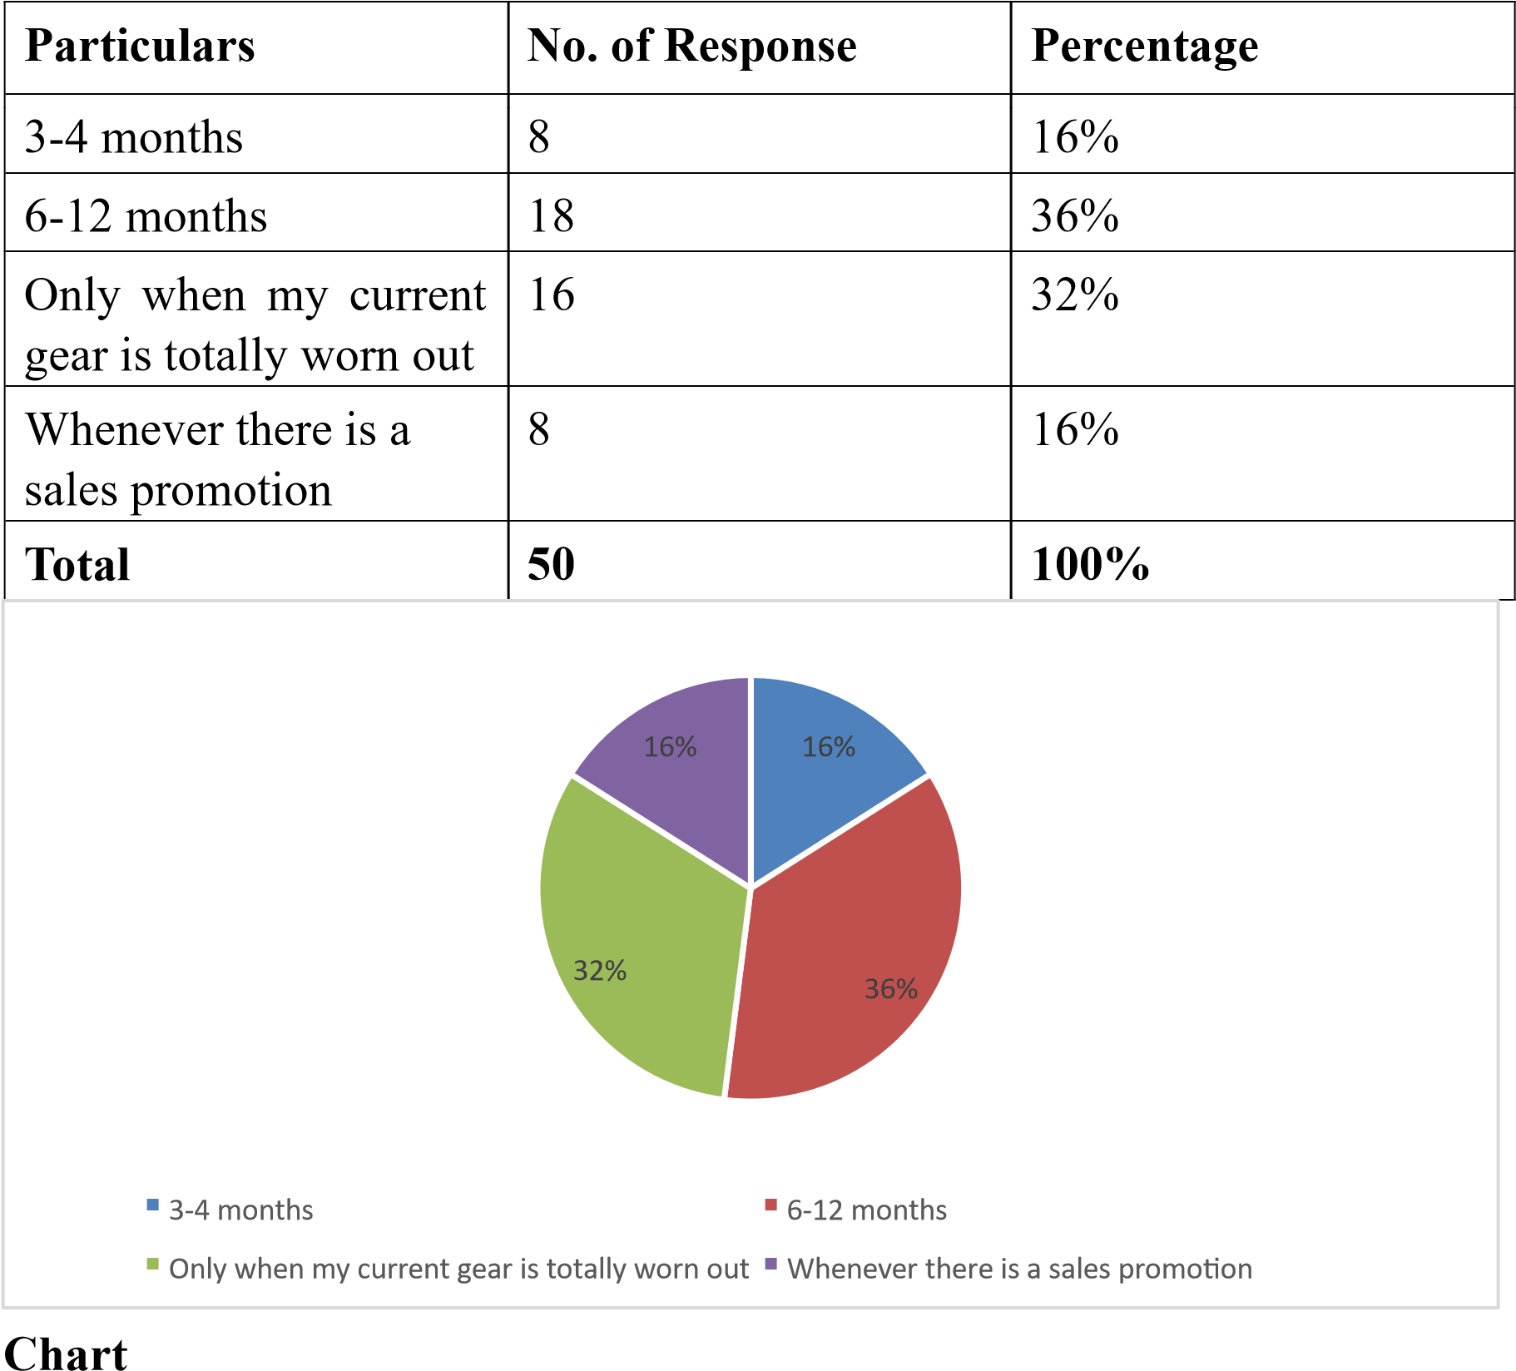

Interpretation

The table shows that most respondents (36%) switch brands every 6–12 months. About 32% change only when their current gear is worn out, showing brand loyalty. Meanwhile, 16% switch every 3–4 months and 16% during sales promotions. Overall, most customers change brands occasionally rather than frequently.

4.15. KEY FACTORS INFLUENCING SPORTS BRAND PURCHASE DECISIONS
Table 4.15

 | Statement | Extremey important | very importan  t | Moder ately import ant | slight ly  impo  rtant | Not import ant | Weight | Rank
 | Product Durability and material  Quality | 19 | 15 | 10 | 5 | 1 | 196 | Ⅲ
 | Celebrity or professional athlete endorsements | 14 | 16 | 12 | 7 | 1 | 185 | Ⅴ
 | Latest technological innovations  (e.g air cushioning smart fabric) | 17 | 13 | 8 | 11 | 1 | 184 | Ⅵ
 | Aesthetic design .colour and fashion appeal | 20 | 10 | 10 | 8 | 2 | 188 | Ⅳ
 | Influence of socialmedia advertisemem ts and influencers | 25 | 15 | 5 | 3 | 2 | 208 | Ⅰ
 | Availability of discounds and promotional offers | 22 | 18 | 8 | 2 | 0 | 206 | Ⅱ

Work sheet

1. 19×5+15×4+10×3+5×2+1×1= 196 2. 14×5+16×4+12×3+7×2+1×1= 185 3. 17×5+13×4+8×3+11×2+1×1= 184 4. 20×5+10×4+10×3+8×2+2×1= 188
5. 25×5+15×4+5×3+3×2+2×1= 208 6.

22×5+18×4+8×3+2×2+0×1= 206
7. 26×5+14×4+5×3+3×2+2×1= 209

Interpretation

The most important factor influencing customers is brand commitment to eco-friendly and sustainable practices (Rank I). This is followed by the influence of social media advertisements and influencers (Rank II) and availability of discounts and promotional offers (Rank III). Product durability and quality and aesthetic design have moderate importance. Celebrity endorsements and technological innovations are the least influential factors in purchase decisions.

4.16 BRAND NAME IMPORTANCE IN SPORTS GOODS

Table 4.16
Statement | Strongly y disagree | Disagree  e | Neutra  l | Agre  e | Strongly y agree | Weigh  t | Ran  k
Footwear running shoes football sheos cricket shoes | 19 | 11 | 6 | 7 | 7 | 178 | Ⅳ
Apparel jerseys shorts tracksuits | 1 | 18 | 19 | 6 | 6 | 200 | Ⅲ
Equipment  s bats rackets  fitness equipment’s  . | 4 | 8 | 16 | 14 | 8 | 214 | Ⅰ
Accessories s bags watches water bottle caps | 2 | 9 | 15 | 12 | 12 | 208 | Ⅱ

Work sheet

1. 19×5+11×4+6×3+7×2+7×1= 178 2. 20×5+15×4+10×3+5×2+0×1= 200 3. 26×5+14×4+8×3+2×2+0×1= 214 4. 23×5+17×4+5×3+5×2+0×1= 208

Interpretation

The table indicates that brand name plays the most important role in the purchase of sports equipment, which ranks first with the highest weight (214). This shows that customers strongly prefer branded equipment for better quality and performance. Accessories rank second (208), suggesting moderate brand influence. Apparel stands third (200), indicating average importance of brand. Footwear ranks last (178), showing that customers are least influenced by brand when buying sports shoes.

4.17 SPORTS BRAND PURCHASE BEHAVIOUR

Table 4.17
Statement | very high | High | moderate | low | Very low |  | Rank
Likelihood of recommending my preferred sports brand to others | 26 | 14 | 5 | 3 | 2 | 203 | Ⅴ
I consider myself loyal to one specific sports brand | 19 | 15 | 10 | 5 | 1 | 196 | Ⅶ
Likelihood of switching brands if a competitor offers a discount | 20 | 18 | 8 | 2 | 2 | 202 | Ⅵ
Willingness to continue buying my brand even if prices increase by  10% | 25 | 20 | 5 | 0 | 0 | 220 | Ⅱ
Frequency of switching brands due to new fashion trends | 27 | 10 | 10 | 3 | 0 | 205 | Ⅳ
After-sales service plays an important role in my brand loyalty | 25 | 19 | 5 | 2 | 0 | 220 | Ⅰ
I prefer brands that I have been using since childhood | 23 | 17 | 5 | 3 | 2 | 206 | Ⅲ

Work sheet
1. 26×5+14×4+5×3+2×1=203 2. 19×5+15×4+10×3+5×2+1×1=196 3. 20×5+18×4+8×3+2×2+1×1=202 4. 25×5+20×4+5×3+0×2+0×11=205 5. 27×5+10×4+10×3+3×2+0×1=220

Interpretation

After-sales service has the strongest influence on brand loyalty (Rank I).
Customers are also willing to stay with their brand even if prices increase (Rank II). Preference for long-used brands ranks third (Rank III). Switching due to fashion trends is moderate (Rank IV). Recommendation to others and switching due to discounts have lower influence on loyalty (Ranks V & VI), while overall self-declared loyalty to one brand is the lowest (Rank VII).

4.18 DESIRED IMPROVEMENTS IN SPORTS BRANDS

Table 4.18
Particulars | No. of Response | RANK
Low pricing | 14 | Ⅳ
Better quality and  Durability | 27 | Ⅰ
More fashionable  Designee | 17 | Ⅱ
Improved after  sales service | 15 | Ⅲ
Wider availability in local store | 8 | Ⅵ

Chart DESIRED IMPROVEMENTS IN SPORTS BRANDS


14

27

17

15

8

0

5

10

15

20

25

30

Low pricing

Better quality and

Durability

More fashionable

Designee

Improved after sales

service

Series 1

Series 2

Series 3

Interpretation

Customers mainly expect better quality and durability from sports brands (Rank I). More fashionable designs are the next priority (Rank II), followed by improved after-sales service (Rank III). Low pricing is a lower priority (Rank IV), and wider availability in local stores is the least preferred improvement (Rank VI).

4.19 FACTORS ENCOURAGING NEW SPORTS BRAND TRIAL

Table 4.19
Particulars | No. of Response | RANK
Completive pricing | 15 | Ⅲ
Attractive promotional offers | 18 | Ⅱ
Positive online reviews | 21 | Ⅰ
Recommendation by  friend | 13 | Ⅳ-
Chart 4.19 FACTORS ENCOURAGING NEW SPORTS BRAND TRIAL

15

18

21

13

0

5

10

15

20

25

Completive pricing

Attractive promotional offers

Positive online reviews

Series 1

Series 2

Column1

Interpretation

Positive online reviews are the main factor encouraging customers to try new or emerging sports brands (Rank I). Attractive promotional offers come next (Rank II), followed by competitive pricing (Rank III). Recommendations by friends have the least influence (Rank IV).

CHAPTER5

FINDINGS, SUGGESTIONS AND CONCLUSION

5.1 FINDINGS
- Majority respondents are male (90%); females are under-represented.
- Most respondents fall in the 19–24 years age group.
- Undergraduates (46%) form the largest education group.
- Most belong to the middle-income range (₹10,001–₹20,000).
- Frequently purchased items are shoes and balls.
- Local sports stores (40%) influence buying decisions the most, followed by malls.
- National brands (38%) are preferred over local and international brands.
- Buying is mostly occasional (40%), not frequent.
- 66% switched brands due to price increase → price sensitivity is high.
- Advertising influences 78% of buyers.
- Friends’ recommendation affects 50% of respondents.
- Prestige/status is the strongest attitude towards branded sports goods.
- Many switch brands every 6–12 months; some only when gear wears out.
- Top purchase factors:
- Eco-friendly & sustainable practices (Rank I)
- Social media & influencer ads (Rank II)
- Discounts & offers (Rank III)
- Brand name matters most for sports equipment, then accessories and apparel.  After-sales service is the biggest driver of brand loyalty.
- Customers want improvements mainly in quality & durability, then fashionable design.
- New brands are tried mainly due to positive online reviews, then promotional offers

5.2 SUGGESTION

- Improve product quality & durability Sportsbrands should focus on long-lasting materials since customers value quality the most.
- Strengthen after-sales service Easy warranty, repair, and customer
Support will improve loyalty and repeat purchases.
- Use social media & influencers effectively Since ads and influencers strongly impact youth, brands should promote actively on Instagram, YouTube, etc.
- Offer attractive discounts & student offers Price sensitivity is high, so seasonal offers and youth discounts can increase sales. 5. Promote eco-friendly & sustainable productsYouth prefer
brands that care about the environment—highlight sustainability

CONCLUCION

The study concludes that youths in Malappuram district show a clear preference for branded sports goods, with national brands being more popular than local and international brands. Their buying decisions are mainly influenced by product quality, durability, after-sales service, advertising, social media influence, and attractive offers. Many youths are price-sensitive and tend to switch brands when prices increase, while some remain loyal when they are satisfied with quality and service. Overall, the findings show that brands that focus on quality, customer service, eco-friendly practices, and effective promotion can build stronger preference and loyalty among youth consumers

BIBLIOGRAPHY

Articles
- Biswas, D., & Biswas, A. (2004). The Diagnostic Role of Signals in the Context of Perceived Risks in Brand Choice. Journal of Consumer Marketing.
- Pelsmacker, Patrick De, Geuens, Maggie, & Van den Bergh, Jeroen. (2018).
Marketing Communications: A European Perspective. Pearson.
- Ahmed, R. R., Vveinhardt, J., & Streimikiene, D. (2018). Brand Loyalty and Customer Satisfaction Relationship: A Moderation Role of Brand Image.
Journal of Competitiveness.
- Shukla, P. (2010). Status Consumption in Cross-National Context: SocioPsychological, Brand and Demographic Correlates. Journal of International Business Studies.
- Lee, S. H., & Kacen, J. J. (2008). Cultural Influences on Consumer Satisfaction with Sports Goods. Journal of Business Research

Books
- Kotler, Philip & Keller, Kevin Lane. Marketing Management. 15th ed., Pearson Education.-Classic text on consumer behavior and branding strategies.
- Solomon, Michael R. Consumer Behavior: Buying, Having, and Being. 13th ed., Pearson.-Comprehensive overview of how and why consumers choose brands.
- Aaker, David A. Brand Equity & Advertising: Advertising’s Role in Building Strong Brands. Free Press, 1991.-Important book on brand equity and brandbuilding.
- Blythe, Jim Consumer Behaviour (3rd Edition) Cengage Learning.— Covers concepts like attitude formation, perception, and decision-making — relevant for studying sports goods preferences.
- Malhotra, Naresh K. Marketing Research: An Applied Orientation

Websites
- https://www.emerald.com/insight/content/doi/10.1108/07363760410564887
- https://www.pearson.com/
- https://www.cjournal.cz/files/110.pdf
- https://www.jibs.net/
- https://www.sciencedirect.com/science/article/pii/S0148296308000521

APPENDIX APPENDIX

- Age Group
☐ 15–18 years ☐ 19–21 years ☐ 22–24 years ☐ Above 24 years
- Gender
☐ Male ☐ Female ☐ Other
- Educational Level
☐ Higher Secondary ☐ Undergraduate ☐ Postgraduate
- Monthly Income
/ Allowance ☐ Below ₹5,000 ☐ ₹5,001 – ₹10,000 ☐ ₹10,001 – ₹20,000
☐ Above ₹20,000
- What are the different type of sports goods you use ?
• Shoes • Baseball bats • Bats • Balls • Helmet
6.Where do you usually purchase sports goods from?
a. ☐ Brand Showroom b. ☐ Online Platforms c. ☐ Local Sports Stores d. d.☐
Shopping Malls
7..Which type of brand do you prefer the most?
a) ☐ International Brands b) ☐ National Brands c) ☐ Local Brands d) ☐ No Specific Preference
8..How often do you purchase sports goods in a year?
a. ☐ Never b. ☐ Occasionally c. ☐ Weekly d. ☐ Daily e. Monthly
9. When choosing a sports brand, how would you rate your preference for a brand
that offers 'digital-first' experiences, such as AI-powered coaching apps or
exclusive access to virtual community events?
" A.most preferred
B.preferred
C.neutral
D.less preferred
E.most less preferred

10.Have you ever switched brands due to price increase?
☐ ☐
11. Does advertising influence your sports brand purchase decision?
☐ ☐
12..Would you try a new sports brand if recommended by a friend?
☐ ☐ Brand Awareness and Perception
13.Please indicate your level of agreement using the scale below:
14.How often do you change or switch to other brands?
- 3-4 months
- 6-12 months
- Only when my current gear is totally worn out
- Whenever there is a sales promotion Factors Influencing Brand Preference 15
Influencing  Factor | Not important | Slightly important | Moderately important | Very important | Extremely important
Product durability and material quality | ☐ | ☐ | ☐ | ☐ | ☐
Celebrity or professional athlete endorsements | ☐ | ☐ | ☐ | ☐ | ☐
Latest technological innovations (e.g., air cushioning, smart fabric) | ☐ | ☐ | ☐ | ☐ | ☐
Aesthetic design, colour, and fashion appeal | ☐ | ☐ | ☐ | ☐ | ☐
Influence of social media advertisements and influencers | ☐ | ☐ | ☐ | ☐ | ☐
Availability of discounts and promotional offers | ☐ | ☐ | ☐ | ☐ | ☐
Brand’s commitment to eco- friendly and sustainable practices | ☐ | ☐ | ☐ | ☐ | ☐

Category-wise Importance of Brand Name

16, How much does the brand name matter to you for the following sports goods?
Sports Goods  Category | Does not matter at  all | Matters slightly | Moderately | Matters a lot | Matters significantly
Footwear (Running shoes, Football shoes, Cricket shoes) | ☐ | ☐ | ☐ | ☐ | ☐
Apparel (Jerseys,  Shorts, Tracksuits) | ☐ | ☐ | ☐ | ☐ | ☐
Equipment (Bats, Rackets, Fitness equipment) | ☐ | ☐ | ☐ | ☐ | ☐
Accessories (Bags, Watches, Water bottles, Caps) | ☐ | ☐ | ☐ | ☐ | ☐

Brand Loyalty and Switching Behaviour

16. Please rate the following statements based on your purchasing behaviour:
Statement | Very low | Low | Moderate | High | Very high
Likelihood of recommending my preferred sports brand to others | ☐ | ☐ | ☐ | ☐ | ☐
I consider myself loyal to one specific sports brand | ☐ | ☐ | ☐ | ☐ | ☐

Likelihood of switching brands if a competitor offers a discount | ☐ | ☐ | ☐ | ☐ | ☐
Willingness to continue buying my brand even if prices increase by 10% | ☐ | ☐ | ☐ | ☐ | ☐
Frequency of switching brands due to new fashion trends | ☐ | ☐ | ☐ | ☐ | ☐
After-sales service plays an important role in my brand loyalty | ☐ | ☐ | ☐ | ☐ | ☐
I prefer brands that I have been using since childhood | ☐ | ☐ | ☐ | ☐ | ☐
Availability of the brand in nearby/local  stores is important to me | ☐ | ☐ | ☐ | ☐ | ☐

