Normalization

1. CUSTOMER Table

The customer table stores the information about customers of this dog daycare center. It consists of Cus_id (Primary key), Cus_name, Address, Zipcode, and Phone.

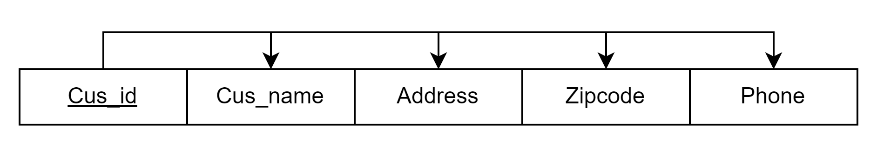

1. DOG Table

The dog table stores the information about dogs that visit the dog daycare center. It consists of Dog_id (Primary key), Dog_name, Breed, Weight and Cus_id (Foreign key from table CUSTOMER) .

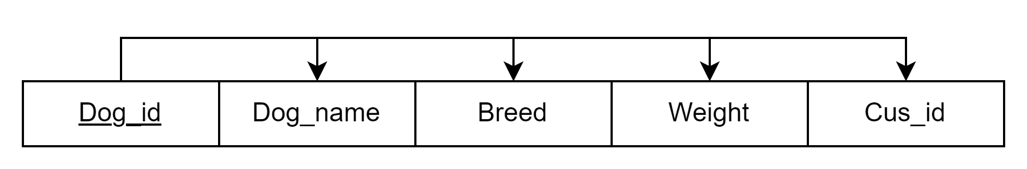

1. APPOINTMENT Table

The appointment table stores the information about appointments customers scheduled for their dogs at the center. It consists of Appt_id (Primary key), Appt_date, Appt_time, Cus_id (Foreign key from table CUSTOMER), Dog_id (Foreign key from table DOG), Service_id (Foreign key from table SERVICE) and Provider_id (Foreign key from table PROVIDER)

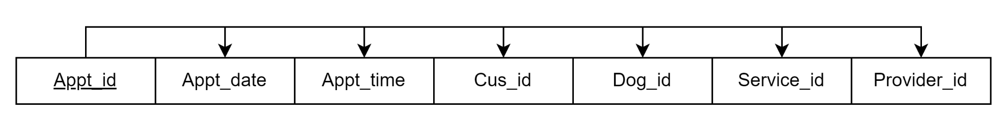

1. SERVICE Table

The service table stores the information about services the center provided for dogs in the appointment. It consists of Service_id (Primary key), Service_name and Service_price.

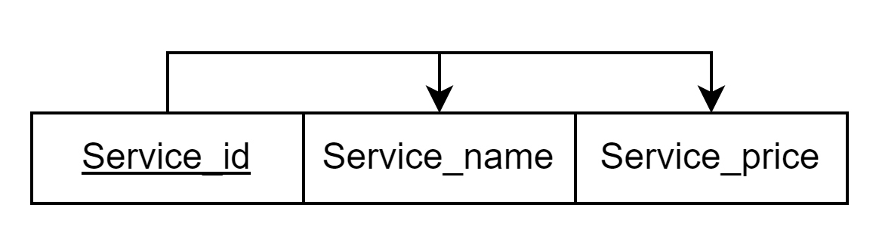

1. PROVIDER Table

The provider table stores the information about the employees who will perform the service during the appointment. It consists of Provider_id (Primary key), Provider_name and Skill.

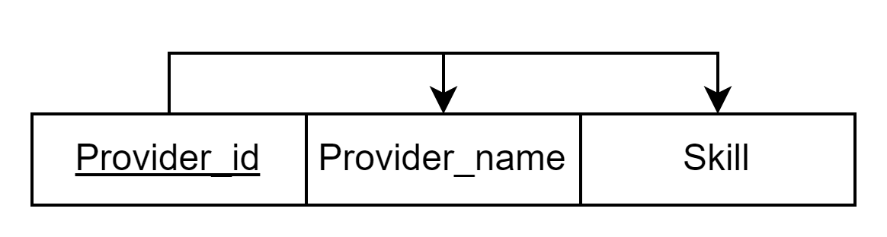

1. TRANSACTION Table

The transaction table stores the information about the payment details customers made for the appointments they booked at the center. It consists of Transaction_id (Primary key), Transaction_date and Appt_id (Foreign key from table APPOINTMENT).

