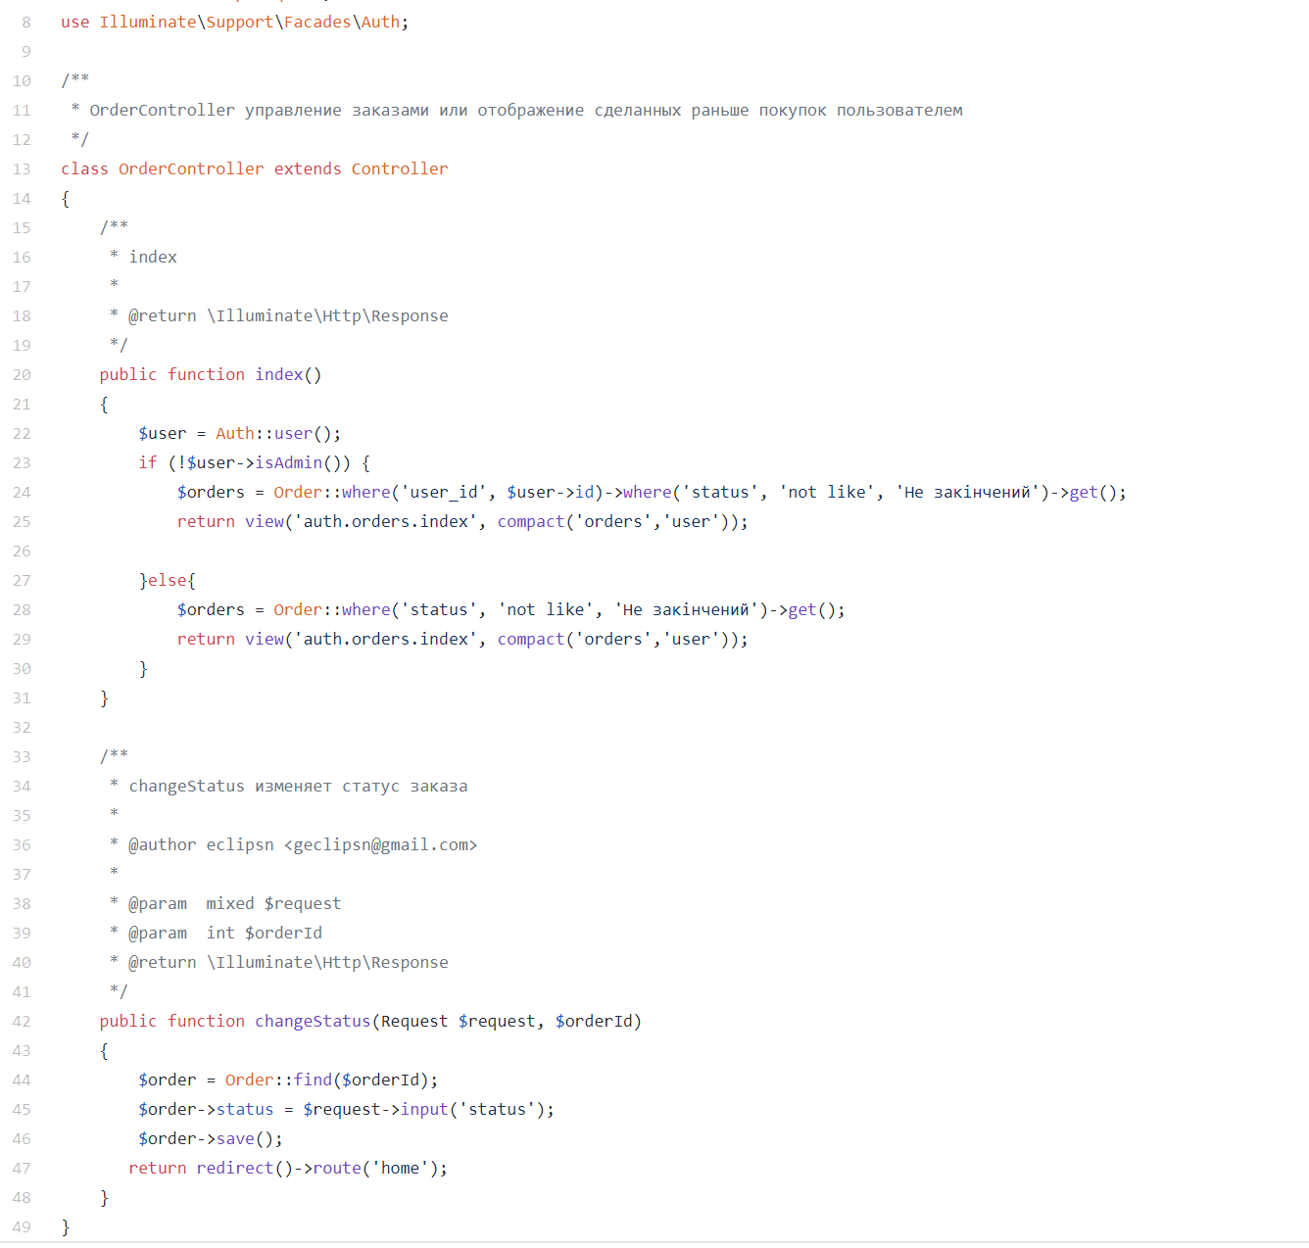

Img.1 – Documentation generation code sample

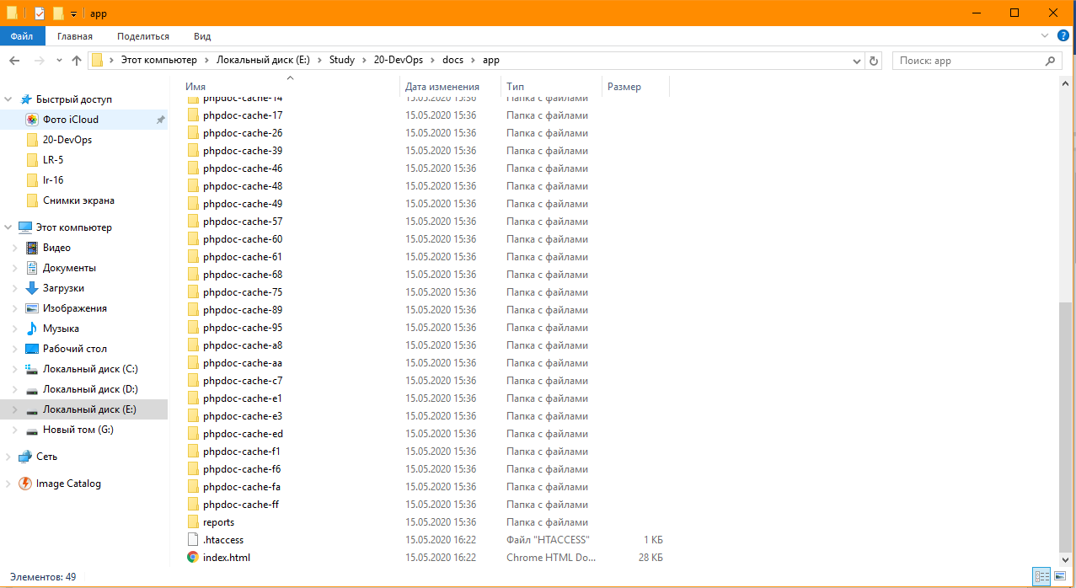

Img.2 – Generated documentation

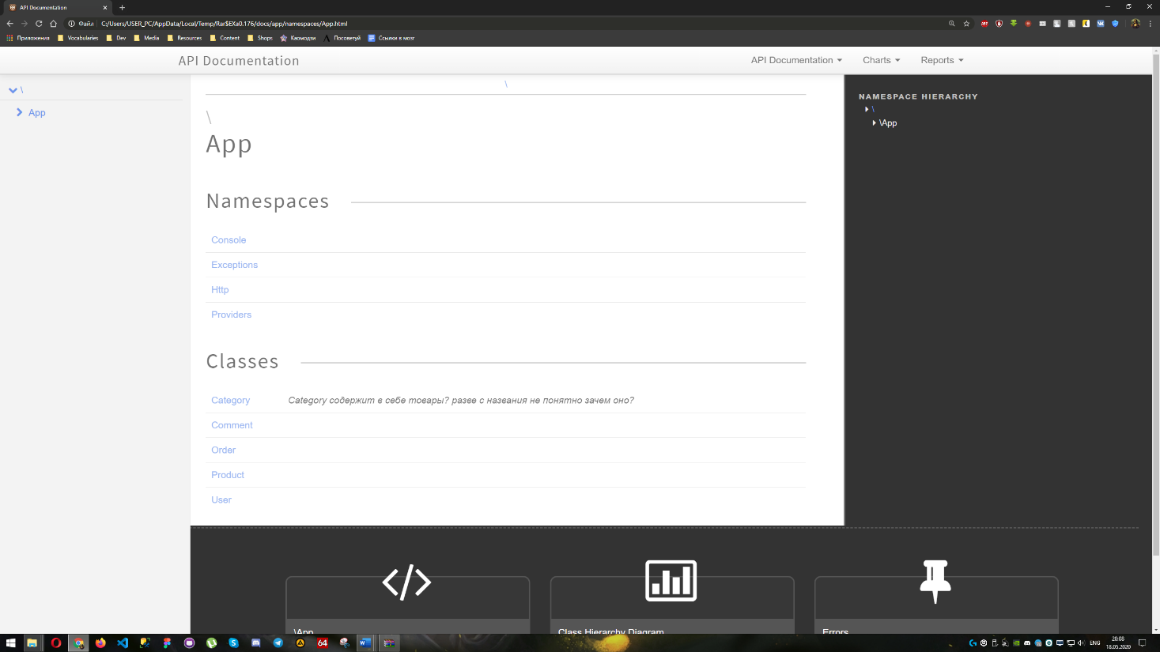

Img.3 – Classes and namespaces overview

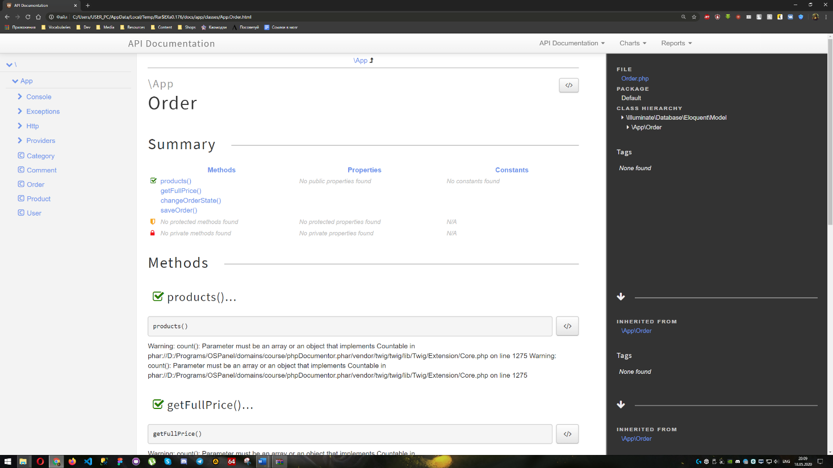

Img.4 – Class overview, based on Order class

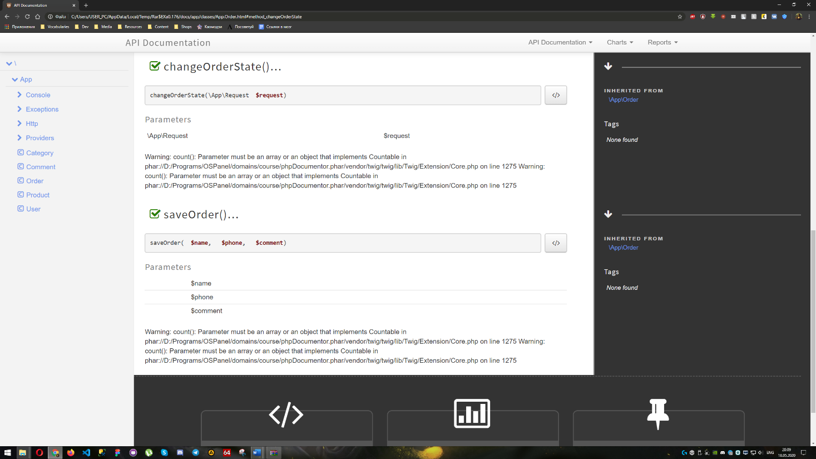

Img.5 – Methods overview, based on Order class