1. (fix this)

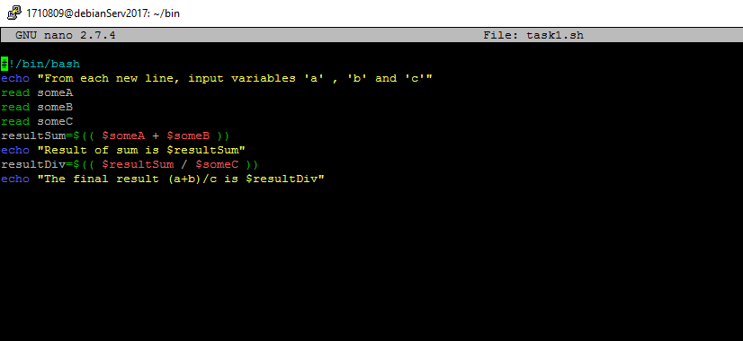

2.

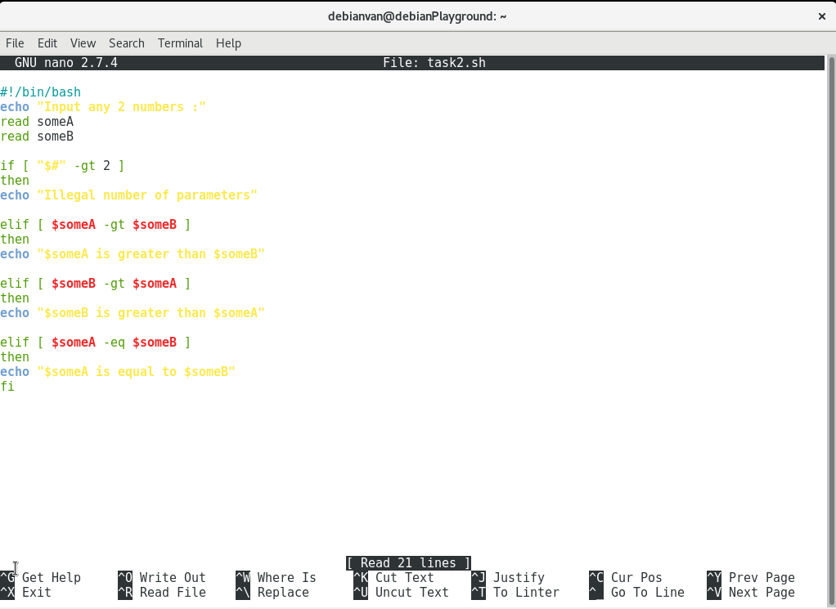

3. (<https://askubuntu.com/questions/757741/how-to-get-file-size-in-bash-with-readable-size-not-in-bytes>)

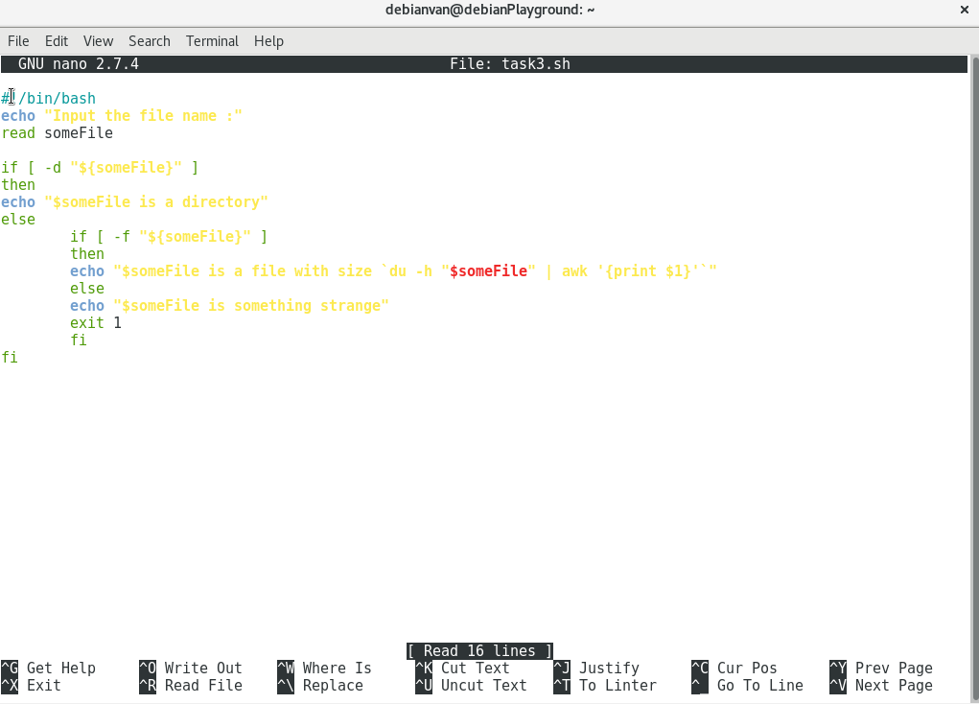

4. (<https://stackoverflow.com/questions/10942825/bash-loop-print-current-iteration>)

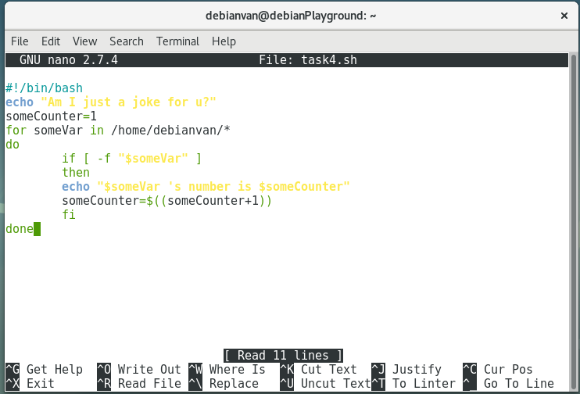

5. (<https://stackoverflow.com/questions/18755244/output-for-loop-to-a-file>

<https://stackoverflow.com/questions/18006581/how-to-append-contents-of-multiple-files-into-one-file>)

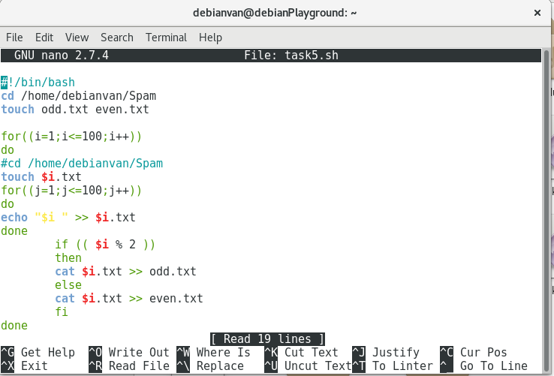

Final

