1.

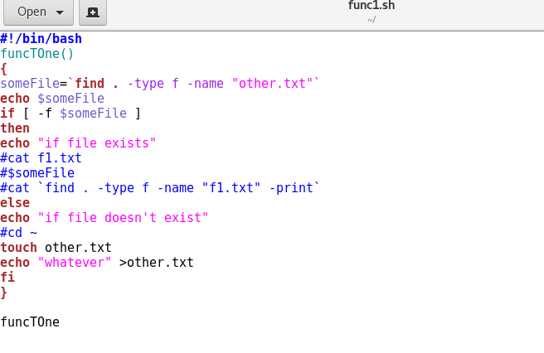

Final

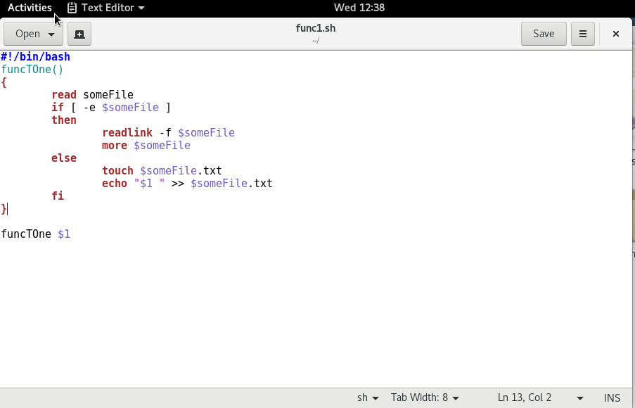

#!/bin/bash

function funcTOne

{

read someFile

if [ -e $someFile ]

then

readlink -f $someFile

more $someFile

else

touch $someFile

echo $1 >> $someFile

fi

}

funcTOne $1

2.

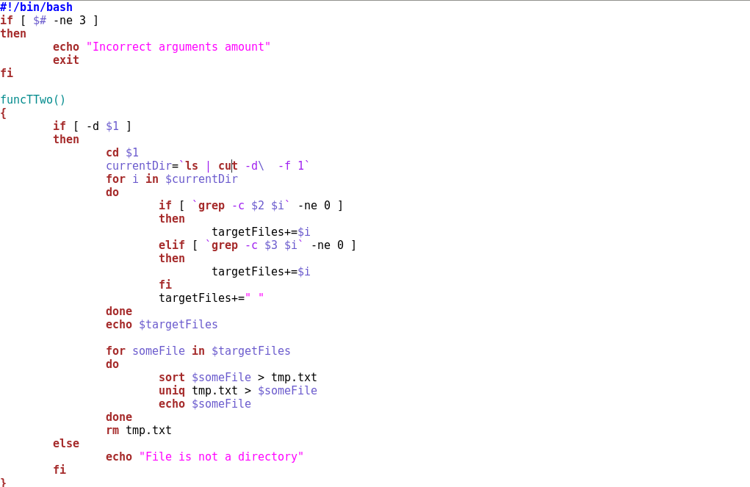

#!/bin/bash

if [ $# -ne 3 ]

then

echo "Incorrect arguments amount"

exit

fi

funcTTwo()

{

if [ -d $1 ]

then

cd $1

currentDir=`ls | cut -d\ -f 1`

for i in $currentDir

do

if [ grep -c $2 $i -ne 0 ]

then

targetFiles+=$i

elif [ grep -c $3 $i -ne 0 ]

then

targetFiles+=$i

fi

targetFiles+=" "

done

echo $targetFiles

for someFile in $targetFiles

do

sort $someFile > tmp.txt

uniq tmp.txt > $someFile

echo $someFile

done

rm tmp.txt

else

echo "File is not a directory"

fi

}

funcTTwo $1 $2 $3

3.

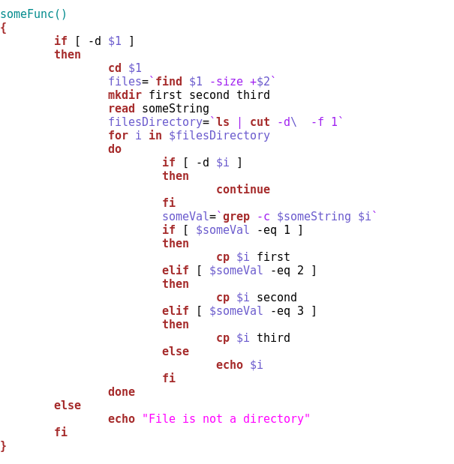

#!/bin/bash

if [ $# -ne 2 ]

then

echo "Fatal error"

exit

fi

someFunc()

{

if [ -d $1 ]

then

cd $1

files=`find $1 -size +$2`

mkdir first second third

read someString

filesDirectory=`ls | cut -d\ -f 1`

for i in $filesDirectory

do

if [ -d $i ]

then

continue

fi

someVal=`grep -c $someString $i`

if [ $someVal -eq 1 ]

then

cp $i first

elif [ $someVal -eq 2 ]

then

cp $i second

elif [ $someVal -eq 3 ]

then

cp $i third

else

echo $i

fi

done

else

echo "File is not a directory"

fi

}

someFunc $1 $2