1. <https://www.theurbanpenguin.com/counting-files-directories-linux/>

<https://stackoverflow.com/questions/17648033/counting-number-of-directories-in-a-specific-directory>

<https://stackoverflow.com/questions/14352290/listing-only-directories-using-ls-in-bash-an-examination>

<http://tldp.org/HOWTO/Bash-Prompt-HOWTO/x700.html>

1. <https://www.shellhacks.com/bash-string-length/>

<https://www.cyberciti.biz/faq/unix-linux-appleosx-bsd-bash-count-characters-variables/>

<https://stackoverflow.com/questions/16679369/count-occurrences-of-a-char-in-a-string-using-bash>

<https://ryanstutorials.net/bash-scripting-tutorial/bash-input.php>

<https://stackoverflow.com/questions/15596199/how-can-i-count-the-number-of-characters-in-a-bash-variable>

<https://www.gnu.org/software/bash/manual/bashref.html#Shell-Parameter-Expansion>

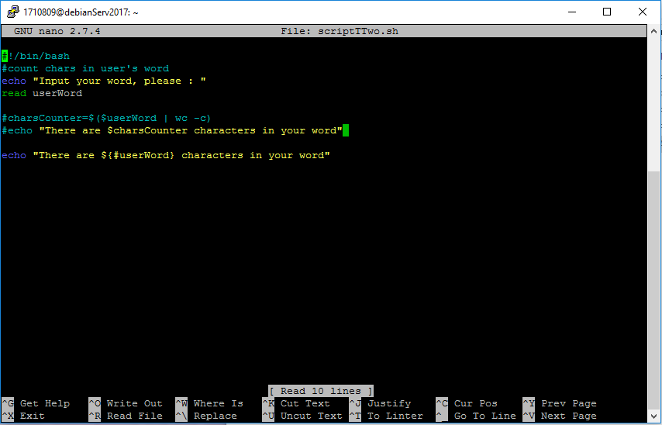

1. <https://www.linuxquestions.org/questions/linux-server-73/how-can-i-display-a-logout-message-595734/>

<http://rcsg-gsir.imsb-dsgi.nrc-cnrc.gc.ca/documents/advanced/node125.html>

<http://osr507doc.xinuos.com/en/OSUserG/_How_to_add_a_logout_script.html>

<https://unix.stackexchange.com/questions/423958/what-is-the-purpose-of-bash-logout>

<https://se.ifmo.ru/~ad/Documentation/Bash_Shell/bash3-CHP-3-SECT-1.html>

(

login screen customize

<https://serversforhackers.com/c/customize-your-login-screen-via-linuxs-message-of-the-day-ubuntucentos>

<https://superuser.com/questions/410525/explain-why-bash-logout-wont-run-commands>

)

fix later

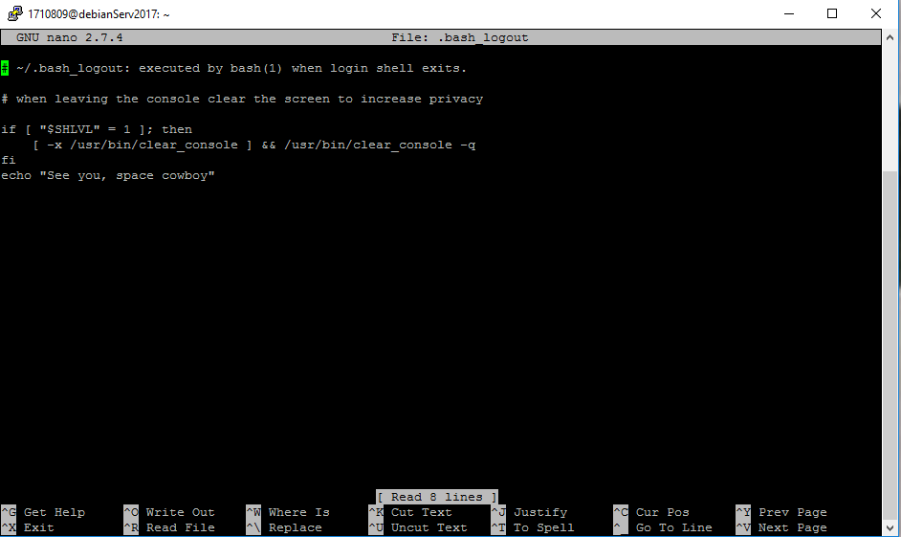

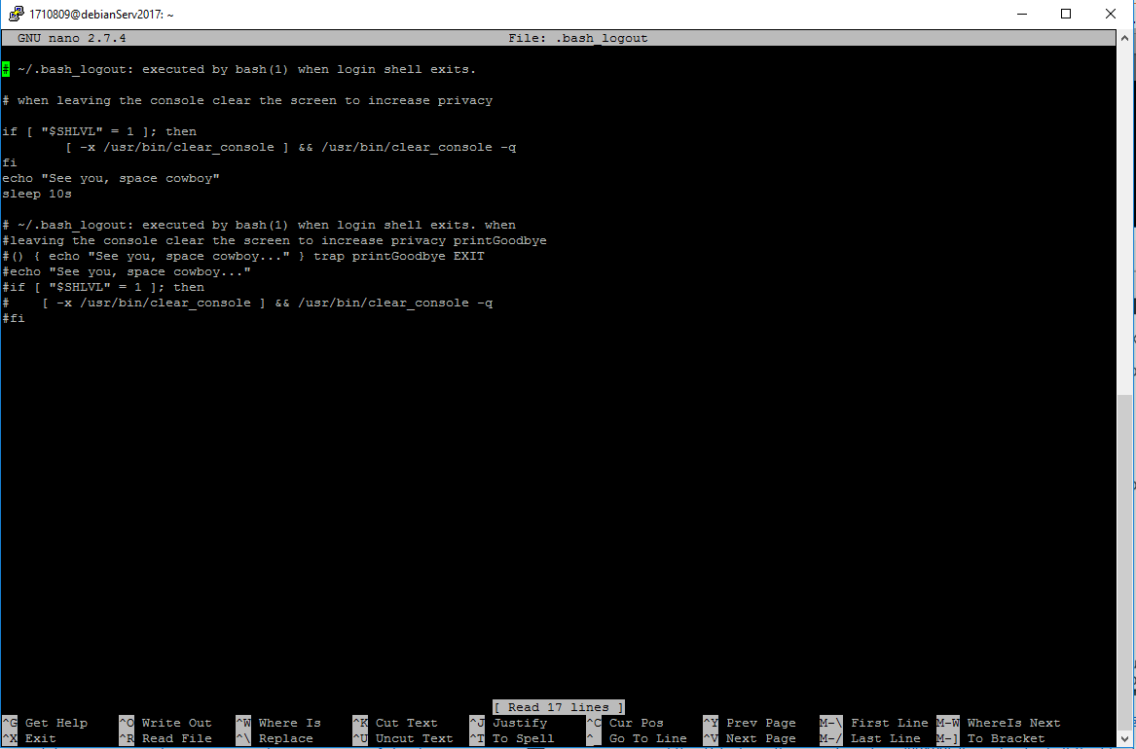

4. <https://askubuntu.com/questions/633474/remove-files-of-0-bytes-in-size-via-command-line>

<https://stackoverflow.com/questions/801095/how-do-i-find-all-the-files-that-were-created-today-in-unix-linux>

<https://www.ostechnix.com/find-copy-certain-type-files-one-directory-another-linux/>

<https://stackoverflow.com/questions/801095/how-do-i-find-all-the-files-that-were-created-today-in-unix-linux>

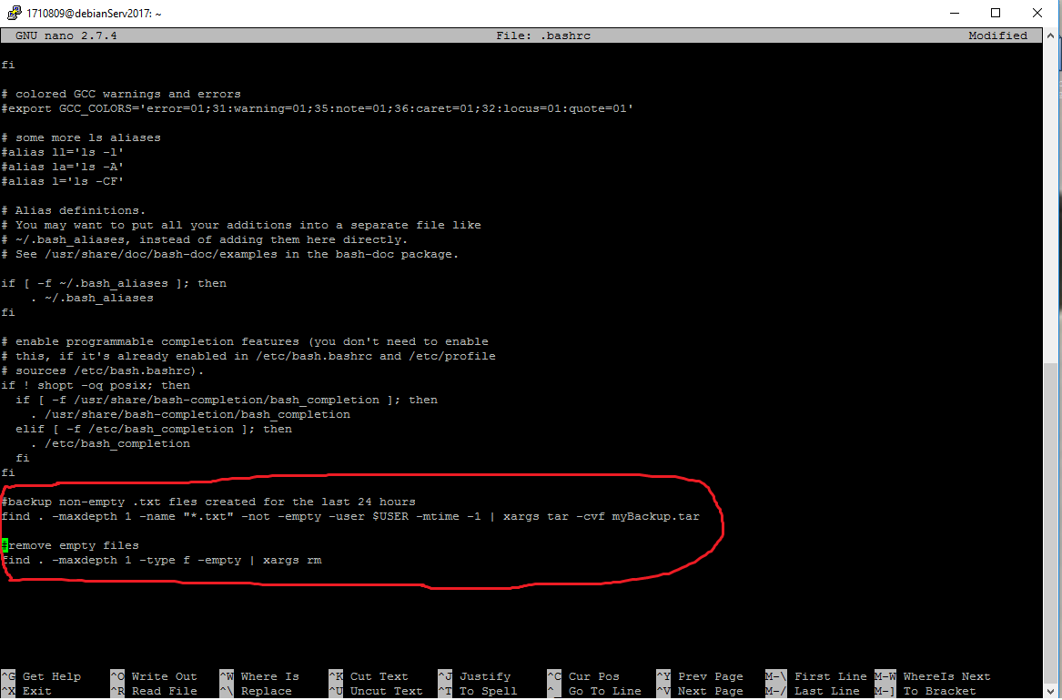

1. ( <https://www.youtube.com/watch?v=vDOVEDl2z84&list=PL-osiE80TeTvGhHkpvfmKWOiIPF8UVy6c&index=8> )

