1.

CREATE TABLE skyscrapper_dwellers (

dweller_code VARCHAR (30) REFERENCES owners (code)

NOT NULL

PRIMARY KEY,

name VARCHAR (30) NOT NULL,

car_code VARCHAR (30) REFERENCES parking_places (code)

NOT NULL,

room INT UNIQUE

NOT NULL

CHECK (room BETWEEN 1 AND 1200)

);

CREATE UNIQUE INDEX dwellers_idx ON skyscrapper_dwellers (dweller_code);

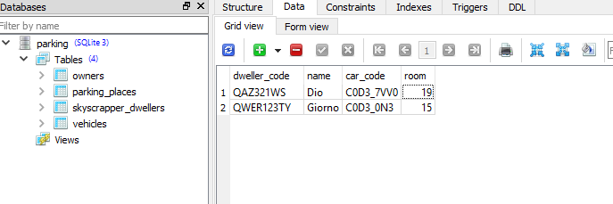

2.

CREATE TABLE job (

number INT UNIQUE

PRIMARY KEY

NOT NULL

CHECK (number BETWEEN 1 AND 200),

last_name_code VARCHAR (30) REFERENCES owners (code)

NOT NULL,

some_code VARCHAR (30) REFERENCES skyscrapper_dwellers (dweller_code)

NOT NULL

);

CREATE UNIQUE INDEX job_idx ON job (number);

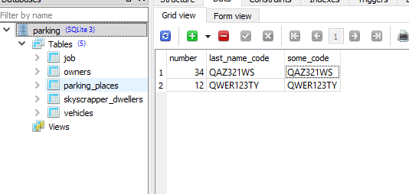

3.

CREATE TABLE mall (

parking_place INT PRIMARY KEY

NOT NULL

UNIQUE

CHECK (parking_place BETWEEN 1 AND 256),

vehicle_code INT (30) REFERENCES parking_places (code)

UNIQUE

NOT NULL,

owner_code INT (30) REFERENCES owners (code)

UNIQUE

NOT NULL

);

CREATE UNIQUE INDEX mall_idx ON mall (parking_place);

