Game Theory Homework1 Report 2025

Github for source code: <https://github.com/IacobIsabelaIE/game-theory_code>

Exercise 1

# Pseudocode

FUNCTION find_NE(number_strategies_player1, number_strategies_player2, payoff_p1, payoff_p2):

Initialize empty list NE to store Nash Equilibria

FOR each strategy i of player 1:

FOR each strategy j of player 2:

Let p1_val = payoff_p1[i][j] // Player 1's payoff at (i, j)

Let p2_val = payoff_p2[i][j] // Player 2's payoff at (i, j)

Set best_response_p1 = TRUE

FOR each strategy z of player 1:

IF payoff_p1[z][j] > p1_val:

Set best_response_p1 = FALSE

BREAK

Set best_response_p2 = TRUE

FOR each strategy y of player 2:

IF payoff_p2[i][y] > p2_val:

Set best_response_p2 = FALSE

BREAK

// If both players are best responding, it's a Nash Equilibrium

IF best_response_p1 AND best_response_p2:

Add (p1_val, p2_val) to NE

RETURN NE

Games that I used to test my game:

## Battle of sexes:

|  |  |  |
| --- | --- | --- |
|  | P2 – Ballet | P2 - Fight |
| P1 - Ballet | (1,2) | (0,0) |
| P1 - Fight | (0,0) | (2,1) |

NE: (1,2) (2,1)

## Prisoner’s Dilemma

|  |  |  |
| --- | --- | --- |
|  | Cooperate(quiet) | Defect(snitch) |
| Cooperate(quiet) | (-1,-1) | (-3,0) |
| Defect(snitch) | (0, -3) | (-2, -2) |

NE: (-2, -2)

## Matching Pennies

|  |  |  |
| --- | --- | --- |
|  | Head | Tail |
| Head | (1,-1) | (-1, 1) |
| Tail | (-1, 1) | (1, -1) |

NE: No Pure NE

Exercise 2:

Experiment1

For N = 20 and K=10, K=100, K=1000, K=10000

N=20, K = 10 -> (0.1 , 0.9)

N=20, K = 100 -> (0.06 , 0.94)

N=20, K = 1000 -> (0.041 , 0.959)

N=20, K = 10000 -> (0.0492 , 0.9508)

|  |  |  |  |
| --- | --- | --- | --- |
| N | K | Stay | Switch |
| 20 | 10 | 0.10 | 0.9 |
| 20 | 100 | 0.06 | 0.94 |
| 20 | 1000 | 0.041 | 0.959 |
| 20 | 10000 | 0.0492 | 0.9508 |

Experiment 2

For N = 50 and K=10, K=100, K=1000, K=10000

|  |  |  |  |
| --- | --- | --- | --- |
| N | K | Stay | Switch |
| 50 | 10 | 0 | 1 |
| 50 | 100 | 0 | 1 |
| 50 | 1000 | 0.019 | 0.981 |
| 50 | 10000 | 0.0198 | 0.9802 |

Experiment 3

For N = 100 and K=10, K=100, K=1000, K=10000, k=100000

|  |  |  |  |
| --- | --- | --- | --- |
| N | K | Stay | Switch |
| 100 | 10 | 0 | 1 |
| 100 | 100 | 0.01 | 0.99 |
| 100 | 1000 | 0.011 | 0.989 |
| 100 | 10000 | 0.0101 | 0.9899 |
| 100 | 100000 | 0.0099 | 0.9901 |

Conclusion of this experiment: The results are stabilizing when increasing the numbers of simulations.

Exercise 3

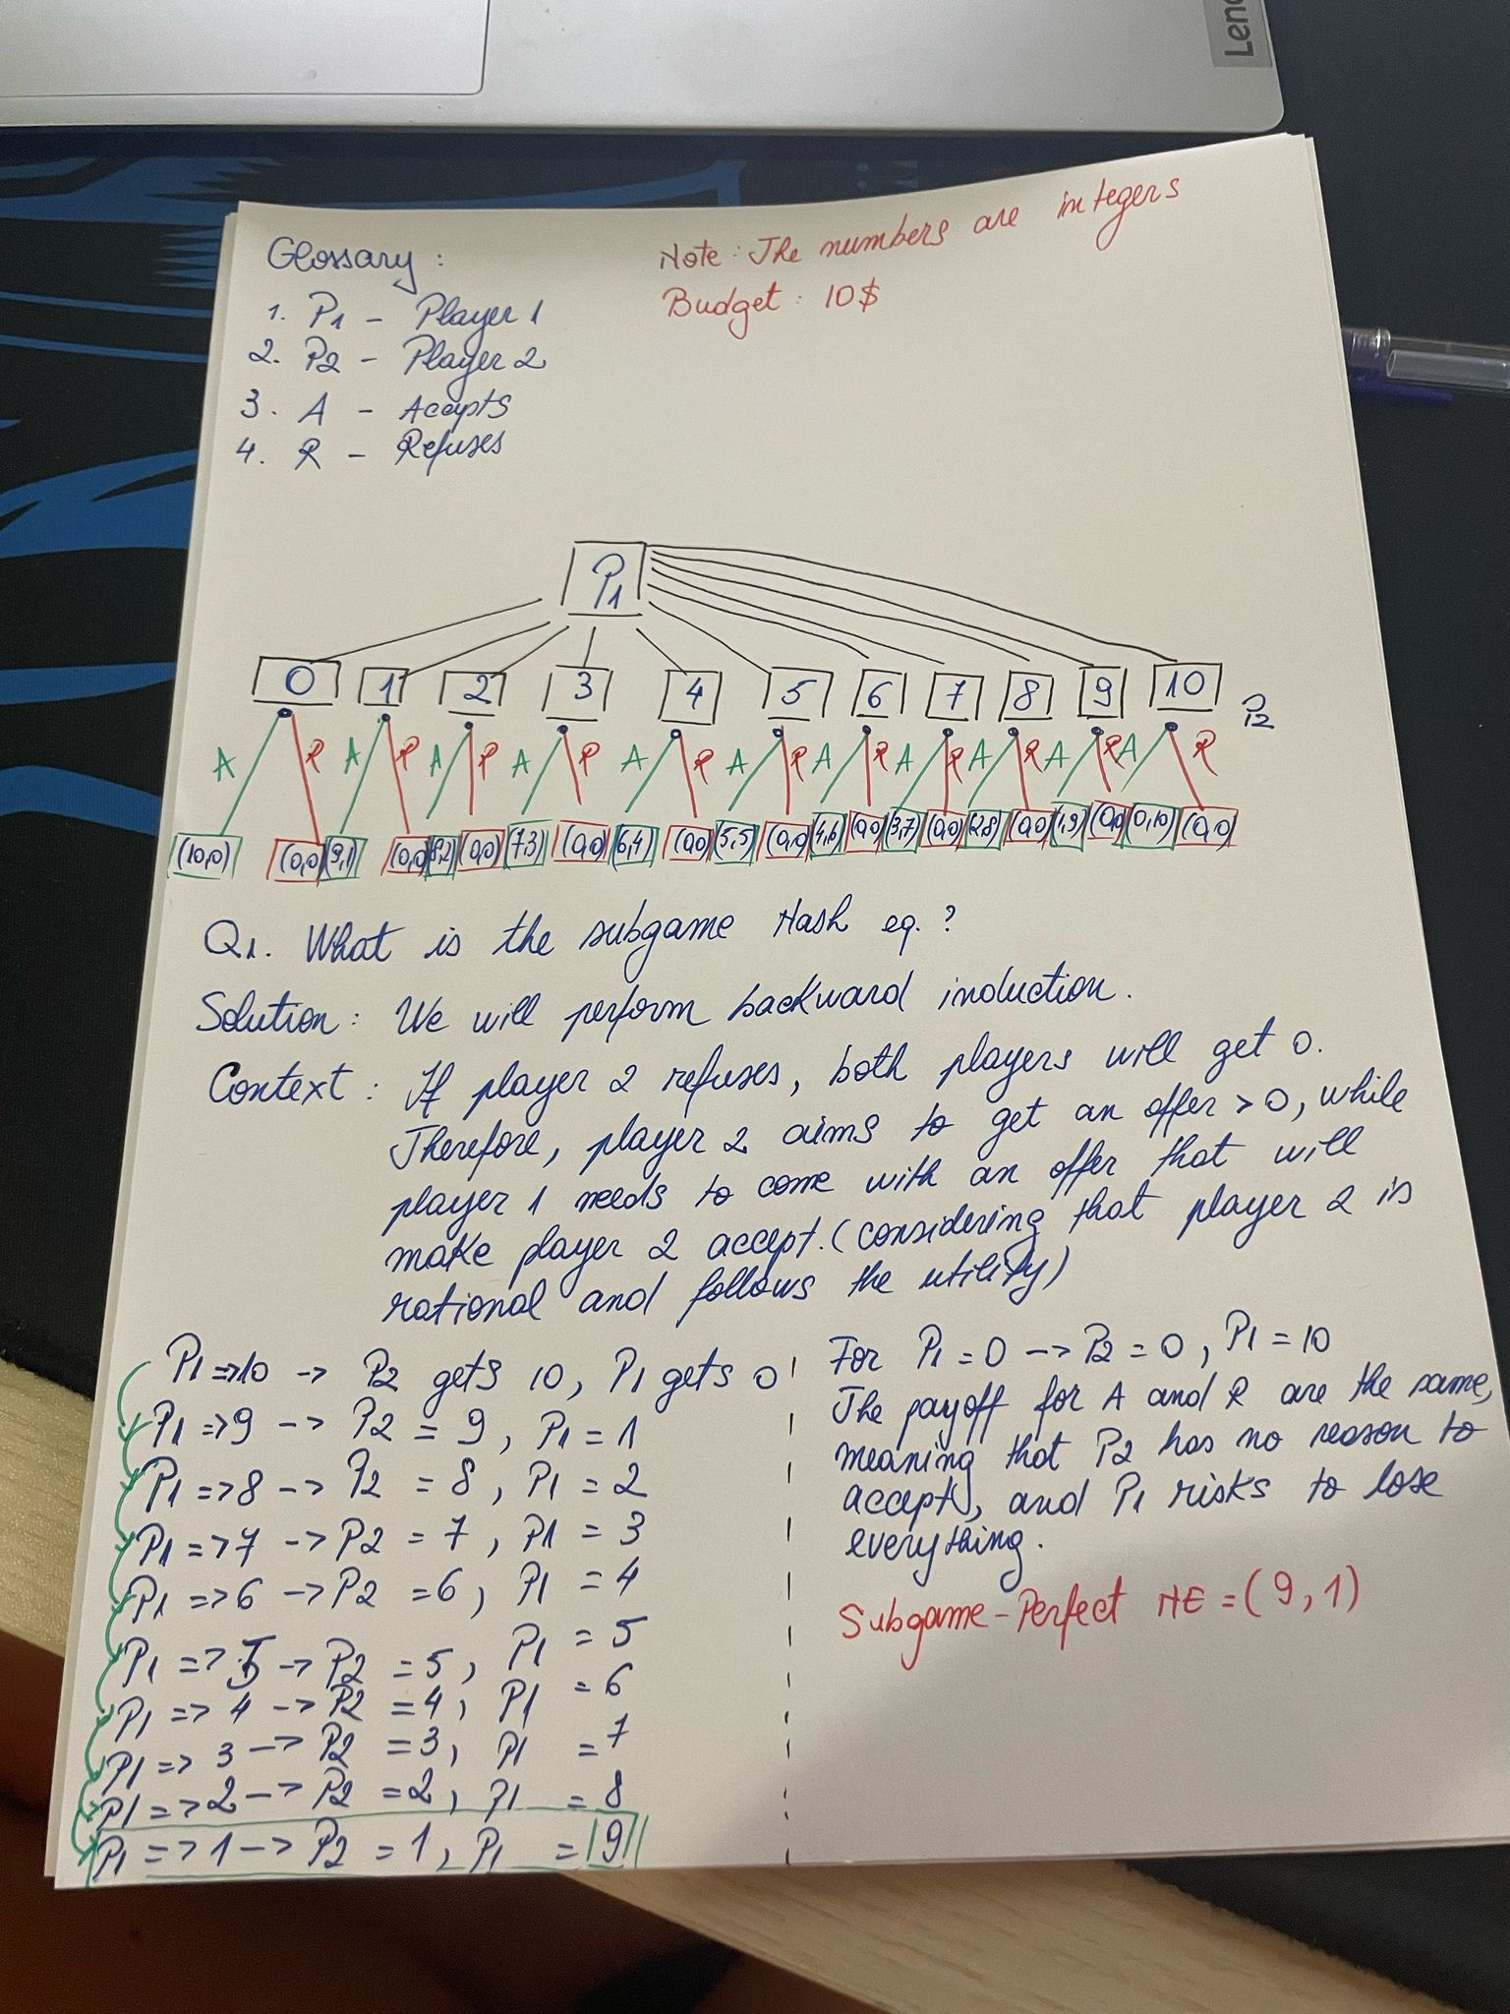

b. If Player 2 rejects any offer where their payoff is less than 2, then the strategy where Player 1 offers (8,2) and Player 2 accepts is a Nash Equilibrium. However, it is not a Subgame Perfect Nash Equilibrium, because Player 1 could do better by offering (9,1), assuming Player 2 would accept any amount greater than 0.

Exercise 4

Experiment 1

Nr. Rounds = 6

payoff = [(1, 0), (0, 2), (3, 1), (2, 3), (5, 2), (4, 6)]

Game stops at round 1 by Player(Player 1)

Final Payoffs: Player 1: 1, Player 2: 0

Experiment 2

number_rounds = 8

payoff = [(1, 0), (0, 2), (3, 2), (2, 4), (5, 4), (4, 6), (7, 6), (6, 9)]

Game stops at round 1 by Player(Player 1)

Final Payoffs: Player 1: 1, Player 2: 0

Experiment 3

number_rounds = 10

payoff = payoff = [ (8, 2), (7, 3), (9, 1), (6, 4), (5, 5), (4, 6), (3, 7), (2, 8), (1, 9), (0, 10)]

Game stops at round 1 by Player(Player 1)

Final Payoffs: Player 1: 8, Player 2: 2

Experiment 4 (class example)

number_rounds = 6

payoff = [ (5, 0), (6, 1), (7, 2),(8, 3),(6, 0),(4, 1)]

Game stops at round 4 by Player(Player 2)

Final Payoffs: Player 1: 8, Player 2: 3