Understanding Axios Response Object
When you make a request using Axios, the response you receive contains multiple properties that describe both the request and the server’s reply. This document explains each property shown in the console screenshot, along with their roles and examples.
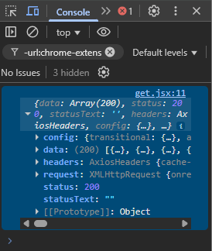

Axios Response Object Structure
Example of a simple GET request in Axios:
- axios.get("https://api.example.com/data")
.then(response => console.log(response))
The response object printed looks just like the one shown in the screenshot.

Breakdown of Each Property
Property | Description | Example
data | The main content (payload) returned from the API. | data: [ {...}, {...}, ... ]
status | The HTTP status code returned by the server. | status: 200
statusText | Short message describing the status, often 'OK'. | statusText: "OK"
headers | All HTTP response headers sent by the server. | headers['content-type'] = 'application/json'
config | Axios request configuration used to make the request. | config: { url: '...', method: 'get', headers: {...} }
request | The actual XMLHttpRequest (XHR) or fetch object used by Axios. | request: XMLHttpRequest
[[Prototype]] | Internal object linking to Axios’ response prototype. | (system-level, not normally used)

Example Visualization
{
data: [/* 200 items from API */],
status: 200,
statusText: '',
headers: {
"content-type": "application/json",
"cache-control": "no-cache"
},
config: {
url: "https://api.example.com/data",
method: "get",
headers: { Accept: "application/json" },
transitional: { ... }
},
request: XMLHttpRequest {...}
}

Quick Summary
Property | Role
data | The response content from the server
status | Numeric HTTP status code
statusText | Textual representation of the status
headers | Metadata from the server
config | Axios request settings
request | Low-level network request object

