WEBSOCKETS
Now lets go behind Imagine your in the restaurant and starving but you don’t know if the food is ready so the only way to know is keep asking that’s POLLING
Now that is how the HTTP word and Former real time apps and browsers where working keep sending a request to the server every few seconds. Just to check if something has changed

And its supper wasteful and everytime you ask you send full HTTP request with a bunch of headers just to get a tiny response back
So if HTTP is so inefficient for real time apps the big apps feel instant
Note: They keep an open connection and not requests everytime
They Do it By using a PROTOCAL
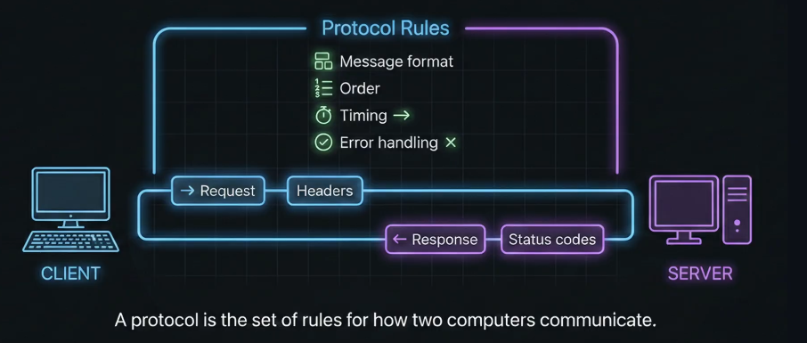
A protocal is basically the rules for how two computers communicate but HTTP protocol is not best for back and fourth communication
For realtime apps we need a protocal that supports an stable and permanent two way connection not requests and responce
That’s why the other Protocol is used called WebSockets
WEBSOCKET – Stays open so both the server and the client can send message any time.
These is called Full-Duplex
Both sides can talk at the same time
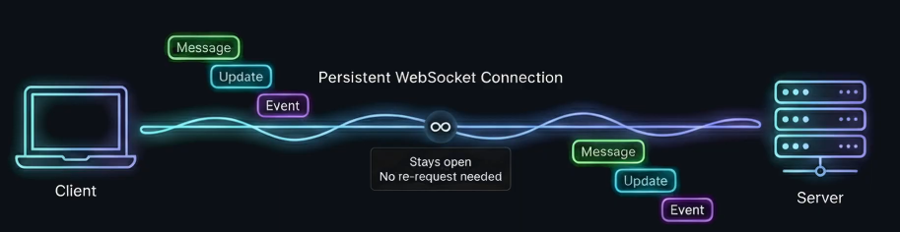
Full-Duplex is Less Expensive than Polling – Because in Polling with every request there is the bunch of headers But with WebSockets Once a connection is open messages are tiny
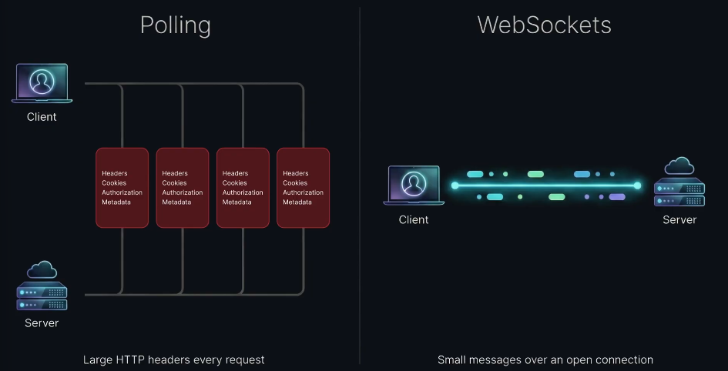
Its also more efficient for servers Because handling many requests opening and closing is harder that just keeping many websockets connections that are permanent
Its also better for Mobile Because Polling wakes up the phone over and over again reading to battery drainage
But a single open connection is usually easier on the battery

WEBSOCKETS HANDSHAKE – These is the first part where the websocket starts as like the normal HTTP request
And then the browser adds a special header saying – Hey server can we upgrade these connection to WebSocket
If the server supports it replies with HTTP 101:switching protocols
And when that happens HTTP is done
And now we have something called a WebSocket Tunnel open, persistent and real-time
Now just like HTTP and HTTPS WebSocket’s have
WS: // - Unencrypted
WSS:// - Encrypted
In Production we always use WSS

ARCHITECTURE
After a WebSocket’s upgrading HTTP into a persistent and open
But once that phone line is open how do we really manage the conversation
Now lets break WebSocket into a real production Architecture
Because a websocket connection isn’t just on or off it has stages
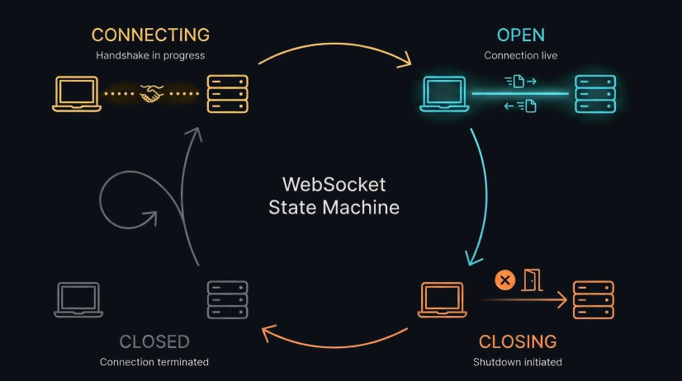
Think of it like highspeed train system you connect you ride you make sure nobody vanish in the trip and you clean up propery
- CONNECT – It starts with a single line, You setup a socket by creating a new websocket and specify specific port
- UPGRADE – The moment these runs the browser sends HTTP Get request to the server with a special header(That may be says hey I want to upgrade this connection to WebSockets.)
Then if the server accepts it replies with HTTP:101 Switching Protocols
And that’s the moment the relationship changes HTTP ends the tunnel stays open
And now both Sides can send messages instantly
- STATE – Here is the biggest architecture shift The state or the Memory
HTTP by default is Stateless The server forgets you after every request
BUT
WebSocket are Stateful The server holds a reference to your socket in memory and that’s how it can put data to you instantly
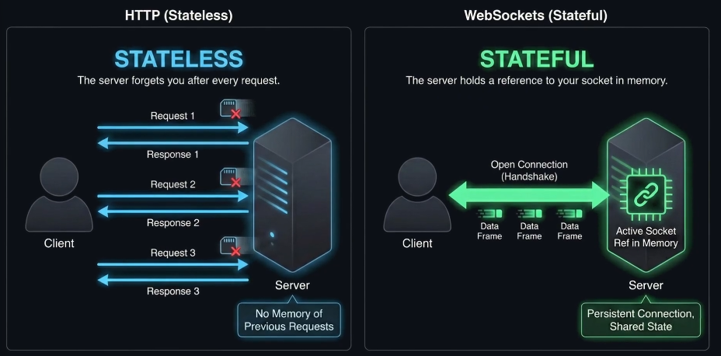
But that raise to a new problem Ghost Connections what if someone loses Wi-Fi or phone dies or close the laptop without Properly disconnecting
Now the server thinks the connection is still alive and keep holding the socket in memory these are called Ghost Connections
And If you don’t clean them up you server eventually dies slowly just from holding onto GHOSTS

So what’s the fix
So in production the servers use something called a Heartbeat or Often called ping/pong – Because a server sends a tiny ping and the client responds with a pong

If the server stops hearing Pongs it assumes the client is dead and terminates the socket that’s how you prevent Ghost Connections

You might think if we ping every thirty seconds isn’t it similar to polling BUT not even close because POLLING is sending an entire HTTP request but a Ping is basically a tiny impulse on an already open tunnel
It is
- Massively lighter

- Massively cheaper

- Far easier on battery

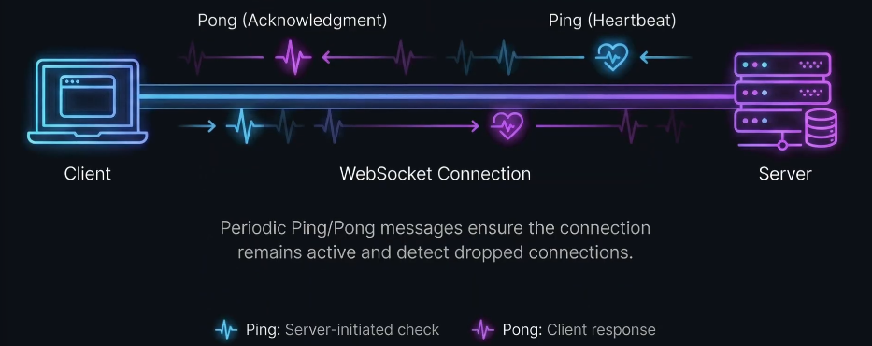

After the connections now lets talk about the Data Transfer Like what actually get sent through that tunnel

DATA TRANSFER
With WebSocket we don’t send webpages we send messages which are of two types
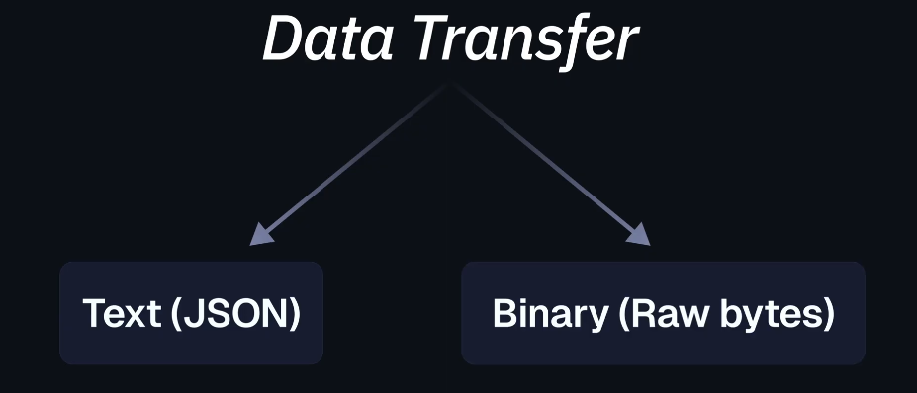
Most realtime apps sends JSON things like user is typing , new message ,score updated , notification received and etc
That’s usually socket.send then you stringify your data
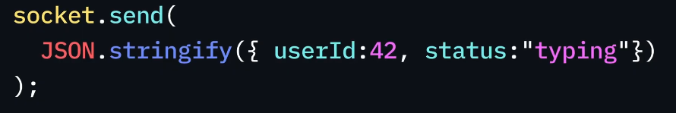
These is human readable easy to debug and perfect for 99% of the apps
But then
We also have binary the binary is what we use when things gets serious like audio streaming, video frames, multiplayer game states , a large pilots
Instead of sending text You send raw bites using ArrayBuffer or Blob

Its faster, smaller and more efficient
But how does the server know of what type of a message it is WELL at the lowest level websockets uses something called and OPCODE Its basically a label that says these frame is text , binary, closing, ping/pong
You wont have to deal with OPCODE most of the time but its what makes the whole protocol work cleanly
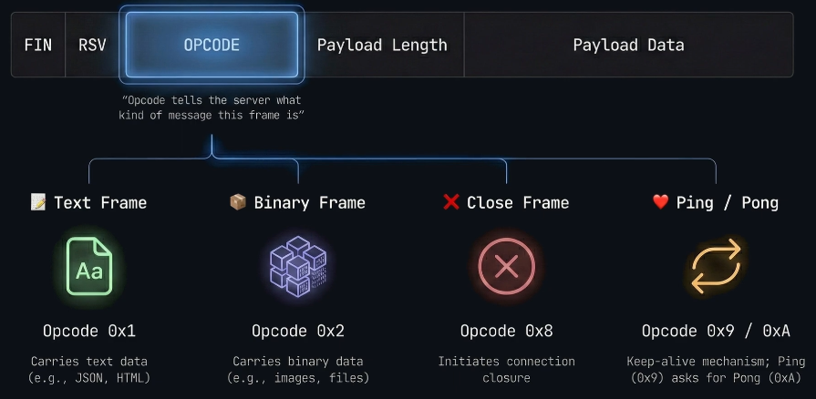

And then there is Backpressure advanced but important
Think about what happens if your server is sending updates like crazy and the user is on a slow internet connections .New messages starts pilling up in memory that’s Backpressure
Production apps monitory how much there is buffered and if it gets too high they slow down the sending grade so the server doesent explode
Note: These is an advanced concept and you won’t need it for every project but once you build real systems these becomes a big deal

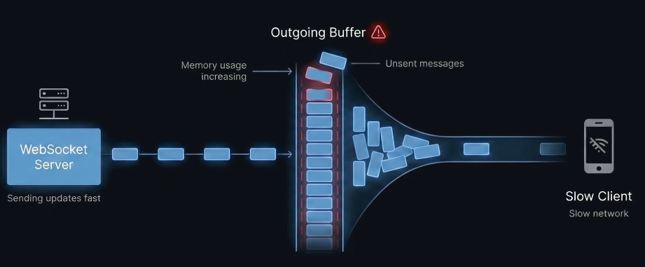

WEBSOCKETS IN ACTION
There are three different options for creating WebSocket’s
Socket.IO, Pusher, Ably, ws library
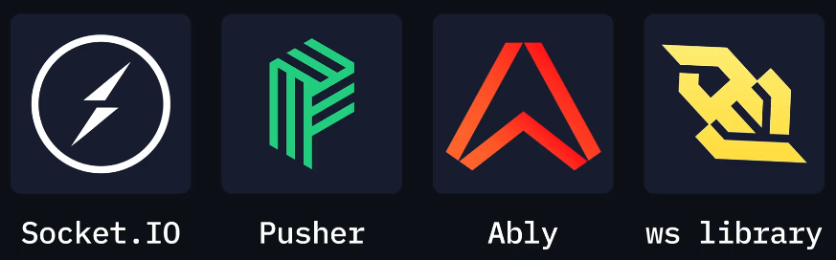
Socket.IO - Most popular real time library in Node.js (It gives you a full management suite on top of webSockets{Reconnects, Rooms, Fallbacks, The whole package})
But its heavier compared to raw websockets
Then there is the Web Sockets as Service tools(WaaS) such as Pusher and Ably
You just pay them and it just scales – It’s the easiest path of production but the trade off is cost and control {Not Greate if you want a full ownership of the system }
And then there is the WS library - these is the low level and high performant compared to others and it matches the browsers WebSocket API closely
But the problem is you build features youself

JUST Before we start lets just Learn about WEB SOCKET lifecycle
A websocket is basically a state machine and if you try to send data in the wrong state you will get bugs brocken messages and crashes
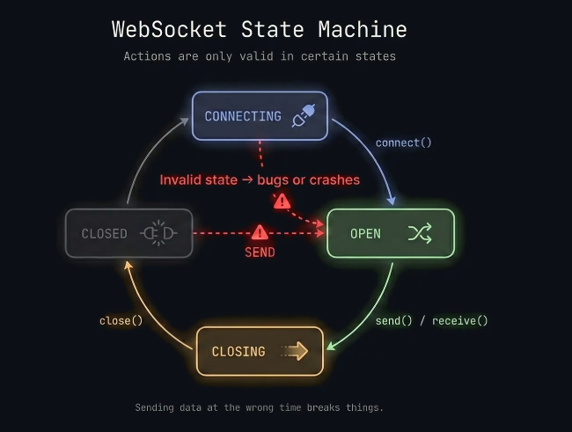

So we need to understand Four Different states
- CONNECTING – Handshake is still happening don’t send yet
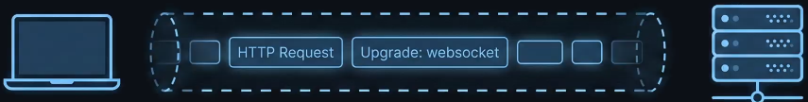
- OPEN – The tunnel is live you can send
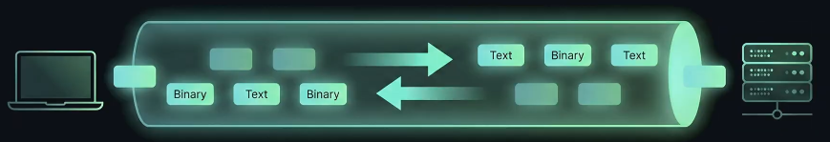
- CLOSING – Connection is shutting down Stop Pushing Data
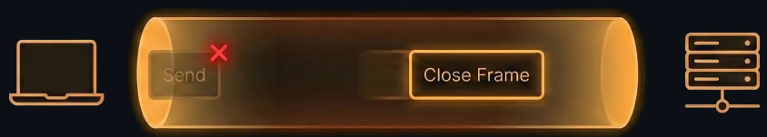
- CLOSED – Its dead time to reconnect
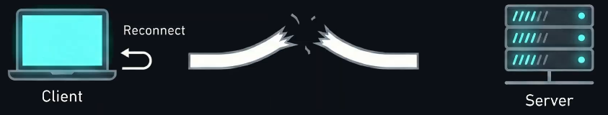
So you can check the states using

Now we will be managing these state from both the client and the server side
So lets talk about the Server Side Events with Websockets
On the server your the host your listening for the
Clients joining
Sending data
Disconnecting
Crashing and all of it

And you starting point(entry point) is the connection
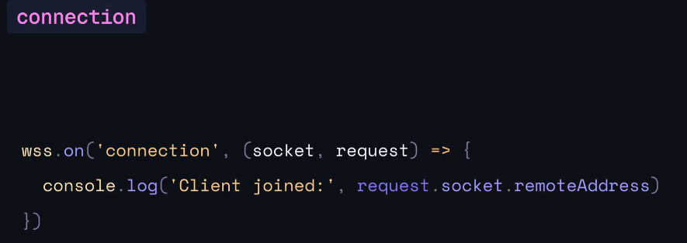
You declare these function and within it you can have all the info about whats happening with the socket and the requests coming in (Such as learning when new clients are joining in)
Then there is the message these is incoming data
In ws its usually comes in as a buffer so you have to convert it
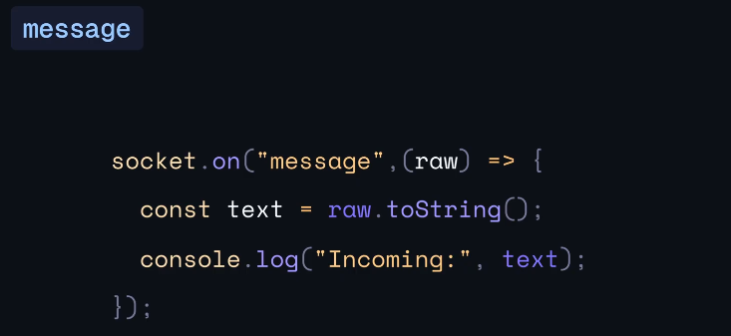
So just saying socket.on message you get the raw data and you know what to do with it

And then there is the error most people ignore it and then regrate latter if you don’t handle it properly It can break the entire NodeJS application
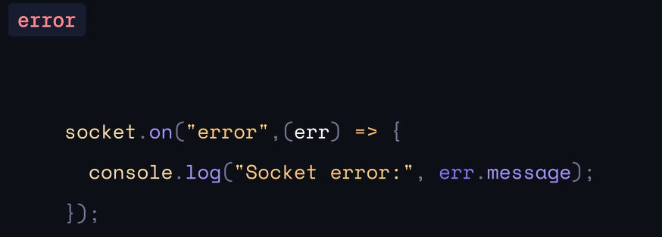

THERE IS ALSO THE OTHER SIDE EVENT HOW YOU ARE HANDLING THE CLIENT SIDE EVENTS
In the browser because on the frontend you are just a participant
There is an open event that means the handshake worked and now its safe to send you can listen for an open event and you can do a console log or send a message because now you are connected
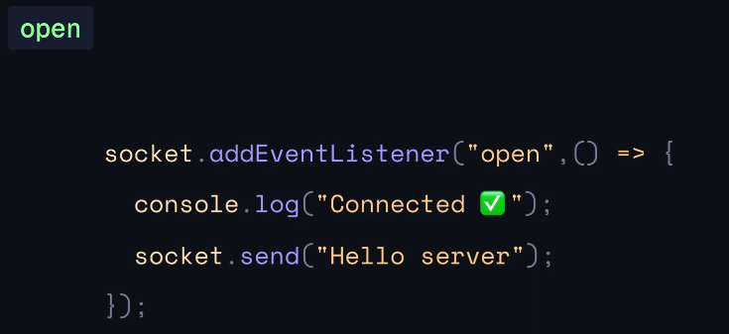

Then there is the message where you receive server Updates of the data coming in and display it
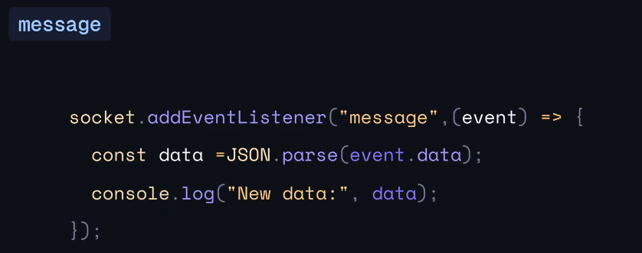

Then there is close Which simply means disconnected
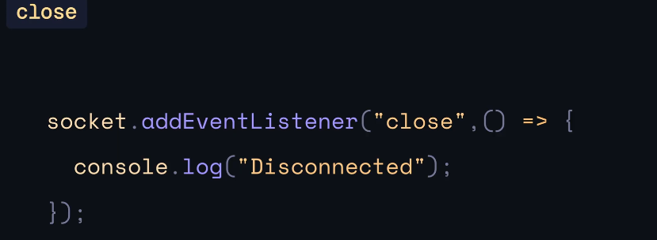

Keep in mind your server is the boss and sending all the data But on the frontend you are just a participant
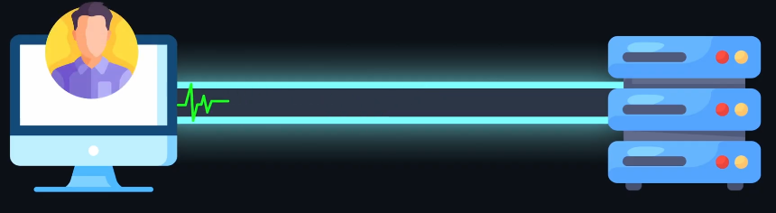

FINAL QUICK CHEATSHEET – With most important methods and listeners on both server side and client
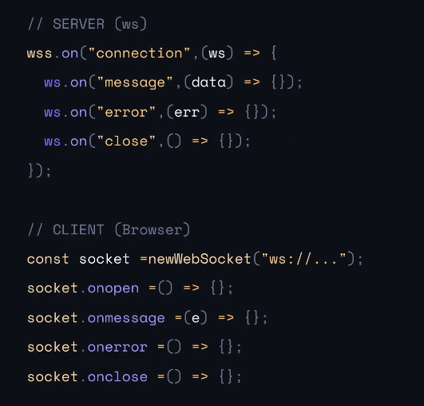
NOW THAT WE UNDERSTAND THE LIFE CYCLES AND THE EVENT
LETS COOK
WEBSOCKETS IN ACTION(DEMO)

