**T01: Reintroduced giant tortoises exhibit effectiveness and topological shifts but maintain structural roles in Seychelles’ mutualistic and antagonistic individual ecological networks.**

**T02: Differential Ecological Roles of Keystone Individuals of Reintroduced Giant Tortoises Across Mutualistic and Antagonistic Interaction Networks**

**T03: The neglected role of keystone individuals of giant tortoises as drivers of mutualistic and antagonistic processes in interaction networks.**

**Iago Ferreiro-Arias1,2*, Sergio García-Peña3,4*, Christopher Kaiser-Bunbury5, Pablo Vargas-Gómez3**

1Department of Conservation Biology and Global Change, Estación Biológica de Doñana, CSIC, Sevilla, Spain.

2Department of Biogeography and Global Change, Museo Nacional de Ciencias Naturales, CSIC, Madrid, Spain.

3Department of Biodiversity and Conservation, Real Jardín Botánico, CSIC, Madrid, Spain.

4Department of Biodiversity and Evolutionary Biology, Museo Nacional de Ciencias Naturales, CSIC, Madrid, Spain.

5Stella Turk Building G3.09. University of Exeter, Penryn Campus.Penryn, TR10 9FE.

\***Shared first authorship.** **Corresponding authors:**

[iago.ferreiro@ebd.csic.es](mailto:iago.ferreiro@ebd.csic.es); [sergio.garcia@mncn.csic.es](mailto:sergio.garcia@mncn.csic.es)

ORCID Iago Ferreiro-Arias: 0000-0003-4178-5783

ORCID Sergio García-Peña: 0000-0003-0414-9980

ORCID Christopher Kaiser-Bunbury: 0000-0001-7254-391

ORCID Pablo Vargas-Gómez: 0000-0003-4502-0382

**Abstract (248 out of 250).**

Giant tortoises are critical to restoration projects aimed at rewiring extinct ecological interactions on defaunated tropical islands. On some remote islands, ecosystem services such as seed dispersal and browsing-grazing depend on key species that got extinct after centuries of human overexploitation. In addition to key species, the role and contributions of key individuals to different ecological processes remain largely underexplored. To address this gap, we combined observational and genetic techniques to analyse ecological interactions of ten reintroduced Aldabra giant tortoises on Aride Island (Seychelles). We assessed the ecological roles of each individual based on effectiveness in dispersing native plants and controlling exotic flora and the individual contributions to antagonistic and mutualistic processes by identifying shifts in topological and structural roles within individual-based interaction networks. DNA metabarcoding of tortoise scats revealed consumption of 98 plants, with native species such as *Ficus reflexa* and *Pisonia grandis* being the most frequently via browsing and grazing. In seed dispersal, native plants accounted for nearly 90% of the 11,248 seeds dispersed, with *Morinda citrifolia* showing the highest interaction frequency. Individual tortoises exhibited varying levels of effectiveness in both antagonistic and mutualistic processes. Topological roles showed no congruence between mutualistic and antagonistic networks, butindividual tortoises exhibited consistent structural roles across antagonistic and mutualistic processes. Our study shows the rapid establishment of lost ecological interactions post-reintroduction while highlighting the importance of individual-scale variability. We hypothesise that critical ecosystem functions may depend substantially on a small number of individuals with diverse and contrasting ecological roles, especially in vulnerable island ecosystems with low functional redundancy.

**Keywords:** *Aldabrachelys gigantea*, Aride Island, browsing, diet, seed dispersal, DNA metabarcoding, refaunation, trophic rewiring**.**

**Introduction.**

Biodiversity is currently undergoing an unprecedented crisis worldwide, with myriads of ecosystems facing the loss of unique and irreplaceable interactions due to the rapid and increasing extinction of species (Kaiser-Bunbury et al., 2017, 2010). Islands, recognised as isolated and fragile ecological systems, are particularly sensitive to species extinction events and their cascading effects derived from human overexploitation (Dirzo et al., 2014; Ferreiro-Arias et al., 2024; Hansen and Galetti, 2009). The loss of key vertebrate species in these systems can lead to disproportionate ecological disruption compared to mainland ecosystems, where functional redundancy within vertebrate assemblages (i.e., several species performing similar ecological roles) is more prevalent (Hansen and Galetti, 2009; Kemp, 2023).

For instance, islands that once hosted large vertebrates have experienced anthropogenic-induced extinctions leading to the loss of key non-redundant functional roles in seed dispersal processes (Dirzo et al., 2014; Heinen et al., 2023; Vidal et al., 2013). A clear example are the islands inhabited by giant tortoises in Seychelles and Galapagos archipelagos where they stand out as iconic embodiments of island gigantism, having independently developed large body sizes from diverse ancestors due to diminished ecological pressures (Jaffe et al., 2011; Le et al., 2006; Vargas, 2014). In such insular systems, there is a scarcity of large-bodied sized herbivores aside from giant tortoises, which occupy unique ecological niches as both antagonists (i.e., via browsing and grazing) and mutualists (e.g., via primary seed dispersers) of many plant species (Blake et al., 2012; Nogales et al., 2017).

Given their unparalleled significance as ecosystems engineers, giant tortoises gained relevance in restoration projects aimed at recovering extinct ecological interactions in defaunated insular ecosystems (Griffiths et al., 2011, 2010; Polak and Saltz, 2011). This importance is exemplified by the reintroduction of Aldabra giant tortoises (*Aldabrachelys gigantea*) whose widespread distribution in the western Indian Ocean has been historically dwindled due to the overexplotation of the species by humans (Gerlach et al., 2013). The population of Aldabra giant tortoises remained in the wild in the Aldabra atoll (Seychelles archipelago), prompting restoration initiatives involving refaunation onto other Seychelles islands such as Curieuse, Frégate, Ile du Nord, Grand Soeur, Moyenne, Cousin, Cousine and Silhouette (Gerlach et al., 2013). Interestingly, this species has been also used as a substitute for giant tortoises of the genus *Cylindraspis*, a group of five extinct species formerly distributed across the Mascarene Islands in the Indian Ocean (Austin and Arnold, 2001). For instance, Mauritius islands were inhabited by *Cylindrapsis triserrata* and *Cylindrapsis inepta*, which were the largest native fruit-eaters, weighing around 100 kg. However, after its human-driven extinction, the Mauritian fruit bat (*Pteropus niger*), which weight only 0.54 kg, was the largest frugivore standing on the island (Heinen et al., 2023). This drastic extinction, representing a loss in body size of the largest frugivore of about 185 times, has prompted a significant ecological imbalance (Heinen et al., 2023; Kehlmaier et al., 2019) and have raised the question of whether it is feasible to restore the benefits of historical tortoise-plant interactions lost due to human-driven extinctions (Hansen, 2015; Hansen et al., 2010).

Nonetheless, two potential drawbacks must be considered. On one hand, the large size and generalist diet of these species could make tortoises significant dispersers of introduced plants, potentially threatening native species in sensitive ecosystems (Waibel et al., 2013). On the other hand, a concern associated with these introductions is the potential for habitat degradation, counteracting the conservation objectives of these programs (Waibel et al., 2013). Hence, assessing the current conditions of introductions is imperative to evaluate conservation efforts that may effectively restore ecosystems processes by rewiring ecological interactions. Exploring the dietary behaviour patterns of keystone species like giant tortoises is fundamental in understanding their ecological roles within insular ecosystems. For instance, the feeding behaviour pattern of Aldabra giant tortoises is known to affect plant composition through selective browsing and grazing (Griffiths et al., 2013). In this sense, it has been suggested that the herbivory defences in Mauritian native flora as evolutionary adaptation to tortoise grazing may turned non-native species more palatable due to the lack of such defences (e.g., spines or pubescences), ultimately leading to the control of exotic plants (Griffiths et al., 2013).

However, during the last decade, assessing the diet of introduced giant tortoises in Seychelles has been hampered by small sample sizes and challenges in accurately discerning dietary items from faecal samples (Moorhouse-Gann, 2017). Recent advances in DNA metabarcoding techniques provided an invaluable opportunity to delve deeper in the feeding ecology of Aldabra giant tortoises (Moorhouse-Gann, 2017), but these investigations have predominantly focused on browsing and grazing behaviours and neglected the exploration of ecosystem services associated with seed dispersal. Aldabra giant tortoises are able to disperse large-seeded plant species and their prolonged gut retention times may compensate for their limited movement rates (Falcón et al., 2021, 2020; Griffiths et al., 2011), providing to the ingested seeds an opportunity to escape Jazen-Connell effects (Falcón et al., 2021; Hansen et al., 2008). Nevertheless, on some islands within Seychelles archipelago, Aldabra giant tortoise populations are small (Gerlach et al., 2013), meaning that key ecosystem services, such as seed dispersal and browsing, are sustained by only few individuals. Moreover, Aldabra giant tortoises showed variability in diet among individuals which have been related to habitat preferences and body size (Moorhouse-Gann, 2017; Pemberton and Gilchrist, 2009). These differences in individual preferences may ultimately lead to fluctuations in their effectiveness as seed dispersers and/or browsers-grazers, impacting both mutualistic and antagonistic ecological processes. Nevertheless, there is a gap in the scientific literature regarding the relative contribution and importance (i.e., ecological role) of different individuals to mutualistic and antagonistic ecological services.

To address this research gap, we used a multifaceted approach combining both observational and genetic methodologies on Aride Island, where ten individuals of Aldabra giant tortoises were reintroduced in 2018. This island hosts a simplified frugivore assemblage, including the fruit bat *Pteropus seychellensis* (0.49 kg) and bird species like *Alectroenas pulcherrimus* (0.17 kg), *Nesoenas picturata* (0.17 kg), and *Foudia madagascariensis* (0.017 kg). Hence, on Aride Island, these reintroduced tortoises fulfil a non-redundant ecological role as the largest frugivore capable of dispersing large seeds and the sole browser-grazer on the island. Furthermore, the historical backdrop of commercial exploitation and coppicing with introduced species on Aride Island highlights the urgent need for the role of Aldabra giant tortoises in restoring ecosystem services through the reestablishment of lost ecological interactions with both native and introduced plants. Despite Aride’s designation as a Special Reserve in 1975, remnants of these introduced plants persist, offering a unique opportunity to observe the initial stages of vegetation response to tortoise reintroduction, including the dispersal dynamics of both native and non-native species. By integrating field observations, faeces examination, and DNA metabarcoding, this study aims to better inform evidence-based conservation and restoration strategies by: 1) characterising the novel antagonistic and mutualistic interactions between the Aride Island flora and reintroduced tortoises; 2) exploring the effectiveness role of individual tortoises as browsers and grazers of exotic flora and dispersers of native species; and 3) describing the differential contributions of individuals in both antagonistic and mutualistic processes.

**Material and Methods.**

*Study area.*

Ten Aldabra giant tortoises (*Aldabrachelys gigantea*) were translocated from the close-by Fregate Island to Aride Island in 2018. Aride Island (4°12'48"S, 55°39'57"E), situated as the northernmost granitic island of the Seychelles archipelago, spans approximately 0.71 km2, reaching 135 meters above sea level (Fig. 1A). Along its southern shoreline lies a 0.07 km2 flat, low-lying plateau. In contrast, the northern section of the island rises abruptly beyond the plateau, with hills ascending to towering cliffs, accentuating a pronounced difference in topography among sections. Up to 154 flora species have been historically recorded at least once on Aride Island, including both introduced and native plants (Table S1) (Castle and Mileto, 1994; Hansen and Laboudallon, 2016). On the basis of the historical records, introduced plant species may represent approximately 48% of the species richness on Aride Island, while native species (c. 52%) include two endemics to the Seychelles archipelago (*Pandanus balfourii*) and Aride Island (*Rothmannia annae*). The majority of the island's surface is covered by *Pisonia grandis* and the genus *Ficus*, represented by three species: *Ficus reflexa, Ficus lutea,* and *Ficus behengaelensis*, the latter two being introduced species with only a single individual each on the island (pers. obs.).

*Plant reference collection.*

We delineated convex polygons using GPS locations from focal observations of individual tortoises as vertices, spanning tortoises feeding areas (Fig. S1). To estimate the plant species available to the tortoises, we conducted collection surveys along these individual feeding areas. We built a reference collection by collecting and identifying tissue samples from each recorded plant species, storing them in bags with silica gel to keep them dry. For each plant species recorded, we gathered information on their distribution range from the Plants of the World Online Database (POWO, 2024) to classify each species as either native or introduced to Aride Island. DNA extraction from all plant species found within tortoise feeding areas was performed following the protocol for the DNeasy Plant Mini Kit (Qiagen, Manchester, UK). We performed a Polymerase Chain Reaction (hereafter, PCR) to amplify the second internal transcribed spacer (ITS-2, 160-320 bp) of nuclear ribosomal DNA, which has been proposed as a useful DNA barcoding region for identifying plant species in dietary studies (Chen et al., 2010; Hollingsworth, 2011; Moorhouse-Gann, 2017; Yao et al., 2010).

In particular, primers UniPlantF (5′-TGTGAATTGCARRATYCMG-3′) and UniplantR (5′-CCCGHYTGAYYTGRGGTCDC-3′) were used for ITS-2 sequencing (Moorhouse-Gann *et al.,* 2018). PCR conditions were as follow: 24 μl of total reaction volume which included 2,5 μl 10X Buffer, 1,4 μl of MgCl2 50mM, 1,6 μl of dNTP’S 2,5mM, 0,5 μl of each primer, 0,3 μl of Taq DNA Polymerase 5U/μl, 1 μl BSA 1mg/μl and 16,2 μl of Milli-Q purified water plus 1 μl of extracted DNA product from each sample. PCR cycling conditions were: initial denaturation at 94ºC for 2 minutes, 40 cycles of 94ºC for 1 minute, 56ºC and 72ºC for 1 minute, a final extension of 72ºC for 10 minutes and an ending base temperature of 4ºC. The results were verified in a 1% agarose gel electrophoresis with SYBR Safe Gel stain for visualization of DNA. For samples that did not amplify, the PCR was repeated testing temperature ranges between 48ºC to 56ºC, including 2 μl of extracted DNA product and removing 1 μl from the 24 μl mix. Verified PCR products were sequenced in both directions by Macrogen (MACROGEN Inc., Madrid, Spain). ITS-2 sequences from the species collected in the field were edited with Geneious (Geneious Prime) and subsequently contrasted with the GenBank reference database using a BLASTn search (Altschul et al., 1990) in order to determine nucleotide differences within each species. Subsequently, a multiple alignment was performed for our sequences and those of the same species deposited in GenBank.

*Interaction data collection.*

Six months after the release, all tortoises were monitored daily throughout a six-week period, from February to March, 2019. During this period, we carried out daily focal observations of each individual tortoise for 30 minutes, contingent upon the feasibility of locating them. In each focal observation, we recorded the GPS location, activity, and feeding behaviour of each individual, including the identification of plant species and the specific parts consumed (e.g., leaves, fruits…), thus characterising each interaction as antagonistic (i.e., browsing and grazing) or mutualistic (i.e., frugivory and seed dispersal).  When available during focal observations, we collected faeces from the tortoises, safely identifying each scat with the corresponding individual. A total of three dung piles per individual were retrieved, with each scat stored in an individual zip-lock bag duly labelled. Scats collected were placed on aluminium baking trays and undigested macroscopic material such as fruits and large visible seeds were manually extracted. Seeds were counted using a magnifier and identified visually at species level using local flora field guides (Castle and Mileto, 1994; Hansen and Laboudallon, 2016). All the seeds extracted from faeces were separated in order to count the total number of seeds per plant species.

The remaining organic matter corresponding to leaves and grasses that could not be identified *in-situ* was dried and stored in a zip-lock bag with silica gel for posterior analysis in the laboratory. In order to avoid exchange of plant material and, thus, cross-contamination between samples, all the instruments were washed, rinsed and dried. Once completely dry, each sample was ground, mixed, and homogenised using a Moulinex Multimoulinette chopper. To extract DNA for metabarcoding analyses, 180 mg of each sample was used following the QIAmp Fast DNA Stool Mini Kit protocol (Qiagen, Manchester, UK). We took three replicates per sample, resulting in a total of 90 replicates from which DNA was extracted and sequenced. Subsequently, we carried out an agarose gel electrophoresis to verify that the resulting extractions had enough DNA content. DNA concentration was measured using a Qubit Flourometer (Mardis & McCombie, 2017). DNA metabacording analyses from faecal samples were performed by the Exeter Sequencing Service (Exeter, United Kingdom), where 90 Amplicon libraries (ITS-2) and a unique MID-tag combination were created for each sample, allowing us tracing back not only DNA sequences, but also individual faecal samples. To ensure that samples were suitable for sequencing and to minimise errors during the sequencing process, a pool quality control (QC) was performed. Each library was then sequenced separately using 300 bp paired end reads on an Illumina HIseq 2500 rapid run (Illumina, San Diego, CA). To this end, we used the UniPlantF and UniplantR primers previously described (Moorhouse-Gann et al., 2018). All ITS-2 sequences were trimmed using Cutadapt (Martin, 2011) to remove low quality sequences, and a second round of trimming removed PCR primers (for amplifying ITS-2). A total of 215,792 sequences containing the ITS-2 spacer from *Streptophyta* were downloaded from the NCBI Nucleotide Database and used to create a library for use in the QIIME2 platform (Bolyen et al., 2019). Paired-end sequences were imported into QIIME2 and denoised using the DADA2 plugin (Callahan et al., 2016). Samples with fewer than 500 assembled reads after denoising were excluded from these analyses.

*Data analysis.*

We assessed sampling completeness by building up accumulation curves of distinct pairwise interaction in relation to the number of tortoises sampled and sampling effort in hours (Jordano, 2016). We constructed two individual-based interaction matrices to represent two distinct ecological processes mediated by the ten individual tortoises: an antagonistic matrix based on interactions derived from browsing and grazing, and a mutualistic one based on interactions derived from frugivory and seed dispersal. For the antagonistic interaction matrix, we used focal observation data on feeding events involving browsing and grazing, supplemented by DNA metabarcoding data from faecal samples containing grass and leaf remains. For the mutualistic interaction matrix, we used focal observation data on foraging events involving fruit ingestion, along with counts of seeds and fruits found in fresh tortoise faeces. To build each ecological interaction matrix, we applied a data-merging approach that integrates and maximizes the complementarity of different sampling techniques when recording ecological interactions. Merging data from multiple sampling techniques has been shown to yield a net increase in detected interactions and provide a more comprehensive characterisation of ecological networks, resulting in more robust network descriptors (Quintero et al., 2022). Accordingly, we applied a quantitative combination using sampling effort standardisation (SES) by controlling for the sampling effort of each individual tortoise (Quintero et al., 2022). For the antagonistic matrix, we standardised by sampling effort the relative read abundance (hereafter, RRA) from the metabarcoding analysis and the count of feeding events obtained during focal observations. The RRA is based on the average sequence count of an item (i.e., plant species) across the three replicates obtained from an individual scat (Deagle et al., 2018) and has been shown to correlate with herbivore consumption rates (Kartzinel et al., 2015). For the mutualistic matrix, we standardised by sampling effort the count of frugivory feeding events from focal observations and the number of seeds found in the faeces of each individual tortoise.

Once the matrices were constructed, we assessed the importance of different plant species in the diet of individual tortoises using node centrality metrics. Plant importance was defined based on three metrics: degree (i.e., the total number of unique links of a plant species has with individual tortoises), interaction strength (i.e., the frequency of interactions between a plant species and individual tortoises), and weighted closeness (i.e, how accessible or central a plant species is to all individual tortoises in the network, considering the interaction weights) (Delmas et al., 2019). Subsequently, we used our plant reference collection (see *Plant reference collection* section) to classify each plant species as native or introduced and to generate a ranking for both antagonistic and mutualistic ecological processes.

To define the ecological role of individual tortoises in both antagonistic and mutualistic ecological processes and their contribution, we applied three complementary approaches. First, we assessed their effectiveness as browsers-grazers and seed dispersers by considering the seed dispersal effectiveness framework (Schupp et al., 2010). The quantitative component for seed dispersal was characterised by the standardised number of seeds dispersed and for browsing and grazing effectiveness, we used the standardised abundance of reads from DNA metabarcoding. The qualitative component for both processes was evaluated based on the proportion of native flora in read abundance and seeds dispersed. From a reintroduction perspective, optimal effectiveness would be achieved by tortoises that disperse a high number of native seeds (i.e., high values for both quantitative and qualitative components) while predominantly browsing and grazing on exotic flora (i.e., high quantitative values but lower qualitative values).

To evaluate the contribution of individuals to both ecological processes, we assessed the topological role of individual using centrality metrics analogous to how we assessed the importance of different plant species in the tortoises' diets (i.e., degree, interaction strength and weighted closeness) (Delmas et al., 2019). The structural role was evaluated through a modularity analysis of the ecological networks (Delmas et al., 2019). Modularity (Q) in interaction networks is defined as a measure of the extent to which a network is divided into distinct modules or communities (i.e., subgroups of plant species and tortoise individuals) in such a way that where each individual tortoise and plant species within a module have more frequent interactions to each other than to individual and plant species in other modules (Olesen et al., 2007). We separately estimated modularity values for the antagonistic and mutualistic networks and tested whether these deviated from expected by chance using 1000 randomizations using null models with the *Vaznull* algorithm and then calculating z-scores (Vázquez et al., 2007). After estimating modularity, we defined the structural roles of individual tortoises by calculating their within-module connectivity (z) and among-module connectivity (c) values (Olesen et al., 2007). High z values indicate tortoises that are well-connected within their module, acting as central hubs within a specific subgroup of plant interactions. High c values, on the other hand, identify tortoises that connect across multiple modules, linking different plant groups and acting as "connectors" within the entire network. Using the 95th percentiles of z and c values from the 1000 randomised networks as thresholds, we classified tortoises into structural roles: peripheral (low z and c values); network hub (high z and c values); module hub (high z, low c); and network connector (high c, low z) (Olesen et al., 2007). To assess whether individual tortoises retained their structural roles across antagonistic and mutualistic networks, we calculated the proportion of individuals classified as peripheral, module hubs, network hubs, or network connectors in the antagonistic network that received different structural role classifications in the mutualistic network. All network analyses and visualization were carried out in R Statistical Software v. 4.2.2 (R Core Team, 2023)  using “*bipartite*” (Dormann et al., 2008) and “*ggplot2*” packages (Dormann et al., 2008), respectively,

**Results.**

*Plant reference collection*

A total of 51 different plant species were collected on tortoises feeding areas (Table S1). Of them, 53% (n=27) correspond to introduced plant species, while 47% (n=24) correspond to native specimens, including two endemic plants: *Pandanus balfourii* and *Rothmannia annae*. Among the 51 identified species, sequencing of the ITS-2 region was successfully accomplished for 31 species (ca. 61%). Sequences extracted from GenBank database yielded 44 sequences of the nr ITS-2, while sequences for the remaining seven species were not found in GenBank database neither successfully sequenced by us (Table S1). The ITS-2 sequences obtained from plant species occurring within the feeding tortoise area matched those ITS-2 sequences obtained from GenBank, thus indicating full congruence, i.e., species from the GenBank correspond with those identified in the out study (Table S1).

*Browsing and Grazing.*

For the identification of plant species using DNA metabarcoding of scats, 90 DNA extractions (i.e., 3 replicates per scat) were performed, of which only 85 had sufficient quality for sequencing, and six did not yield results after analysis. As a result, DNA metabarcoding unveiled 98 distinct taxa, encompassing a cumulative count of 8,992,243 sequencing reads across all samples. Among these taxa, 76 were identified at the species level, including 45 introduced plant species, 14 native species, 16 human food leftovers (which were excluded from subsequent analyses), and one bryophyte species (*Macrothamnium macrocarpum*). Additionally, among the taxa identified at the genus level (7,548,053 reads), the vast majority (97%) corresponded to the genus *Ficus* (7,317,486 reads), representing 81.4% of the total sequencing reads.

By merging focal observation data and DNA metabarcoding results, the resulting accumulation curve of distinct pairwise interactions relative to browsing and grazing displayed a growing trend further from the asymptote, while still approaching it in both number of individuals sampled and sampling effort in hours (Figure S2). Based on node centrality metrics, *Pisonia grandis* has been the only plant species consumed by all 10 tortoise individuals, followed by *Ficus cf. reflexa*, both native species. However, interaction strength and weighted closeness indicate that *Pisonia grandis*, *Ficus* *cf*. *reflexa*, and *Commelina benghalensis* are the plants sustaining the highest interaction frequency, all of which are native to Aride Island. Other plants exhibited relatively high degree values, interacting with approximately half of the individuals, yet displayed very low interaction strength and weighted closeness (e.g., *Euphorbia* *spp*.).

*Frugivory and Seed Dispersal.*

A total of 11,248 seeds (mean ± SD per scat: 375 ± 609, min: 0; max=2599) were found in 20 tortoise scats, while the 10 remaining scats had no seeds. The mean (± SD) percentage of species richness of native and introduced plants consumed by tortoises was 73.3% and 26.7% (± 37), respectively. However, in terms of the total number of seeds consumed, introduced species accounted for only 10.5% (± 31.5), whereas native species comprised approximately 90% (± 31.5) of the seeds consumed. *Morinda citrifolia* was by far the species with the highest number of seeds found in tortoise feaces (9063, nscats=11), followed by *Ficus reflexa* (1732, nscats= 5) and *Megathyrsus maximus* (249, nscats= 3), all native species.

The accumulation curves of interactions of frugivory and seed dispersal nearly reach an asymptote, both in the number of individuals sampled and in the number of hours of sampling (Figure S2). Based on node centrality metrics, *Morinda citrifolia* exhibited the highest values for degree and closeness, as well as the second highest for interaction strength. *Ficus reflexa* shared the highest degree value but showed greater interaction strength despite lower levels of weighted closeness compared to *Morinda citrifolia*. Several introduced plant species (e.g., *Terminalia catappa, Ananas comosus,* and *Ficus benghalensis*) displayed a degree of less than 2, indicating interactions with only 2 individuals or fewer, alongside low levels of interaction strength and/or weighted closeness.

*Ecological role of individual tortoises.*

Based on the effectiveness approach, we found that the majority of tortoises maintain high values in the qualitative component of seed dispersal effectiveness. However, only three individuals demonstrated high effectiveness in both quantitative and qualitative terms, meaning they disperse a large number of seeds, almost all of which are native plant species (Fig. 2). Similarly, tortoises also proved to be efficient as browsers and grazers, with a large proportion of exotic species being subjected to antagonistic interactions (Fig. 2). However, only two individuals showed high effectiveness in the quantitative aspect for browsing and grazing. Furthermore, we found that effectiveness roles vary among individuals (Fig. 2). Notably, individuals with high effectiveness as seed dispersers (e.g., T01, T08, and T02) displayed low effectiveness as browsers and grazers, while those with high effectiveness in browsing and grazing (e.g., T06 and T07) had low effectiveness as seed dispersers (Fig. 2).

Regarding the topological role, tortoises displayed higher degree and interaction strength in the antagonistic networks compared to the mutualistic ones, where the maximum degree was 4 links in the mutualistic network and 27 in the antagonistic network (Fig. 4A and 4B). Individual tortoises exhibited notable differences in their topological roles within the antagonist and mutualist individual-based networks. Specifically, their degree, interaction strength, and weighted closeness values varied significantly depending on the interaction type (Fig. 4A and 4B). Regarding the structural role, antagonistic individual interaction network showed lower modularity than expected by chance (Q observed: 0.32, Q expected: 0.42, Z-score: -13.8), forming two modules: one comprising two tortoises (T02 and T08) primarily interacting with *Morinda citrifolia*, *Terminalia catappa*, *Commelina benghalensis*, and *Artocarpus altilis*; and another module of eight tortoises (T01, T03, T05, T06, T07, T10, T11, T12) mainly interacting with *Ficus spp.* and *Pisonia grandis*. Conversely, the mutualistic individual interaction network exhibited a more modular structure (Q observed: 0.582, Q expected: 0.515, Z-score: 1.16), with five modules: one composed of T03 and *Ananas comosus*, another of T05, T10, and T12 with *Ficus reflexa*, a third of T06 and T07 with *Megathyrsus maximus*, a fourth module comprising T02, T08, and T11 with *Cordia subcordata*, *Ficus benghalensis*, *Morinda citrifolia*, and *Terminalia catappa*, and a fifth module of T01 with *Phyllanthus amarus* and *Syzygium cumini*. Tortoises generally showed low among-module connectivity (c) in both ecological processes, with higher values recorded in frugivory interactions, particularly for T02 and T01 (Fig. 5A). Within-module connectivity (z) was highest for T12, T08, and T06 in both networks. Overall, 90% of individuals retained their peripheral role in both the antagonistic and mutualistic networks, with only one individual maintaining a module hub role in the antagonistic network and a close value in the mutualistic network (Fig. 5A).

**Discussion.**

Our study highlights the pivotal importance of restoring lost ecological interactions through the reintroduction of a keystone species, the Aldabra giant tortoise (*Aldabrachelys gigantea*), into the insular ecosystem of the Seychelles archipelago. Based on data collected from ten individuals, representing the entire Aldabra giant tortoise population on Aride Island, this reintroduction facilitated the rapid establishment of ecological interactions absent since their extinction around 1840 (Gerlach et al., 2013). Using a multifaceted approach that combines observational and genetic methodologies, alongside an individual-based network analysis within two different and contrasting ecological processes, we found that different tortoise individuals exhibit varying roles and performance as antagonists or mutualists, a variation that has direct implications for the seed dispersal of native plants and the control of exotic flora.

*Sampling ecological interactions performed by Aldabra tortoises*Our methodology, which integrates complementary sampling techniques for ecological interactions (i.e. focal observations, faecal examination, and DNA metabarcoding), has led to a net increase in detected interactions that would otherwise have remained unrecorded (Jordano, 2016; Quintero et al., 2022). Although our study is constrained by the limited number of reintroduced individuals and the sampling period, the interaction accumulation curves showed a stable trend approaching an asymptote indicating a relative complete sampling of ecological interactions (Jordano, 2016).

Notably, our data collection approach involving different sampling techniques helped us to mitigate some biases that may arise from single data gathering strategy of ecological interactions (Quintero et al., 2022). Nonetheless, we must acknowledge several methodological considerations, particularly regarding DNA metabarcoding. For antagonistic interactions, we used DNA metabarcoding of faecal material as a proxy of consumption. The use of metabarcoding for quantifying interactions has sparked debate, as using sequence counts (i.e., reads) as proxies for consumption rates is contentious (Cuff et al., 2022; Deagle et al., 2018). For example, accurately obtaining a biomass signature from sequence counts is fraught with technical and biological biases that influence barcode marker recovery rates across different taxa. Deagle et al. (2018) suggested that relative read abundance (RRA) could offer a weighting of food present in a sample based on biomass, but the differential recovery of markers —especially from dominant food taxa— may impact data interpretations. However, studies employing RRA based on metabarcoding in herbivores have shown a strong correlation between grass RRA and isotopic estimates of grass consumption, indicating that RRA conveys reliable quantitative information about herbivory dietary intake (Kartzinel et al., 2015).

Additionally, the completeness of reference databases is a significant challenge in metabarcoding and, more broadly, in DNA-based studies that aim for taxonomic resolution (Cuff et al., 2022). Taxonomic resolution can profoundly influence network structure, with even minor changes leading to alterations in network metrics and reducing inter-network comparability. The assembly of comprehensive reference databases, particularly in regions with poorly characterised or hyper-diverse flora and fauna, is often a laborious and costly endeavour (Gonzalez et al., 2009), which can result in inadequate characterisation of the taxa consumed by local species. However, the established of a plant reference collection from individual tortoise feeding areas helped us to ensure that plant species detected through DNA metabarcoding were indeed available for tortoises.

*Beneficial seed dispersal and browsing*

Based on our results, we emphasise the role of Aldabra giant tortoises as a keystone species within insular ecosystems, highlighting their multitasking function as both browsers and grazers, as well as seed dispersers . Large chelonians, such as *Aldabrachelys gigantea*, significantly influence seed dispersal processes, particularly on small islands like Aride Island (Falcón et al., 2020). The seeds of two plant species most frequently identified in tortoise faecal samples were the common trees *Morinda citrifolia* and *Ficus reflexa*. From a plant's perspective, tortoise dung piles may provide ingested seeds with a favourable microhabitat, offering the moisture and nutrients necessary for seedling establishment far away from maternal plants (Falcón et al., 2021, 2020; Hansen et al., 2008). Our results indicated that the tortoises disperse a large number of native seeds compared to exotic seeds, while interacting antagonistically with a wide variety of exotic species, adding evidence that the restoration of ecological interactions is a more cost-effective approach to controlling non-native vegetation than other methods involving mechanical removal (Griffiths et al., 2013).

*Differential contribution of individuals to ecological processes*

. For the first time, our study addresses the inherent variability among Aldabra giant tortoise individuals in performing different ecological roles. Our findings illustrate that, although this species is crucial as a browser, grazer, and seed disperser, it is essential to consider how individual differences in diet may influence their effectiveness in these roles. As keystone species can perform multiple ecological functions (Timóteo et al., 2023), one might also ask: do individuals exhibit multitasking capabilities? Our findings suggest that the contributions of tortoises to browsing-grazing and seed dispersal effectiveness can vary significantly from individual to individual, particularly when viewed through the lens of rewiring ecological interactions and managing exotic and invasive species in insular ecosystems. The reintroduction of diverse individuals into a given habitat can yield equally beneficial outcomes concerning the control of exotic species through antagonistic interactions and the dispersal of native plants via mutualistic relationships (Falcón et al., 2020; Hansen, 2015; Waibel et al., 2013). However, our results showed a trend in which the majority of reintroduced individuals performed more effectively as seed dispersers for native plants than as browser-grazers of exotic plants. Notably, only one individual excelled as a browser-grazer of exotic species, demonstrating the complexities inherent in these multitasking roles.

These variations are also intrinsically linked to the topological roles of individual tortoises as assessed by centrality metrics in antagonistic and mutualistic individual-based ecological networks. Topological roles within mutualistic ecological networks were closely linked to species' contributions to seed dispersal, indicating that those most significant from a topological perspective were also key contributors to seed dispersal processes (Acevedo-Quintero et al., 2020). The lack of congruence observed between the degree, interaction strength, and weighted closeness among rankings of browsing-grazing and frugivoriy and seed dispersal suggests individual topological differences across mutualistic and antagonistic ecological networks, meaning that different individuals of tortoises may have different relative importance in contrasting ecological processes. This finding underscores the potential for some individuals to contribute disproportionately to certain functions while being less effective in others whichmay have implications for the robustness of ecological networks (Domínguez-García and Kéfi, 2024; Ramos-Jiliberto et al., 2012), as the disappearance of an individual could significantly impact one ecological process while having little effect on another.

Nevertheless, despite this switch in topological roles, our analysis of the structural roles of individuals within both browsing and seed dispersal networks indicates a tendency for individual tortoises to maintain their structural roles across different ecological processes. This stability is pivotal, as the modularity of ecological networks is associated with increased robustness to external perturbations (Delmas et al., 2019; Olesen et al., 2007). By limiting the propagation of disturbances —such as species extinction or, in our case study, the removal of a single individual— modular networks help maintain the integrity of ecological processes. Moreover, the robustness of mutualistic-antagonistic tripartite networks has been intrinsically related to the robustness of the two bipartite networks composing them (Domínguez-García and Kéfi, 2024). The observation that a single individual may fulfil similar structural roles in different ecological processes may carry significant ecological implications, especially for those processes governed by keystone species with small population sizes such as Aldabra giant tortoises in Aride Island. For instance, individuals with relevant structural roles (such as module hubs, network connectors, or network hubs) which share same structural roles within different ecological processes, may hold disproportionate ecological importance, as their loss can trigger the propagation of perturbations across both antagonistic and mutualistic networks.

**Conclusions**

Our findings highlight the importance of individual-scale ecological processes, which, when examined at the community level (i.e., species-based networks), reveal structural nuances that would otherwise be overlooked (Guimarães, 2020). Ultimately, the persistence of key ecological functions on small islands may rely heavily on a select few individuals (i.e., keystone individuals) (Modlmeier et al., 2014), underscoring the critical need for conservation and research efforts to focus on the roles of individual organisms in maintaining the balance of ecological processes. Given the variability in the relative importance of different individuals when examining ecosystem services and in an analogous way to the concept of effective population size for maintaining genetic viability (Lande and Barrowclough, 1987), ecologists should start to conceptualise the effective number of individuals necessary to sustain ecological processes. To ensure the integrity of ecological processes, the effective number should reflect individual variability in ecological roles and help establish a minimum population size that accounts for the diverse contributions of each individual. Thus, understanding the distribution and identity of these key individuals within populations may be crucial for effective conservation strategies aimed at restoring ecological integrity, such as reintroduction programs of Aldabra giant tortoises across various islands in the Seychelles archipelago. Yet, future studies involving a greater number of individuals, extended sampling periods accounting for plant phenology, and a multilayer network approach could yield further robust insights into the ecological roles of individual tortoises in larger populations and different ecological process, as well as the underlying drivers of ecological role shifts.

**References.**

Acevedo-Quintero, J.F., Zamora-Abrego, J.G., García, D., 2020. From structure to function in mutualistic interaction networks: Topologically important frugivores have greater potential as seed dispersers. Journal of Animal Ecology 89, 2181–2191. https://doi.org/10.1111/1365-2656.13273

Altschul, S.F., Gish, W., Miller, W., Myers, E.W., Lipman, D.J., 1990. Basic local alignment search tool. Journal of Molecular Biology 215, 403–410. https://doi.org/10.1016/S0022-2836(05)80360-2

Austin, J.J., Arnold, E.N., 2001. Ancient mitochondrial DNA and morphology elucidate an extinct island radiation of Indian Ocean giant tortoises (Cylindraspis). Proceedings of the Royal Society of London. Series B: Biological Sciences 268, 2515–2523. https://doi.org/10.1098/rspb.2001.1825

Blake, S., Wikelski, M., Cabrera, F., Guezou, A., Silva, M., Sadeghayobi, E., Yackulic, C.B., Jaramillo, P., 2012. Seed dispersal by Galápagos tortoises. Journal of Biogeography 39, 1961–1972. https://doi.org/10.1111/j.1365-2699.2011.02672.x

Bolyen, E., Rideout, J.R., Dillon, M.R., Bokulich, N.A., Abnet, C.C., Al-Ghalith, G.A., Alexander, H., Alm, E.J., Arumugam, M., Asnicar, F., Bai, Y., Bisanz, J.E., Bittinger, K., Brejnrod, A., Brislawn, C.J., Brown, C.T., Callahan, B.J., Caraballo-Rodríguez, A.M., Chase, J., Cope, E.K., Da Silva, R., Diener, C., Dorrestein, P.C., Douglas, G.M., Durall, D.M., Duvallet, C., Edwardson, C.F., Ernst, M., Estaki, M., Fouquier, J., Gauglitz, J.M., Gibbons, S.M., Gibson, D.L., Gonzalez, A., Gorlick, K., Guo, J., Hillmann, B., Holmes, S., Holste, H., Huttenhower, C., Huttley, G.A., Janssen, S., Jarmusch, A.K., Jiang, L., Kaehler, B.D., Kang, K.B., Keefe, C.R., Keim, P., Kelley, S.T., Knights, D., Koester, I., Kosciolek, T., Kreps, J., Langille, M.G.I., Lee, J., Ley, R., Liu, Y.-X., Loftfield, E., Lozupone, C., Maher, M., Marotz, C., Martin, B.D., McDonald, D., McIver, L.J., Melnik, A.V., Metcalf, J.L., Morgan, S.C., Morton, J.T., Naimey, A.T., Navas-Molina, J.A., Nothias, L.F., Orchanian, S.B., Pearson, T., Peoples, S.L., Petras, D., Preuss, M.L., Pruesse, E., Rasmussen, L.B., Rivers, A., Robeson, M.S., Rosenthal, P., Segata, N., Shaffer, M., Shiffer, A., Sinha, R., Song, S.J., Spear, J.R., Swafford, A.D., Thompson, L.R., Torres, P.J., Trinh, P., Tripathi, A., Turnbaugh, P.J., Ul-Hasan, S., van der Hooft, J.J.J., Vargas, F., Vázquez-Baeza, Y., Vogtmann, E., von Hippel, M., Walters, W., Wan, Y., Wang, M., Warren, J., Weber, K.C., Williamson, C.H.D., Willis, A.D., Xu, Z.Z., Zaneveld, J.R., Zhang, Y., Zhu, Q., Knight, R., Caporaso, J.G., 2019. Reproducible, interactive, scalable and extensible microbiome data science using QIIME 2. Nat Biotechnol 37, 852–857. https://doi.org/10.1038/s41587-019-0209-9

Burger, A.E., 2005. Dispersal and germination of seeds of Pisonia grandis, an Indo-Pacific tropical tree associated with insular seabird colonies. Journal of Tropical Ecology 21, 263–271. https://doi.org/10.1017/S0266467404002159

Callahan, B.J., McMurdie, P.J., Rosen, M.J., Han, A.W., Johnson, A.J.A., Holmes, S.P., 2016. DADA2: High-resolution sample inference from Illumina amplicon data. Nat Methods 13, 581–583. https://doi.org/10.1038/nmeth.3869

Castle, G.E., Mileto, R., 1994. Flora of Aride Island, Seychelles. ECO TECH.

Chen, S., Yao, H., Han, J., Liu, C., Song, J., Shi, L., Zhu, Y., Ma, X., Gao, T., Pang, X., Luo, K., Li, Y., Li, X., Jia, X., Lin, Y., Leon, C., 2010. Validation of the ITS2 Region as a Novel DNA Barcode for Identifying Medicinal Plant Species. PLOS ONE 5, e8613. https://doi.org/10.1371/journal.pone.0008613

Cuff, J.P., Windsor, F.M., Tercel, M.P.T.G., Kitson, J.J.N., Evans, D.M., 2022. Overcoming the pitfalls of merging dietary metabarcoding into ecological networks. Methods in Ecology and Evolution 13, 545–559. https://doi.org/10.1111/2041-210X.13796

Deagle, B.E., Thomas, A.C., McInnes, J.C., Clarke, L.J., Vesterinen, E.J., Clare, E.L., Kartzinel, T.R., Eveson, J.P., 2018. Counting with DNA in metabarcoding studies: How should we convert sequence reads to dietary data? Molecular Ecology 28, 391. https://doi.org/10.1111/mec.14734

Delmas, E., Besson, M., Brice, M.-H., Burkle, L.A., Dalla Riva, G.V., Fortin, M.-J., Gravel, D., Guimarães Jr., P.R., Hembry, D.H., Newman, E.A., Olesen, J.M., Pires, M.M., Yeakel, J.D., Poisot, T., 2019. Analysing ecological networks of species interactions. Biological Reviews 94, 16–36. https://doi.org/10.1111/brv.12433

Dirzo, R., Young, H.S., Galetti, M., Ceballos, G., Isaac, N.J.B., Collen, B., 2014. Defaunation in the Anthropocene. Science 345, 401–406. https://doi.org/10.1126/science.1251817

Domínguez-García, V., Kéfi, S., 2024. The structure and robustness of ecological networks with two interaction types. PLOS Computational Biology 20, e1011770. https://doi.org/10.1371/journal.pcbi.1011770

Dormann, C.F., Gruber, B., Fründ, J., 2008. Introducing the bipartite Package: Analysing Ecological Networks. R News 8, 8–11.

Falcón, W., Bunbury, N., Hansen, D.M., 2021. Larger Doesn’t Mean Longer: Neither Body Size Nor Seed Size Affect the Gut Retention Times of Aldabra Giant Tortoises. herp 77, 128–133. https://doi.org/10.1655/Herpetologica-D-21-00060

Falcón, W., Moll, D., Hansen, D.M., 2020. Frugivory and seed dispersal by chelonians: a review and synthesis. Biological Reviews 95, 142–166. https://doi.org/10.1111/brv.12558

Ferreiro-Arias, I., Santini, L., Sagar, H.S.S.C., Richard-Hansen, C., Guilbert, E., Forget, P.-M., van Kuijk, M., Scabin, A.B., Peres, C.A., Revilla, E., Benítez-López, A., 2024. Drivers and spatial patterns of avian defaunation in tropical forests. Diversity and Distributions n/a, e13855. https://doi.org/10.1111/ddi.13855

Gerlach, J., Rocamora, G., Gane, J., Jolliffe, K., Vanherck, L., 2013. Giant Tortoise Distribution and Abundance in the Seychelles Islands: Past, Present, and Future. ccab 12, 70–83. https://doi.org/10.2744/CCB-0902.1

Gonzalez, M.A., Baraloto, C., Engel, J., Mori, S.A., Pétronelli, P., Riéra, B., Roger, A., Thébaud, C., Chave, J., 2009. Identification of Amazonian Trees with DNA Barcodes. PLOS ONE 4, e7483. https://doi.org/10.1371/journal.pone.0007483

Griffiths, C.J., Hansen, D.M., Jones, C.G., Zuël, N., Harris, S., 2011. Resurrecting Extinct Interactions with Extant Substitutes. Current Biology 21, 762–765. https://doi.org/10.1016/j.cub.2011.03.042

Griffiths, C.J., Jones, C.G., Hansen, D.M., Puttoo, M., Tatayah, R.V., Müller, C.B., Harris, S., 2010. The Use of Extant Non-Indigenous Tortoises as a Restoration Tool to Replace Extinct Ecosystem Engineers. Restoration Ecology 18, 1–7. https://doi.org/10.1111/j.1526-100X.2009.00612.x

Griffiths, C.J., Zuël, N., Jones, C.G., Ahamud, Z., Harris, S., 2013. Assessing the potential to restore historic grazing ecosystems with tortoise ecological replacements. Conservation Biology 27, 690–700.

Guimarães, P.R., 2020. The Structure of Ecological Networks Across Levels of Organization. Annual Review of Ecology, Evolution, and Systematics 51, 433–460. https://doi.org/10.1146/annurev-ecolsys-012220-120819

Hansen, D.M., 2015. Non-native megaherbivores: the case for novel function to manage plant invasions on islands. AoB PLANTS 7, plv085. https://doi.org/10.1093/aobpla/plv085

Hansen, D.M., Donlan, C.J., Griffiths, C.J., Campbell, K.J., 2010. Ecological history and latent conservation potential: large and giant tortoises as a model for taxon substitutions. Ecography 33, 272–284. https://doi.org/10.1111/j.1600-0587.2010.06305.x

Hansen, D.M., Galetti, M., 2009. The Forgotten Megafauna. Science 324, 42–43. https://doi.org/10.1126/science.1172393

Hansen, D.M., Kaiser, C.N., Müller, C.B., 2008. Seed Dispersal and Establishment of Endangered Plants on Oceanic Islands: The Janzen-Connell Model, and the Use of Ecological Analogues. PLOS ONE 3, e2111. https://doi.org/10.1371/journal.pone.0002111

Hansen, G., Laboudallon, F., 2016. Striking Plants of Aride Island (Seychelles). Mifa Publications.

Heinen, J.H., Florens, F.B.V., Baider, C., Hume, J.P., Kissling, W.D., Whittaker, R.J., Rahbek, C., Borregaard, M.K., 2023. Novel plant–frugivore network on Mauritius is unlikely to compensate for the extinction of seed dispersers. Nat Commun 14, 1019. https://doi.org/10.1038/s41467-023-36669-9

Hollingsworth, P.M., 2011. Refining the DNA barcode for land plants. Proceedings of the National Academy of Sciences 108, 19451–19452. https://doi.org/10.1073/pnas.1116812108

Jaffe, A.L., Slater, G.J., Alfaro, M.E., 2011. The evolution of island gigantism and body size variation in tortoises and turtles. Biology Letters 7, 558–561. https://doi.org/10.1098/rsbl.2010.1084

Jordano, P., 2016. Sampling networks of ecological interactions. Functional Ecology 30, 1883–1893. https://doi.org/10.1111/1365-2435.12763

Kaiser-Bunbury, C.N., Mougal, J., Whittington, A.E., Valentin, T., Gabriel, R., Olesen, J.M., Blüthgen, N., 2017. Ecosystem restoration strengthens pollination network resilience and function. Nature 542, 223–227. https://doi.org/10.1038/nature21071

Kaiser-Bunbury, C.N., Traveset, A., Hansen, D.M., 2010. Conservation and restoration of plant–animal mutualisms on oceanic islands. Perspectives in Plant Ecology, Evolution and Systematics, Comparative ecological research on oceanic islands 12, 131–143. https://doi.org/10.1016/j.ppees.2009.10.002

Kartzinel, T.R., Chen, P.A., Coverdale, T.C., Erickson, D.L., Kress, W.J., Kuzmina, M.L., Rubenstein, D.I., Wang, W., Pringle, R.M., 2015. DNA metabarcoding illuminates dietary niche partitioning by African large herbivores. Proceedings of the National Academy of Sciences 112, 8019–8024. https://doi.org/10.1073/pnas.1503283112

Kehlmaier, C., Graciá, E., Campbell, P.D., Hofmeyr, M.D., Schweiger, S., Martínez-Silvestre, A., Joyce, W., Fritz, U., 2019. Ancient mitogenomics clarifies radiation of extinct Mascarene giant tortoises (Cylindraspis spp.). Sci Rep 9, 17487. https://doi.org/10.1038/s41598-019-54019-y

Kemp, M.E., 2023. Defaunation and species introductions alter long-term functional trait diversity in insular reptiles. Proceedings of the National Academy of Sciences 120, e2201944119. https://doi.org/10.1073/pnas.2201944119

Lande, R., Barrowclough, G.F., 1987. Effective population size, genetic variation, and their use in population management, in: Soulé, M.E. (Ed.), Viable Populations for Conservation. Cambridge University Press, Cambridge, pp. 87–124. https://doi.org/10.1017/CBO9780511623400.007

Le, M., Raxworthy, C.J., McCord, W.P., Mertz, L., 2006. A molecular phylogeny of tortoises (Testudines: Testudinidae) based on mitochondrial and nuclear genes. Molecular Phylogenetics and Evolution 40, 517–531. https://doi.org/10.1016/j.ympev.2006.03.003

Martin, M., 2011. Cutadapt removes adapter sequences from high-throughput sequencing reads. EMBnet.journal 17, 10–12. https://doi.org/10.14806/ej.17.1.200

Modlmeier, A.P., Keiser, C.N., Watters, J.V., Sih, A., Pruitt, J.N., 2014. The keystone individual concept: an ecological and evolutionary overview. Animal Behaviour 89, 53–62. https://doi.org/10.1016/j.anbehav.2013.12.020

Moorhouse-Gann, R., 2017. Ecological replacement as a restoration tool: Disentangling the impacts of Aldabra giant tortoises (Aldbrachelys gigantea) using DNA metabarcoding (phd). Cardiff University.

Moorhouse-Gann, R.J., Dunn, J.C., de Vere, N., Goder, M., Cole, N., Hipperson, H., Symondson, W.O.C., 2018. New universal ITS2 primers for high-resolution herbivory analyses using DNA metabarcoding in both tropical and temperate zones. Sci Rep 8, 8542. https://doi.org/10.1038/s41598-018-26648-2

Nogales, M., González-Castro, A., Rumeu, B., Traveset, A., Vargas, P., Jaramillo, P., Olesen, J.M., Heleno, R.H., 2017. Contribution by vertebrates to seed dispersal effectiveness in the Galápagos Islands: a community-wide approach. Ecology 98, 2049–2058. https://doi.org/10.1002/ecy.1816

Olesen, J.M., Bascompte, J., Dupont, Y.L., Jordano, P., 2007. The modularity of pollination networks. Proceedings of the National Academy of Sciences 104, 19891–19896. https://doi.org/10.1073/pnas.0706375104

Pemberton, J.W., Gilchrist, J.S., 2009. Foraging Behavior and Diet Preferences of a Released Population of Giant Tortoises in the Seychelles. ccab 8, 57–65. https://doi.org/10.2744/CCB-0728.1

Polak, T., Saltz, D., 2011. Reintroduction As an Ecosystem Restoration Technique. Conservation Biology 25, 424–424. https://doi.org/10.1111/j.1523-1739.2011.01669.x

POWO, 2024. Plants of the World Online. Facilitated by the Royal Botanic Gardens, Kew. [WWW Document]. URL https://powo.science.kew.org/ (accessed 11.11.24).

Quintero, E., Isla, J., Jordano, P., 2022. Methodological overview and data-merging approaches in the study of plant–frugivore interactions. Oikos 2022. https://doi.org/10.1111/oik.08379

R Core Team, 2023. R: A Language and Environment for Statistical Computing.

Ramos-Jiliberto, R., Valdovinos, F.S., Moisset de Espanés, P., Flores, J.D., 2012. Topological plasticity increases robustness of mutualistic networks. Journal of Animal Ecology 81, 896–904. https://doi.org/10.1111/j.1365-2656.2012.01960.x

Schupp, E.W., Jordano, P., Gómez, J.M., 2010. Seed dispersal effectiveness revisited: a conceptual review. New Phytologist 188, 333–353. https://doi.org/10.1111/j.1469-8137.2010.03402.x

Timóteo, S., Albrecht, J., Rumeu, B., Norte, A.C., Traveset, A., Frost, C.M., Marchante, E., López-Núñez, F.A., Peralta, G., Memmott, J., Olesen, J.M., Costa, J.M., da Silva, L.P., Carvalheiro, L.G., Correia, M., Staab, M., Blüthgen, N., Farwig, N., Hervías-Parejo, S., Mironov, S., Rodríguez-Echeverría, S., Heleno, R., 2023. Tripartite networks show that keystone species can multitask. Functional Ecology 37, 274–286. https://doi.org/10.1111/1365-2435.14206

Vargas, P., 2014. Evolution on islands, in: The Tree of Life: Evolution and Classification of Living Organisms. Sinauer Associates, Sunderland MA, pp. 577–594.

Vázquez, D.P., Melián, C.J., Williams, N.M., Blüthgen, N., Krasnov, B.R., Poulin, R., 2007. Species abundance and asymmetric interaction strength in ecological networks. Oikos 116, 1120–1127. https://doi.org/10.1111/j.0030-1299.2007.15828.x

Vidal, M.M., Pires, M.M., Guimarães, P.R., 2013. Large vertebrates as the missing components of seed-dispersal networks. Biological Conservation, Special Issue: Defaunation’s impact in terrestrial tropical ecosystems 163, 42–48. https://doi.org/10.1016/j.biocon.2013.03.025

Waibel, A., Griffiths, C.J., Zuël, N., Schmid, B., Albrecht, M., 2013. Does a giant tortoise taxon substitute enhance seed germination of exotic fleshy-fruited plants? Journal of Plant Ecology 6, 57–63. https://doi.org/10.1093/jpe/rts003

Wickham, H., 2016. ggplot2: Elegant graphics for data analysis. Springer-Verlag New York.

Yao, H., Song, J., Liu, C., Luo, K., Han, J., Li, Y., Pang, X., Xu, H., Zhu, Y., Xiao, P., Chen, S., 2010. Use of ITS2 Region as the Universal DNA Barcode for Plants and Animals. PLOS ONE 5, e13102. https://doi.org/10.1371/journal.pone.0013102

**Authors’ contributions.**

SGP and PVG conceived the original idea of studying the diet of reintroduced tortoises on Aride Island and IFA conceived the idea of differential contribution of individuals to antagonistic and mutualistic processes. PVG contributed with financial support. CKB supported the methodology and logistics of this study in Seychelles. SGP conducted the field observations, compiled observational data, and performed DNA extraction on the samples. CKB and PVG coordinated the study's design. IFA led data analysis and figure design. IFA and SGP led the manuscript writing. All authors contributed to manuscript writing and review.

**Competing interests.**

The authors declare no conflict of interest.

**Acknowledgements.**

We would like to thank the Island Conservation Society (ICS) for allowing us to conduct this project on Aride Island, as well as the Aride Island team for their invaluable support in the field. We also extend our gratitude to the Spanish National Research Council (CSIC) and the Royal Botanical Garden of Madrid (RJB) for providing the resources that made this project possible. Additionally, we thank the University of Exeter and its Sequencing Service for their assistance with the DNA metabarcoding and bioinformatics analyses.

**Funding.**

This study was funded by the Spanish Ministry of Science, Innovation and Universities (PGC2018-101650-B-I00). I.F.A. was supported by a predoctoral grant (PREDOC_01122) from the Regional Government of Andalucía (Spain).

**Figures**

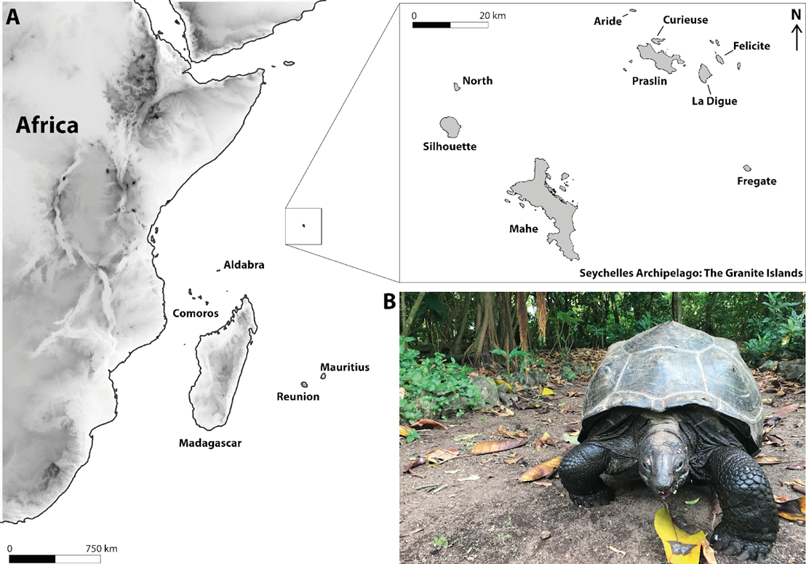

**Fig. 1. (A)** Map showing the location of Seychelles archipelago on the Western Indian Ocean and its main granitic islands, including Aride Island. (B) One of the ten reintroduced individuals of Aldabra giant tortoises (*Aldabrachelys gigantea)* on Aride Island.

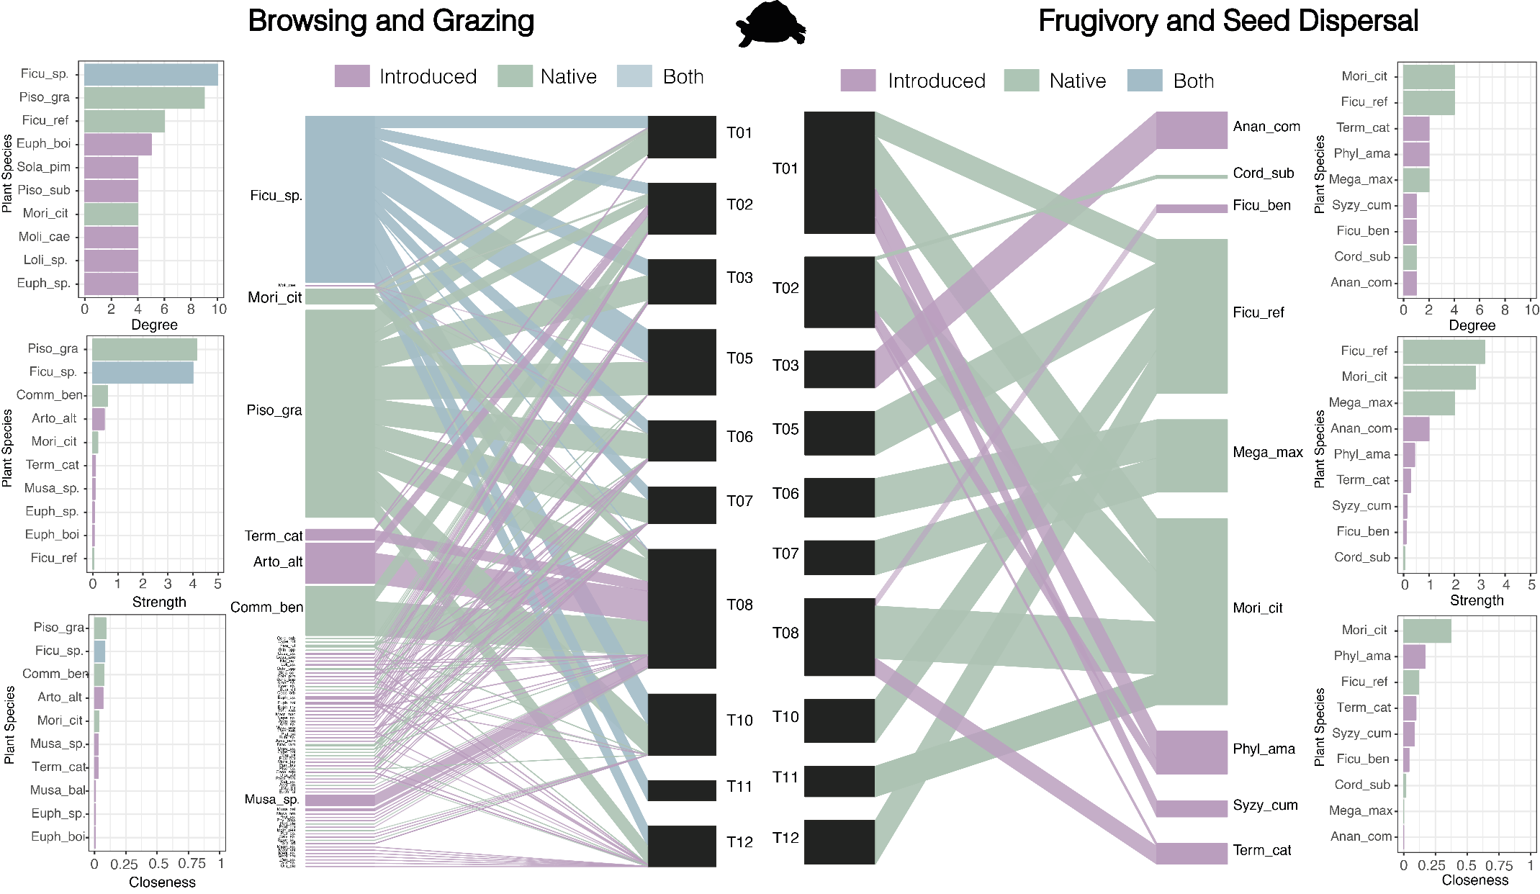**Fig. 2.** Bipartite individual-based network depicting antagonistic (browsing and grazing; left panel) and mutualistic (frugivory and seed dispersal; right panel) interactions. Black rectangles represent individual tortoises. Green rectangles represent native flora from Aride Island, purple rectangles represent introduced taxa, and blue rectangles represent genera with species that may be either native or introduced (e.g., *Ficus* spp.). Links between nodes represent interaction frequency. The lateral bar plots rank plant species by importance based on centrality metrics (i.e., degree, interaction strength, and weighted closeness) within the two distinct ecological processes mediated by Aldabra’s giant tortoises.

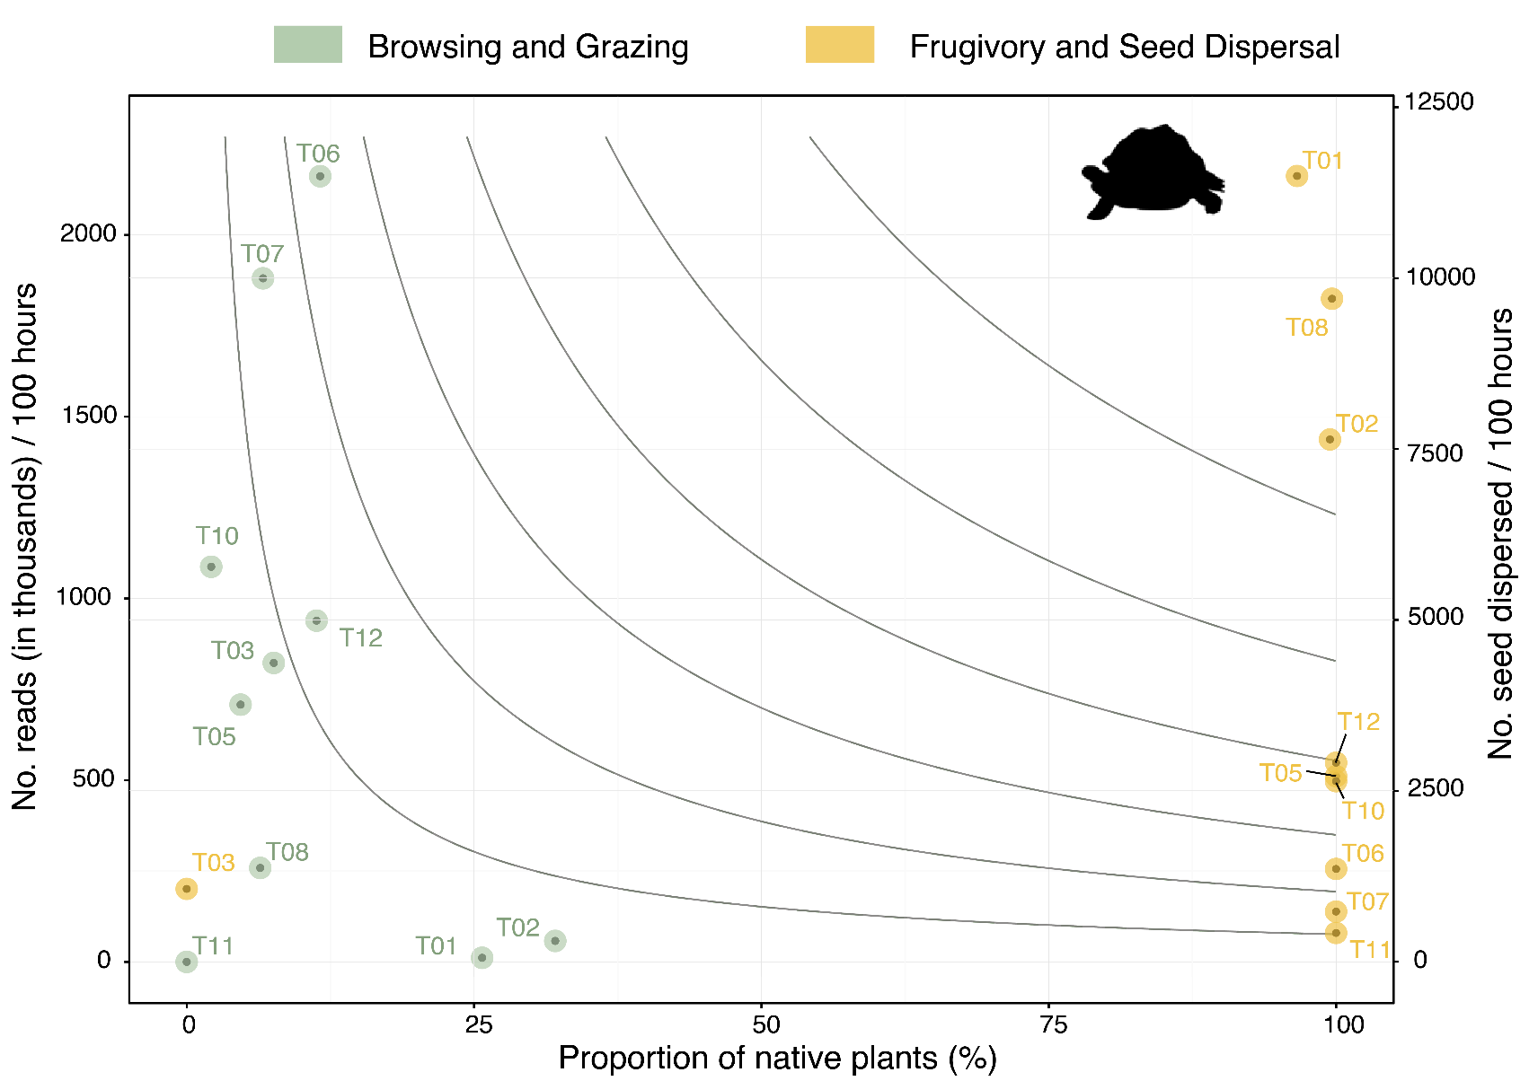

**Fig 3.**  Browsing-grazing and seed dispersal effectiveness of individual tortoises. The X-axis represents the proportion of native plants involved, reflecting the qualitative aspect of antagonistic and mutualistic interactions. The Y-axis shows the number of reads in thousands, standardised by sampling effort (antagonistic, left axis) and the number of seeds dispersed, also standardised by sampling effort (mutualistic, right axis). Isoclines connect values of quantity and quality aspect yielding the same effectiveness for both antagonistic and mutualistic processes. Green dots represent individual tortoise effectiveness in browsing and grazing, while yellow dots indicate individual tortoise effectiveness in seed dispersal.

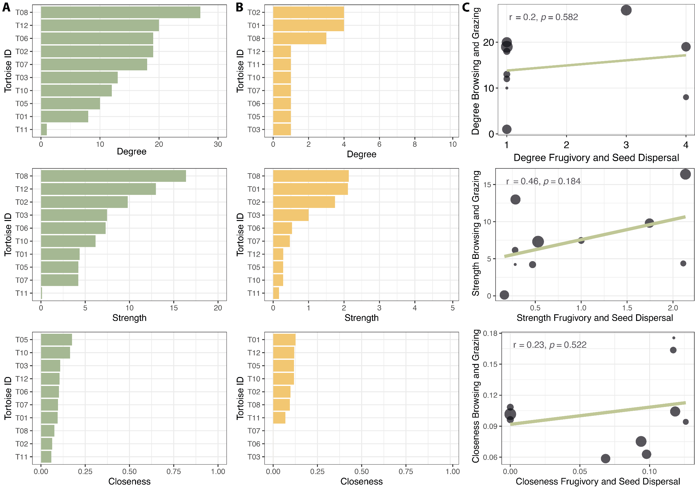

**Fig. 4.** Topological roles of individual giant tortoises based on centrality metrics. Columns show the ranking of individual tortoises based on degree, interaction strength, and weighted closeness in (A) antagonistic interactions (browsing and grazing) and (B) mutualistic interactions (frugivory and seed dispersal).

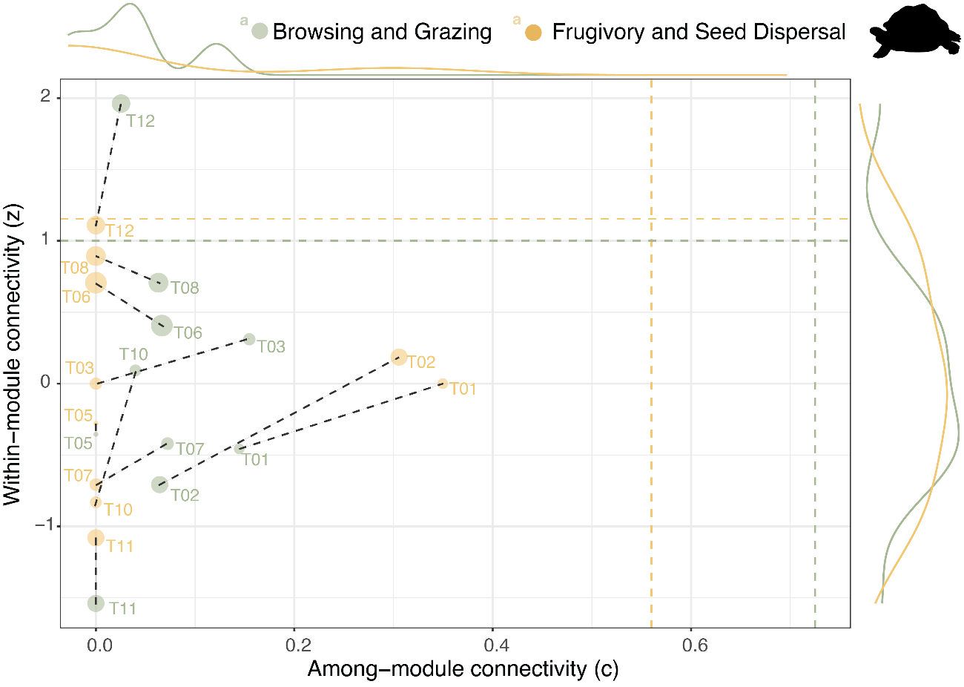**Fig. 5**. Structural roles of individual tortoises in antagonistic and mutualistic ecological networks. Among-module (c) and within-module (z) connectivity for each individual tortoise in antagonistic (browsing and grazing, green dots) and mutualistic (frugivory and seed dispersal, yellow dots) networks. Black dashed lines indicate distances between connectivity values in the two types of ecological processes. Dashed lines (vertical and horizontal) represent the 95% quantile thresholds used to define structural roles within mutualistic (yellow) and antagonistic (green) networks, respectively.