**Individual-based networks reveal turnover of individual ecological roles of giant tortoises across ecological processes with diverging outcomes.**

## Abstract.

Giant tortoises are critical to restoration projects aimed at rewiring extinct ecological interactions on defaunated tropical islands. On some remote islands, ecosystem services such as seed dispersal, browsing, grazing or detritivory depended largely on giant tortoises that got extinct after centuries of human overexploitation. In addition to these keystone species, the role and contributions of key individuals to different ecological processes remain largely underexplored. To address this gap, we combined observational and genetic techniques to analyse ecological interactions of ten recently reintroduced Aldabra giant tortoises (*Aldabrachelys gigantea*) on Aride Island (Seychelles). We evaluated the effectiveness from a reintroduction perspective based on interactions performed by individuals trough detritivory (commensalism), browsing and grazing (antagonism) and frugivory and seed dispersal (mutualism) in relation to the proportion of native and exotic plants consumed. We further assessed the individual ecological roles based topological and structural roles in individual-based networks as a proxy of individual contributions to each aforementioned ecological process. From a reintroduction perspective, individual tortoises exhibited significant differences in their effectiviness of their interactions across different ecological processes. Topological roles showed no congruence between individual-based networks, but individual tortoises exhibited consistent peripheral structural roles across ecological processes. Our study shows the rapid establishment of lost ecological interactions post-reintroduction of tortoises, while highlighting the importance of studying individual-scale variability. We argue that critical ecosystem functions in small islands may depend substantially on a small number of individuals with diverse and contrasting ecological roles, particularly in vulnerable insular ecosystems with low functional redundancy.

## Keywords.

*Aldabrachelys gigantea*, Aride Island, browsing, diet, seed dispersal, DNA metabarcoding, refaunation, trophic rewiring**.**

## Introduction.

Biodiversity is currently undergoing an unprecedented crisis worldwide, with myriads of ecosystems facing the loss of unique and irreplaceable interactions due to the rapid and increasing extinction of species (Kaiser-Bunbury et al. 2010, 2017). Islands, recognised as isolated and fragile ecological systems, are particularly sensitive to species extinction events derived from human overexploitation and their cascading effects (Hansen and Galetti 2009, Dirzo et al. 2014, Ferreiro-Arias et al. 2024). The loss of key vertebrate species in these systems can lead to disproportionate ecological disruption compared to mainland ecosystems, where functional redundancy within vertebrate assemblages (i.e., several species performing similar ecological roles) is more prevalent (Hansen and Galetti 2009, Kemp 2023).

For instance, islands that once hosted megafauna specimens have experienced anthropogenic-induced extinctions that led to the loss of key and non-redundant functional roles in ecological processes (Vidal et al. 2013, Dirzo et al. 2014, Heinen et al. 2023). Nowadays, a clear example are the islands in Seychelles and Galapagos archipelagos inhabited by giant tortoises. In such insular systems, there is a scarcity of large-bodied sized herbivores aside from giant tortoises, where they stand out as iconic embodiments of island gigantism as a result of diminished ecological pressures (Le et al. 2006, Jaffe et al. 2011, Vargas 2014) and occupy unique ecological niches as comensalists (i.e., via detritivory and litter consumption), antagonists (i.e., via browsing and grazing) and mutualists (e.g., via seed dispersal) of many plant species (Blake et al. 2012, Nogales et al. 2017).

Given their unparalleled significance as ecosystems engineers, giant tortoises gained relevance in restoration projects aimed at recovering extinct ecological interactions in defaunated insular ecosystems (Griffiths et al. 2010, 2011, Polak and Saltz 2011). This importance is exemplified by the reintroduction of Aldabra giant tortoises (*Aldabrachelys gigantea*) whose widespread distribution in the western Indian Ocean has been historically dwindled due to the overexplotation of the species by humans (Gerlach et al. 2013). The population of Aldabra giant tortoises has persisted in the wild in the Aldabra atoll (Seychelles archipelago), prompting restoration initiatives through refaunation onto other Seychelles islands, including Curieuse, Frégate, Ile du Nord, Grand Soeur, Moyenne, Cousin, Cousine and Silhouette (Gerlach et al. 2013). Interestingly, this species has been also used as a substitute for giant tortoises of the genus *Cylindraspis*, a group of five extinct species formerly distributed across the Mascarene Islands in the Indian Ocean (Austin and Arnold 2001). For instance, Mauritius islands were inhabited by *C. triserrata* and *C. inepta*, which were the largest native fruit-eaters, weighing around 100 kg. However, after its human-driven extinction, the Mauritian fruit bat (*Pteropus niger*), which weight only 0.54 kg, was the largest frugivore standing on the island (Heinen et al. 2023). This drastic extinction, representing a loss in body size of the largest frugivore by approximately 185 times, has prompted a significant ecological imbalance (Kehlmaier et al. 2019, Heinen et al. 2023) and raise the question of whether it is feasible to restore the benefits of historical tortoise-plant interactions lost due to human-driven extinctions (Hansen et al. 2010, Hansen 2015).

Nonetheless, potential drawbacks must be considered. The large size and generalist diet of these species could make tortoises significant dispersers of introduced plants, potentially threatening native species in sensitive ecosystems, counteracting the conservation objectives of introduction programs (Waibel et al. 2013). Hence, assessing the current conditions of giant tortoise’s introductions is imperative to evaluate conservation efforts that may effectively restore ecosystems processes by rewiring ecological interactions. Exploring the dietary behaviour patterns of this keystone species is fundamental in understanding their ecological roles within insular ecosystems. For instance, the feeding behaviour pattern of Aldabra giant tortoises is known to affect plant composition in Mauritius through selective browsing and grazing (Griffiths et al. 2013). In this sense, it has been suggested that the herbivory defenses in Mauritian native flora, as evolutionary adaptation to tortoise grazing, may turned non-native species more palatable due to the lack of such defenses (e.g., spines or pubescences), ultimately leading to the control of exotic plants (Griffiths et al. 2013).

However, during the last decade, assessing properly the diet of giant tortoises has been hampered by challenges in accurately discerning dietary items visually from faecal samples (Moorhouse-Gann 2017). Recent advances in DNA metabarcoding techniques provided an invaluable opportunity to delve deeper in the feeding ecology of Aldabra giant tortoises (Moorhouse-Gann 2017), but these investigations have predominantly focused on detritiviroy, browsing and grazing and neglected the exploration of ecosystem services associated with seed dispersal. Aldabra giant tortoises are able to disperse large-seeded plant species and their prolonged gut retention times may compensate for their limited movement rates (Griffiths et al. 2011, Falcón et al. 2020, 2021), providing to the ingested seeds an opportunity to escape Jazen-Connell effects (Hansen et al. 2008, Falcón et al. 2021). Nevertheless, on some islands within Seychelles archipelago, Aldabra giant tortoise populations are small (Gerlach et al. 2013), meaning that key ecosystem services, such as seed dispersal, browsing and grazing, are sustained by few individuals. Moreover, Aldabra giant tortoises showed variability in diet among individuals which have been related to individual habitat preferences and body size (Pemberton and Gilchrist 2009, Moorhouse-Gann 2017). These differences in individual preferences in diet may ultimately lead to fluctuations in their effectiveness as detritivores, seed dispersers and/or browsers-grazers, likely influencing ecological processes when population size is small. Yet, there is a gap in the scientific literature regarding the relative contribution and importance of different individuals to different ecological services.

To address this research gap, we studied contributions and ecological roles of different individuals of Aldrabra giant tortoises in three main ecosystem services performed on Aride Island, where ten giant tortoises were reintroduced in 2018. This island renders a interesting landscape to study individual ecological roles of giant tortoises as it hosts a simplified frugivore assemblage, including the fruit bat *Pteropus seychellensis* (0.49 kg) and 3 bird species like *Alectroenas pulcherrimus* (0.17 kg), *Nesoenas picturata* (0.17 kg), and *Foudia madagascariensis* (0.017 kg) while it is estimated that 80% to 90% of Seychelles’ native woody plants species are dispersed by frugivores, a similar percentage to those found for woody floras of Neotropical rainforests (Jordano 2000, Küffer Schumacher 2006). Hence, reintroduced individuals of *Aldabrachelys gigantea* on Aride Island fulfil a non-redundant and pivoral ecological role as the largest frugivore capable of dispersing large seeds and the sole browser-grazer on the island. Furthermore, Aldraba giant tortoises are highly important for favouring nutrient cycling, as they are able to consume a large amount of litter biomass that otherwise is only processed by detritivores such as giant millipedes (*Sechelleptus seychellarum*) and other small arthopods (Lawrence and Samways 2003, Falcón and Hansen 2018). Yet, nutrient cycling and transport functions of giant tortoises on Seychelles islands are expected to match those of large mammals in continental ecosystems while providing an essential contribution of organic and inorganic nutrients to the highly infertile soils of granitic islands with low concentrations of K, P, N, Ca and Mg (Küffer Schumacher 2006, Falcón and Hansen 2018).

Consequently, the historical backdrop of commercial exploitation and coppicing with introduced flora on some Seychelles islands, such as Aride, highlights the urgent need for studying the role of reintroduced Aldabra giant tortoises in restoring ecosystem services through the establishment of lost ecological interactions with both native and introduced plants. Despite Aride’s designation as a Special Reserve in 1975, remnants of these introduced plants persist, offering a unique opportunity to observe the initial stages of tortoise reintroduction on ecosystem dynamics. By integrating field observations, faeces examination, and DNA metabarcoding, this study aims to better inform evidence-based conservation and restoration strategies by: 1) characterising the novel establishment of antagonistic and mutualistic interactions between the Aride Island flora and reintroduced tortoises; 2) exploring the effectiveness role of individual tortoises as detritivores, browsers and grazers and dispersers of exotic and native flora; and 3) describing the differential contributions of individuals in three different ecological processes with diverging outcomes for plant species.

## Material and Methods.

### Study area.

Ten Aldabra giant tortoises (*Aldabrachelys gigantea*) were translocated from the close-by Fregate Island to Aride Island in 2018. Aride Island (4°12'48"S, 55°39'57"E), situated as the northernmost granitic island of the Seychelles archipelago, spans approximately 0.71 km2, reaching 135 meters above sea level (Fig. 1A). Along its southern shoreline lies a 0.07 km2 flat, low-lying plateau. In contrast, the northern section of the island rises abruptly beyond the plateau, with hills ascending to towering cliffs, accentuating a pronounced difference in topography among sections. Up to 154 flora species have been historically recorded at least once on Aride Island, including both introduced and native plants (Table S1) (Castle and Mileto 1994, Hansen and Laboudallon 2016). On the basis of the historical records, introduced plant species may represent approximately 48% of the species present on Aride Island, while native species include two endemics to the Seychelles archipelago (*Pandanus balfourii*) and Aride Island (*Rothmannia annae*). The majority of the island's woodlands consists of the native species *Pisonia grandis* and *Ficus reflexa* (García-Peña pers. obs.). Additionally, two other species of *Ficus* are present: *F. lutea* (native) and *F. benghalensis* (introduced), each represented by a single individual on the island (García-Peña pers. obs.).

### Plant reference collection.

We delineated convex polygons using GPS locations from focal observations of individual tortoises as vertices, spanning tortoises feeding areas (Fig. S1). To estimate the plant species available to the tortoises, we conducted collection surveys along these individual feeding areas. We built a reference collection by collecting and identifying tissue samples from each recorded plant species, storing them in bags with silica gel to keep them dry. For each plant species recorded, we gathered information on their distribution range from the Plants of the World Online Database (POWO 2024) to classify each species as either native or introduced to Aride Island. DNA extraction from all plant species found within tortoise feeding areas was performed following the protocol for the DNeasy Plant Mini Kit (Qiagen, Manchester, UK). We performed a Polymerase Chain Reaction (hereafter, PCR) to amplify the second internal transcribed spacer (ITS-2, 160-320 bp) of nuclear ribosomal DNA, which has been proposed as a useful DNA barcoding region for identifying plant species in dietary studies (Chen et al. 2010, Yao et al. 2010, Hollingsworth 2011, Moorhouse-Gann 2017).

In particular, primers UniPlantF (5′-TGTGAATTGCARRATYCMG-3′) and UniplantR (5′-CCCGHYTGAYYTGRGGTCDC-3′) were used for ITS-2 sequencing (Moorhouse-Gann *et al.,* 2018). PCR conditions were as follow: 24 μl of total reaction volume which included 2,5 μl 10X Buffer, 1,4 μl of MgCl2 50mM, 1,6 μl of dNTP’S 2,5mM, 0,5 μl of each primer, 0,3 μl of Taq DNA Polymerase 5U/μl, 1 μl BSA 1mg/μl and 16,2 μl of Milli-Q purified water plus 1 μl of extracted DNA product from each sample. PCR cycling conditions were: initial denaturation at 94ºC for 2 minutes, 40 cycles of 94ºC for 1 minute, 56ºC and 72ºC for 1 minute, a final extension of 72ºC for 10 minutes and an ending base temperature of 4ºC. The results were verified in a 1% agarose gel electrophoresis with SYBR Safe Gel stain for visualization of DNA. For samples that did not amplify, the PCR was repeated testing temperature ranges between 48ºC to 56ºC, including 2 μl of extracted DNA product and removing 1 μl from the 24 μl mix. Verified PCR products were sequenced in both directions by Macrogen (MACROGEN Inc., Madrid, Spain). ITS-2 sequences from the species collected in the field were edited with Geneious (Geneious Prime) and subsequently contrasted with GenBank reference database using a BLASTn search (Altschul et al. 1990) in order to determine nucleotide differences within each species. Subsequently, a multiple alignment was performed for our sequences and those of the same species deposited in GenBank.

### Interaction data collection.

Six months after the release, all tortoises were monitored daily from early February to late March in 2019, matching with the fruit production period of ca. 80% of the plant species occurring on Aride island (Table S2). During this period, we carried out daily focal observations of each individual tortoise for 30 minutes, contingent upon the feasibility of locating them. In each focal observation, we recorded the GPS location and feeding behaviour of each individual, including the identification of plant species and the specific parts consumed (e.g., fallen leaves, fresh leaves from plants, fruits…), thus characterising each interaction as antagonistic (i.e., browsing and grazing), mutualistic (i.e., frugivory and seed dispersal) or commensalism (i.e., detritivory).  When available during focal observations, we collected faeces from the tortoises, safely identifying each scat with the corresponding individual. A total of three dung piles per individual were retrieved, with each scat stored in an individual zip-lock bag duly labelled. Scats collected were placed on aluminium baking trays and undigested macroscopic material such as fruits parts and large visible seeds were manually extracted. Seeds were counted using a magnifier and identified visually at species level using local flora field guides (Castle and Mileto 1994, Hansen and Laboudallon 2016). All the seeds extracted from faeces were separated in order to count the total number of seeds per plant species.

The remaining organic matter corresponding to leaves and grasses that could not be identified *in-situ* was dried and stored in a zip-lock bag with silica gel for posterior analysis in the laboratory. In order to avoid exchange of plant material and, thus, cross-contamination between samples, all the instruments were washed, rinsed and dried. Once completely dry, each sample was ground, mixed, and homogenised using a Moulinex Multimoulinette chopper. To extract DNA for metabarcoding analyses, 180 mg of each sample was used following the QIAmp Fast DNA Stool Mini Kit protocol (Qiagen, Manchester, UK). We took three replicates per sample, resulting in a total of 90 replicates from which DNA was extracted and sequenced. Subsequently, we carried out an agarose gel electrophoresis to verify that the resulting extractions had enough DNA content. DNA concentration was measured using a Qubit Flourometer (Mardis & McCombie, 2017). DNA metabacording analyses from faecal samples were performed by the Exeter Sequencing Service (Exeter, United Kingdom), where 90 Amplicon libraries (ITS-2) and a unique MID-tag combination were created for each sample, allowing us tracing back not only DNA sequences, but also individual faecal samples. To ensure that samples were suitable for sequencing and to minimise errors during the sequencing process, a pool quality control (QC) was performed. Each library was then sequenced separately using 300 bp paired end reads on an Illumina HIseq 2500 rapid run (Illumina, San Diego, CA). To this end, we used the UniPlantF and UniplantR primers previously described (Moorhouse-Gann et al. 2018). All ITS-2 sequences were trimmed using Cutadapt (Martin 2011) to remove low quality sequences, and a second round of trimming removed PCR primers (for amplifying ITS-2). A total of 215,792 sequences containing the ITS-2 spacer from *Streptophyta* were downloaded from the NCBI Nucleotide Database and used to create a library for use in the QIIME2 platform (Bolyen et al. 2019). Paired-end sequences were imported into QIIME2 and denoised using the DADA2 plugin (Callahan et al. 2016). Samples with fewer than 500 assembled reads after denoising were excluded from these analyses.

### Data analysis.

First, we assessed sampling completeness by building up accumulation curves of distinct pairwise interaction in relation to the number of individuals and sampling effort for each type of interaction (Jordano 2016). Subsequently, we constructed three individual-based interaction matrices to represent three distinct ecological processes mediated by the ten individual tortoises: an commensalism matrix based on interactions derived from detritivory, an antagonistic matrix based on interactions derived from browsing and grazing, and a mutualistic one based on interactions derived from frugivory and seed dispersal. For the commensalism and antagonistic interaction matrices, we used focal observation data on feeding events involving detritivory and browsing and grazing respectively, supplemented by DNA metabarcoding data from faecal samples containing grass and leaf remains. For the commensalism matrix, we filtered metabarcoding reads corresponding to woody plants whose branch and leaf heights prevent tortoises from browsing their foliage, leaving them accessible only for consumption on the ground through detritivory. For the mutualistic interaction matrix, we used focal observation data on foraging events involving fruit ingestion, along with counts of seeds found in tortoise scats. To build each ecological interaction matrix, we applied a data-merging approach that integrates and maximizes the complementarity of different sampling techniques when recording ecological interactions. Merging data from multiple sampling techniques has been shown to yield a net increase in detected interactions and provide a more comprehensive characterisation of ecological networks, resulting in more robust network descriptors (Quintero et al. 2022). For the antagonistic matrix, we merged the frequency of feeding events obtained during focal observations and the abundance of reads from the metabarcoding analysis. Read abundance has been shown to correlate positively with herbivore consumption rates (Kartzinel et al. 2015) and was calculated based on the mean frequency of sequence count of an item (i.e., plant species) across the three replicates obtained from tortoise scats (Deagle et al. 2018). For the mutualistic matrix, we standardised by sampling effort the frequency of frugivory feeding events from focal observations and the frequency of seeds found in the faeces of each individual tortoise. Accordingly, we applied a quantitative combination and a sampling effort standardisation (SES) by controlling differences in the sampling effort associated to each individual tortoise (Quintero et al. 2022).

Once the matrices were constructed, we build-up ecological networks and assessed the importance of different plant species in the diet of individual tortoises using node centrality metrics. Plant importance was defined based on three metrics: degree (i.e., the total number of unique links of a plant species has with individual tortoises), interaction strength (i.e., the frequency of interactions between a plant species and individual tortoises), and weighted closeness (i.e, how accessible or central a plant species is to all individual tortoises in the network, considering the interaction weights) (Delmas et al. 2019). Subsequently, we used our plant reference collection (see *Plant reference collection* section) to classify each plant species as native or introduced and to generate a ranking of plant species for each ecological process.

To define the ecological role and the contribution of individual tortoises in ecological processes, we applied three complementary approaches. First, we assessed their effectiveness from a reintroduction program perspective as detritivores, browsers-grazers and as seed dispersers by considering the seed dispersal effectiveness (SDE) framework (Schupp et al. 2010) using the R package “*effect.lndscp*” (Jordano and Rodriguez-Sanchez 2024). From a reintroduction and rewiring of ecological interactions perspective, optimal effectiveness would be achieved by tortoises that disperse a high number of native seeds (i.e., high values for both quantitative and qualitative components) while predominantly browsing and grazing on exotic flora (i.e., high quantitative values but lower qualitative values) (Waibel et al. 2013). For detritivory, optimal effectiveness would involve high values of the quantitative component, while from a qualitative perspective, both native and introduced plants could be beneficial. Detritivory of native litter accelerates nutrient cycling due to their slow decomposition rates, whereas detritivory of introduced plants may help to avoid nutrient turnover caused by exotic flora (Küffer Schumacher 2006). The quantitative component for seed dispersal was characterised by the standardised number of seeds dispersed. For browsing and grazing and detritivory effectiveness, we used the standardised abundance of reads from DNA metabarcoding, while the qualitative component for all processes was evaluated based on the proportion of native flora in standardized read abundance or number of seeds dispersed.

To evaluate the contribution of individuals to both ecological processes, we assessed the topological role of individual using centrality metrics analogous to how we assessed the importance of different plant species in the tortoises' diets (i.e., normalised degree, interaction strength and weighted closeness) (Delmas et al. 2019). Subsequently, we explored shifts in topological roles by calculating Pearson correlation coefficients (*r*) among normalised degree, interaction strength and weigthed clossedes of individual tortoises obtained from each individual-based network. The structural role was evaluated through a modularity analysis of the ecological networks (Delmas et al. 2019). Modularity (*Q*) in interaction networks is defined as a measure of the extent to which a network is divided into distinct modules or communities (Olesen et al. 2007). In this sense, each individual tortoise and plant species within a module would have more frequent interactions to each other than to individual and plant species in other modules. We separately estimated modularity values for each individual-based ecological network and tested whether these deviated from expected by chance using 1000 randomizations using null models with the *Vaznull* algorithm and then calculating *z-scores* (Vázquez et al. 2007). After estimating modularity, we defined the structural roles of individual tortoises by calculating their within-module connectivity (*z*) and among-module connectivity (*c*) (Olesen et al. 2007). High *z* values indicate tortoises that are well-connected within their module, acting as central hubs within a specific subgroup of plant interactions. High *c* values, on the other hand, identify tortoises that connect across multiple modules, linking different plant groups and acting as "connectors" within the entire network. Using the 95th percentiles of z and c values from the 1000 randomised networks as thresholds, we classified tortoises into structural roles: peripheral (low *z* and *c* values); network hub (high *z* and *c* values); module hub (high *z*, low *c*); and network connector (high *c*, low *z*) (Olesen et al. 2007). To assess whether individual tortoises retained their structural roles across ecological processes, we calculated the proportion of individuals classified as peripheral, module hubs, network hubs, or network connectors in a given individual-based network that received different structural role classifications in the rest. We further evaluated shifts in connectivity among and within modules values of individual tortoises by calculating Pearson correlation coefficients (*r*) among different ecological processes. All network analyses and visualization were carried out in R Statistical Software v. 4.2.2 (R Core Team 2023)  using “*bipartite*” (Dormann et al. 2008) and “*ggplot2*” packages (Dormann et al., 2008), respectively,

## Results.

### Plant reference collection.

A total of 51 different plant species were collected on tortoises feeding areas (Table S3). Of these, 53% (n=27) were introduced plant species, while 47% (n=24) were native, including two endemic plants: *Pandanus balfourii* and *Rothmannia annae*. Among the 51 identified species, sequencing of the ITS-2 region was successfully accomplished for 31 species (ca. 61%). Sequences retrieved from GenBank database yielded 44 sequences of the nr ITS-2, while sequences for the remaining seven species were not found in GenBank database neither successfully sequenced by us (Table S3). The ITS-2 sequences obtained from plant species occurring within the feeding tortoise area matched those ITS-2 sequences obtained from GenBank, thus indicating full congruence, i.e., species from GenBank correspond with those identified in the out study (Table S3).

### DNA metabarcoding of plant material.

For the identification of plant species using DNA metabarcoding of scats, 90 DNA extractions (i.e., 3 replicates per scat) were performed, of which only 85 had sufficient quality for sequencing, and six did not yield results after analysis. As a result, DNA metabarcoding unveiled 98 distinct taxa, encompassing a cumulative count of 8,992,243 sequencing reads across all samples. Among these taxa we identified 45 introduced plant taxa, 14 native species, 16 human food leftovers (which were excluded from subsequent analyses), and one bryophyte (*Macrothamnium macrocarpum*). Among the taxa identified at the genus level (7,548,053 reads), the vast majority (97%) corresponded to the genus *Ficus* (7,317,486 reads), representing 81.4% of the total sequencing reads.

### Scats examination and seeds dispersed.

We found a total of 11,248 seeds (mean ± SD per scat: 375 ± 609, min: 0; max=2599) in 20 tortoise scats, while the 10 remaining scats had no seeds. The mean (± SD) percentage of species richness of native and introduced plants consumed by tortoises was 73.3% and 26.7% (± 37), respectively. However, in terms of the total number of seeds consumed, introduced species accounted for only 10.5% (± 31.5), whereas native species comprised approximately 90% (± 31.5) of the seeds consumed. *Morinda citrifolia* was by far the species with the highest number of seeds found in tortoise feaces (9063, nscats=11), followed by *Ficus reflexa* (1732, nscats= 5) and *Megathyrsus maximus* (249, nscats= 3), all native species.

### Tortoise-plant interaction networks.

Interaction accumulation curves for detritivory reached an asymptote in both number of individuals sampled and sampling effort in hours (Fig. S2). Based on focal observations and metabarcoding, tortoises fed mostly on fallen leaves of 6 woody plant species: *Ficus cf. reflexa, Morinda citrifolia, Pisonia grandis, Terminalia cattappa, Artocarpus altilis* and *Euphorbia pyrifolia*. Based on node centrality metrics, *Ficus cf. reflexa* has been the only plant species consumed by all 10 tortoise individuals, followed by *Pisonia grandis*, both native species that accounted for the highest values of interaction strength and weighted closeness. Almost half of individuals fed on litter from two exotic species, *T. cattappa* and *A. altilis*, but showed low levels of interaction strength and weigthed closeness (Fig. 2A).

Accumulation curves of distinct pairwise interactions relative to browsing and grazing displayed a growing trend approaching an asymptote it in both number of individuals sampled and sampling effort in hours (Fig. S2). We found that tortoises browse and graze in 54 plants, with a greater number of exotic fora species compared to native specimens. The five most significant species, based on degree centrality, were all introduced species including *Euphorbia* *sp.*, *Asystasia gangetica,* *Lolium sp*., *Solanum pimpinellifolium* and *Amaranthus sp*., with *Asystasia gangetica* exhibiting the highest interaction strength values. Notably, we found that plant species browsed and grazed by giant tortoises showed extremely low values of weighted closeness (Fig. 2B).

The accumulation curves of interactions of frugivory and seed dispersal nearly reach an asymptote, both in the number of individuals sampled and in the number of hours of sampling (Fig. S2). Based on node centrality metrics, *Morinda citrifolia* exhibited the highest values for degree and closeness, as well as the second highest for interaction strength. *Ficus reflexa* shared the highest degree value but showed greater interaction strength despite lower levels of weighted closeness compared to *Morinda citrifolia*. Several introduced plant species (e.g., *Terminalia catappa, Ananas comosus,* and *Ficus benghalensis*) displayed a degree lower than 2, indicating interactions with only 2 individuals or fewer, alongside low levels of interaction strength and/or weighted closeness (Fig. 2A)

### Efectiveness of reintroduced tortoises.

We found that tortoises individuals exhibited marked differences in the observed frequencies of feeding events related to detritivory, browsing-grazing, and frugivory (Fig. 3A). Most of the tortoises exhibited high qualitative values in their detritivory roles, while six individuals showed elevated quantitative values. Only one individual, T08, displayed intermediate values for both quantitative and qualitative aspects, indicating it acts as a detritivore on both exotic and native litter equally (Fig. 3C). Regarding browsing and grazing, half of the tortoises acted as antagonists of exotic plants, while the other half exhibited high quantitative values and intermediate qualitative values, indicating that they forage proportionately between exotic and native species (Fig. 3D).In contrast, the vast majority of the tortoises dispersed seeds from native plants, but only three individuals displayed high quantitative values (Fig.3E). Notable variation was observed in the effectiveness of individual tortoises across different ecological processes. Some individuals exhibited high effectiveness across all three processes, others showed high effectiveness in at least one ecological process, and some displayed low effectiveness in all three. For instance, T03 demonstrated high effectiveness as a detritivore of native litter and as a browser-grazer of exotic flora but had low effectiveness in seed dispersal, with most seeds dispersed belonging to exotic flora. On the other hand, T08 showed high effectiveness in browsing-grazing exotic flora, dispersing a high number of native seeds, and consuming equally large amount of litter from both exotic and native species. Lastly, T11 exhibited low effectiveness in detritivory, browsing and grazing exotic flora, and seed dispersal of native species.

### Topological and structural roles of tortoises.

Overall, individuals of giant tortoises did not maintain their topological roles in the three individual-based networks. We did not found consistent significant relationships between the normalized degree, interaction strength and weighted closeness of same individuals in the three different ecological processes (Figure 4). We only found positive significant relationships among the weighted closeness of individuals in detritivory and frugivory and browsing and grazing, and among the normalized degree of individuals in detritivory and frugivory and seed dispersal (Figure 4). All individual-based networks showed modular patterns that deviate from random: the detritivory interaction network showed a higher modularity (Q observed: 0.3, Q expected: 0.13 , Z-score: 8.88) with 4 modules (Fig. S3); browsing-grazing interaction network showed lower modularity (Q observed: 0.34, Q expected: 0.44, Z-score: -8.38), forming five modules (Fig. S3) and frugivory and seed dispersal interaction network exhibited a higher modular structure (Q observed: 0.44, Q expected: 0.16, Z-score: 3.88), with four modules (Fig. S3), than expected by chance. Individual tortoises generally showed low among-module connectivity (c) and within-module connectivity (z) in all ecological processes, thus exhibiting mostly peripheral roles in all ecological processes (Fig. 5A). Only one tortoise (T06) exhibited a module-hub role in browsing and grazing ecological network. (Fig. 5A). Thus, 90% of individuals retained their peripheral structural role across all individual-based networks and only one individual switch its structural role (Fig. 5A). Further, no significant correlation was found among-module connectivity (c) and within-module connectivity (z) values of individual tortoises across different ecological processes, indicating that individuals mantain they structural role but individual connectivity values are not related among individual-based networks (Fig. 5B).

## Discussion.

Our study highlights the pivotal importance of restoring lost ecological interactions through the reintroduction of a keystone species, the Aldabra giant tortoise (*Aldabrachelys gigantea*), into the insular ecosystem of the Seychelles archipelago. Based on data collected from ten individuals, representing the entire Aldabra giant tortoise population on Aride Island after reintrodution, this conservation initiative facilitated the rapid establishment of ecological interactions likely absent since their extinction around 1840 (Gerlach et al. 2013). Using a multifaceted approach that combines observational and genetic methodologies, alongside an individual-based network analysis of three different and contrasting ecological processes, we found that different tortoise individuals exhibit varying roles and performance as detritivores, browser-grazers and seed dispersers, a variation that has direct implications for the seed dispersal of native plants and the control of exotic flora on Aride island.

### Sampling ecological interactions performed by Aldabra giant tortoises.

Our methodology, which integrates complementary sampling techniques for ecological interactions (i.e. focal observations, faecal examination, and DNA metabarcoding), has led to a net increase in detected interactions that would otherwise have remained unrecorded (Jordano 2016, Quintero et al. 2022). Although our study is constrained by the limited number of reintroduced individuals, the interaction accumulation curves showed a stable trend closely approaching an asymptote indicating a relative complete sampling of ecological interactions for all ecological processes (Jordano 2016) and potentially indicating that the reintroduction of ten individuals redeemed ecological interaction credit in such small island (Genes et al. 2017).

Notably, our data collection approach involving different sampling techniques helped us to mitigate some biases that may arise from single data gathering strategy of ecological interactions (Quintero et al. 2022). Nonetheless, we must acknowledge several methodological considerations, particularly regarding DNA metabarcoding. For detritivory and browsing-grazing interactions, we used DNA metabarcoding and read abundance obtained from faecal material as a proxy of plant material consumption. The use of metabarcoding for quantifying interactions has sparked debate, as using sequence counts (i.e., reads) as proxies for consumption rates is contentious (Deagle et al. 2018, Cuff et al. 2022). For instance, accurately obtaining a biomass signature from sequence counts is fraught with technical and biological biases that influence barcode marker recovery rates across different taxa. Deagle et al. (2018) suggested that relative read abundance could offer a weighting of food present in a sample based on biomass compared to other metrics, yet the differential recovery of markers —especially from dominant food taxa— may impact data interpretations. However, studies employing read abundance based on metabarcoding in herbivores have shown a strong positive correlation between grass read abundance and isotopic estimates of grass consumption, indicating that RRA conveys reliable quantitative information about herbivory dietary intake that, otherwise, could not be obtained (Kartzinel et al. 2015).

Additionally, the completeness of reference databases is a significant challenge in metabarcoding and other DNA-based studies aimed at achieving taxonomic resolution (Cuff et al. 2022). This resolution is crucial as even minor discrepancies can profoundly influence network structure, leading to alterations in network metrics and reducing inter-network comparability. The assembly of comprehensive reference databases, particularly in regions with poorly characterised or hyper-diverse flora and fauna such as those from tropical settings, is often a laborious and costly endeavour (Gonzalez et al. 2009) and may ultimately result in inadequate characterisation of the taxa consumed by local species. However, the established of a plant reference collection from individual tortoise feeding areas helped us to ensure that plant species detected through DNA metabarcoding were indeed available for the tortoises.

### Benefits of restored tortoise-plant interactions.

Based on our results, we emphasise the role of Aldabra giant tortoises as a keystone species within insular ecosystems, highlighting their multitasking function as detritivores, browsers and grazers, as well as seed dispersers. Large chelonians, such as *Aldabrachelys gigantea*, significantly can influence largely population phytodynamics trough seed dispersal processes (Falcón et al. 2020). From a plant's perspective, tortoise dung piles may provide ingested seeds with a favourable microhabitat, offering the moisture and nutrients necessary for seedling establishment far away from maternal plants (Hansen et al. 2008, Falcón et al. 2020, 2021). Our results indicated that the tortoises disperse a large number of native seeds compared to exotic seeds, while interacting antagonistically with a wide variety of exotic species, which is in line with previous studies indicating that tortoise are able to downsize considerably the vegetation cover, height and seed production of non-native plants via antagonistic interactions (Griffiths et al. 2013). Hence, we add evidence to the fact that the restoration of ecological interactions is a more cost-effective approach to controlling non-native vegetation than other methods involving mechanical removal (Griffiths et al. 2013). Moreover, our findings further highlight the role of giant tortoises as detritivores, with the majority of individuals foraging predominantly in the leaf litter of native species. The prominence of *Ficus reflexa* and *Pisonia grandis* as key species in detritivory networks may be closely tied to their abundant availability, as these species dominate much of the island's vegetation (García-Peña, pers. obs.). The detritivorous activity of the tortoises could enhance nutrient cycling by accelerating the slow decomposition of litter from dominant native species and facilitating nutrient transport across different areas of the island (Küffer Schumacher 2006, Falcón and Hansen 2018). Conversely, the observation that only three individuals, with just one maintaining a strong interaction with *Artocarpus altilis*, sporadically forage in the litter of exotic species suggests that giant tortoises may not favour the detritivory of non-native plants. Nevertheless, further research is required to understand the tortoises’ litter selectivity and how detritivory involving both native and exotic species might influence nutrient turnover and cycling dynamics.

### Differential contribution of individuals to ecological processes.

For the first time, our study addresses the inherent variability among giant tortoise individuals in performing different ecological roles. Our findings illustrate that, although this species is crucial for diverse ecological processes, it is essential to consider how individual differences may influence their effectiveness in their ecological roles. As keystone species can perform multiple ecological functions (Timóteo et al. 2023), one might also ask: do individuals exhibit multitasking capabilities? Our findings suggest that the contributions of tortoises to detritivory, browsing-grazing and seed dispersal effectiveness can vary significantly from individual to individual, particularly when viewed through the lens of rewiring ecological interactions and managing exotic and invasive species in insular ecosystems. Yet, we found that some individuals may be highly effective for all ecological processes. The reintroduction of diverse individuals into a given habitat can yield equally beneficial outcomes concerning the control of exotic species through antagonistic interactions and the dispersal of native plants via mutualistic relationships (Waibel et al. 2013, Hansen 2015, Falcón et al. 2020). However, our results showed a trend in which the majority of reintroduced individuals performed more effectively as seed dispersers for native plants than as browser-grazers of exotic plants.

These variations are also intrinsically linked to the topological roles of individual tortoises as assessed by centrality metrics in individual-based ecological networks. Topological roles within mutualistic ecological networks are closely linked to species' contributions to seed dispersal, indicating that those most significant from a topological perspective were also key contributors to seed dispersal processes (Acevedo-Quintero et al. 2020). The lack of congruence observed between the degree, interaction strength, and weighted closeness among suggests individual topological differences across mutualistic and antagonistic ecological networks, meaning that different individuals of tortoises may have different relative importance in contrasting ecological processes. This finding underscores the potential for some individuals to contribute disproportionately to certain functions while being less effective in others, which may have implications for the robustness of ecological networks (Ramos-Jiliberto et al. 2012, Domínguez-García and Kéfi 2024), as the disappearance of an individual could significantly impact one ecological process while having little effect on another.

Nevertheless, despite this switch in topological roles, our analysis of the structural roles of individuals within both browsing-grazing and seed dispersal networks indicates a tendency for individual tortoises to maintain their peripheral structural roles across different ecological processes. This stability is pivotal, as the modularity of ecological networks is associated with increased robustness to external perturbations (Olesen et al. 2007, Delmas et al. 2019). By limiting the propagation of disturbances —such as species extinction or, in our case study, the removal of a single individual— modular networks help maintain the integrity of ecological processes. Moreover, the robustness of mutualistic-antagonistic tripartite networks has been intrinsically related to the robustness of the two bipartite networks composing them (Domínguez-García and Kéfi 2024). The observation that a single individual may fulfil similar structural roles in different ecological processes may carry significant ecological implications, especially for those processes governed by keystone species with small population sizes such as Aldabra giant tortoises in Aride Island. For instance, individuals with relevant structural roles (such as network connectors or network hubs) within different ecological processes, may hold disproportionate ecological importance, as their loss can trigger the propagation of perturbations across multiple and diverging ecological processes driven by keystone species with small population size.

## Conclusions.

Our findings highlight the importance of individual-scale ecological processes, which, when examined at the community level (i.e., species-based networks), reveal structural nuances that would otherwise be overlooked (Guimarães 2020). Ultimately, the persistence of key ecological functions on small islands may rely heavily on a select few individuals (i.e., keystone individuals) (Modlmeier et al. 2014), underscoring the critical need for conservation and research efforts to focus on the roles of individual organisms in maintaining the balance of ecological processes. Given the variability in the relative importance of different individuals when examining ecosystem services and in an analogous way to the concept of effective population size for maintaining genetic viability (Lande and Barrowclough 1987), ecologists should start to conceptualise the effective number of individuals necessary to sustain ecological processes. To ensure the integrity of ecological processes, the effective number should reflect individual variability in ecological roles and help establish a minimum population size that accounts for the diverse contributions of each individual. Thus, understanding the distribution and identity of these key individuals within populations may be crucial for effective conservation strategies aimed at restoring ecological integrity, such as reintroduction programs of Aldabra giant tortoises across various islands in the Seychelles archipelago. Yet, future studies involving a greater number of individuals, extended sampling periods accounting for plant phenology, and a multilayer network approach could yield further robust insights into the ecological roles of individual tortoises in larger populations and different ecological process, as well as the underlying drivers of ecological role shifts.

## References.

Acevedo-Quintero, J. F., Zamora-Abrego, J. G. and García, D. 2020. From structure to function in mutualistic interaction networks: Topologically important frugivores have greater potential as seed dispersers. - Journal of Animal Ecology 89: 2181–2191.

Altschul, S. F., Gish, W., Miller, W., Myers, E. W. and Lipman, D. J. 1990. Basic local alignment search tool. - Journal of Molecular Biology 215: 403–410.

Austin, J. J. and Arnold, E. N. 2001. Ancient mitochondrial DNA and morphology elucidate an extinct island radiation of Indian Ocean giant tortoises (Cylindraspis). - Proceedings of the Royal Society of London. Series B: Biological Sciences 268: 2515–2523.

Blake, S., Wikelski, M., Cabrera, F., Guezou, A., Silva, M., Sadeghayobi, E., Yackulic, C. B. and Jaramillo, P. 2012. Seed dispersal by Galápagos tortoises. - Journal of Biogeography 39: 1961–1972.

Bolyen, E., Rideout, J. R., Dillon, M. R., Bokulich, N. A., Caporaso, J. G., et al. 2019. Reproducible, interactive, scalable and extensible microbiome data science using QIIME 2. - Nat Biotechnol 37: 852–857.

Callahan, B. J., McMurdie, P. J., Rosen, M. J., Han, A. W., Johnson, A. J. A. and Holmes, S. P. 2016. DADA2: High-resolution sample inference from Illumina amplicon data. - Nat Methods 13: 581–583.

Castle, G. E. and Mileto, R. 1994. Flora of Aride Island, Seychelles. - ECO TECH.

Chen, S., Yao, H., Han, J., Liu, C., Song, J., Shi, L., Zhu, Y., Ma, X., Gao, T., Pang, X., Luo, K., Li, Y., Li, X., Jia, X., Lin, Y. and Leon, C. 2010. Validation of the ITS2 Region as a Novel DNA Barcode for Identifying Medicinal Plant Species. - PLOS ONE 5: e8613.

Cuff, J. P., Windsor, F. M., Tercel, M. P. T. G., Kitson, J. J. N. and Evans, D. M. 2022. Overcoming the pitfalls of merging dietary metabarcoding into ecological networks. - Methods in Ecology and Evolution 13: 545–559.

Deagle, B. E., Thomas, A. C., McInnes, J. C., Clarke, L. J., Vesterinen, E. J., Clare, E. L., Kartzinel, T. R. and Eveson, J. P. 2018. Counting with DNA in metabarcoding studies: How should we convert sequence reads to dietary data? - Molecular Ecology 28: 391.

Delmas, E., Besson, M., Brice, M.-H., Burkle, L. A., Dalla Riva, G. V., Fortin, M.-J., Gravel, D., Guimarães Jr., P. R., Hembry, D. H., Newman, E. A., Olesen, J. M., Pires, M. M., Yeakel, J. D. and Poisot, T. 2019. Analysing ecological networks of species interactions. - Biological Reviews 94: 16–36.

Dirzo, R., Young, H. S., Galetti, M., Ceballos, G., Isaac, N. J. B. and Collen, B. 2014. Defaunation in the Anthropocene. - Science 345: 401–406.

Domínguez-García, V. and Kéfi, S. 2024. The structure and robustness of ecological networks with two interaction types. - PLOS Computational Biology 20: e1011770.

Dormann, C. F., Gruber, B. and Fründ, J. 2008. Introducing the bipartite Package: Analysing Ecological Networks. - R News 8: 8–11.

Falcón, W. and Hansen, D. M. 2018. Island rewilding with giant tortoises in an era of climate change. - Philosophical Transactions of the Royal Society B: Biological Sciences 373: 20170442.

Falcón, W., Moll, D. and Hansen, D. M. 2020. Frugivory and seed dispersal by chelonians: a review and synthesis. - Biological Reviews 95: 142–166.

Falcón, W., Bunbury, N. and Hansen, D. M. 2021. Larger Doesn’t Mean Longer: Neither Body Size Nor Seed Size Affect the Gut Retention Times of Aldabra Giant Tortoises. - herp 77: 128–133.

Ferreiro-Arias, I., Santini, L., Sagar, H. S. S. C., Richard-Hansen, C., Guilbert, E., Forget, P.-M., van Kuijk, M., Scabin, A. B., Peres, C. A., Revilla, E. and Benítez-López, A. 2024. Drivers and spatial patterns of avian defaunation in tropical forests. - Diversity and Distributions n/a: e13855.

Genes, L., Cid, B., Fernandez, F. A. S. and Pires, A. S. 2017. Credit of ecological interactions: A new conceptual framework to support conservation in a defaunated world. - Ecology and Evolution 7: 1892–1897.

Gerlach, J., Rocamora, G., Gane, J., Jolliffe, K. and Vanherck, L. 2013. Giant Tortoise Distribution and Abundance in the Seychelles Islands: Past, Present, and Future. - ccab 12: 70–83.

Gonzalez, M. A., Baraloto, C., Engel, J., Mori, S. A., Pétronelli, P., Riéra, B., Roger, A., Thébaud, C. and Chave, J. 2009. Identification of Amazonian Trees with DNA Barcodes. - PLOS ONE 4: e7483.

Griffiths, C. J., Jones, C. G., Hansen, D. M., Puttoo, M., Tatayah, R. V., Müller, C. B. and Harris, S. 2010. The Use of Extant Non-Indigenous Tortoises as a Restoration Tool to Replace Extinct Ecosystem Engineers. - Restoration Ecology 18: 1–7.

Griffiths, C. J., Hansen, D. M., Jones, C. G., Zuël, N. and Harris, S. 2011. Resurrecting Extinct Interactions with Extant Substitutes. - Current Biology 21: 762–765.

Griffiths, C. J., Zuël, N., Jones, C. G., Ahamud, Z. and Harris, S. 2013. Assessing the potential to restore historic grazing ecosystems with tortoise ecological replacements. - Conservation Biology 27: 690–700.

Guimarães, P. R. 2020. The Structure of Ecological Networks Across Levels of Organization. - Annual Review of Ecology, Evolution, and Systematics 51: 433–460.

Hansen, D. M. 2015. Non-native megaherbivores: the case for novel function to manage plant invasions on islands. - AoB PLANTS 7: plv085.

Hansen, D. M. and Galetti, M. 2009. The Forgotten Megafauna. - Science 324: 42–43.

Hansen, G. and Laboudallon, F. 2016. Striking Plants of Aride Island (Seychelles). - Mifa Publications.

Hansen, D. M., Kaiser, C. N. and Müller, C. B. 2008. Seed Dispersal and Establishment of Endangered Plants on Oceanic Islands: The Janzen-Connell Model, and the Use of Ecological Analogues. - PLOS ONE 3: e2111.

Hansen, D. M., Donlan, C. J., Griffiths, C. J. and Campbell, K. J. 2010. Ecological history and latent conservation potential: large and giant tortoises as a model for taxon substitutions. - Ecography 33: 272–284.

Heinen, J. H., Florens, F. B. V., Baider, C., Hume, J. P., Kissling, W. D., Whittaker, R. J., Rahbek, C. and Borregaard, M. K. 2023. Novel plant–frugivore network on Mauritius is unlikely to compensate for the extinction of seed dispersers. - Nat Commun 14: 1019.

Hollingsworth, P. M. 2011. Refining the DNA barcode for land plants. - Proceedings of the National Academy of Sciences 108: 19451–19452.

Jaffe, A. L., Slater, G. J. and Alfaro, M. E. 2011. The evolution of island gigantism and body size variation in tortoises and turtles. - Biology Letters 7: 558–561.

Jordano, P. 2000. Fruits and frugivory. - In: Seeds: the ecology of regeneration in plant communities. 2nd ed.n. CABI Books. pp. 125–165.

Jordano, P. 2016. Sampling networks of ecological interactions. - Functional Ecology 30: 1883–1893.

Jordano, P. and Rodriguez-Sanchez, F. 2024. effect.lndscp: Effectiveness landscapes.

Kaiser-Bunbury, C. N., Traveset, A. and Hansen, D. M. 2010. Conservation and restoration of plant–animal mutualisms on oceanic islands. - Perspectives in Plant Ecology, Evolution and Systematics 12: 131–143.

Kaiser-Bunbury, C. N., Mougal, J., Whittington, A. E., Valentin, T., Gabriel, R., Olesen, J. M. and Blüthgen, N. 2017. Ecosystem restoration strengthens pollination network resilience and function. - Nature 542: 223–227.

Kartzinel, T. R., Chen, P. A., Coverdale, T. C., Erickson, D. L., Kress, W. J., Kuzmina, M. L., Rubenstein, D. I., Wang, W. and Pringle, R. M. 2015. DNA metabarcoding illuminates dietary niche partitioning by African large herbivores. - Proceedings of the National Academy of Sciences 112: 8019–8024.

Kehlmaier, C., Graciá, E., Campbell, P. D., Hofmeyr, M. D., Schweiger, S., Martínez-Silvestre, A., Joyce, W. and Fritz, U. 2019. Ancient mitogenomics clarifies radiation of extinct Mascarene giant tortoises (Cylindraspis spp.). - Sci Rep 9: 17487.

Kemp, M. E. 2023. Defaunation and species introductions alter long-term functional trait diversity in insular reptiles. - Proceedings of the National Academy of Sciences 120: e2201944119.

Küffer Schumacher, C. 2006. Impacts of woody invasive species on tropical forests of the Seychelles.

Lande, R. and Barrowclough, G. F. 1987. Effective population size, genetic variation, and their use in population management. - In: Soulé, M. E. (ed), Viable Populations for Conservation. Cambridge University Press, pp. 87–124.

Lawrence, J. M. and Samways, M. J. 2003. Litter breakdown by the Seychelles giant millipede and the conservation of soil processes on Cousine Island, Seychelles. - Biological Conservation 113: 125–132.

Le, M., Raxworthy, C. J., McCord, W. P. and Mertz, L. 2006. A molecular phylogeny of tortoises (Testudines: Testudinidae) based on mitochondrial and nuclear genes. - Molecular Phylogenetics and Evolution 40: 517–531.

Martin, M. 2011. Cutadapt removes adapter sequences from high-throughput sequencing reads. - EMBnet.journal 17: 10–12.

Modlmeier, A. P., Keiser, C. N., Watters, J. V., Sih, A. and Pruitt, J. N. 2014. The keystone individual concept: an ecological and evolutionary overview. - Animal Behaviour 89: 53–62.

Moorhouse-Gann, R. 2017. Ecological replacement as a restoration tool: Disentangling the impacts of Aldabra giant tortoises (Aldbrachelys gigantea) using DNA metabarcoding.

Moorhouse-Gann, R. J., Dunn, J. C., de Vere, N., Goder, M., Cole, N., Hipperson, H. and Symondson, W. O. C. 2018. New universal ITS2 primers for high-resolution herbivory analyses using DNA metabarcoding in both tropical and temperate zones. - Sci Rep 8: 8542.

Nogales, M., González-Castro, A., Rumeu, B., Traveset, A., Vargas, P., Jaramillo, P., Olesen, J. M. and Heleno, R. H. 2017. Contribution by vertebrates to seed dispersal effectiveness in the Galápagos Islands: a community-wide approach. - Ecology 98: 2049–2058.

Olesen, J. M., Bascompte, J., Dupont, Y. L. and Jordano, P. 2007. The modularity of pollination networks. - Proceedings of the National Academy of Sciences 104: 19891–19896.

Pemberton, J. W. and Gilchrist, J. S. 2009. Foraging Behavior and Diet Preferences of a Released Population of Giant Tortoises in the Seychelles. - ccab 8: 57–65.

Polak, T. and Saltz, D. 2011. Reintroduction As an Ecosystem Restoration Technique. - Conservation Biology 25: 424–424.

POWO 2024. Plants of the World Online. Facilitated by the Royal Botanic Gardens, Kew.

Quintero, E., Isla, J. and Jordano, P. 2022. Methodological overview and data-merging approaches in the study of plant–frugivore interactions. - Oikos in press.

R Core Team 2023. R: A Language and Environment for Statistical Computing.

Ramos-Jiliberto, R., Valdovinos, F. S., Moisset de Espanés, P. and Flores, J. D. 2012. Topological plasticity increases robustness of mutualistic networks. - Journal of Animal Ecology 81: 896–904.

Schupp, E. W., Jordano, P. and Gómez, J. M. 2010. Seed dispersal effectiveness revisited: a conceptual review. - New Phytologist 188: 333–353.

Timóteo, S., Albrecht, J., Rumeu, B., Norte, A. C., Traveset, A., Frost, C. M., Marchante, E., López-Núñez, F. A., Peralta, G., Memmott, J., Olesen, J. M., Costa, J. M., da Silva, L. P., Carvalheiro, L. G., Correia, M., Staab, M., Blüthgen, N., Farwig, N., Hervías-Parejo, S., Mironov, S., Rodríguez-Echeverría, S. and Heleno, R. 2023. Tripartite networks show that keystone species can multitask. - Functional Ecology 37: 274–286.

Vargas, P. 2014. Evolution on islands. - In: The tree of life: evolution and classification of living organisms. Sinauer Associates, pp. 577–594.

Vázquez, D. P., Melián, C. J., Williams, N. M., Blüthgen, N., Krasnov, B. R. and Poulin, R. 2007. Species abundance and asymmetric interaction strength in ecological networks. - Oikos 116: 1120–1127.

Vidal, M. M., Pires, M. M. and Guimarães, P. R. 2013. Large vertebrates as the missing components of seed-dispersal networks. - Biological Conservation 163: 42–48.

Waibel, A., Griffiths, C. J., Zuël, N., Schmid, B. and Albrecht, M. 2013. Does a giant tortoise taxon substitute enhance seed germination of exotic fleshy-fruited plants? - Journal of Plant Ecology 6: 57–63.

Wickham, H. 2016. ggplot2: Elegant graphics for data analysis. - Springer-Verlag New York.

Yao, H., Song, J., Liu, C., Luo, K., Han, J., Li, Y., Pang, X., Xu, H., Zhu, Y., Xiao, P. and Chen, S. 2010. Use of ITS2 Region as the Universal DNA Barcode for Plants and Animals. - PLOS ONE 5: e13102.

## Figures

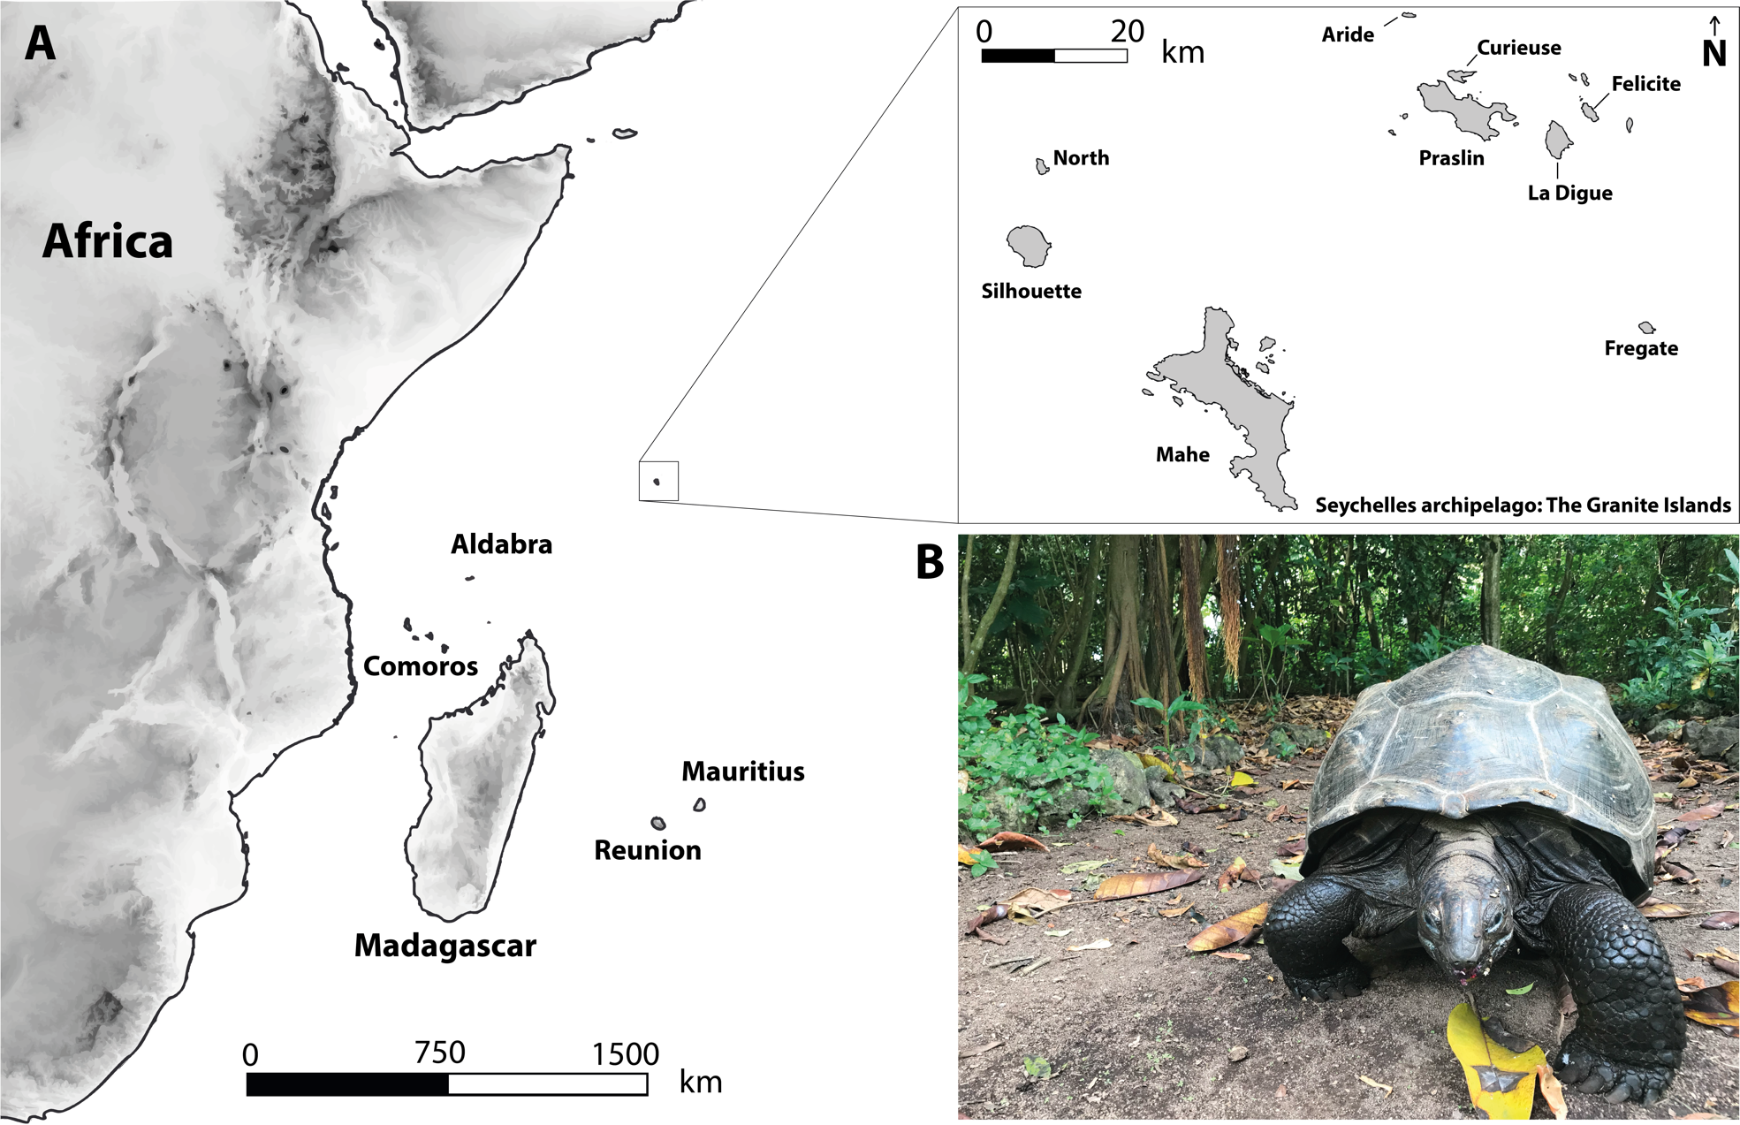

**Fig. 1. (A)** Map showing the location of the Seychelles archipelago on the Western Indian Ocean and its main granitic islands, including Aride Island. (B) One of the ten Aldabra giant tortoises (*Aldabrachelys gigantea)* reintroduced to Aride Island.

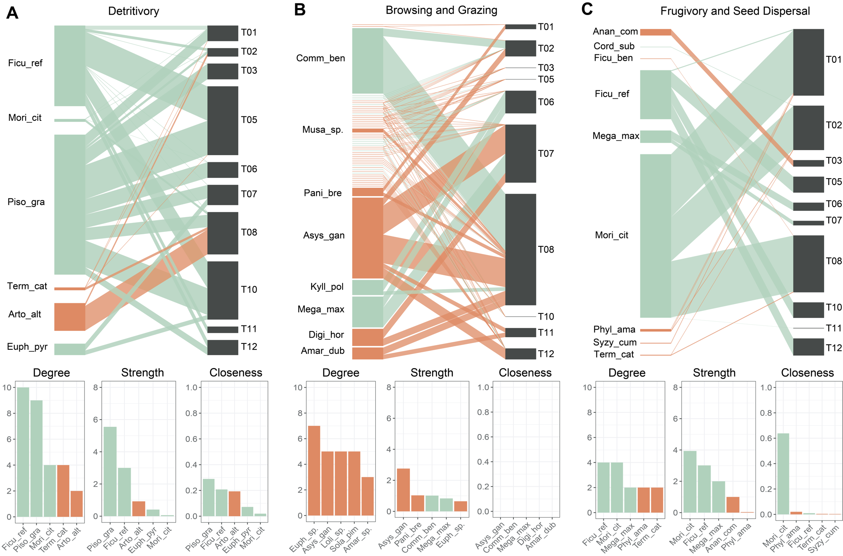

**Fig. 2.** Idividual-based network depicting detritivory (left panel A), browsing and grazing (central panel B) and frugivory and seed dispersal (right panel C) performed by individual tortoises. Green rectangles represent native flora from Aride Island while orange rectangles represent introduced taxa. Black rectangles represent individual tortoises. Bar plots rank the 5 most important plant species based on centrality metrics (i.e., degree, interaction strength, and weighted closeness) within the distinct ecological processes mediated by Aldabra’s giant tortoises.

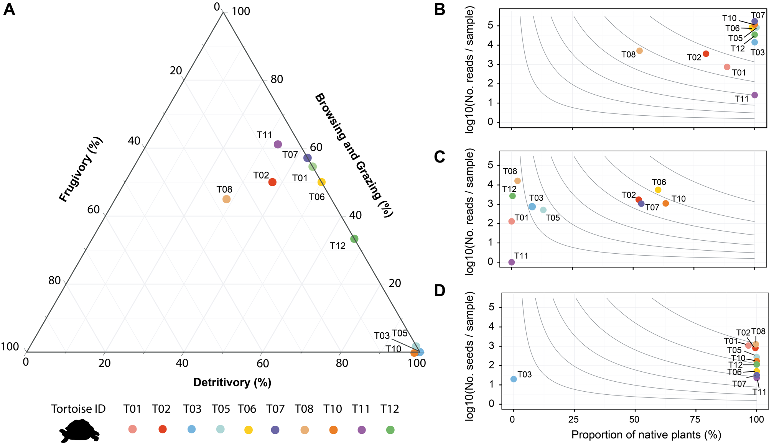

**Fig 3.**  Individual effectiveness of reintroduced tortoises in ecological processes on Aride island. Panel A shows a ternary plot depicting the behavioural frequencies of frugivory, browsing and grazing, and detritivory observed during focal observations for individual tortoises. Panels B, C and D depict the individual effectiveness in detritivory, browsing and grazing and frugivory and seed dispersal, respectively. The X-axis represents the proportion of native plants involved, reflecting the qualitative aspect of the effectiveness framework. The Y-axis shows the standarised number of reads in thousands for detritivory and browsing and grazing (Panel B and C) and the standarized number of seeds dispersed (Panel D). Isoclines connect values of quantity and quality aspects yielding the same effectiveness values for each ecological process.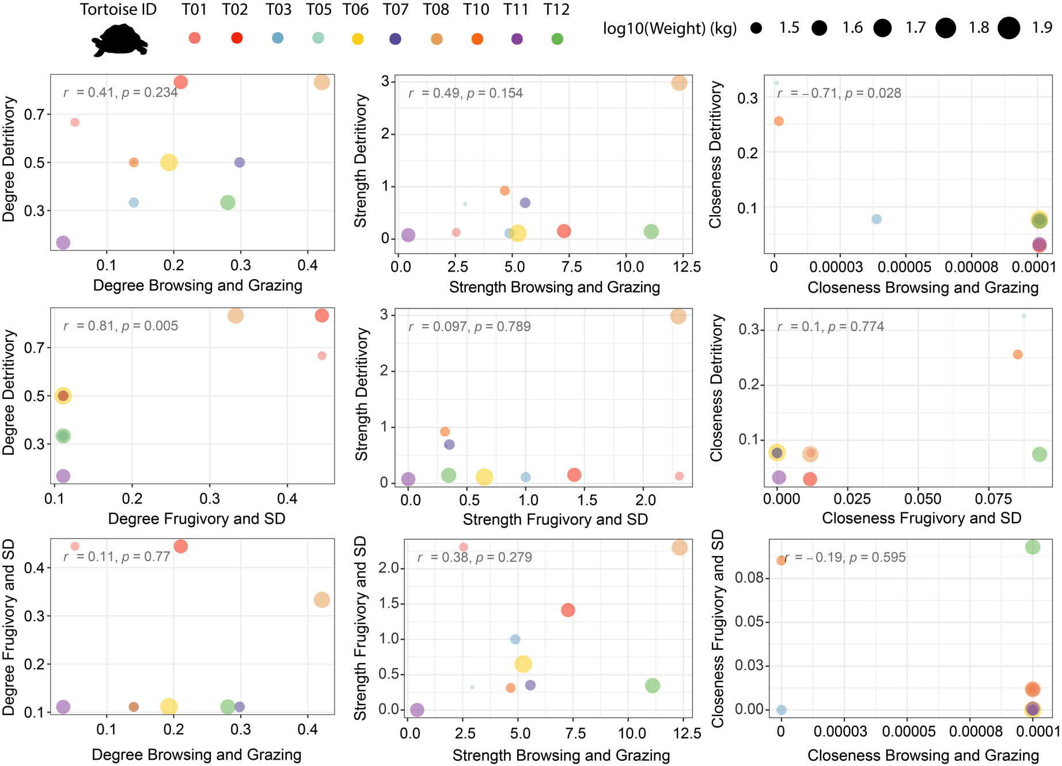

**Fig. 4.** Relationship between topological roles of individual giant tortoises based on centrality metrics among different types of interactions. First column shows the relationship between normalised degree of individual tortoises in detritivory, browsing and grazing and frugivory and seed dispersal ecological networks, while second and third columns show the relationship between interaction strength and weighted closeness among different ecological networks, respectively.

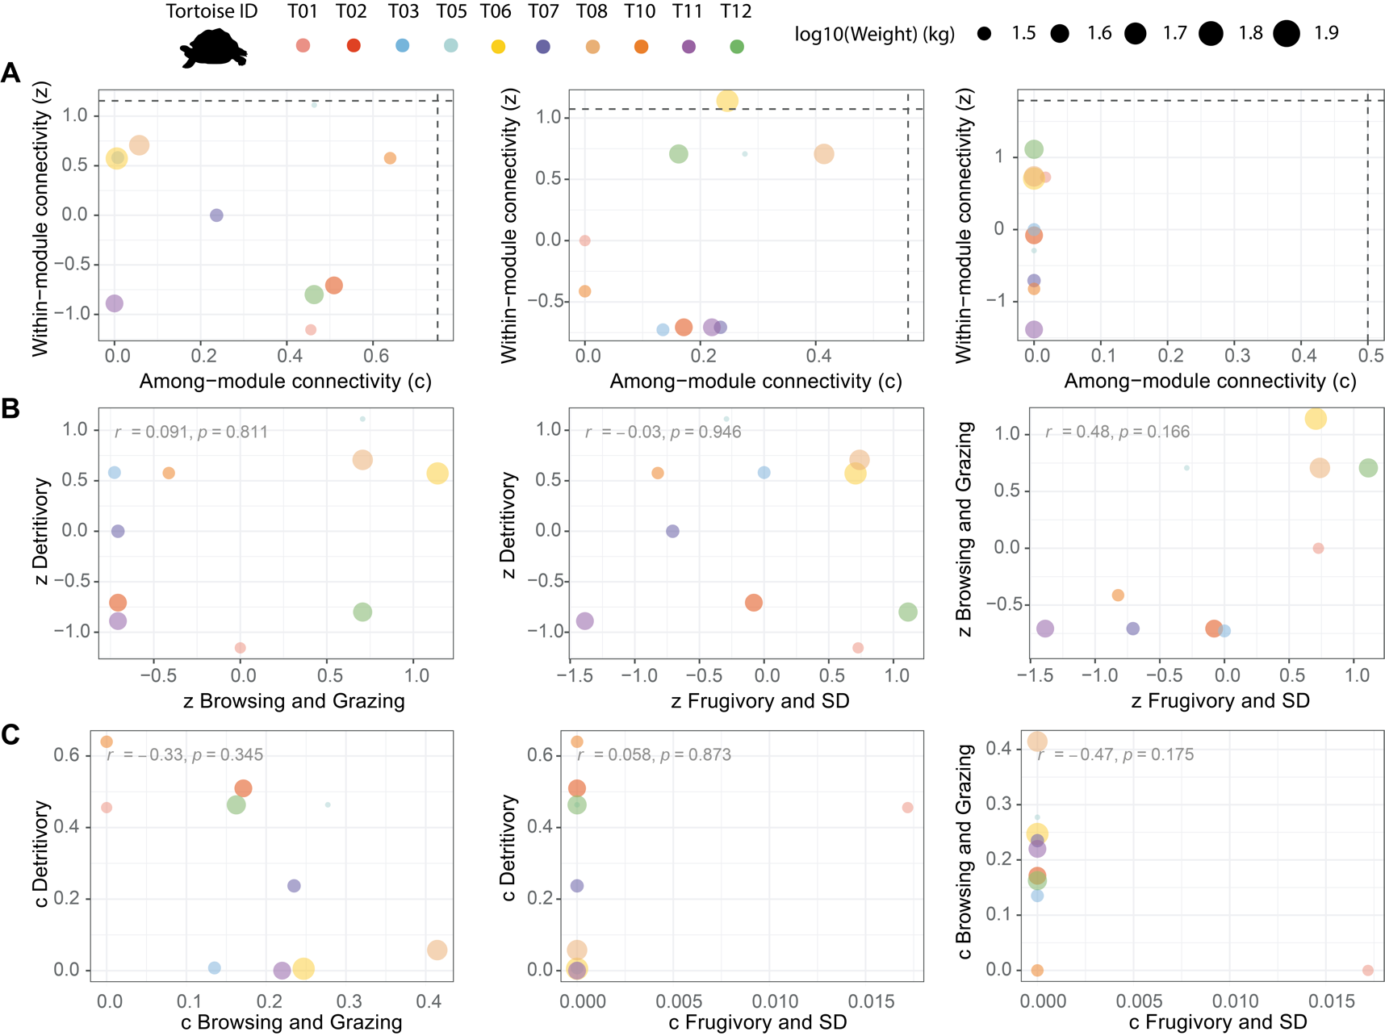

**Fig. 5**. Structural roles of individual tortoises in antagonistic and mutualistic ecological networks. Panel A shows among-module (*c*) and within-module (*z*) connectivity for each individual tortoise for each ecological process: detritivory (left), browsing and grazing (centre) and frugivory (right). Dashed lines in Panel A (vertical and horizontal) represent the 95% quantile thresholds used to define structural roles. Panel B and C depicts relationship between *z* and *c* values of individual tortoises among ecological processes, including Pearson correlation coefficients (*r*) and its significance (*p-value*).