Results Report

# Autor: Everardo Gutiérrez

# Date: 06/04/2018

A New DNA isolation technique was developed at Hsapiens.inc. We evaluated to specificity to capture a set of Golden Genes without capturing the surrounding unwanted regions.

Sequencing depth was evaluated for a given set of 5 genomic loci. The following coverage values were found:

|  |  |  |  |  |  |
| --- | --- | --- | --- | --- | --- |
| Chromosome | Start | End | Locus_name | breadth of coverage | mean depth of coverage |
| 22 | 147620 | 147719 | GOLDEN_GENE1 | 82% | 3.70X |
| 22 | 147970 | 148069 | GOLDEN_GENE2 | 91% | 4.27X |
| 22 | 148490 | 148639 | GOLDEN_GENE3 | 64.6% | 2.47X |
| 22 | 147820 | 147889 | UNWANTED_REGION1 | 100% | 53.14X |
| 22 | 148190 | 148389 | UNWANTED_REGION2 | 97.5% | 72.66X |

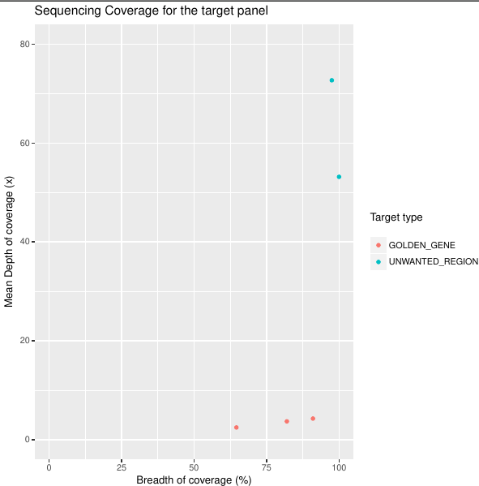

**Figure 1.** Comparison of coverage values for the targeted genes and the surrounding unwanted regions.

In average, the panel of Golden Genes was 79.2% covered, at 3.4X; for the unwanted regions the average values were 98.75% covered, at 62.9X.

Conclusions

* According to the results obtained, the new method to isolate DNA regions has a low specificity. Although the coverage percentage is high in the regions of interest, the average depth per base is very low with respect to the unwanted regions.
* The average depth of readings per base is 18 times greater in the unwanted regions with respect to the Golden gene regions.
* The quality of the sequencing is good in both regions, since the average coverage percentage is high. However, the amount of DNA extracted is very low in the regions of interest compared to the unwanted regions.
* Due to the high values ​​obtained in the two parameters measured in the unwanted regions, it is possible that the marking of the samples was erroneous. That is, they were marked upside down.