|  |  |  |  |  |  |  |  |
| --- | --- | --- | --- | --- | --- | --- | --- |
| OpenreachLogo_Purple | |  | | --- | | ISIS practice  For all BT People | | EPT/OHP/B058 | | Issue 13, 30-Oct-2018  Use until 30-Oct-2020 | | Published by Access Engineering & Innovation | | Privacy- Internal | | |
| Poles - General Information and Layout Policy | |  |
|  | |  |

About this document ...

Author

The author of this document may be contacted at:

|  |
| --- |
| Chief Engineer AEI Technical Documentation team |
| Technical Capability |
| Openreach Access Engineering & Innovation () |
| Post Point DL ATE CDarlington ATE  Barnard Street  Darlington  Co. Durham  DL3 7DT |
|  |
| Telephone: 0800 678 1106 |
| Fax: |
| Email: aei.doc.control@bt.com |

Content approval

|  |
| --- |
| This is the Issue 13 of this document. |
| The information contained in this document was approved on 30-Oct-2018 by Glen Barford, Senior Overhead Strategy, Products & Standards Manager |

**Version History**

|  |  |  |  |
| --- | --- | --- | --- |
| Version No. | Date | Author | Comments |
| Issue 13 | 30-Oct-2018 | Chief Engineer AEI Technical Documentation team | Validity extended due to review, update to pole test phone number & damage guide links. |
| Issue 12 | 03-Mar-2015 | Document Manager T | Document migrated onto new platform with no content change |
| Issue 12 | 18-Dec-2014 | Chief Engineer AEI Technical Documentation team | Inclusion of Stout Pole info and also info on AC500 treatment added |
| Issue 11 | 10-Jan-2010 | Chief Engineer AEI Technical Documentation team | Document reviewed.New para 2.4.2 to incorporate EM 44-2005 (DCC548) |
| Issue 10 | 23-Feb-2009 | Chief Engineer AEI Technical Documentation Team | Inclusion of ESM 35/2008 and change of author & approver |
| Issue 9 | 1-Feb-2008 | Nick Adams | Addition of hollow pole kit and pole re-use information, inclusion of ESMs 23/2007 & 9/2007 |
| Issue 8 | 27-Mar-2007 | Nick Adams | Removal of performance standards to relevant EPT/ANS/xxx documents, and full content review and updating |
| Issue 7 | 29-Jun-2006 | Nick Adams | changes to planting depth information, attachments & other minor changes |
| Issue 6 | 29-Jun-2006 | Nick Adams | changes to planting depth information, attachments, bird nuisance, hollow pole infomation and other minor changes |
| Issue Draft 5a | 9-Feb-2006 | Nick Adams | Draft 5A - changes to planting depths, attachments info and other minor changes |
| Issue 5 | 14-Apr-2004 | Nick Adams | Changes to pole dropwire loadings, and restricted depth standards, and other minor modifications. |
| Issue Draft 4a | 29-Dec-2003 | Nick Adams | Changes to pole dropwire loading, restricted depth standard and other minor changes |
| Issue 4 | 14-Jul-98 | A W Renshaw | Revision of pole depth information and other minor amendments. Update to EDRS. |
| Issue Draft 3b | 9-Jul-98 | A Renshaw | Final Draft |
| Issue Draft 3a | 9-Apr-98 | Tony Renshaw | UPDATE AND EDRS |
| Issue 3 | 1-Nov-95 | Tony Renshaw | Revised Documentation. Supersedes previous issue and EPT/OHP/B020. Minor amendments, Pole weights revised, Creosote detail added. |
| Issue 2 | 1-Nov-95 | Tony Renshaw | UPDATE |
| Issue 1 | 1-Nov-95 | Tony Renshaw | UPDATE |

Table of Content

1 Introduction 5

2 Pole Layout Policy& General Information 5

2.1 Scope 5

2.2 Background 5

2.3 Climbing 6

2.4 Envelopes of Available Space for Pole Mounted Equipment/Connector Systems etc 6

2.5 Measures to Prevent Birds Roosting on Wooden Pole Tops 11

2.6 Measures to Prevent Squirrel Damage, Roosting Birds and Condensation, in Hollow Poles 12

2.7 Restrictions on the use of Creosote Treated Poles 12

2.8 Pole Mounted Equipment Requiring the Use of Gas or Hot Air Torches 13

2.9 Dropwire Strength 13

2.10 Dropwire Loadings 13

2.11 Joint Use Poles 13

2.12 Dropwire Span Lengths 13

2.13 Aerial Cable Loading 13

2.14 Non-BT Attachments 14

2.15 Maximum Permissible Equipment Working Loads 14

3 Detail of Standard Current Poles and Installation 14

3.1 Wood Poles 14

3.2 Hollow Poles 19

4 Superseded Poles 20

4.1 Superseded Wood Poles 20

4.2 Superseded Hollow Poles 20

5 Markings 21

6 Other Authority's Poles Taken Over by BT / Openreach 24

7 Revised Working Procedures for Poles Involved in Road Traffic Accidents (RTAs) 24

8 Recovered Poles 27

8.1 Wood Poles to be Scrapped 27

8.2 Wood Poles Fit for Re-issue 27

9 Disposal 27

9.1 "Adastra" Type Poles 27

10 References 28

# Introduction

This document describes the types of Pole purchased by BT and gives details of usage, pole loading, attachments, and some detail on pole layout policy. The document should be read in conjunction with EPT/ANS/A010, EPT/ANS/A011, EPT/ANS/A012, EPT/ANS/A013, EPT/ANS/A014 & EPT/ANS/A015 which specify the construction standards for Overhead work.

Details of current and obsolete poles which may still be in the BT system are included in this document.

# Pole Layout Policy& General Information

## Scope

This section details how and where Overhead Hardware may be fitted to Wooden and Hollow Poles. Reference is made to Climbing and Turning operations, the positioning of closures requiring the use of Gas Torches, Dropwire Population, design of access to plant, Non-BT Attachments, measures to prevent bird nuisance, restrictions on the use of creosoted poles, network security and other general information.

1. This section does NOT include Joint User poles or the provision of mains power supplies on BT poles. These aspects are covered by the Joint User Documents -EPT/PPS/B037 & EPT/PPS/B038.

## Background

It should be noted that poles are crucial to the business as they form an essential part of the Network. Pole issues are sensitive because of the safety implications of the potentially hazardous procedures of climbing and working on a pole.

Prevention of injury relies on a safe Pole, secure Steps, clear access, and adherence to relevant procedural instructions.

A pole is a unitary structure which has to support a person working in addition to the network plant. Thus failure of this single element can result in catastrophic failure with the attendant risk of injury.

In order to maintain a safe structure both the checks by a pole Examiner on a cyclic basis and those made every time prior to and during climbing or working on the pole must not be impeded by any pole mounted hardware.

Additionally, poles are a sensitive environmental issue. If their current acceptance is to be continued the visual impact of poles and attachments must remain within limits acceptable to the general public.

## Climbing

Refer to the relevant section in [Health & Safety Handbook](https://intra.bt.com/bt/hr/wish/safety/Pages/index.aspx) for information relating to pole climbing.

## Envelopes of Available Space for Pole Mounted Equipment/Connector Systems etc

When overhead distribution necessitates the use of cable joints, or transmission equipment the preferred option is to locate them in an underground jointing chamber.

However, where no practical or economic underground option exists the hardware may be installed on wooden poles providing that due regard is paid to the requirements of normal overhead practices and this document.

All pole mounted hardware shall comply with the following:

(a) Nothing shall be fixed to the top face of the pole, unless detailed in, or approved by the author of this document. There is now no requirement from Local Authority byelaws requiring the fitting of finials. However, retrospective action to remove such attachments need not generally be taken.

(b) There are two areas, as listed below in d and f, where hardware may be fitted. However, due regard must be paid to positioning of the hardware in order to:

(I) avoid restricting access for fitting dropwires.

(ii) Not obstruct climbing.

(iii) Not obstruct safe ladder placement.

(iv) Not present a hazard by way of sharp edges or corners.

(v) Be readily removed for pole testing operations.

(c) All hardware shall be securely mounted to the pole but must also meet the requirement of (b) (v) regarding removal.

(d) Hardware may be fitted between the top bass step and the pole top providing that the documents listed in EPT/OHP/B033 are complied with.

No wiring etc. shall be fitted such as to cause obstruction to belting up below the top bass step. An exception to this is Aerial Cable which, according to circumstance, may be fitted below the bass steps. However, care should be taken to ensure that any obstruction is kept to a minimum.

(e) Access to the working and bass steps must not be impeded by any item fitted within the area described in (d).

(f) Small pole mounted micro connect antennas may be fitted, and extend beyond the top of the pole, see section 2.4.1

(g) The following space may also be used for mounting hardware;

The space on either side of the pole in line with steps, extending 250mm radially from the pole, from 2.0m above ground level to immediately below the lowest climbing step. The overriding requirement is that safe ladder placement and climbing must not be obstructed (see Figure 1).

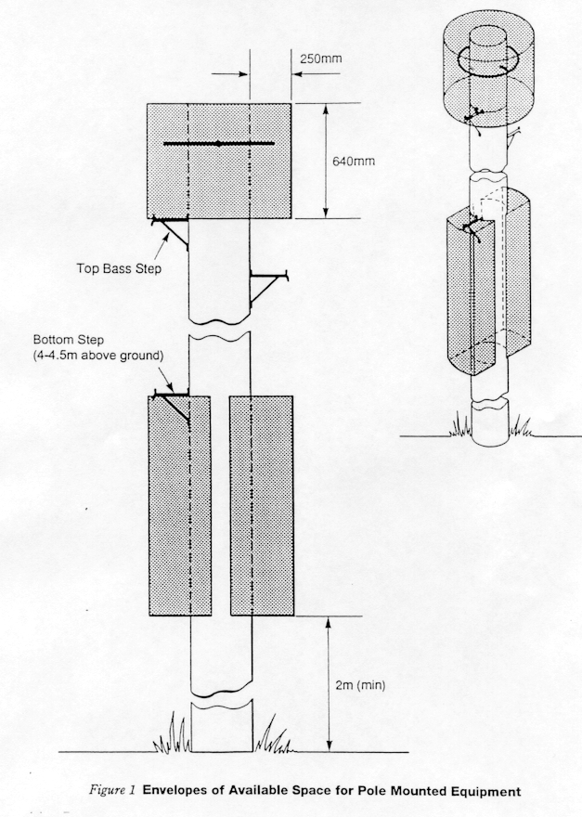

Figure1: Envelopes of space for pole mounted equipment

(h) Due consideration should be given to the likelihood of vandalism when contemplating the use of the space described in (f). Also the visual aesthetics of hardware mounted in this position may more readily be considered visual pollution, in some locations.

### Pole Mounted Micro-connect Antennas

Occasionally, small micro-connect pole mounted antennas may be found. These should be fitted in accordance with the planning and installation guidelines found in the appropriate Planning Guide. These poles should be fitted with appropriate warning labels.

Before climbing or working on any pole fitted with a micro connect antenna, ensure all safety instructions regarding power down or other safety procedures are followed. If in doubt, consult your Line Manager. The antenna and its associated cabling in itself do not affect the climbing practices to be followed.

### External Connection Boxes on BT Poles for use by Mobile Post Offices

BT has agreed with the Post Office to supply a bespoke telephone service for use by travelling Post Offices in remote rural areas, by fitting special boxes to nominated wooden poles. This section gives details on the service, how it can be identified, and any necessary additional steps to be taken.

The mobile Post Office will arrive at nominated sites at pre-agreed times, to give Post Office facilities in rural areas where previously no facilities existed, or have now closed. The BT connection is to provide a suitable computer connection for Post Office use.

All Post Office transactions now have to be online to the Post Office Horizon system. The mobile postmaster pulls-up near the pole, unlocks the box and using an extendable lead, connects the Horizon system onboard to the PSTN socket and the system dials-up the Horizon network and connects. The line is O/G barred but allows 999 and 0800 calls. Horizon connection number is 0800.

The following conditions must be observed:

Pole is BT only, and not shared eg shared use with Electricity

No Health & Safety issues around the chosen stopping place of the Mobile Van.

Carry out a survey and tests to ensure pole is suitable in terms of non decayed.

Checks that there are no plans to remove / relocate the pole in the foreseeable future.

Provide line plant if required to supply a PSTN line.

Ensure access to the pole for BT Engineers is not affected.

Attachment of a waterproof box to house a waterproof NTE (Network Waterproof Enclosure 1A)

Ease of fitting.

Additional Installation Information

It should be positioned so as to not interfere with climbing, testing or normal engineering work on the pole.

If the cable is fed from above, a drip loop should be left to prevent moisture ingress.

If it has a UG feed, capping should be fitted to protect the cable.

The drawing below shows the external connection box positioned on a pole. It should usually be positioned between 1.5m & 1.8m from the floor. Post Office staff will have the necessary keys to open the box and access the NTE.

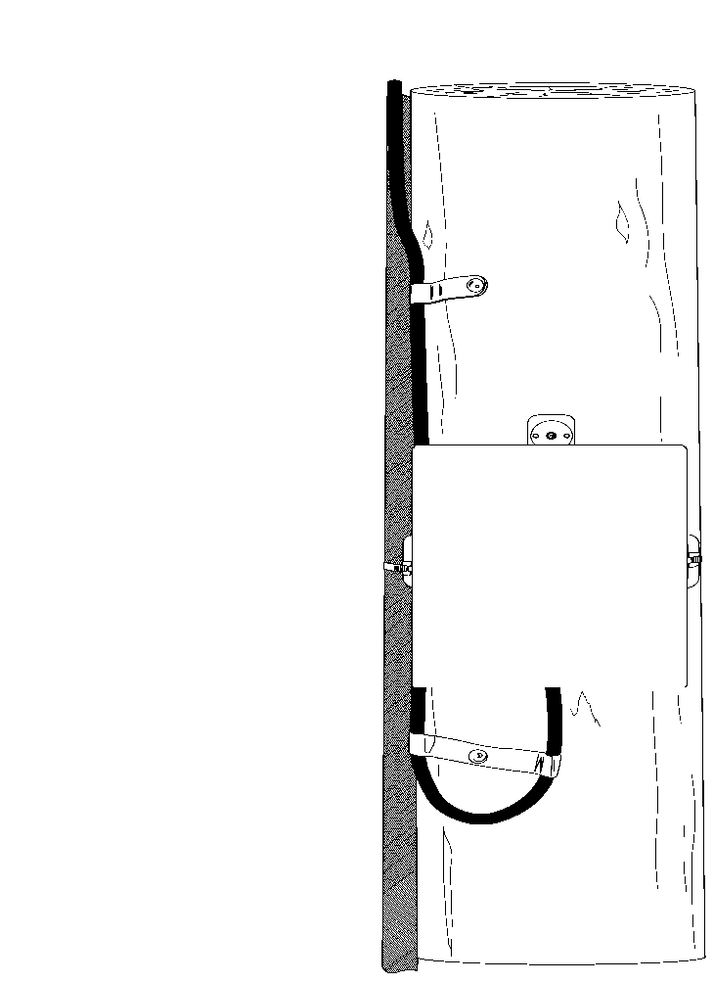

For the provision job, the additional information regarding how to obtain the box etc. will be within the notes field of the CSS job.

For maintenance purposes a key to the secure box will be retained at what is known as the Rural Post Office Hub which will be local to the area. There will be an entry on CSS for each telephone number connected to the process detailing where the key can be collected.

There should be no reason for BT Engineers to access inside the box, unless they are actually working on the line concerned.

In the very unlikely event of having to work on a pole at the same time as the Post Office is present, ensure that your work, and the position of the ladder etc, presents no additional hazards, either to yourself or members of the public. Carry out a full on-site risk assessment.

When fixing the box & cabling on the pole etc. ensure you take all necessary precautions with regard to contact with creosote, especially if it is a newly erected pole. Refer to the Health & Safety Handbook if necessary.

## Measures to Prevent Birds Roosting on Wooden Pole Tops

On receipt of a CCH complaint that birds are sitting on pole tops or on the cables adjacent and are causing mess and damage to property, at the Local Customer Manager's discretion, a visit should be made to the site to determine if a platform elevating can access the pole top. If access is available, the following process should be followed.

Using Straps, cable fixing 14A black, form a foot by "zipping up" the strap completely, cut the tail to a length of approx. 200mm and using staples galvanised 25mm (item code 016270) secure the strap to the pole top forming a "crown" (5-8 straps depending on the size of the pole top or bird to be deterred) see Fig 2. This will deter birds from perching on the pole top.

If it is found that birds continue to roost on the adjoining cables, then using straps, cable fixing 1A as described above, placed 120mm apart for the first 2 metres of cable will deter birds from perching.

Safety: Before proceeding, the usual on site risk assessments should be made Appropriate PPE should be worn

As this work can only be performed from a platform elevating, is there sufficient access?

References:

* ISIS SFY/GRA/A019 Generic Risk Assessment, working with Mobile Elevating Work Platforms.
* H&S Handbook Section 5 – SFY/HSH/D039, working at height with a Mobile Elevating Work Platform.

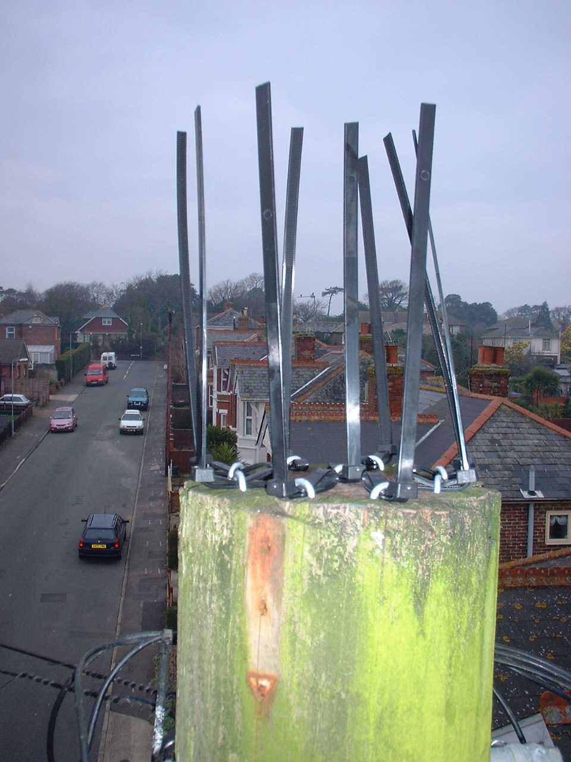

Figure 2: – Showing straps used as a bird deterrent

## Measures to Prevent Squirrel Damage, Roosting Birds and Condensation, in Hollow Poles

A kit is available to prevent problems with squirrel damage and roosting birds in hollow poles. The kit also contains a special breathable bag, which should be used for the BT71 inside the pole, to help to prevent condensation faults.

The kit is supplied with full instructions, and is available from stores with the following item code: - 037995 – Kit Hollow Pole.

If the bag alone is required, these are available with the following item code: 237195 – Polypropylene sack small 500x800. These may need to be cut down to size.

The kit and/or bag should be deployed on all poles considered susceptible.

## Restrictions on the use of Creosote Treated Poles

There are restrictions on the locations where creosote treated poles can be used. For details of these restrictions see EPT/ANS/A010

## Pole Mounted Equipment Requiring the Use of Gas or Hot Air Torches

Pole mounted equipment requiring the use of gas torches or other similar devices for installation or maintenance should be arranged to avoid the necessity to use the heat source aloft. Sufficient lengths of cable to enable the work to be carried out at ground level should be provided to facilitate this

Due regard should also be paid to the positioning and bend radii of affected cables, both as work is in progress and at the final position.

## Dropwire Strength

In order to enhance the safety of the general public the 'mechanical fuse' in the local Overhead Network should be the dropwire. Should a vehicle strike or damage due to wind and/or ice overloading occur, the dropwire must break. If this happens the dropwire falls to the ground. Whilst there are obvious hazards in this occurring, and Network Construction Standards aim to ensure this will not occur under normal circumstances, should another part of the system fail, potentially much more dangerous situations arise.

Hence it has been determined that the Ultimate Tensile Strength of dropwires shall not exceed 1550 Newtons. All current dropwires fall within this limit including those used in power crossings. Some obsolete and special purpose dropwires such as co-axial and optical fibre may not meet this requirement.

## Dropwire Loadings

Full details of Dropwire loadings on Poles are detailed in EPT/ANS/A011

## Joint Use Poles

Joint use poles should conform to the requirements of the appropriate Joint User arrangements; see ISIS documents EPT/PPS/B037 & EPT/PPS/B038. A maximum of 5 dropwires should be attached to one Ring Pole Head Standoff 1A due to loading considerations.

## Dropwire Span Lengths

For details of Maximum Dropwire Span Lengths, see: EPT/ANS/A011

## Aerial Cable Loading

It must be ensured that the Pole/Strut/Stay construction is adequate for any cable loadings being placed on it (see EPT/ANS/A014 & EPT/ANS/A015)

## Non-BT Attachments

All details regarding non-BT attachments, including what is permitted, and the processes for applying for permission are included in ISIS EPT/OAM/F070.

## Maximum Permissible Equipment Working Loads

### Access to Plant

Any plant or equipment mounted to a pole, which has to be accessed for equipment or network maintenance whilst attached to the pole, shall not require horizontal forces of more than 50 Newtons to access the plant or carry out test or termination functions on the plant.

### Dropwiring Loads

Any practices or equipment to install, replace or remove dropwires or other equivalent lines tensioned by hand from the pole top shall not require the application of forces of more than 350 Newtons to carry out the above functions.

# Detail of Standard Current Poles and Installation

## Wood Poles

Only three classes of wood pole, "Light", "Medium" and “Stout” are now supplied as standard, but Stout poles must only be used where necessary. In exceptional circumstances non-standard poles may be supplied by advising BT [Supply Chain Partners](http://procurement2.intra.bt.com/supplychain/index.shtml) of the requirements. Poles to be installed in the Openreach Network must only be purchased through BT Supply Chain Partners.

Standard poles are supplied cut to length with one pre-drilled hole 200mm +/-3mm from the tip. All are treated with a preservative - creosote. (See section 3.1.2).

All poles are marked 3 metres from the butt to show ownership, length, class and year of treatment. They are also marked on the butt for identification on a pole stack, and a batch number label is on the tip. Detail of the coding system used is given in Section 4.

The majority of poles used are of Scots-Pine (Pinus sylvestris), also commonly known as European Redwood. They are mainly imported from Scandinavia, or are from the UK. If suitable, other species from various countries are also used from time to time, in particular Southern Yellow Pine from the USA.

### Quality

The specification for wood poles is rigorous to ensure that poles of suitable quality, size, shape, strength, and life are supplied. The poles used have to be compatible with BT installation and use requirements, and have to be compatible with BT testing and examination regimes. In addition the species/preservation regime has to provide adequate life in the climate and insect regimes in which they are installed. The following are some of the parameters specified - species, limiting defects (e.g. knot sizes, ring sizes, inbarks and rind galls etc.), freedom from decay, shape, maximum weight, preservation type, content and treatment process parameters, environmental factors etc.

Allowable tolerances on wood poles mean that the poles may be delivered up to 50mm shorter than the 'nominal' length and up to 150mm longer. The 3m mark, however should never be closer to the butt than 3m (It may be up to 50mm further away).

### Preservative Treatment

All standard wood poles are currently pressure impregnated with 100% coal tar creosote which meets BS 144 Part 1 Type 2. Guidance on the risks and the precautions which must be followed when handling creosote treated timber is given in: [The Health & Safety Handbook](https://intra.bt.com/bt/hr/wish/safety/Pages/index.aspx), [The Working with Creosote Document](http://documents.intra.bt.com:84/bookstore/isis/sfy/i_sfyhsh/1hshc009/@Generic__BookTextView/3060)and Poling practice documents.

A small number of poles are supplied treated with an alternative treatment, to be used in specific locaitons, as required by EU legislation. See Section 2.7 above.

Historically, other preservative treatments were used within BT, but only very small numbers of poles having these alternative treatments will still be in use in BT. Poles having such treatments can be identified by the three metre marking. See: Section 5.

Care should be taken when handling Creosote to avoid contaminating the skin or clothing. Appropriate protective clothing should be worn, and spare protective clothing should be carried. Clothing which has been contaminated such that creosote is in contact with the skin must not be worn.

### Bleeding

The requirements for Poles which are found to be "bleeding" with Creosote are defined in EPT/ANS/A010.

1. Where bleeding poles have to be handled, wear protective clothing (gloves PVC No2, overalls and if there is any risk of the creosote splashing into the eyes, eye shields). Use handling aids wherever possible e.g. PEU or Crane, Pole Grabs Manual, Rope Carry, etc. Where it is essential to close handle or shoulder poles, use rags or Hessian to absorb some of the creosote prior to handling and place clean rags or Hessian between you and the pole to minimise contact with the creosote. Wash creosote from the skin and change clothing impregnated with creosote as soon as practical.

See guidance in the H&S handbook on avoiding contact with creosote.

### Sizes

If the correct size pole for the requirement does not exist the next size pole up should be used (subject to the agreement of the Works Originator).

See detail in Table 1 below. The maximum butt sizes give the minimum hole size for the class of pole.

Poles must never be shortened or altered in shape either at the Top or the Butt

* Shortening at the butt renders the 3m mark invalid and normal depth checking cannot be carried out.
* Shortening at the tip will cause rapid tip decay and will result in the Pole being made automatically "D" when next tested by the Pole tester in the Periodic Test cycle.
* Removing material from any section of a pole from the butt to 4.5 m above the ground line other than to fix the lowest block of a blocked pole will adversely effect the stability or strength of the pole and is prohibited.

Table 1: Dimensions of Current Sizes of Wood Poles

|  |  |  |  |  |  |  |  |  |
| --- | --- | --- | --- | --- | --- | --- | --- | --- |
| Class | Light | | | | Medium | | | |
| Length Metres | Diameter at top | | Min Dia at 1500mm from Butt End | Max Butt Dia | Diameter at top | | Min Dia at 1500mm from Butt End | Max Butt Dia |
|  | Minmm | Max mm |  | mm | Min mm | Max mm |  | mm |
| 6 | 125 | 175 | 150 | 300 | - | - | - | 350 |
| 7 | 125 | 175 | 160 | " | 140 | 175 | 200 | " |
| 8 | 125 | 175 | 170 | " | 145 | 180 | 210 | " |
| 9 | 125 | 175 | 180 | " | 150 | 180 | 220 | " |
| 10 | 125 | 175 | 185 | " | 150 | 200 | 230 | " |
| 11 | 125 | 175 | 195 | " | 150 | 200 | 240 | " |
| 12 | - | - | - | " | 150 | 200 | 250 | " |
| 13 | 130 | 175 | 210 | " | 160 | 200 | 260 | " |
| 15 | - | - | - | " | 165 | 210 | 290 | " |

|  |  |  |  |  |
| --- | --- | --- | --- | --- |
| * Class | * Stout | | | |
|  | Diameter at top | | Min Dia at 1500mm from Butt End | Max Butt Dia |
|  | Min  mm | Max mm |  | * mm |
| * 9 | * 190 | * 240 | * 275 | * 400 |
| * 10 | * 190 | * 245 | * 285 | * “ |
| * 11 | * 190 | * 250 | * 295 | * “ |

### Correct Choice of Pole

ON many occasions Medium poles are used when it is unnecessary. There are many examples of carrier poles used to give clearance across a road for 2-3 wires, using medium poles. The cost difference between light & medium is approximately £20, and when the number of poles installed or renewed per annum is taken into account, this amounts to considerable additional expenditure. There are a few misconceptions regarding pole sizing, e.g.:-

* All DPs must be medium poles
* It is not possible to connect aerial cables to Light poles
* It is not possible to fit many dropwires to Light poles
* We should ALWAYS allow for network growth, and therefore use medium poles

NONE OF THESE ARE TRUE

Detailed guidance on pole loadings are given in EPT/ANS/A011. In some cases, especially urban areas, the maximum radial dropwire loadings for Light & Medium poles are the same.

In virtually all cases, for carrier poles used to give extra clearance for a limited number of dropwires, Light poles will be sufficient.

### Planting Depth for Wood Poles

Pole planting depth's for all Poles are detailed fully in EPT/ANS/A010

### Wood Pole Weights

Table 2: Approximate Weights of Current Sizes of Wood Poles

As wood poles are a natural product, sizes and weights vary considerably. Minimum sizes are specified to ensure adequate strength, but the average size and average weight will be above this minimum, and the absolute maximum weight for poles in any one size or class is higher still.

|  |  |  |  |  |  |  |
| --- | --- | --- | --- | --- | --- | --- |
| Class | Light | | | Medium | | |
| Length  Metres | Approx Average Weight | Maximum Specified Weight Pinus sylvestris Species (H or I Marking) | Maximum Specified Weight Southern Yellow Pine (Z) | Approx Average Weight | Maximum Specified Weight Pinus silvestris Species (H or I) | Maximum Specified Weight Southern Yellow Pine (Z) |
|  | kg | kg | kg | kg | kg | kg |
| 6 | 80 | 112 | 132 | - | - | - |
| 7 | 95 | 134 | 158 | 135 | 194 | 228 |
| 8 | 115 | 165 | 194 | 155 | 230 | 270 |
| 9 | 140 | 203 | 234 | 200 | 275 | 323 |
| 10 | 170 | 245 | 289 | 260 | 329 | 387 |
| 11 | 200 | 276 | 325 | 275 | 383 | 451 |
| 12 | - | - | - | 330 | 457 | 538 |
| 13 | 270 | 391 | 460 | 390 | 625 | 735 |
| 15 | - | - | - | 535 | 697 | 820 |

|  |  |  |  |
| --- | --- | --- | --- |
| Class | Stout | | |
| Length  Metres | Approx Average Weight | Maximum Specified Weight Pinus sylvestris Species (H or I Marking) | Maximum Specified Weight Southern Yellow Pine (Z) |
|  | kg | kg | kg |
| 9 | 250 | 319 | n/a |
| 10 | 295 | 378 | n/a |
| 11 | 360 | 443 | n/a |

1. 1: Small poles should be selected where manual pole handling or erection is necessary.
2. 2: Southern Yellow Pine poles are infrequently purchased, but owing to their extra weight it is not recommended that they are used where manual pole handling or erection is necessary.

## Hollow Poles

Galvanised steel poles manufactured since January 2005 are designed to be utilised in the same way as wooden Poles but in locations where a wooden Pole may not be used, i.e. due to environmental conditions, adjacent hazards or for other reasons where climbing poles is not possible, or permitted. Hollow Poles manufactured before this date i.e. Stainless Steel & GRP have limitations to their application. See EPT/ANS/A014 for details.

All Hollow Poles have an access door at low level through which all dropwire work on the pole can be performed. Aerial cables should be fitted using current documented practices.

### Identification of Hollow Poles

Both galvanised & stainless steel poles can be identified by the markings stamped on the dropwire fixing ring, inside the pole. The marking gives the length, gauge and finish of the pole.

# Superseded Poles

## Superseded Wood Poles

Wood Poles have previously been supplied in Imperial sizes and in Extra Light and Stout classes. Details of these poles are sometimes required and are therefore given in Table 3 below.

Table 3: Superseded Wood Poles

|  |  |  |  |  |  |  |
| --- | --- | --- | --- | --- | --- | --- |
| Class | Length Feet  (Metres) | Diameter at top | | Min Diam at 1500 mm from Butt End | Approx Average Weight | Estimated maximum Weight all species other than Southern Yellow Pine |
|  |  | Min mm | Max mm | mm | kg | kg |
| Extra Light | 18 (5.5)  20 (6)  22 (6.5) | 100  100  100 | 125  125  125 | 125  125  125 | 45  55  60 | 56  63  70 |
| Light | 15 (4.5)  16 (5)  22 (6.5)  28 (8.5)  31 (9.5)  40 (12) | 125  125  125  125  125  125 | 150  150  150  150  160  170 | 150  150  160  180  180  200 | 50  60  85  120  150  200 | 87  94  123  183  221  337 |
| Medium | 28 (8.5)  31 (9.5)  32 (10) | 150  150  150 | 180  180  190 | 220  230  230 | 180  230  260 | 257  303  329 |
| Stout | 28 (8.5)  30 (9)  32 (9.5)  34 (10)  36 (11)  40 (12)  45 (14)  50 (15)  55 (17)  60 (18) | 190  190  190  190  190  190  195  195  200  200 | 235  240  245  245  245  245  255  260  265  265 | 260  270  280  285  290  300  330  350  375  395 | 255  305  345  385  430  520  635  850  950  1130 | 356  396  447  485  523  613  760  926  1123  1269 |

## Superseded Hollow Poles

Table 4: Superseded Hollow Poles

Type A: - parallel sided Mild Steel tube with a galvanised finish.

Type B: - tapered octagonal Mild Steel sheet with a galvanised finish.

Type C: - tapered tubular Glass Reinforced Plastic (GRP).

Type D: - Medium poles

|  |  |  |  |  |  |
| --- | --- | --- | --- | --- | --- |
| Type | Material | Class | Length  metres | Colour/  Finish | Max  Weight kg |
| A  B | Mild steel  Mild Steel | Light  Light | 8.5  8.5 | Sprayed Aluminium  Sprayed Aluminium | 105  125 |
| C  C | GRP  GRP | Light  Light | 8.5  9.5 | Grey or Brown  Grey or Brown | 80  80 |
| D  D | Stainless Steel  Stainless Steel | Medium  Medium | 8.5  10 | Matt  Matt | 105  125 |

# Markings

Poles supplied by BT are marked so that they can be readily identified. The markings and their position on wood poles are given in Table 5.

Scots Pine treated with creosote by the Rueping empty cell method (current process) does not have a preservation mark.

Additional code markings to indicate other Species and Preservative treatments are given in Table 6. Current alternative treated poles are marked “AC” on the 3m mark. Markings are also detailed in Drawing CN351.

Hollow Poles are marked with the letters BT, Length, Class and Manufacturers Code letters on the dropwire support ring inside the poles.



Figure 3: Pole Markings

Table 5: Type and Position of Marking on Wood Poles

|  |  |  |  |
| --- | --- | --- | --- |
| Position | Current Markings | Previous Markings | Meaning |
| On Butt | Class Letter 'L' | One Crown or One 'T' | Extra Light or Light Poles |
| On Butt | Class Letter 'M' | Two Crowns or Two 'T's | Medium Poles |
| On Butt |  | Three Crowns | Stout Poles |
| On Butt |  | Two Code Letters | Shipper and Creosoting Depot |
| On Butt |  | Initials (Two Letters) | Inspecting Officer |
| On Butt | Length (Figures) | Length (Figures) | Stock Length |
| 3 Metres  from Butt approx | BT | GPO or PO | Ownership |
| 3 Metres  from Butt approx | Length in metres and class letter L or M | Length in feet, and Class Letters (XL, L, M or S) | Stock Length and Class of Pole |
| 3 Metres  from Butt approx |  | Single letter origin code | Country of Origin |
| 3 Metres  from Butt approx | Date (Figures) | Date (Figures) | Last two figures of year of applying preservative |
| 3 Metres  from Butt approx | Supplier Code  (Single Figure) | Pole Depot Code  (Single Figure) | Supply identification code |
| 3 Metres  from Butt approx | One or more Letters | One or more Letters | Species and/or Preservative Treatment see below. |
| 3 metres from butt ( + 50mm /- 0mm ) | 3m reference line under ownership mark ---- | 3m reference, top of ownership mark where no reference line exists | Depth reference mark |

All wood poles are now also fitted with an additional plastic label at the tip of the pole. This label is the process batch identification label and should not be removed.

Table 6: Species and Preservative Treatments - Code Markings

|  |  |
| --- | --- |
| Code Marking | Species and Preservative Treatment |
| A | Russian Red Fir (Archangel) |
| AL | American and Canadian Larch |
| B or BL | Preserved with Wolman salts (Triolith 1930) Tanalith (1944 and 1947/8) |
| BX | Preserved with Wolman Salts and Fuel Oil (1930) |
| BB | Preserved by "Quick" process |
| C or CE | Preserved with Celcure |
| CP | Corsican Pine |
| CDF | Canadian Douglas Fir |
| CS | Canadian Spruce |
| D | Creosoted by "Full Cell" process and supplied by LMS |
| DF | Douglas Fir (Home Grown) incised and creosoted by "Full Cell" process (1935) |
| DF | Douglas Fir |
| E | Larch (Summer Felled) |
| EF | Wallaba |
| ER | European Redwood |
| F | Polish Poles of second quality |
| GNS | German, Norway Spruce |
| H | Home Grown (UK) Scots Pine |
| H (pre-1982) | Silver Spruce (Summer Felled) |
| HL | Hybrid Larch |
| I | Imported European Redwood |
| IC | Iron Bark (Queensland) Eucalyptus, Crebra |
| IP | Iron Bark (Queensland) Eucalyptus, Paniculata |
| JL | Japanese Larch |
| JP | Jack Pine |
| K | Creosoted by "rueping" process (Mark discontinued 1931) |
| L | Larch (Home Grown) |
| LP | Lodge Pole Pine (Canadian) |
| M | Western Red Cedar (Canadian) |
| N | Creosoted by "China" process |
| NS | Norway Spruce (Home Grown) |
| O | Oversize Light Poles |
| P | Preserved with Penta-chloro-phenol |
| PC | Lodge Pole Pine (Scotland) |
| PP | Ponderosa Pine |
| Q | Creosoted by "Quick" process |
| R | Russian Red Fir (Riga) |
| RP | Red Pine (Canadian) |
| S | Poles acquired from other Authorities |
| SF | Red Fir (Summer Felled) |
| SP | Scots Pine |
| SS | Sitka Spruce (Home Grown) |
| T | Larch seasoned with bark on |
| TC | Preserved with Tanalith "C" (TC and TC1-5) |
| V | Creosote by "Pre-vac" process |
| W | Weymouth Pine (Home Grown) |
| WC | Eastern White Cedar (Canadian) |
| X | Redressed pole |
| Y | Western Red Cedar (Home Grown) |
| Z | Southern Pine (USA) |
| 4 | Pre-creosoted Swedish poles |
| 2 | Re-dressed Medium poles Scotland |
|  | Purchased from War Office |

1. :The majority of poles on BT's system are treated with Creosote.

# Other Authority's Poles Taken Over by BT / Openreach

Only creosoted treated wood poles to BT Specifications or Electricity Company specifications may be accepted into BT ownership.

The procedures to be followed when Joint-User Electricity poles are to be taken into BT ownership are detailed in ISIS EPT/OHP/C027.

1. The adoption process may only be undertaken by the Openreach Pole Tester.

Poles taken into BT ownership must be included in the Periodic Pole Examination Program and be dealt with as normal BT poles.

# Revised Working Procedures for Poles Involved in Road Traffic Accidents (RTAs)

Although not actually detailed in any AE&I practice ISIS document, it has become 'custom & practice' for all poles involved in RTAs to be renewed. A technical review has determined that this approach is wholly inappropriate, and that the decision to renew the pole should be based on a combination of the extent of the damage, and a full test & inspection of the pole.

**The principle is that if there is ANY damage, and we can recover the cost, we will renew the pole. This is appropriate, as there is potential for minor damage to shorten pole life, although this may not be apparent at the time. However, such minor damage will not make the pole unsafe to climb or to continue in service. If the costs are not recoverable, then we will examine the pole and make the decision accordingly**

**Process for "first person on site" or discoverer of RTA damage**

All of the existing guidance regarding on site Risk Assessment, making the site safe, reporting/liaison with emergency services etc. remains exactly the same.

[Guide to reporting third party damage](https://openreach.office.bt.com/sites/pan-openreach-comms/Shared%20Documents/Health%20and%20Safety/Documents/Complete%20Third%20Party%20Damage%20Presentation.pdf)

The only process change is with regard to whether the incident requires a pole request test, and whether it should lead to a pole renewal activity.

**In the first instance, refer to the table below, to determine the course of action.**

|  |  |  |  |
| --- | --- | --- | --- |
|  | **Pole definitely has NO evidence of damage** | **Some evidence of damage, but probably within limits** | **Damaged beyond limits** |
| **Details of damager are available, and have been recorded in line with process** | See Step 1 for pole examination guidance.  IF no damage is confirmed - No further Action | Arrange for pole renewal, with costs charged to appropriate HL estimate | Arrange for pole renewal, with costs charged to appropriate HL estimate |
| **Details of damager are NOT available.** | See Step 1 for pole examination guidance.  IF no damage is confirmed - No further Action | GO to Step 2 below | Arrange for pole renewal, with costs charged to appropriate HDU estimate |

Step 1

Examine the pole:- if it is leaning beyond limits, is damaged beyond limits set out in pole test guidance, aerial cables are disconnected or damaged, or the pole is broken, splintered or on the ground proceed with a request for attendance by a pole team, as detailed in existing guidance - END

However, if the pole is still upright, not broken, and no aerial cables are disconnected or damaged, carry out a full pole examination, as detailed in EPT/OHP/C022 or the HSH. If there is evidence of damage, go to Step 2

Step 2

Contact the Pole Request Test Field Support Office,

0330 1233304

They will offer guidance on how to verify the condition of the pole, and only if necessary, arrange for a pole tester to visit site.

Step 3

If the pole examination (either by pole tester or by "first person on site") confirms that pole renewal is not necessary, then no further action is required.

If it is determined that the pole is damaged beyond limits, or some damage and the damager's details are available, and renewal is required, continue with the existing process regarding contacting Damage Duty and arranging for a Pole Team to attend.

Process for Pole Examiners

Pole testers should examine the pole in line with the standards in ISIS EPT/OHP/C025. Only if it fails these tests should if be confirmed that renewal is required.

Confirmation of the result should be given to both the "first person on site" and also back to the Pole Examination FSO. If the pole is defective and needs to be renewed, label as D, but do NOT record on HHT. The renewal activity will be progressed by the "first person on site" process, and will be linked to the relevant HL/HDU estimate. The D label is to prevent the pole being climbed should there be a delay for any reason in the pole renewal

Guidance for poling teams

If Poling teams are called to an incident with a request for a pole renewal following an RTA, then the assumption is that the above process has been followed and the pole definitely requires renewal.

Process For Pole examination field support office

To allow for tracking of request tests, the Pole examination FSO should record each request for either guidance or an actual test visit, and produce a monthly download of relevant data, showing:-

Date, exchange, district, address details, pole/DP no, originators EIN, result of pole inspection, notes/comments.

Summary

The purpose of this process change, is to ensure a more appropriate response to instances of pole damage. Therefore, to ensure this:-

**If you are the first person on site, follow guidance in Section 2 above**

**All existing guidance with regard to making the site safe, liaising with Emergency Services and noting detail of actual damage/damaging vehicles etc remains the same**

**The principle is that if there is ANY damage, and we can recover the cost, we will renew the pole.**

**If the costs are not recoverable, then we will examine the pole and make the decision accordingly**

**Pole Testers will visit for an actual request test if this is considered necessary, after contacting the Pole examination FSO**

**Pole Examination FSO, are to keep records of all calls for guidance or request tests, to determine the impact of this process change.**

# Recovered Poles

## Wood Poles to be Scrapped

Recovered Poles which have been shortened, or altered in shape, at either the Top or the Butt, must be scrapped.

## Wood Poles Fit for Re-issue

Recovered wooden poles should in general be re-used, providing:-

* They have not been shortened or altered in shape
* The 3 metre mark is still legible
* They are subject to a successful full visual examination
* They are subjected to a successful hammer test (and probe test if applicable) as detailed in the general test ISIS EPT/OHP/C022, but over the full length of the pole
* All previous designation nails, labels, staples, etc, are removed and holes previously used for coach-screws are plugged with "Plugs Creosote". The butt end of the poles should be cleaned as necessary.

1. Many poles recovered from site offices etc. have only been used for a few months or less than a year, and in a lot of cases are perfectly fit to be re-used.
2. If there are genuine doubts or suspicions, the Pole/s should be scrapped.
3. Poles over 25 years old must not be re-used.

# Disposal

Pole disposal requirements are detailed in EPT/ANS/A010.

## "Adastra" Type Poles

These are circular sheet steel sectional poles fitted with steps etc. Most of these poles have now been recovered. Any remaining should be classified as "D" and scrapped.

### Hollow Poles made of Stainless or Galvanised Steel

After recovery, Stainless or Galvanised steel poles should be carefully checked for physical damage, rusting, pitting or general deterioration of the basic material. Those found to be satisfactory should be re-issued.

All Hollow Poles made of Glass Reinforced Plastic (GRP) should be scrapped.

Disposal should be in accordance with the BT Waste Guide. RAL/ENV/B011

# References

EPT/ANS/A010 Specification for Poling Work

EPT/ANS/A011 Specification for Dropwire Work

EPT/ANS/A012 Specification for Aerial Cable Work

EPT/ANS/A013 Minimum Heights & Carriageway Definitions

EPT/ANS/A014 Principles of Overhead Route Stability

EPT/ANS/A015 Specification for Route Strengthening (Staying)

EPT/OHP/C022 Pole Examination and Testing

EPT/OHP/C027 Poles – Periodic Examination Manual

EPT/PPS/B037 Joint User Poles / Principles

EPT/PPS/B038 Joint User Poles / Technical requirements

EPT/OAM/F070 Non BT pole attachments

RAL/ENV/B011 Waste Guide

SFY/GRA/A019 GRA - Use of Mobile Elevating Work Platforms

BT Drawing –CN351: Pole Markings

Health & Safety Handbook

Supply Chain Partners

END OF DOCUMENT