|  |  |  |  |  |  |  |  |
| --- | --- | --- | --- | --- | --- | --- | --- |
|  | |  | | --- | | ISIS directive  For Openreach & Partners | | NWK/LNK/C519 | | Issue 16, 31-Mar-2023  Use until 30-Mar-2024 | | Published by Openreach Chief Engineer | | Privacy- None | | |
| Spine - Fibre – Overblowing - Policy | |  |
| Network Policy | |  |

About this document ...

Author

The author of this document may be contacted at:

|  |
| --- |
| Kevin Fisher |
| Network Policy Professional |
| Openreach (BOI) |
| Post Point 15 York Street  Atlantic Quay  Glasgow  G2 8LA |
|  |
| Telephone: +443316201897 |
| Fax: |
| Email: kevin.fisher@openreach.co.uk |

Content approval

|  |
| --- |
| This is the Issue 16 of this document. |
| The information contained in this document was approved on 31-Mar-2023 by Stan Edwards, Senior Manager, Network Policy, Standards and Accreditation |

**Version History**

|  |  |  |  |
| --- | --- | --- | --- |
| Version No. | Date | Author | Comments |
| Issue 16 | 31-Mar-2023 | Kevin Fisher | Inserted the 24f element COF260-144 for SDMB5 and dropped the 12f element version. COF260 can now be overblown where COF800 is the legacy cable in the sub duct. |
| Issue 15 | 19-Oct-2022 | Kevin Fisher | Inserted COF260-144 for SDMB5 into subsection 4.2. Added new subsection 4.6.3 about COF-260 and pole-mounted nodes. Latest document template applied. |
| Issue 14 | 11-Feb-2022 | Kevin Fisher | Warning reference to Cablelink orders inserted into section 4.6.2 |
| Issue 13 | 06-Sep-2021 | Kevin Fisher | Change of author. Content thoroughly refreshed and updated to reflect EPT/COF/D960 |
| Issue 12 | 18-Sep-2019 | Ada Hilton | Section 2.12 inserted for KNNS specialist equipment |
| Issue 11 | 09-Jul-2019 | Ada Hilton | Section 2.9 & 2.10 updated |
| Issue 10 | 30-May-2019 | Ada Hilton | Section 2.3 added |
| Issue 9 | 04-May-2018 | Ada Hilton | Section 2.8/3.8 requested by Penny Moore – Networkk Inventory |
| Issue 8 | 24-May-2017 | Ada Hilton | Secction 1 changed |
| Issue 7 | 28-Mar-2017 | Ada Hilton | Title change |
| Issue 6 | 06-Mar-2016 | Ada Hilton | Change of author |
| Issue 5 | 19-Mar-2015 | Document Manager T | Document migrated onto new platform with no content change |
| Issue 5 | 6-Mar-2015 | Graham Newell | Minor changes |
| Issue 4 | 3-Mar-2015 | Graham Newell | Revise document layout to new format. Policy change to widen the use of overblow in the network, authorised by Kim Mears, MD Infrastructure Delivery, on the 8th of February 2015. |
| Issue 3 | 21-Jan-2013 | Graham Newell | Correct wording above table in 8.2 and reformat pictures for inproved viewing. |
| Issue 2 | 4-Dec-2012 | Graham Newell | Update table in section 8.2. |
| Issue 1 | 5-Oct-2012 | Graham Newell | Publication of new policy guidance. |

Table of Content

1 Openreach Network Policy 5

2 Introduction 5

3 Scope 5

4 Policy 6

4.1 Equipment and practice 6

4.2 Cable-series for overblowing 8

4.3 Available sub duct 9

4.4 JF6 smallest chamber size 9

4.5 Rejoin legacy cable 10

4.6 Nodes 10

4.7 Avoiding congested or damaged duct 11

4.8 Recording 11

4.9 Repairing damage to the overblown network 11

5 Synthetics 12

6 Stakeholders 12

7 Further Guidance 12

7.1 Useful ISIS 12

8 Further Network Policy Guidance 13

8.1 Network Policy, Quality & Accreditation Website 13

8.2 Network Policy Briefings & Planning Communications 13

8.3 Policy & Build App 13

8.4 Policy team Workplace Groups 13

9 Glossary 14

# Openreach Network Policy

Openreach network policy defines a set of requirements to guide the decisions taken when planning and building a telecommunications network.

These requirements ensure we achieve the required outcomes in terms of meeting the strategic direction, architectural design, financial targets, and quality standards for the respective network.

This document forms a part of the authorised portfolio of Openreach network planning policy documentation. Adherence to these standards and policy is mandatory. Any deviation presents a risk to the required outcomes and will be subject to future compliance checking. Network deployments which do not meet network policy will fail any build audit and jeopardise our ability to provide service to our customers.

1. Policies are liable to change. Therefore, you must ensure that this copy/material is from a controlled source e.g. the [Book Store Libraries](https://officeapp.bt.com/sites/documentmanager/SitePages/BookStore.aspx) (where you are able to register for email alerts when updates are made, from within the documents you reference), or the Policy & Build App (whereby you can save an ISIS to your favourites). [NWK/LNK/C486](https://officeapp.bt.com/sites/documentmanager/SitePages/ReadDocument.aspx?lib=/sites/documentmanager/ISIS%20Library/nwk/i_nwklnk/1lnkc486.xml) - Network Policy and Planning Communications Guide – Policy will also provide guidance on how to use some of the bookstore functionality.

# Introduction

Overblowing is a technique that allows a Cable Optical Fibre (COF) 260 cable of up to 144 fibres (f) to be blown within a Sub Duct Mono Bore (SDMB) 3, 4, or 5 containing a legacy cable.

When a ducted route is necessary to deliver the spine network, consider overblowing the legacy spine route before laying new duct because of the cost saving.

# Scope

This document details Openreach Limited's planning policy for overblowing spine cables within existing sub-ducts.

1. As of March 2023, BFB overblowing is under review, and we have not formally launched it as a solution.
2. For clarity, BFB overblow is a technique for blowing a second bundle in a tube that already has a legacy bundle. It does NOT mean blowing COF260 into a tube nor does it mean blowing BFB into SDMB3/4/5.

# Policy

## Equipment and practice

ISIS EPT/COF/D960 "Openreach Overblow: Equipment & Practice" contains detailed information on overblow equipment, stores items codes, and field practices.

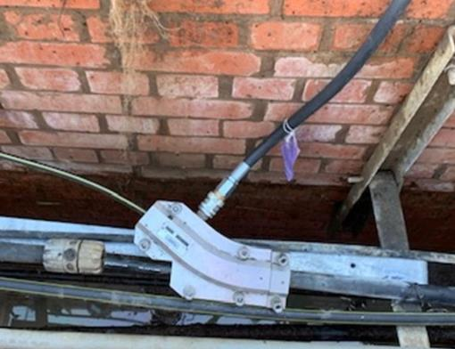

Figure 1: Overblowing within a subduct [Source: Matt Harris]

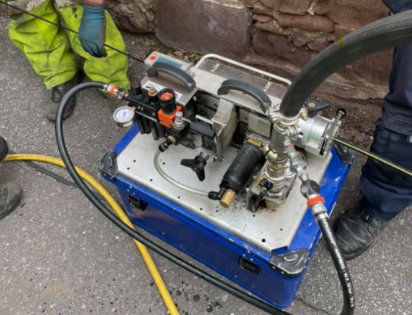

Figure 2: Plumett Minijet™ in use for overblowing [Source: Workplace]

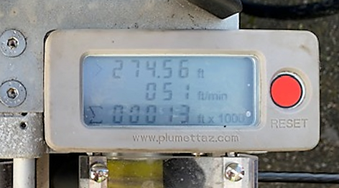

Figure 3: Minijet's distance and speed counter [Source: Matt Harris]

## Cable-series for overblowing

Three COF260-series cables are available for overblowing:

|  |  |  |  |
| --- | --- | --- | --- |
| Code | Name | Description | Information |
| 087368 | COF260 72 fibre SDMB5 OB cable | Cable Optical Fibre 260 72 Fibre Sub-Duct Mono-Bore 5 (SDMB5) overblow cable | COF260-72 is a non-metallic construction ⌀ 5mm diameter 72f micro cable for overblowing on top of COF200 (12 to 144 fibre) or COF202 (12 and 24 fibre) or COF800 (up to 432 fibre) cable that is already present in SDMB5. Unsuitable for direct installation in underground ducts. Unsuitable for pulled installation using a cabling rope. Unsuitable for installation in SDMB3 or SDMB4. |
| 113048 | COF260 144 fibre SDMB5 OB cable | Cable Optical Fibre 260 144 Fibre Sub-Duct Mono-Bore 5 (SDMB5) overblow cable | COF260 144 is a non-metallic construction ⌀ 5mm 144f micro cable for overblowing on top of COF200 (12 to 144 fibre) or COF202 (12 and 24 fibre) or COF800 (up to 432 fibre) cable that is already present in SDMB5. Unsuitable for direct installation in underground ducts. Unsuitable for pulled installation using a cabling rope. Unsuitable for installation in SDMB3 or SDMB4. |
| 105375 | COF260 144 fibre SDMB3/4 OB cable | Cable Optical Fibre 260 144 Fibre Sub-Duct Mono-Bore 3/4 (SDMB3/4) overblow cable | COF260 144 is a non-metallic construction ⌀ 7.5mm 144f micro cable for overblowing on top of legacy cable that is already present in SDMB3 or SDMB4. Unsuitable for direct installation in underground ducts. Unsuitable for pulled installation using a cabling rope. Unsuitable for installation in SDMB5. |

1. COF205 is obsolete and no longer used for overblowing.

## Available sub duct

Appropriately sized SDMB shall be available within the route to be overblown.

If a SDMB5 has a COF200 192f thru 276f or a COF800-864 then overblow shall not be used because there is insufficient clearance for the COF260.

## JF6 smallest chamber size

A JF6 (including JUF6 & JR6) with a minimum depth of 750mm is the smallest chamber for terminating overblown cable.

## Rejoin legacy cable

Overblown sections shall rejoin legacy cables at the earliest opportunity and not only at the end of the route.

1. The overblown cable can rejoin any external access cable that is spare within a node, for example COF215, COF315, COF600, COF640, COF800.

## Nodes

### New nodes

Section 8 (titled "Overblow Installation Practices") of EPT/COF/D960 contains embedded PDF files detailing the steps to open SDMB containing legacy cable at a location where a new node is needed.

For information, a snippet of the SDMB5 centre overblow installation process is shown in Figure 5 below:

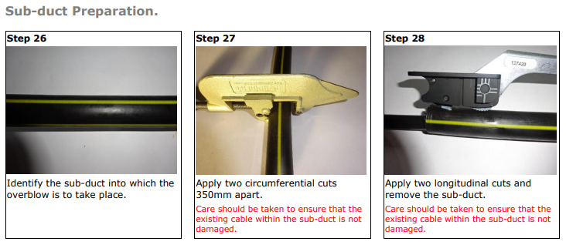

Figure 5: Snippet of SDMB5 centre overblow installation [Source: EPT/COF/D960]

### Exchange cable chamber

1. This section does not apply to Cablelink provision and you must refer to [NWK/LNK/C361 - Ethernet – Cablelink (EBCL) - Policy](https://officeapp.bt.com/sites/documentmanager/SitePages/ReadDocument.aspx?lib=/sites/documentmanager/ISIS%20Library/NWK/i_nwklnk/1lnkc361.xml).

SDMB [and therefore COF260] shall not be installed within an exchange's cable chamber.

1. Taking SDMB through duct seals would ruin the integrity of the duct seal and lead to potential water or gas ingress into the exchange building.

If the end of the route is also the exchange manhole, then a new node shall be used to extend the fibres onto a COF200 cable and into the exchange's cable chamber, terminated in a CCJ.

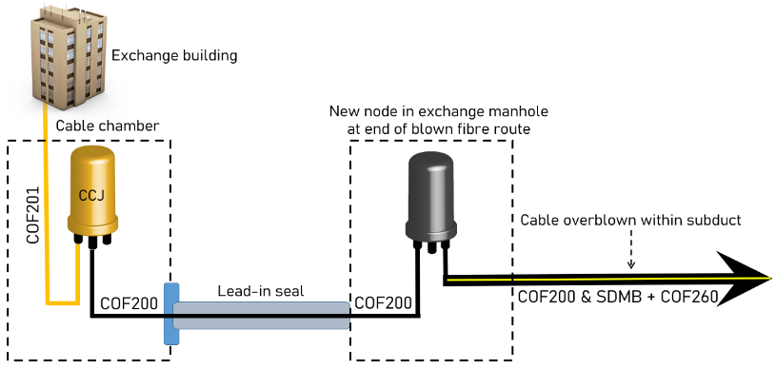

Figure 6: Node needed before cable chamber.

### Pole-mounted Nodes

COF260 can be used to serve a pole-mounted node. For example, when the jointing chamber is too congested but there is space available on a nearby pole. The cable must be protected with kopex between the jointing chamber and the pole-mounted node.

## Avoiding congested or damaged duct

Civils should be avoided, where possible, by using our full range of techniques. The Intranet page titled "To dig or not to dig" explains the key principles: <https://intra.bt.com/bt/openreach/chief-engineer/insight-videos/Pages/civils-techniques.aspx>.

## Recording

Planners must ensure that all optical fibre cables are recorded in the right systems.

## Repairing damage to the overblown network

EPT/COF/R001 "Fibre - Damage – Repair – Policy" describes how to repair damaged SDMB and overblown cable.

# Synthetics

The table below has the GQTT and WAU associated with overblowing.

|  |  |  |
| --- | --- | --- |
| Code | Title | Unit of Issue |
| N39A | ONSA - Overblow pre-planning survey | per survey |
| N66A | Provision of overblow cabling (First 1000m) | first 1000 metres |
| N66B | Subsequent provision of overblow cabling | per 100 metres |
| NI7G | Overblow fibre cable into existing subduct U/G | per 100 metres |

# Stakeholders

|  |  |
| --- | --- |
| Name | Role |
| Nigel Allsop | Senior Transition Lead |
| Steve Cooper | Senior Manager, Access Architecture & Economics |
| Stan Edwards | Senior Manager, Network Policy, Standards and Accreditation |
| Arthur Gormley | Senior Manager, Partner Management |
| Hamish Foster | Senior Manager, Full Fibre Delivery |
| Steven Miles | Network Cable Specialist |
| Paul Quinton | Senior Manager, Spine Planning |
| Denise Robinson | Access Components Copper & NGA Specialist |

# Further Guidance

## Useful ISIS

For further guidance, please also refer to:

* EPT/COF/R001 Fibre - Damage – Repair – Policy
* EPT/COF/D960 Openreach Overblow: Equipment & Practice
* EPT/UGP/B100 Civils Manual
* EPT/UGP/B101 FTTP D.i.G Estates, Civils & Cabling
* NWK/LNK/C212 Fibre – Spine Planning - Policy
* NWK/LNK/C587 Chief Engineer Innovations

# Further Network Policy Guidance

## Network Policy, Quality & Accreditation Website

[Network Policy, Quality & Accreditation](https://intra.bt.com/bt/openreach/chief-engineer/network-evolution/networkpolicy/Pages/index.aspx) is the front door to all things policy, with links to policy documentation and guidance.

## Network Policy Briefings & Planning Communications

[Network Policy Briefings & Planning Communications](https://intra.bt.com/bt/openreach/chief-engineer/network-evolution/networkpolicy/plcomms/plcommspol/Pages/index.aspx) provides an interim method to communicate key network policy/planning policy, pending inclusion of the briefing content into the relevant Policy ISIS document.

Registration for Network Policy Briefings & Planning Communications ensures that you will be notified once a policy briefing is either published or updated.

To register for notifications, please go to:

* [Registration for Policy Briefings and Planning Communications](http://managementinformation.intra.bt.com/directorycheck/logon.asp?caller=http://managementinformation.intra.bt.com/policy_Team/registration.asp)

## Policy & Build App

The Policy and Build app has been launched and is available to all iPhone (automatically uploaded) and Android users who can view this ‘[How to guide](https://openreach.office1.bt.com/sites/network-evolution-policy/_layouts/15/WopiFrame.aspx?sourcedoc=%7b7b0c2461-a0d3-43d3-80a3-bcad911b2816%7d&action=default)’ for assistance when trying to download the app.

It includes essential network policy and build ISIS documents covering engineering topics from the exchange to our customers' premises.

Feedback functionality will allow you to suggest more content by texting the word POLICY to 81192 followed by your suggestion.

For more information on the Policy & Build App please contact:

[mark.a.fletcher@openreach.co.uk](mailto:mark.a.fletcher@openreach.co.uk)

[ada.hilton@openeach.co.uk](mailto:ada.hilton@openeach.co.uk)

## Policy team Workplace Groups

[Workplace - how to join](http://ophonemedia.nat.bt.com/store/looplive/Roger/GETTING_STARTED_PDF.pdf)​ is a step-by-step guide to creating an account on Openreach's Workplace.

### Network Policy: Workplace Group

[Network Policy](https://openreach.workplace.com/groups/1386032428270827/) has the policy team's recent posts and regular videos.

### Network Policy Academy: Workplace Group​

[Network Policy Academy](https://openreach.workplace.com/groups/482047913192771/) provides a series of short network policy modules as a visual guide to understanding, and to evaluate you if you're feeling confident!

### Network Myths & Legends: Workplace Group

[Network Myths & Legends](https://openreach.workplace.com/groups/264153295275831/),as they are dispelled by Openreach's Chief Engineer, Andy Whale.

# Glossary

|  |  |
| --- | --- |
| Term | Definition |
| BFB | Blown Fibre Bundle |
| CCJ | Cable Chamber Joint |
| COF | Cable Optical Fibre |
| f | fibres |
| ⌀ | diameter |
| PDF | Portable Document Format (ISO 32000) |
| SDMB | Sub Duct Mono Bore |

For a comprehensive list of acronyms: [Glossary of terms](https://openreach.office1.bt.com/sites/network-evolution-policy/_layouts/15/WopiFrame2.aspx?sourcedoc=%7bD7A1380B-89B7-4656-B562-BDD3A1845AE6%7d&file=Openreach%20acronyms.docx&action=default)

END OF DOCUMENT