

**American International University-Bangladesh**

**Project Report**

**Software Engineering, Fall 2019-20**

**SECTION: J**

**COURSE TEACHER: SUPTA RICHARD PHILIP**

|  |  |
| --- | --- |
| **NAME** | **ID** |
| **ASHFAQ AFZAL CHOWDHURY**  <https://github.com/aacfahim/jobportal> | **17-35800-3** |
| **MD FAHIM HOQUE**  [https://github.com/](https://github.com/aacfahim/jobportal)arnob-hoque | **17-35864-3** |
| **IFTIKHER AHMED LIUM**  [https://github.com/](https://github.com/aacfahim/jobportal)Ialiam | **17-35793-3** |
| **MD RAFIQUL ISLAM**  [https://github.com/](https://github.com/aacfahim/jobportal)r0fiqulislam | **17-35850-3** |
| **MD MINHAZUL ISLAM OMI**  [https://github.com/](https://github.com/aacfahim/jobportal)MinhazOmi | **17-35811-3** |

**JOB PORTAL**

**Stack Holder:**

* Administrator. A group of people or an individual who is maintaining the entire system by monitoring and analyzing the application along with centralized database.
* Job Seeker. Job seeking people who are searching for jobs through the Job Portal Application.
* Job Provider. Who are recruiting employees by posting job offers through the application.
* UML designing member
* Project implementation members

**Requirements:**

Job portal is an application which connects employers and job seekers where employers are the source of the resources and the job seeker can find and apply for their targeted job.

It is built in java that provides the candidates ability to Register to this application and search for jobs and manage their accounts. Each candidate will have their own account with their own home page.

On the other hand, companies that are willing to publish the jobs for their company to candidates can register to the job provider and get their own account created and can post jobs to provider’s database. Registered companies can add or remove jobs and these jobs can be seen by various candidates and they can apply for it. Main aim of this web application is to make a good application that can make this job search option easy and accessible to everyone who is interested.

A Centralized database is maintained in between a job provider and a job seeker by an administrator so that it is accessible every registered user. The database is controlled so that unnecessary are not stored in the database and are deleted as they are completed. The entire system is built taking at most care of user friendliness and simplicity.

**Objective of the project:**

* Registration
* Login
* Updating profile
* Posting a job and removing or modifying job
* Searching for a job

**Some key points of this application:**

* Job portal consists of three actors which are Admin, Job Seeker and Job Provider
* This can be also providing information about online job.
* The customer can get the registration.
* The Job Portal application can be used by any employee to apply job and any employer are post to job.
* This application also provides advanced searching functionality so that a job seeker can search the required jobs according to their qualifications and interests.

**USE CASE DIAGRAM:**

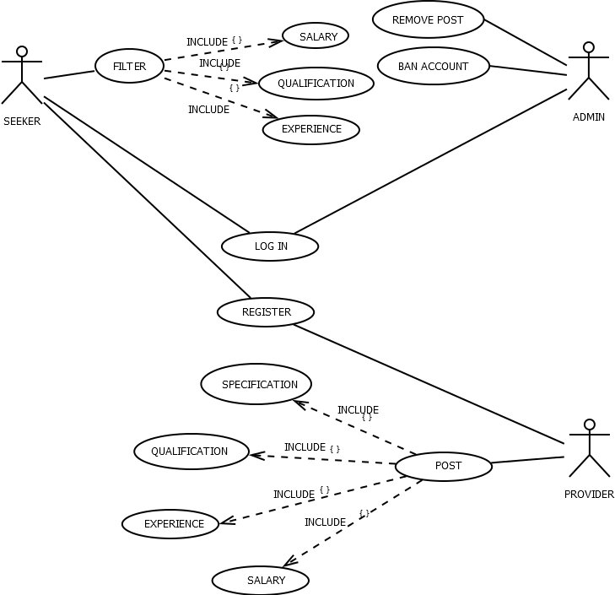

**ER DIAGRAM:**

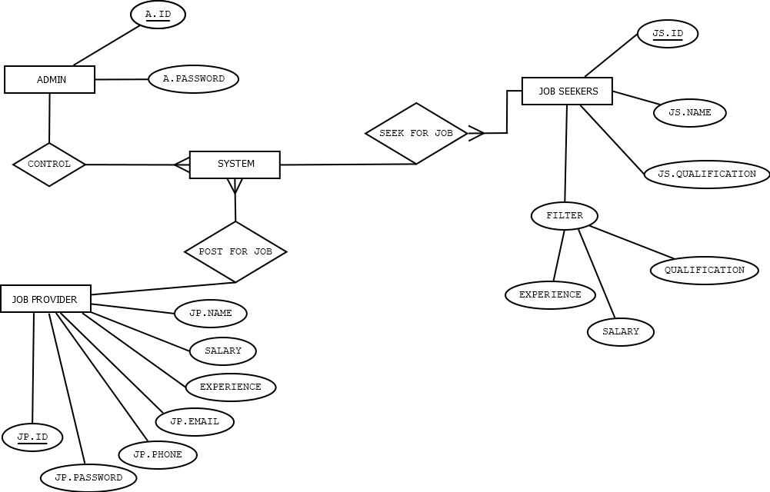

**ACTIVITY DIAGRAM:**

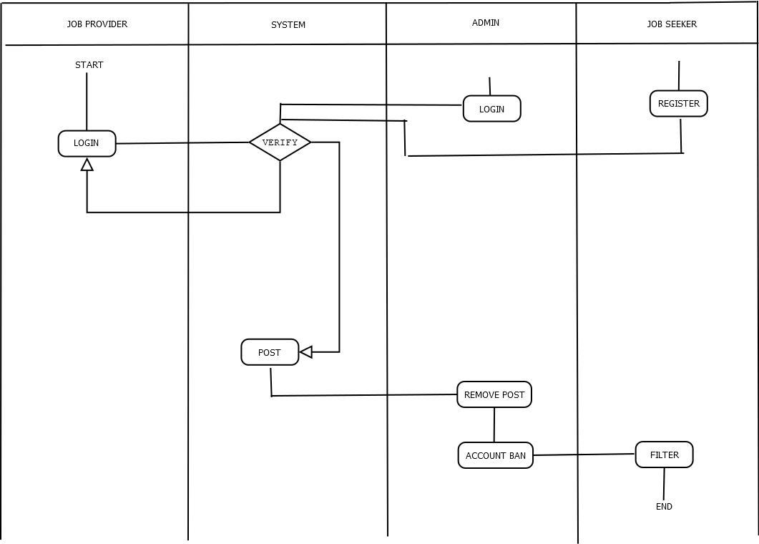

**CLASS DIAGRAM:**

