**DB2 PROJECT 2 PHASE 2**

**Team Members for Group 1:**

|  |  |
| --- | --- |
| **Name** | **ID** |
| Elsy Fernandes | **1001602253** |
| Maria Lancy Devadoss | **1001639262** |

**Queries**

**retrieve all team scores for the team “Japan”**

db.TEAM_SCORES.find({Team: ‘Japan’ })

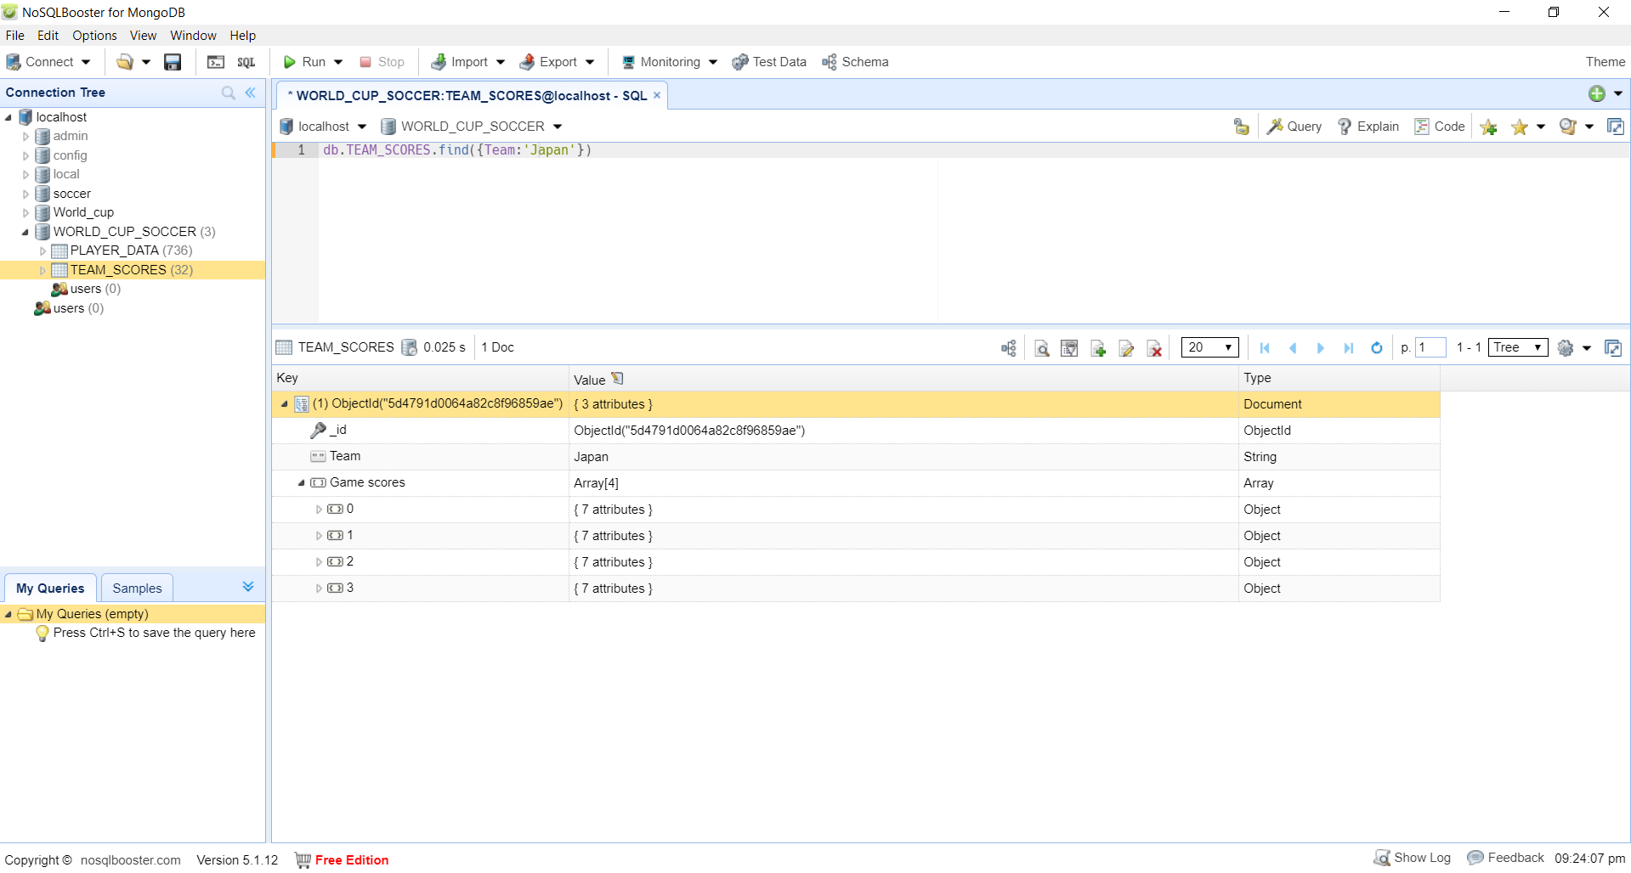

**Retrieve all team scores for Team Russia where Russia score is greater than 2**

db.getCollection('TEAM_SCORES').aggregate([

{ "$unwind": "$Game_scores" },

{ "$match":{"Game_scores.TeamScore":{$gt:2},"Game_scores.TeamName":'Russia'}},

{ "$project": {

"_id": 0,

"Game_scores.TeamName": 1,

"Game_scores.TeamScore": 1,

"Game_scores.OpposingTeam": 1}

}

])

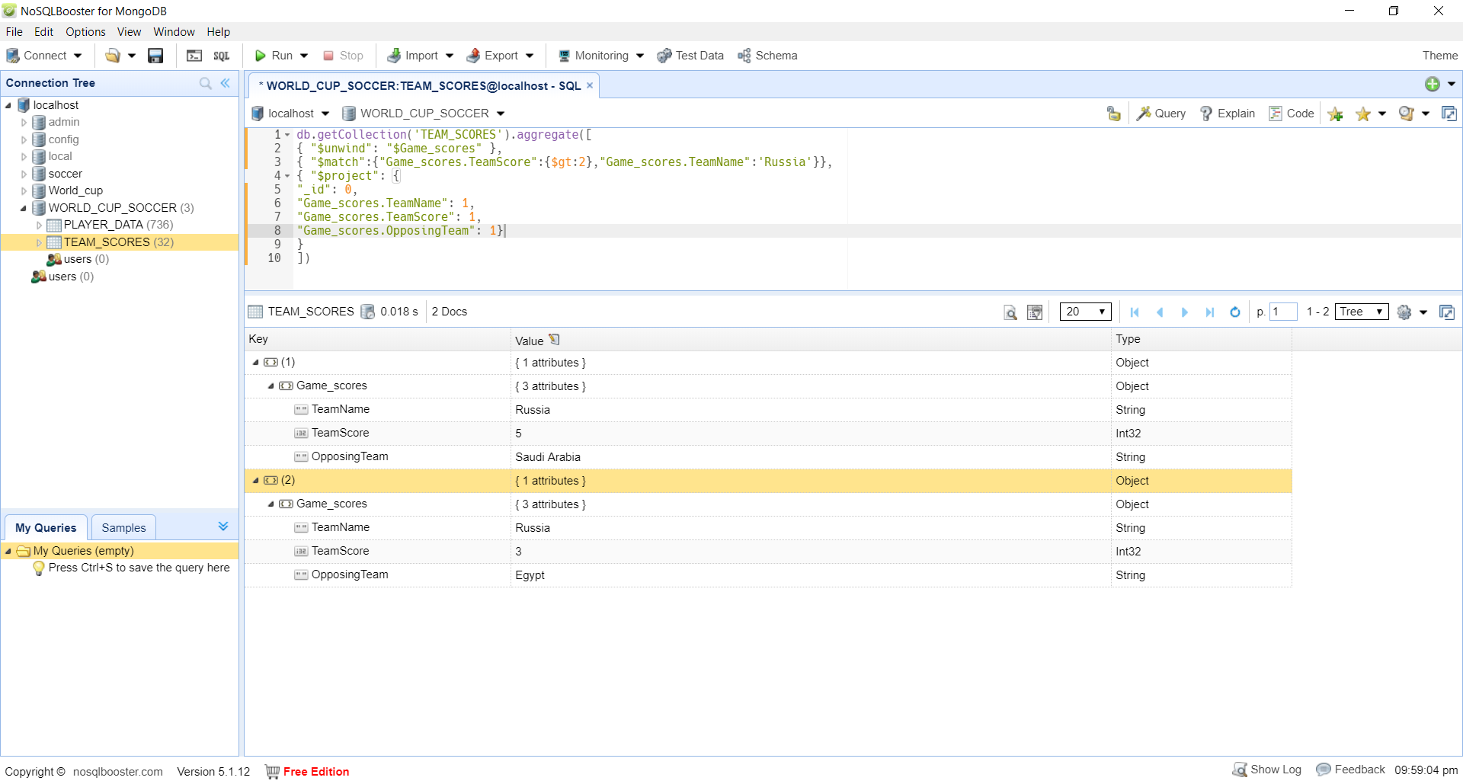

**Display number of goals scored by each player in PLAYER_DATA**

db.getCollection('PLAYER_DATA').aggregate([

{ "$project": {

"_id": 0,

"Player Name" : 1,

"Position" : 1,

"Team" : 1,

"No of goals": { "$size": "$Player_Goals_collection" }

}},

{ "$sort": { "No of goals": -1 }

}

])

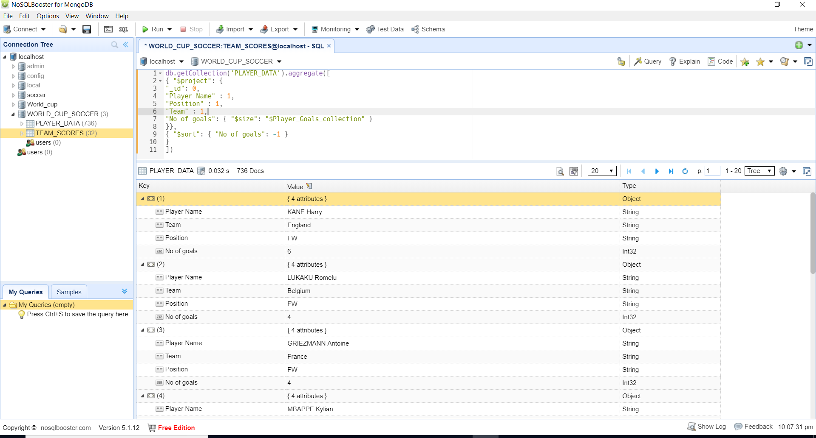

**Retrieve Player_Data who scored Penalty Goal**

db.getCollection('PLAYER_DATA').aggregate([

{"$unwind": "$Player_Goals_collection" },

{ "$match": {"Player_Goals_collection.Goal Type":'Penalty'}},

{ "$project": {

"_id": 0,

"Player Name" : 1,

"Position" : 1,

"Team" : 1,

"Player_Goals_collection.Goal Type" : 1

}},

])

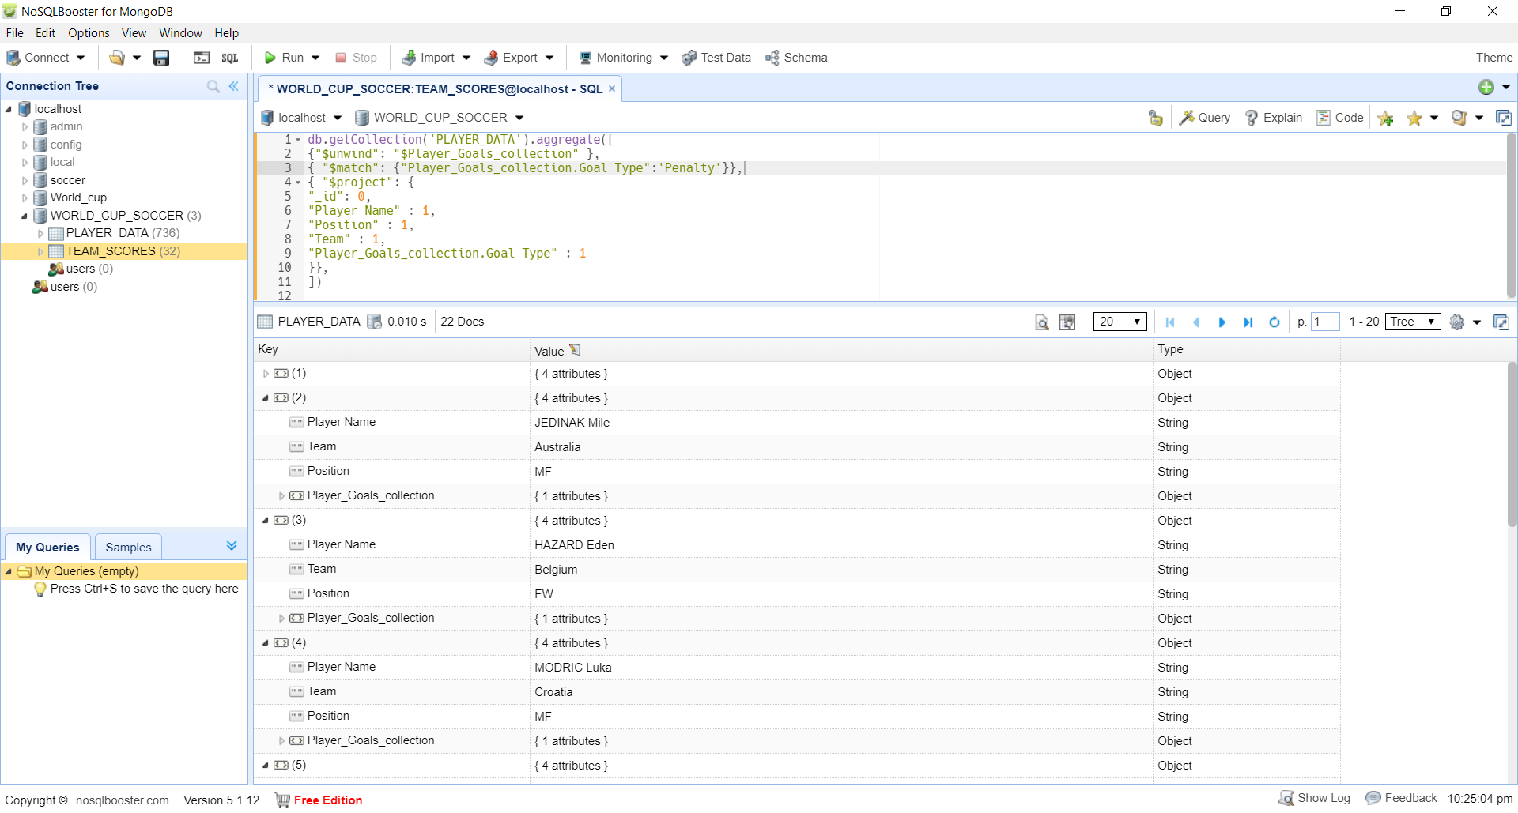

**Retrieve Team scores where team 1 or team2 scored more than 4 goals**

db.getCollection('TEAM_SCORES').aggregate([

{ "$unwind": "$Game_scores" },

{ "$match": {"$or": [{"Game_scores.TeamScore":{$gt:4}},{"Game_scores.OpposingScore":{$gt:4}}]}},

{ "$project": {

"_id": 0,

"Game_scores.TeamName": 1,

"Game_scores.TeamScore": 1,

"Game_scores.OpposingTeam": 1,

"Game_scores.OpposingScore" :1,

"matches collection.Stadium Name": 1}

}

])

