Name: Elsy Fernandes

Student Id:100602253

CSE 5321 Homework 1

Fall 2019

Question 1-5 worth 14 percent each. Question 4 is worth 30 percent. 100 points total

Guidance for all problems:

1. Develop the minimum set of test cases needed to adequately test all actions and boundary values.
2. List all inputs and expected outputs using the test case table shown in the problem.
3. Develop the test needed for all partitions with two test cases per partition, where possible.
4. Assume that currency is truncated to the nearest cent.
5. State any assumptions made, but do not change the function of the problem.

The following are customer descriptions of software scenarios. For each problem state any assumptions made - but **do** **not** **change** the function being described.

1) Maverick Financial Planner is an investment management software that helps its customers keep track of shares bought of Hoopla Technology Ltd and calculates the portfolio amount. The Portfolio amount is defined as total value of all shares including dividends received and fees paid, if any. The software keeps track of the customer’s portfolio amount, status of the customer and the amount of brokerage fees paid by the customer. If the number of shares owned is less than or equal to 100, Hoopla pays a dividend of 0.79%. For shares between 100 and 350, the dividend received is 1.13%. For shares greater than 350, the dividend received is 1.82%. For shares greater than 500, the dividend received is 2.09%. For shares greater than 750, the dividend received is 2.44%. For shares above 1000, the dividend received is 3.33%. If a customer has more than 350 shares, he/she is required to pay a brokerage fee of $75, which is automatically deducted from the dividend. A customer receives a “Prime” status, when his/her share amount is greater than 1,000 shares. Use below given formulas for your calculation:

Value of Shares = Number of Shares * Value of each share

Dividend Received = Dividend% * Value of Shares

Assumptions for this problem:

1. Assume the closing price of a Hoopla share is $140.0.

2. Customers are only allowed to own whole, non-negative shares.

3. Assume all fees and statuses need to be tracked.

Use the following template for your test case table.



2) Metro Arlington Xpress (MAX) operates bus service between Arlington and Dallas. MAX wants to measure traveler frequency on its bus service and the software has been designed to count this volume. The tester is assigned the task of developing test cases needed to test all actions and boundary values. The software counts the volume of passengers - these requirements are specified elsewhere - the customer desires that the tester develops acceptance tests based on the analysis of the volume which is the following.

Holiday travel volume is 200 % higher than weekend volume. Weekend volume reduces by 40% over business day (M-F) travel. The average weekday rate of passengers is 45 passengers/hour. Volume increases for travel that departs after 6:00 am (high volume traffic) by a factor of 1.75 over average hourly volume. ﻿﻿All high-volume traffic uses this same factor. Low volume traffic occurs for local departures after 8.00 am until 2pm pm. High volume traffic also applies to buses leaving on or after 2 pm. Buses later than 7 pm revert back to Low volume traffic.

Additional guidance:

1. Volume calculations are always truncated to the whole person.
2. Assume significance of 1 second on time.
3. For the test cases start the day at 12 midnight (12:00:00 "am").

Use the following template for your test case table.



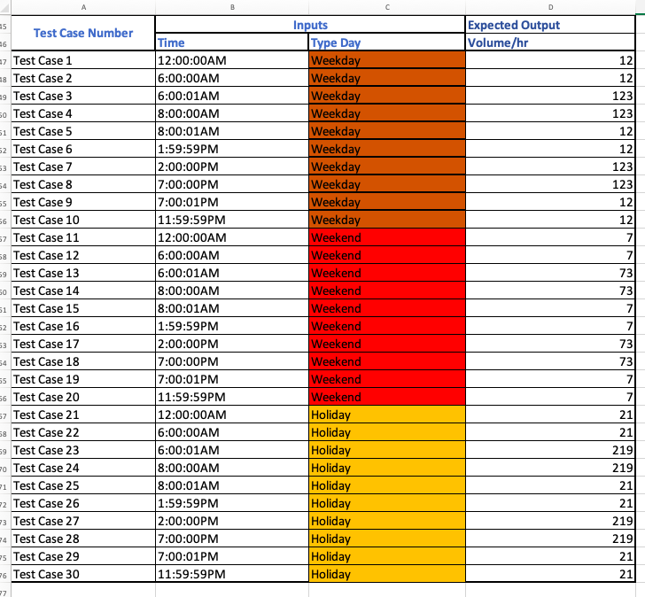

3) A car uses gas at a rate of 35 miles/gallon. The owner drives his car an average of 62.5 miles/day and has a gas tank of 25 gallons. He likes to listen to music and is sometimes a little distracted, so he forgets to pay attention to the gas gauge at all. His friends laugh at him because he has run out of gas several times. He got an upgrade made by a local dealer so that the car now has a bell, buzzer, and red, yellow and green lights. The bell and buzzer are triggered at 1/2 tank and 1/4 tank respectively. The green light is on when there is less than or equal to 5.5 gallons, yellow when less than 15 gallons, and red when less than or equal to 20. He is hoping all of these warnings will solve his problem.

Additional guidance:

1. Assume all values are Java doubles with a significance of 0.1.
2. Also assume that when the car is filled, all alerts reset because they are above their trigger levels.

Use the following template for your test case table. Bell, Buzzer, Red, Yellow, Green={On, Off}



4) Maverick Financial Planner (Question 1) has acquired a huge customer base, and around 20% of its total customers have achieved the Prime status. In order to better recognize their prime customers, they have now decided to replace the previous recognition ("Prime") with a new recognition scheme: “Silver” status for customers with portfolio amount after dividends and fees greater than or equal to $150,000.00; “Gold” for customers with portfolio amount after dividends and fees greater than or equal to $200,000.00; and “Platinum” for customers with portfolio amount after dividends and fees greater than or equal to $250,000.00.

Use the following template for your test case table.



5) Convert the first three problems above into decision tables. Divide this problem into parts a) b) and c) for problem 1, 2 and 3 respectively. For each, provide

1. the decision table
2. the number of test cases required (do not supply the specific test cases)
3. does this number agree with the number of tests developed above? Yes or No. If no, why not?

6) You are to implement and test the software that operates a bank safe. The safe has the following components:

1. A keypad with digits 0-9
2. An Enter button
3. A Clear button
4. An Unlock button
5. A Lock button
6. A blue LED
7. A red LED
8. A yellow LED
9. A green LED
10. A lock bolt (not shown)

The following are the inputs to the safe software:

1. A keypad with digits 0-9
2. Number depressed (N) {T/F}
3. Numeric value depressed (V) {0-9}
4. Enter button depressed (E) {T/F}
5. Clear button depressed (C) {T/F}
6. Unlock button depressed (U) {T/F}
7. Lock button depressed (L) {T/F}

and the outputs from the software:

1. A red LED (R) {T/F}
2. A green LED (G) {T/F}
3. A blue LED (B) {T/F}
4. A yellow LED (Y) {T/F}
5. A lock bolt (B) {T/F}

The software uses these internal variables:

1. Code1 (two-digit integer value)
2. Code2 (two-digit integer value)
3. D1 (single digit integer)
4. D2 (single digit integer)
5. PIN1 (factory set) - two-digit integer value
6. PIN2 (factory set) - two-digit integer value

The safe operation is described as follows

A four digit code is required to unlock the safe. The user must successively enter a four-digit code to unlock the safe. The detailed operation from a user perspective is as follows to unlock the safe

1. The user presses a first single digit, D1
2. The user presses a second single digit, D2
3. The user presses a third single digit, D3
4. The user presses a fourth single digit, D4
5. The user presses the Enter button
6. The user presses the U button, if the safe combination is correct the safe is unlocked

Digits are read by the software as follows.

1. When the user selects a digit, N=T.
2. The software reads the V value provided by the safe (single digit integer) and sets D1=V.
3. This sequence is repeated to get all four values (D1, D2, D3, and D4).

The lights operate as follows.

1. When the first digit D1 is selected, only the Blue light (B) is turned on (B=T,R=F,Y=F,G=F).
2. When the second D2 is selected, only the Red light (R) is turned on (B=F,R=T,Y=F,G=F).
3. When the third D3 is selected, only the Yellow light (Y) is turned on (B=F,R=F,Y=T,G=F).
4. When the fourth D4 is selected, only the Green light (G) is turned on (B=F,R=F,Y=F,G=T).
5. When the Enter button is pressed (E) or when the safe is powered on, all lights are turned off (B=F,R=F,Y=F,G=F).
6. When the safe is unlocked all 4 lights are turned on (B=T,R=T,Y=T,G=T).

E button rules follow.

1. Ignored unless all four digits have been entered.
2. Ignored when the safe is unlocked.

U button rules follow.

1. Ignored unless all four digits have been entered and the E button has been pressed.
2. When all four digits have been entered and the E button has been pressed all 4 concatenated digits D1D2D3D4 are compared to the Code value with the following result
   1. If not equal, returns to the idle state and turns lights off (B=F,R=F,Y=F,G=F).
   2. If equal, unlocks the safe (B=Unlock) and turns lights on (B=T,R=T,Y=T,G=T).

In either case it sets D1=D2=D3=D4=null.

1. U is ignored when the safe is unlocked.

L button rules follow.

1. Ignored unless the safe is unlocked.
2. If the safe is unlocked when L is pressed, the safe is locked and the software goes to the idle state. All digits entered are set to null. All lights are turned off.

C button rules follow.

1. The last entered single digit is set to null - all other digits remain at their previous values. The lights are set based on non-null digits (see previous description on lights). The lights indicate the number of digits still captured.
2. Ignored when the safe is unlocked.

N indicator rules follow.

1. N is ignored when the safe is unlocked.
2. N is ignored when all four digits have been entered.

Start rules follow.

1. The software starts with the safe locked and all lights off. D1=D2=D3=D4=null. This is the idle state.

Submit the State diagram.

State diagram.

1. Draw the state diagram and number states from S0 to S(N-1).
2. Each state must consider all inputs and show all outputs.
3. Use the single letter abbreviations for inputs and outputs on your diagram.
4. This may be hand drawn.

