**Statement of Work:**

***Integration Taxilla with Simphony***

***INDPT***

**Contents**

|  |  |
| --- | --- |
| **Page** | |
| 1. Document Use | **3** |
| 2. Revision Information | **3** |
| 3. Introduction / Background | **3** |
| 4. Description of Services | **3** |
| 5. Your Obligation and Project Assumptions | **6** |
| 6. Project Management | **7** |
| 7. Prerequisites | **7** |
| 8. Expenses | **7** |
| 9. Estimate Delivery | **8** |
| 10. Acceptance | **8** |
|  |  |

# Document Use

The following is intended to outline our general product direction. It is intended for information purposes only, and may not be incorporated into any contract. It is not a commitment to deliver any material, code, or functionality, and should not be relied upon in making purchasing decision. The development, release, and timing of any features or functionality described for KIT products remains at the sole discretion of KIT.

1. **Introduction / Background**

This document is a statement of work for integration of the Taxilla Program with Simphony in INDPT.

# Description of Services

KIT will assist you with the following services:

## Post Invoice Data to Taxilla

## Description:

* During the final tender below tasks will be done.
* Auth token API will be called for generating authorization token.
* Auth token will be used for authorization in Post Data API.
* Post Data API will be called with necessary fields.

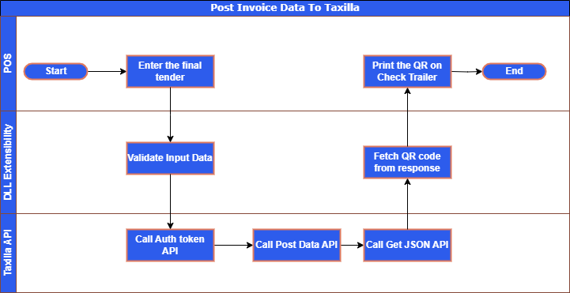

## Print QR on Check Trailer

## Description:

* During the final tender after calling Post Data API, Get Json API will be called.
* From the response we will print the QR code at the check trailer.

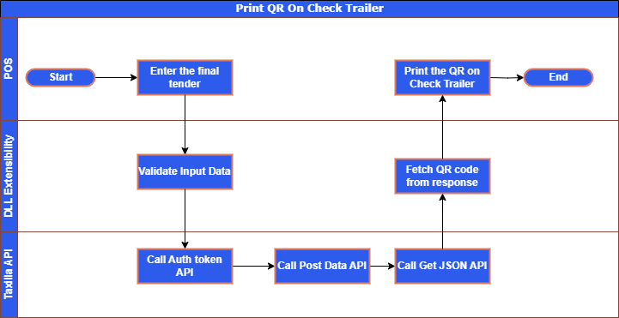

## KIT will assist with the following services:

* Provide all functionalities mentioned in ‘Description of services'.
* Implement System on Site. Configure System extension application.
  + ISL file and
  + DLL file
* Test and verify the system functionality.
* Implementation in production system.

# Your Obligations and Project Assumptions

You acknowledge that your timely provision of and access to assistance, cooperation, complete and accurate information and data from your officers, agents, and employees (collectively, “cooperation”) are essential to the performance of any services as set forth in this exhibit. K I T will not be responsible for any deficiency in performing services if such deficiency results from your failure to provide full cooperation. You acknowledge that KIT’s ability to perform the services and any related estimate depends upon your fulfillment of the following obligations and the following project assumptions:

# Obligations:

1. Provide access to Property server IPs to Test and Implement.
2. Provide required security permissions for the Program to work well.
3. Provide, for all K I T resources performing Services at Your site, a safe and healthful workspace (e.g., a workspace that is free from recognized hazards that are causing, or likely to cause, death or serious physical harm, a workspace that has proper ventilation, sound levels acceptable for resources performing Services in the workspace, and ergonomically correct work stations, etc.). Provide any notices, and obtain any consents, required for KIT to perform Services.

# Project Assumptions

1. The parties acknowledge and agree that the performance of Services does not require or involve the processing of personal data.
2. K I T Services will be performed under your direction, and you shall remain responsible for management of the Services and any outputs arising.
3. Project cost is based on hours proposed.

# Prerequisites

* Test Workstation
* Simphony EMC access
* UAT server access and CAPS DB Server Access.
* Production server access.
* APIs

# Project Management

You and KIT each agree to designate a Project Manager who shall work together with the other party's Project Manager to facilitate an efficient delivery of Services.

# Expenses

The Services specified above are provided on a time and materials ("T&M") basis; that is, you shall pay KIT (if charges are involved) for all of the time spent performing such Services, plus materials, taxes and expenses.

The Services described above will be provided at K I T’S standard consulting rates in effect when such Services are performed.

The development time estimate for labor performed under this exhibit can be found below.

**Tasks**

|  |  |
| --- | --- |
| **Development Task** | **Hours** |
| Evaluation, Analysis and Requirement gathering | **02 X 8 = 16** |
| Development | **10 X 8 = 80** |
| Testing | **02 X 8 = 16** |
| Implementation & Testing | **01 X 8 = 08** |
| **Total Days** | **120 hrs. (15Days)** |

**Note**: 15 working days are the calculated days expected in completing this project for live deployment. Out of this, the total development days are expected to be 10 working days (it may vary from this). Working days may vary if the INDPT Team failed to provide information on time. Development is dependent upon the INDPT Taxilla API’s and may require to change scope if the API’s are modified. **Implementation is charged for only one particular property in this**. Additional charges will be cited for surplus properties

These estimates and any other estimates related to this exhibit are intended only to be for your budgeting and KIT’s resource scheduling purposes. KIT will invoice you for actual time spent performing the Services, plus materials, taxes and expenses; such invoice may exceed the total estimated amount documented above. Once fees for Services reach the estimate, KIT will cooperate with you to provide continuing Services on a T&M basis.

# Estimated Delivery

TBD

# Acceptance

For avoidance of doubt, professional service fees quoted in this proposal are estimates. The service scope and fees payable for the services will require final confirmation and mutual agreement via the finalized Statement of Work (SOW) process prior to SOW signature.

Changes in scope may impact the amount quoted in this proposal. This has been developed for the exclusive use of INDPT and should not be copied into any other environments / database.

No service will begin without a Customer/K I T signed Statement of Work (SOW). This Statement of Work is valid for thirty (30) days from date of issue.

|  |  |
| --- | --- |
| Company |  |
| Full Name |  |
| Title |  |
| Signature |  |
| Date |  |