MG MOTOR INDIA
AutoPredict — Predictive Maintenance Platform

Technical Architecture Document

System design, technology stack, and architectural decisions

Version: v1.0
Date: July 2025
Status: Confidential — Internal Use
Platform: AutoPredict v2.0

1. Executive Summary
AutoPredict is a full-stack predictive maintenance platform built for MG Motor India. It processes vehicle telemetry from TBox ECUs in real time, applies LightGBM machine learning models to predict component failures up to 30 days in advance, and surfaces actionable maintenance alerts through a React-based dealer portal. The platform is designed for offline-first operation using CSV data stores, enabling deployment in environments with limited connectivity.

2. System Architecture Overview
The system is organised into five distinct layers, each with a clear responsibility boundary:
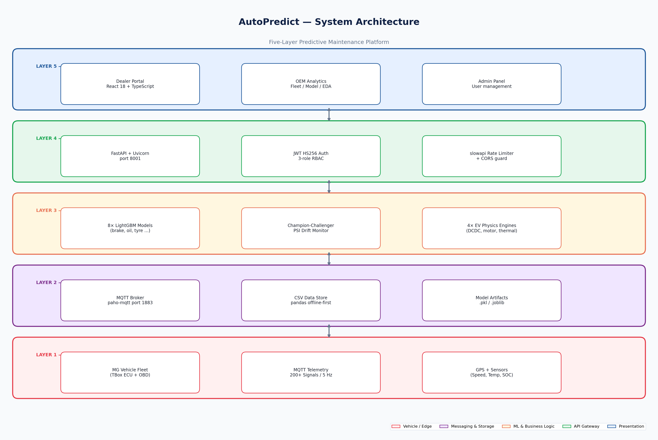
Figure 1 — Five-layer system architecture of AutoPredict
Layer 1 — Vehicle / Edge: MG vehicles equipped with TBox ECUs emit 200+ telemetry signals at 5 Hz via MQTT. Signals follow the MG TBox Big Data Specification with EV/PHEV/ICE schema variants.
Layer 2 — Messaging & Storage: Eclipse Mosquitto broker receives MQTT telemetry. The platform uses pandas CSV files as the primary data store — a deliberate offline-first decision enabling operation without a live database.
Layer 3 — ML & Business Logic: 8 LightGBM models provide RUL (Remaining Useful Life) predictions for major components. A Champion-Challenger registry with PSI drift monitoring governs model promotion. 4 physics-based EV engines (DCDC, motor, charging, thermal) complement the statistical models.
Layer 4 — API Gateway: FastAPI with Uvicorn provides 36 REST endpoints across 6 routers. Authentication uses JWT HS256 with three-role RBAC (DEALER/OEM/ADMIN). slowapi enforces rate limits on auth endpoints.
Layer 5 — Presentation: React 18 + TypeScript dealer portal with role-gated routing. TanStack Query v5 manages server state. Recharts renders analytics charts.

3. Data Flow Pipeline
Raw telemetry signals flow from TBox ECUs through the full stack to generate dealer-facing alerts:
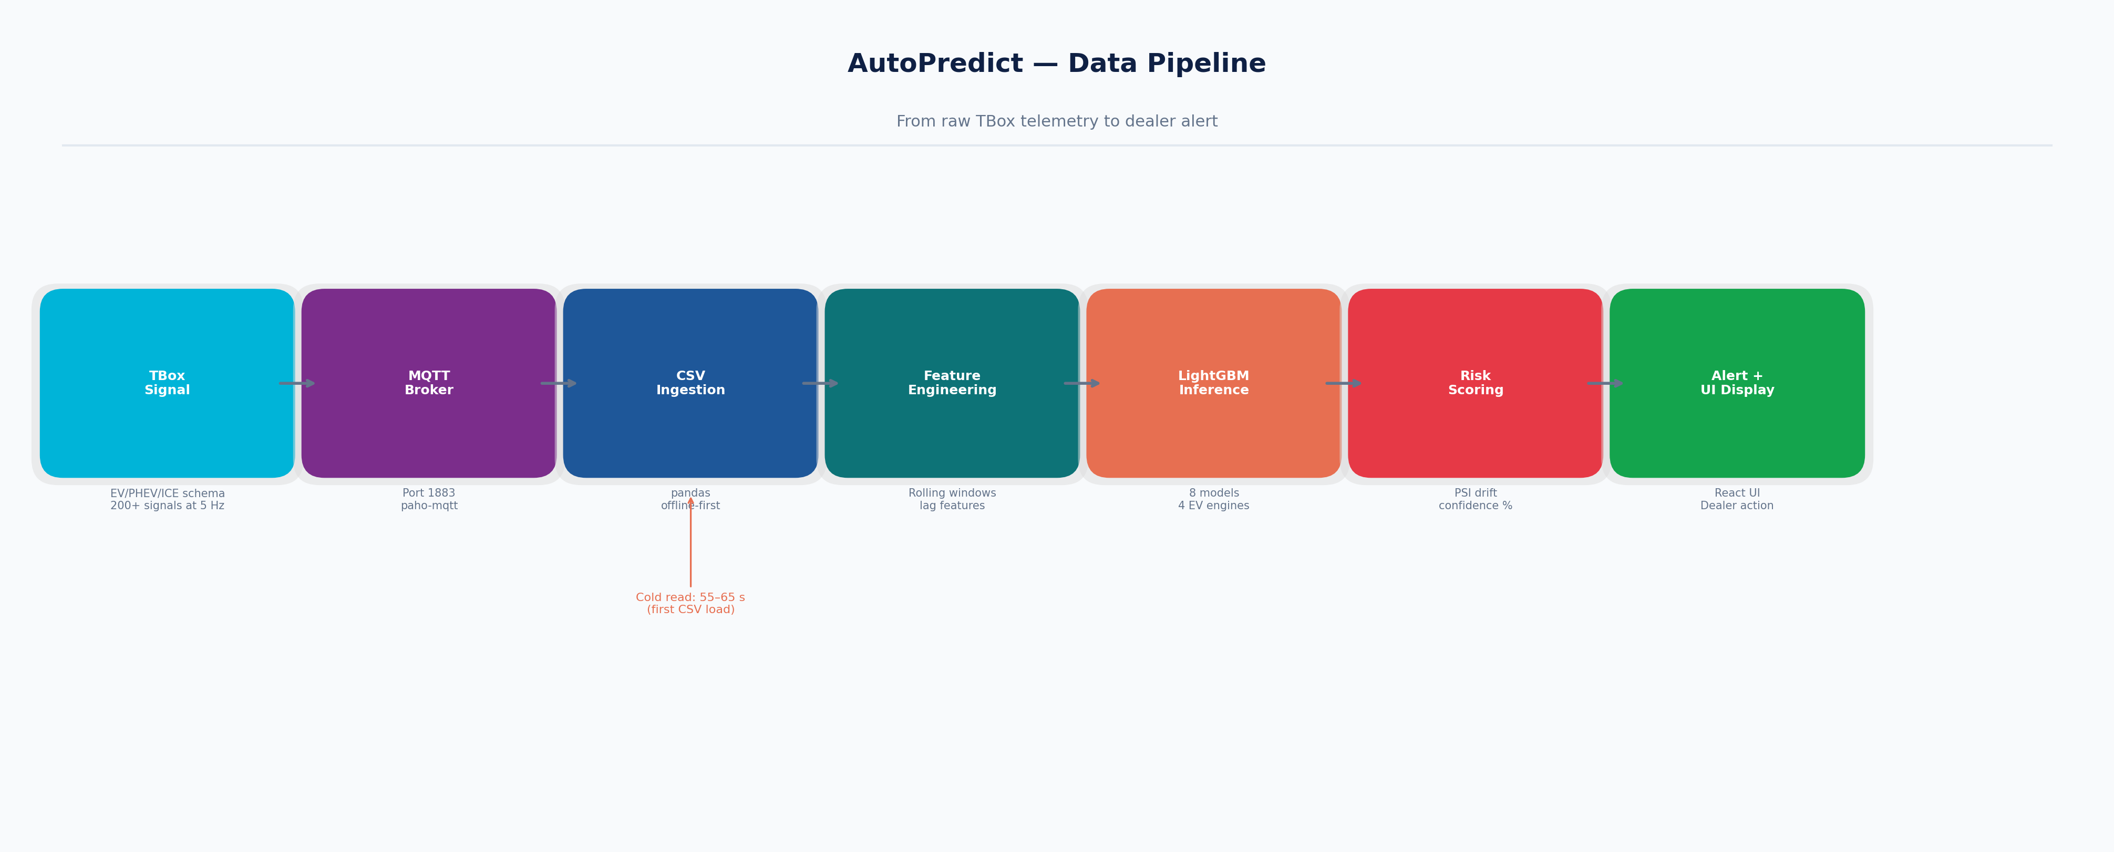
Figure 2 — Data pipeline from TBox signal to dealer alert
Note: The first CSV read on a cold start takes 55–65 seconds due to pandas loading and aggregating the full telemetry history. Subsequent reads are cached in memory.

4. Authentication & RBAC Architecture
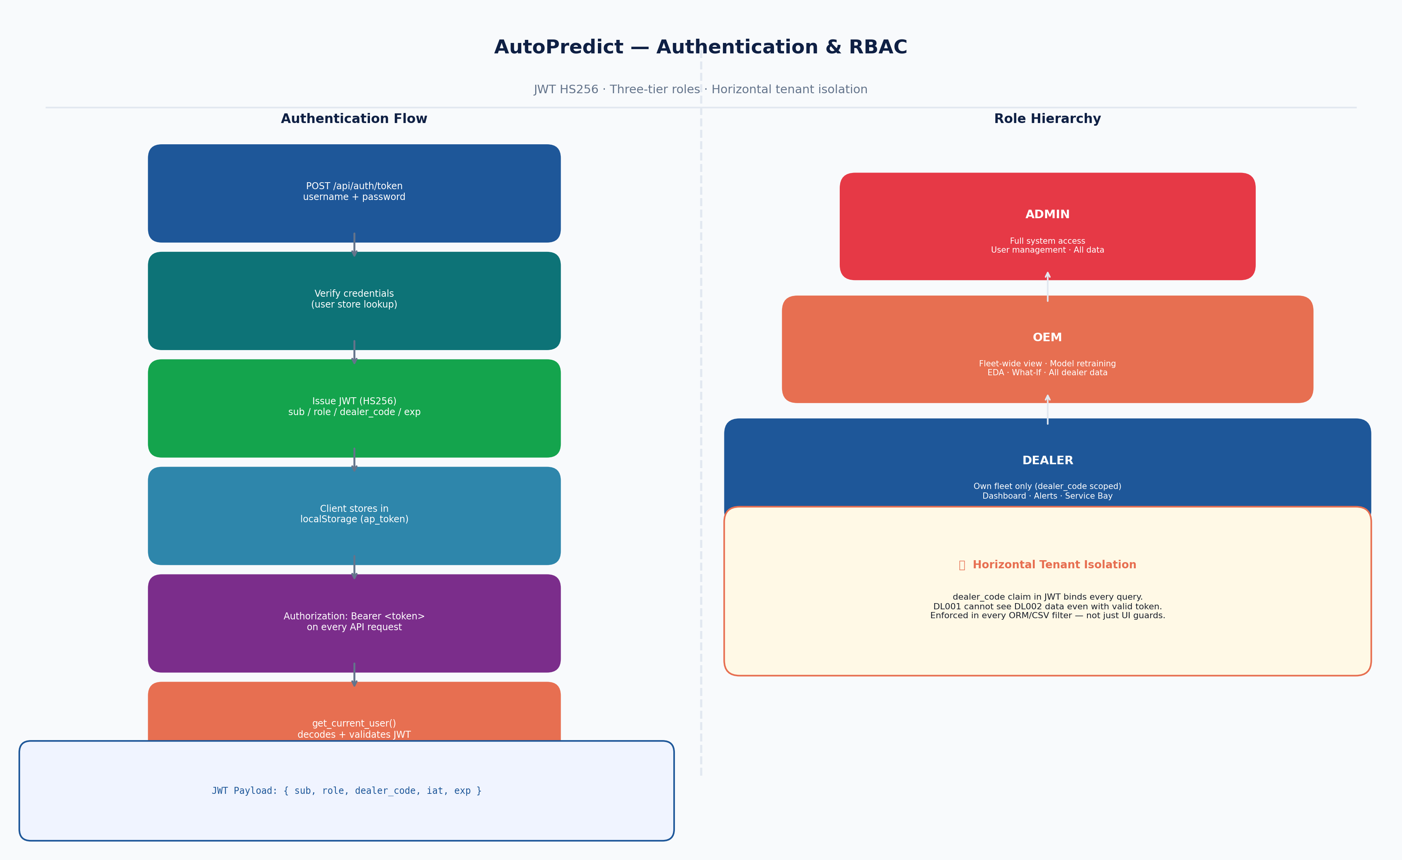
Figure 3 — JWT authentication flow and role hierarchy
The JWT payload carries three claims critical to authorisation: sub (username), role (dealer/oem/admin), and dealer_code. Every database query filters on dealer_code, ensuring that a dealer with a valid JWT cannot access another dealer's data even if they intercept or forge a token with a different dealer_code claim.

5. Technology Stack
Layer | Technology | Version | Rationale
Frontend | React + TypeScript | 18 / 5 | Component model fits the dashboard/portal pattern; TypeScript prevents runtime type errors across 11 pages
Frontend | Vite | 5 | Sub-second HMR; native ES modules; faster than CRA/Webpack for this project size
Frontend | TanStack Query | v5 | Automatic caching, stale-while-revalidate, and background refetch — eliminates manual useEffect data fetching
Frontend | Recharts | 2 | Pure SVG; passes props through to path elements enabling aria-label injection for WCAG compliance
Frontend | Tailwind CSS | 3 | Utility-first CSS eliminates naming overhead and keeps bundle size low via PurgeCSS
Backend | FastAPI | 0.110 | Auto-generates OpenAPI schema; native async; Pydantic validation at system boundary
Backend | Uvicorn | 0.29 | ASGI server; --reload during dev; single worker in prod matches CSV single-threaded constraint
Backend | python-jose | 3.3 | JWT HS256 encode/decode; battle-tested; integrates cleanly with FastAPI Depends pattern
Backend | pandas | 2.x | Offline-first CSV engine; vectorised aggregation over millions of telemetry rows
ML | LightGBM | 4.x | Gradient boosted trees; fastest training on tabular data; handles missing values natively
ML | scikit-learn | 1.4 | Feature pipeline, scaler, and model evaluation metrics
ML | paho-mqtt | 1.6 | MQTT client for TBox telemetry subscription
Testing | Playwright | 1.61 | Native TypeScript; built-in APIRequestContext; reliable cross-browser automation
Testing | axe-core | 4.x | WCAG 2.1 AA automated accessibility scanning in-browser

6. Deployment Architecture
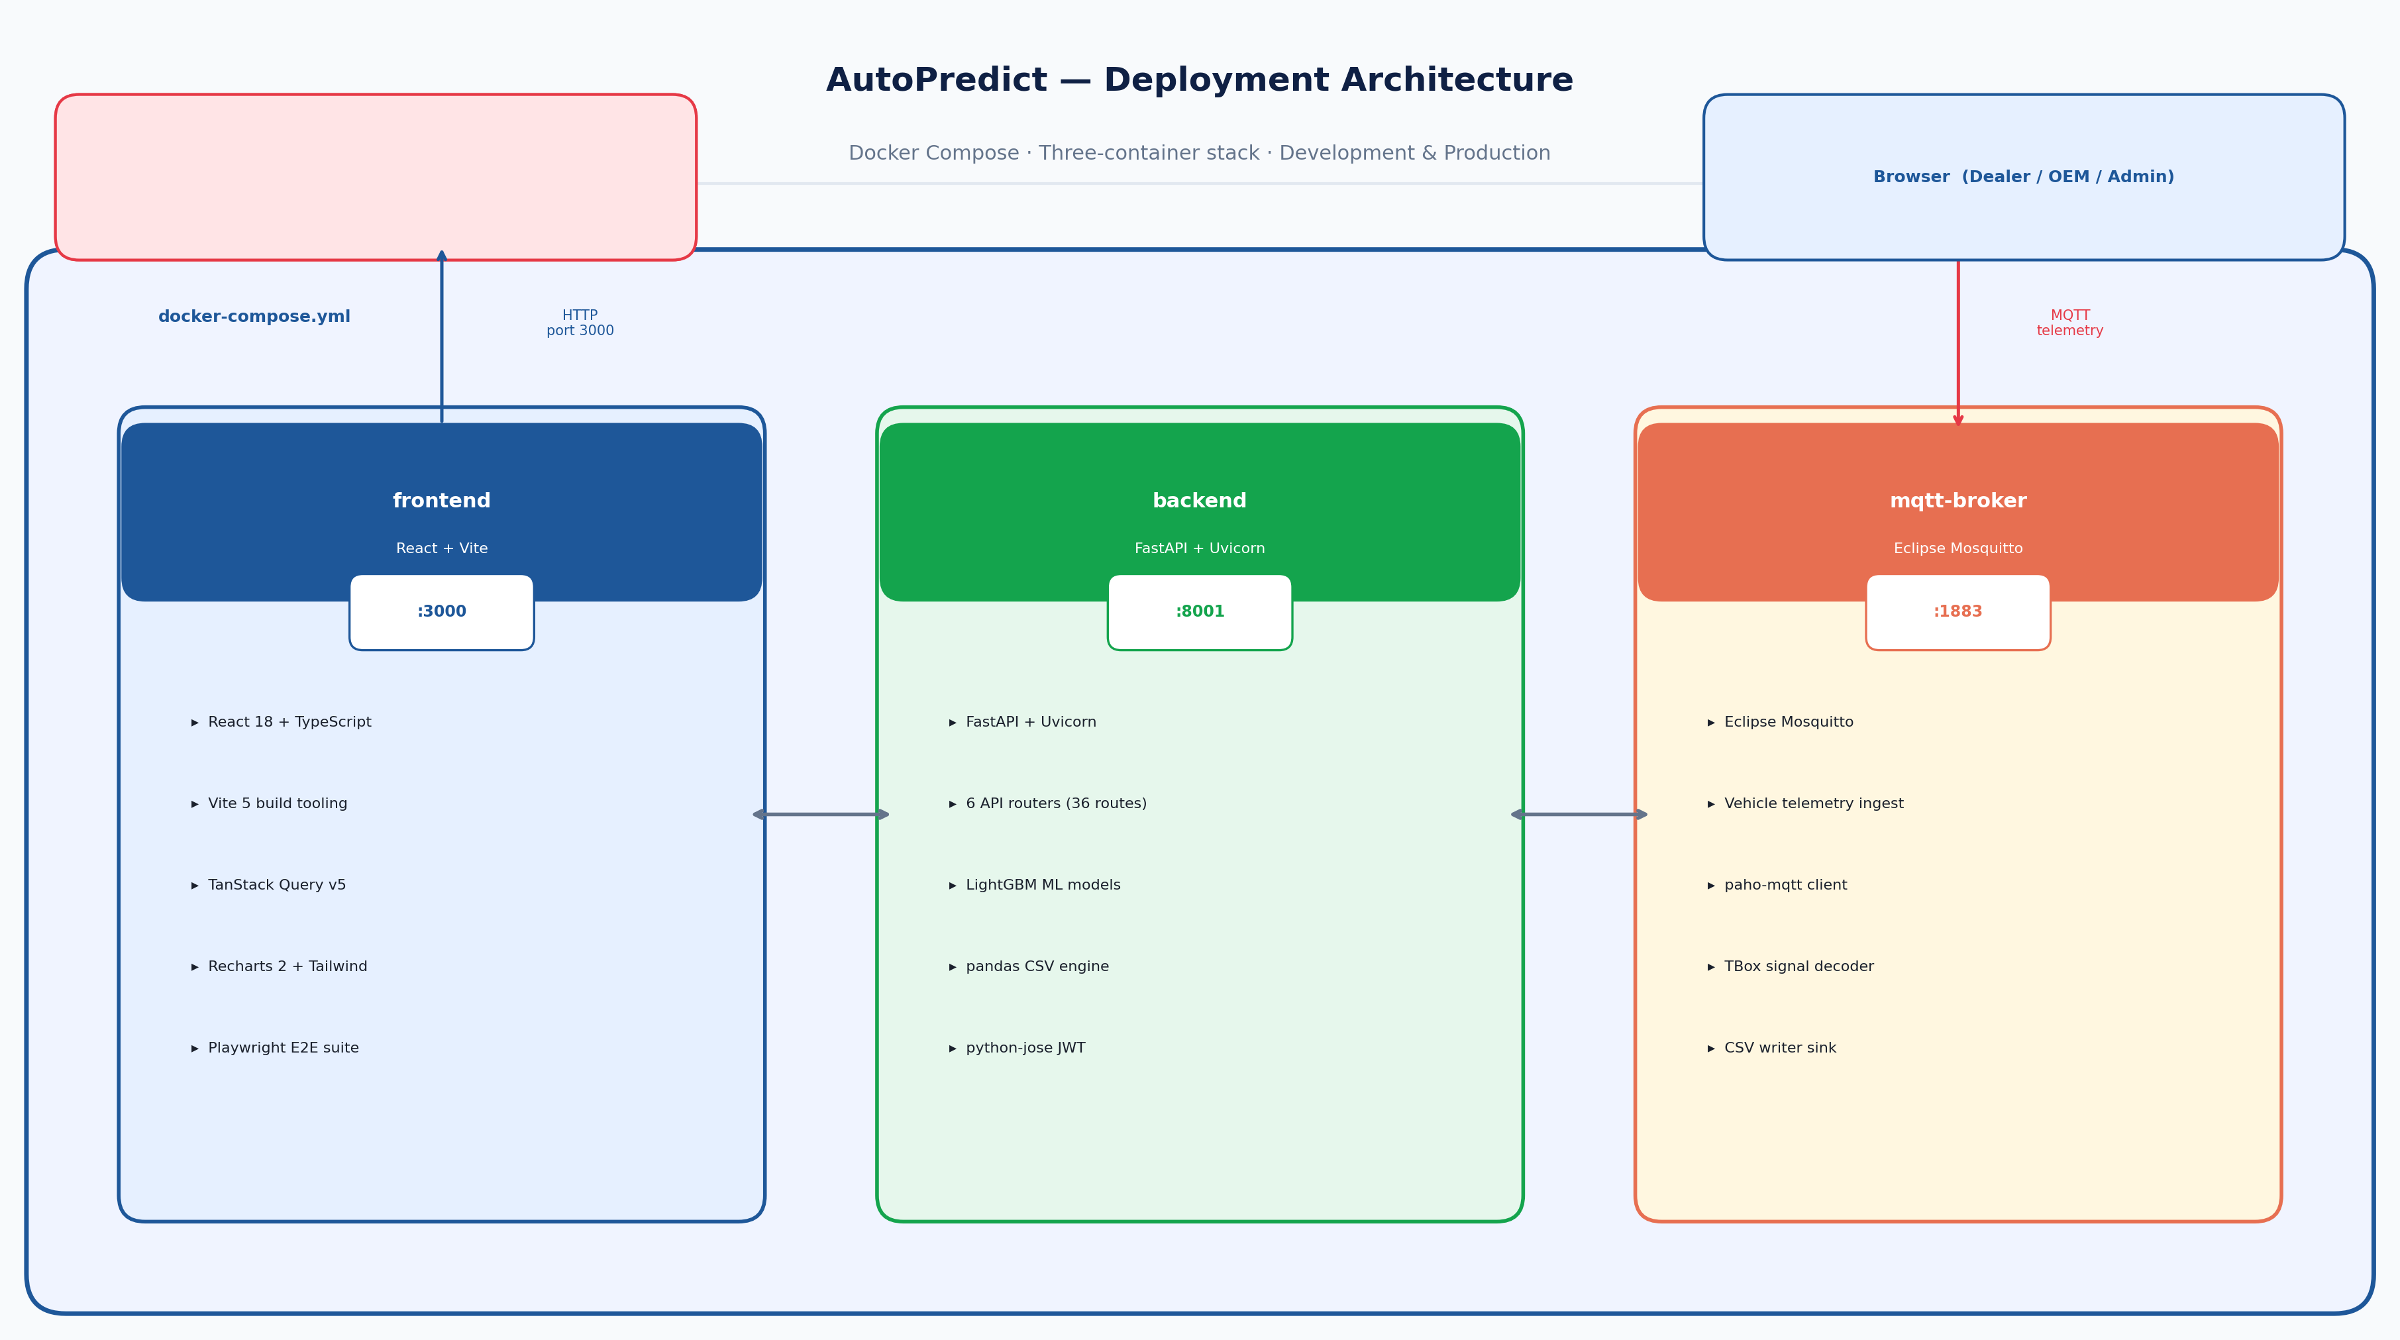
Figure 4 — Docker Compose deployment with three containers
Service | Port | Technology | Purpose
frontend | 3000 | React + Vite / Nginx | Serves compiled React SPA
backend | 8001 | FastAPI + Uvicorn | REST API, JWT auth, ML inference
mqtt-broker | 1883 | Eclipse Mosquitto | Vehicle telemetry ingestion

7. ML Pipeline
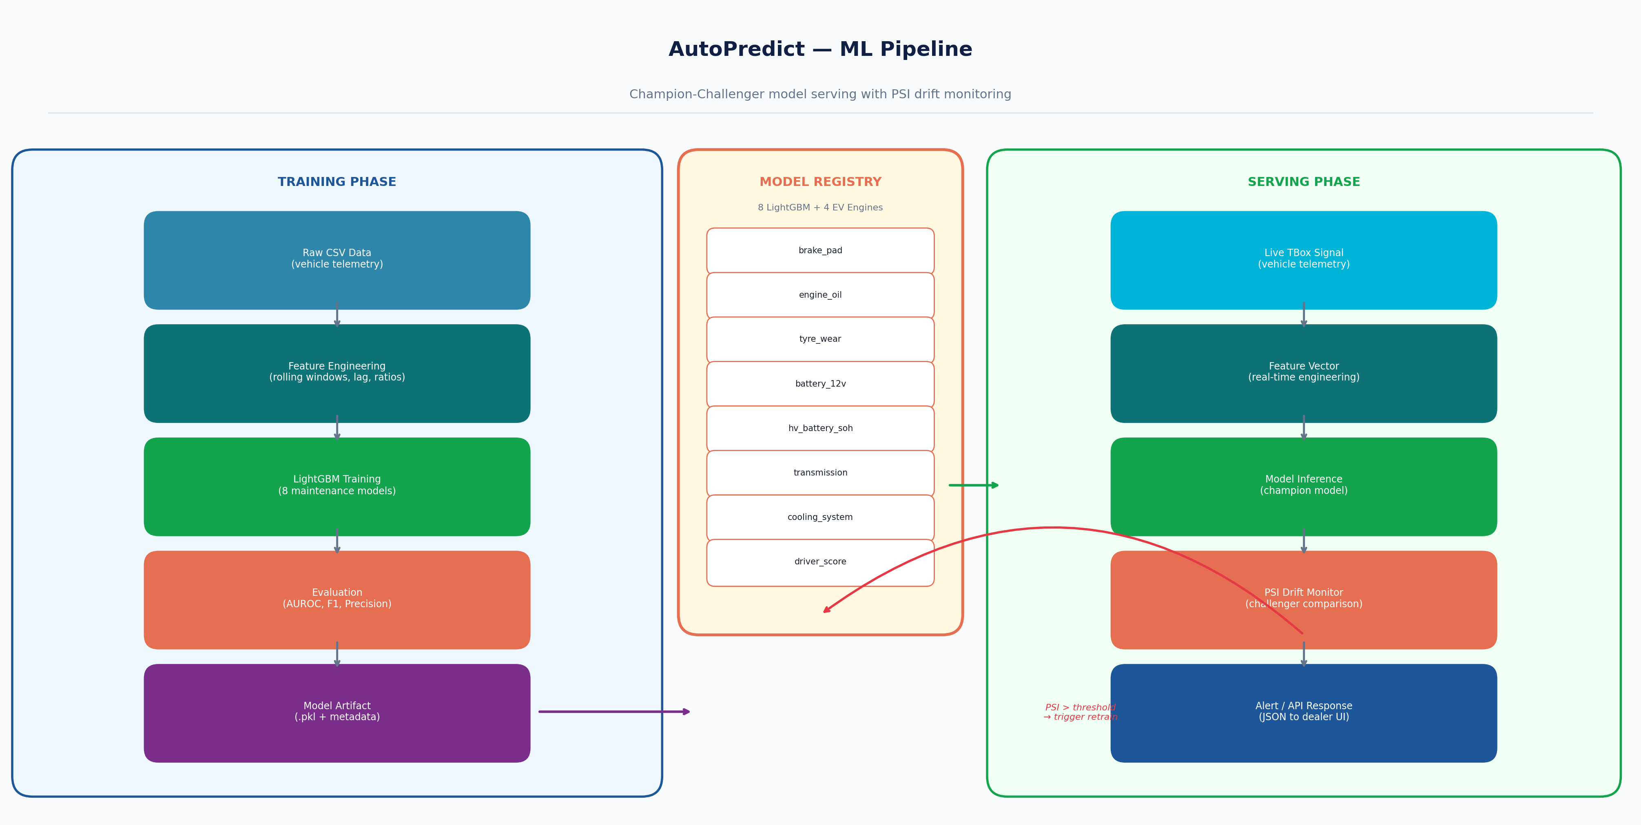
Figure 5 — ML training and serving pipeline with Champion-Challenger registry
The Champion-Challenger framework ensures safe model promotion: a new model (Challenger) runs in shadow mode against live traffic. PSI (Population Stability Index) monitors feature distribution drift. When PSI exceeds the configured threshold, the OEM analyst is notified via the Retrain Control UI and can promote the challenger to champion.

8. API Architecture
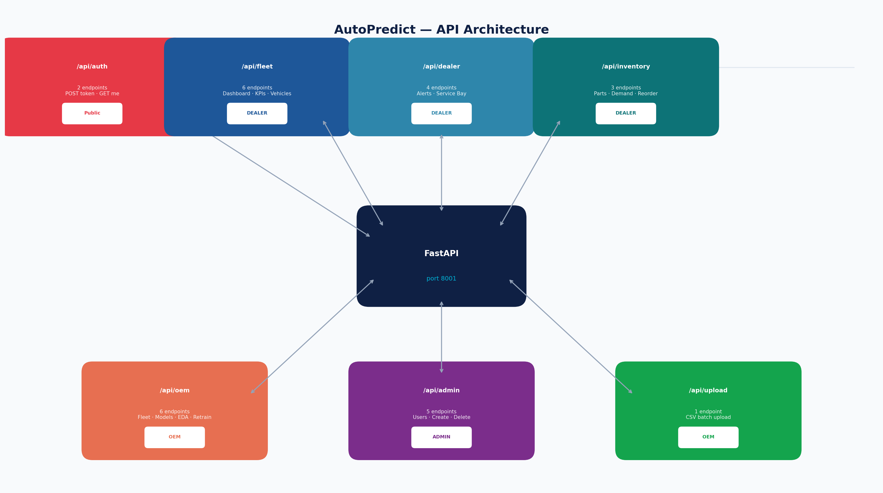
Figure 6 — API router map showing 36 endpoints across 6 routers

9. Architectural Decisions & Rationale
CSV over Database: Enables fully offline deployment in dealerships with intermittent connectivity. pandas provides sufficient performance for the current fleet size (<50,000 vehicles). Migration path to PostgreSQL is documented in the Phase 4 roadmap.
JWT over Session Cookies: Stateless auth simplifies horizontal scaling and eliminates server-side session storage. All auth state lives in localStorage — acceptable for the internal dealer portal threat model.
LightGBM over Neural Networks: Tabular vehicle telemetry data with hand-crafted features performs better with gradient boosted trees than neural networks. LightGBM trains in minutes on commodity hardware; neural nets would require GPU resources not available at dealerships.
workers=1 in Production: The CSV data store is not thread-safe for concurrent writes. Single-worker Uvicorn is a deliberate constraint, not a limitation. The Phase 4 database migration removes this constraint.
React Query over Redux: Server state (API data) is separate from client state (UI). React Query handles the former with caching and background refetch; useState/Context handle the latter. Redux would add unnecessary boilerplate.

