MG MOTOR INDIA
AutoPredict — Predictive Maintenance Platform

Product Specification Document

Feature definitions, user roles, and functional scope

Version: v1.0
Date: July 2025
Status: Confidential — Internal Use
Platform: AutoPredict v2.0

1. Product Overview
AutoPredict is a cloud-ready, offline-capable predictive maintenance platform purpose-built for MG Motor India. It connects vehicle telemetry from the TBox ECU network with machine learning models to predict component failures before they occur, enabling proactive service scheduling at the dealer level and fleet-wide analytics at the OEM level.
The platform replaces reactive maintenance (fix after failure) with predictive maintenance (fix before failure), targeting a 30% reduction in unplanned breakdowns and a 20% improvement in service bay utilisation.

2. User Roles & Permissions
AutoPredict supports three distinct user roles with hierarchical access:
Role | Scope | Key Capabilities | Restriction
DEALER | Own fleet (dealer_code scoped) | Dashboard, Alerts, Service Bay, Inventory | Cannot see other dealers' data
OEM | All dealers and all vehicles | Fleet Analytics, Model Health, EDA, What-If, Retrain | Cannot manage users
ADMIN | Full system | User management, all OEM capabilities | No additional restriction

3. System Architecture
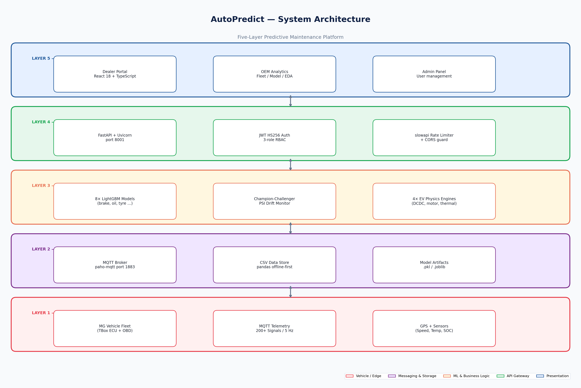
Figure 1 — AutoPredict five-layer system architecture

4. Feature Specifications

4.1 Authentication & Role Management
JWT HS256-based authentication with 3-tier role hierarchy. Tokens carry sub, role, dealer_code, iat, and exp claims. HTTPBearer with auto_error=False returns HTTP 401 for missing credentials and HTTP 403 for valid token with insufficient role.
- Login page with username/password form and branded MG Motor split layout
- localStorage-based auth persistence (ap_token, ap_role, ap_dealer_code, ap_user)
- PrivateRoute and OemRoute guards in React Router v6
- slowapi rate limiting on /api/auth/token (5 requests/minute)
- Automatic redirect to /login on token expiry or 401 response

4.2 Fleet Dashboard (Dealer)
The primary dealer-facing page providing a fleet health overview with ML-driven risk scoring for every vehicle in the dealer's fleet.
- 4 KPI cards: Total Vehicles, Active Alerts, Due for Service, Fleet Health Score
- Sortable vehicle table with columns: VIN, Model, Year, Mileage, Last Service, Risk Score, Status
- Search/filter by VIN or model name
- Colour-coded risk status: Critical (red), High (orange), Medium (yellow), Good (green)
- Upcoming Service panel with next 7 days appointments
- Real-time data refresh every 5 minutes via TanStack Query

4.3 Predictive Alerts
Rule-based and ML-derived alerts surfaced in a filterable table, enabling dealers to prioritise vehicle maintenance by severity and component type.
- Severity filter: All / Critical / High / Medium / Low
- Time-window filter: Last 24h / 7 days / 30 days / 90 days
- Alert columns: VIN, Component, Predicted Failure Window, Confidence, Days Remaining
- Manual refresh button with debounce
- Empty state when no alerts match filters

4.4 ML Prediction Models
Eight LightGBM models provide component-specific Remaining Useful Life (RUL) predictions. Four additional physics-based engines handle EV-specific subsystems.
Model | Target Component | Key Features Used | Output
brake_pad | Brake pads | Brake applications/km, decel G-force, pad wear signal | RUL in km
engine_oil | Engine oil | Oil temp, viscosity proxy, km since last change | RUL in km
tyre_wear | Tyres | Mileage, inflation pressure, cornering G | RUL in km
battery_12v | 12V auxiliary battery | Voltage, temperature, charge cycles | RUL in days
hv_battery_soh | HV battery (EV/PHEV) | SOC, charge cycles, thermal history | SoH %
transmission | Transmission | Gear changes, temperature, fluid level proxy | RUL in km
cooling_system | Cooling system | Coolant temp, fan duty cycle, flow rate | RUL in days
driver_score | Driver behaviour | Harsh braking, rapid acceleration, speed percentiles | Score 0–100
DCDC Converter | EV DCDC system | Input/output voltage, current, efficiency | Health %
Motor Health | EV drive motor | Phase currents, temperatures, torque efficiency | Health %
Charging Health | Charging system | Charge rate, thermal, BMS logs | Health %
Thermal Management | Battery thermal | Cell temperatures, delta T, coolant flow | Health %

4.5 Service Bay Management
- Visual bay grid showing bay number, current status (Free/Occupied/Reserved)
- Booking modal: VIN selection, service type, estimated duration, technician
- Appointment list with upcoming bookings sortable by date and urgency
- Integration with alert system — book directly from an alert record

4.6 Inventory Management
- 7-tab inventory interface: Overview, Stock Levels, Reorder Plan, Demand Forecast, Slow Moving, EV Parts, Supplier Contacts
- Stock levels per part with min/max thresholds and current quantity
- ML-driven demand forecast with configurable horizon (30/60/90 days)
- Automatic reorder plan generated from demand forecast vs current stock
- EV-specific parts tab with battery pack and charging component inventory

4.7 OEM Fleet Intelligence
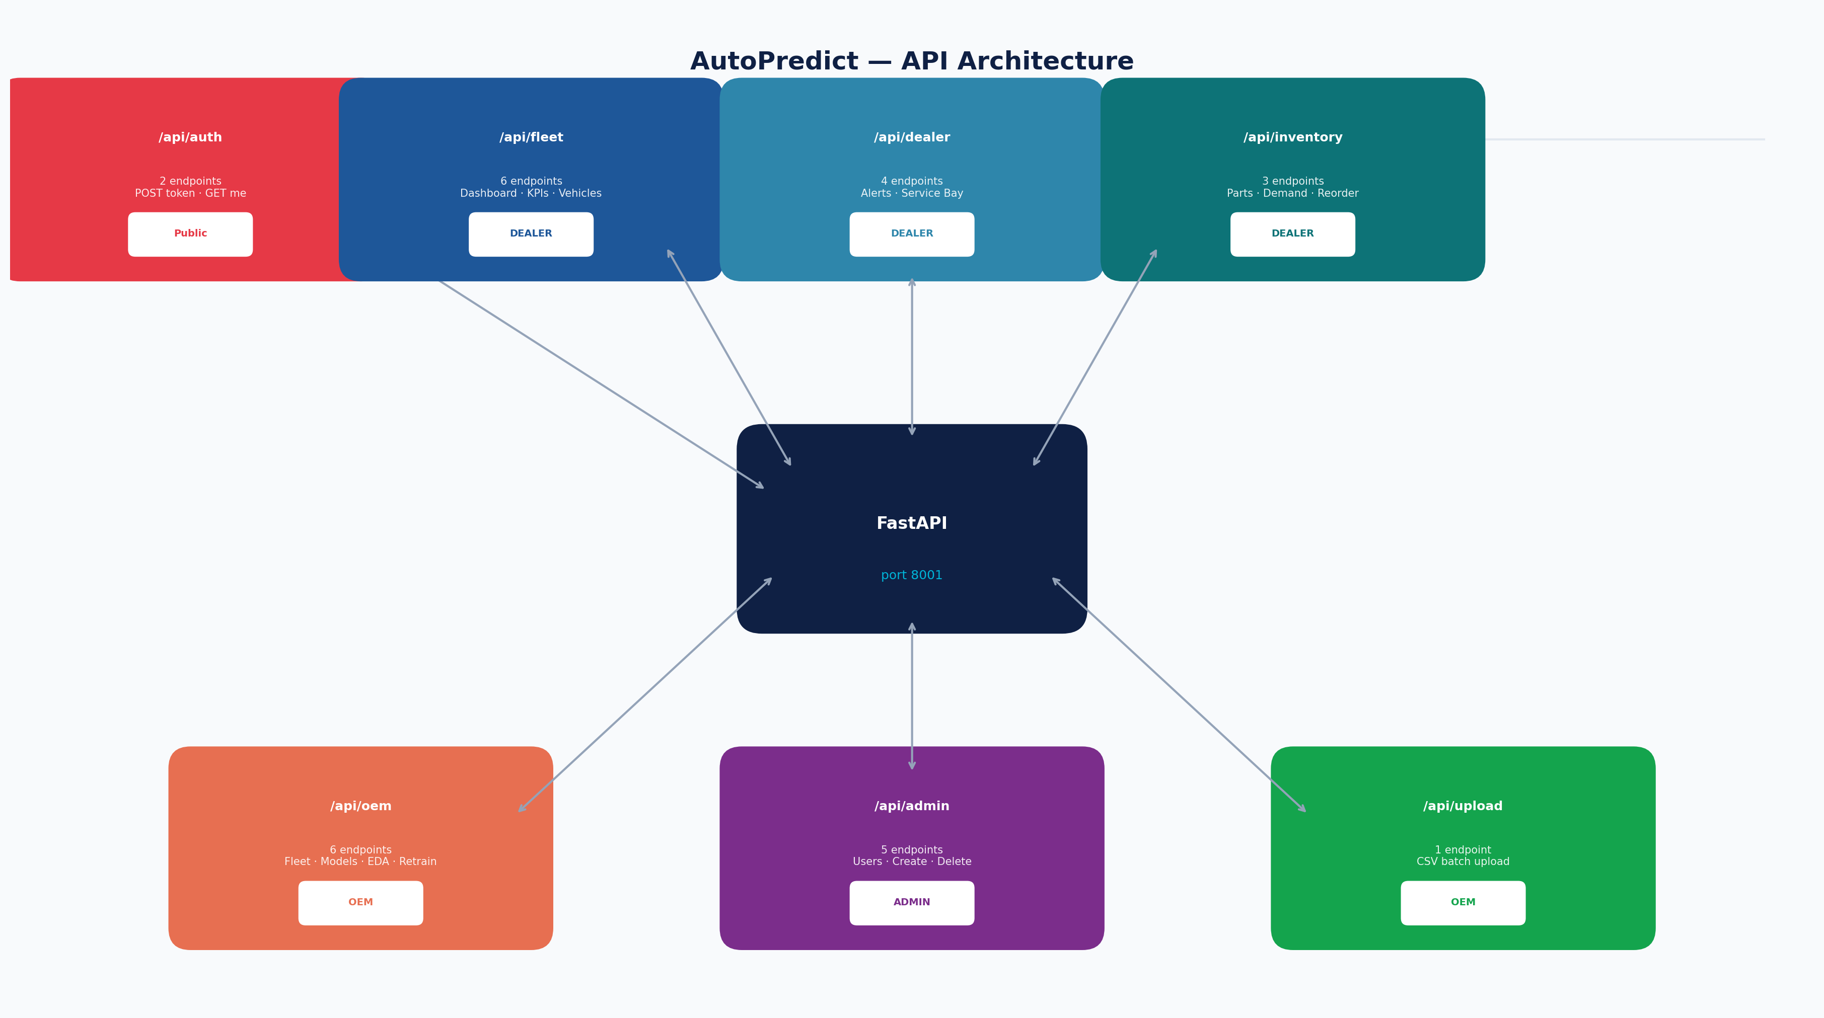
Figure 2 — OEM API router structure with role access
- Fleet-wide overview with group-by: Model / Region / Year / Fuel Type
- Model Health heatmap: AUROC, PSI drift, Precision, Recall per model per region
- EDA dashboard: Feature distributions, correlation heatmap, outlier detection
- What-If analysis: Adjust feature values and observe predicted outcome change
- Demand breakdown: Per-part pivot table segmented by region and dealer code

4.8 Model Retrain Control (OEM)
- Multi-select checkboxes for 8 LightGBM models + 4 EV physics engines
- Select All / Clear All controls for batch operations
- Training notes text field for documenting the rationale for retraining
- Submit triggers background training job with progress tracking
- Retrain history table: Model, timestamp, triggered by, status, AUROC before/after

5. Non-Functional Requirements
Requirement | Target | Notes
Dashboard load time | < 3s (warm) | Cold CSV read 55–65s; cached thereafter
Alert prediction latency | < 500ms | In-memory model inference after warm-up
Concurrent users | 50 per dealer | Single Uvicorn worker; Phase 4 scales to multi-worker
Data retention | 24 months rolling | CSV files rotated monthly
Uptime | 99.5% | Single-server deployment; Phase 4 adds HA
WCAG Compliance | 2.1 AA | axe-core verified; all 8 pages pass
Security | OWASP Top 10 awareness | 5 vulnerabilities documented; remediation in Phase 4

