MG MOTOR INDIA
AutoPredict — Predictive Maintenance Platform

Product Requirements Document

Functional requirements, personas, MoSCoW prioritisation, and acceptance criteria

Version: v1.0
Date: July 2025
Status: Confidential — Internal Use
Platform: AutoPredict v2.0

1. Background & Problem Statement
MG Motor India operates a growing fleet managed through a network of authorised dealers. Vehicle maintenance today is largely reactive — service happens after warning lights appear or customers report problems. This creates three business problems:
- Unplanned breakdowns erode customer trust and generate warranty costs
- Service bays are underutilised due to unpredictable demand spikes
- OEM teams have no visibility into fleet health trends across dealer networks

2. Product Vision
"Enable every MG dealer to act on a vehicle failure 30 days before it happens — turning reactive maintenance into a proactive, data-driven service operation."

3. User Personas
Persona | Role | Goal | Pain Point
Rajesh Kumar | Dealer Service Manager  Mumbai dealership | Know which vehicles need service before customers complain | Currently relies on customer calls and warning lights
Priya Sharma | OEM Fleet Data Engineer  MG Motor India HQ | Monitor ML model quality and retrain when data drifts | No centralised view of model performance across fleet
Arjun Mehta | System Administrator | Manage user accounts and access rights | Manual user management with no audit trail

4. Requirements

4.1 MoSCoW Prioritisation
Must Have (P1)
- JWT authentication with role-based access control
- Fleet dashboard with vehicle risk scores
- Predictive alerts with severity levels
- LightGBM ML models for 8 components
- CSV offline-first data storage
- OEM fleet analytics overview
- WCAG 2.1 AA accessibility compliance
Should Have (P2)
- Service bay booking management
- Inventory management with demand forecast
- OEM model health monitoring (AUROC, PSI)
- OEM What-If analysis tool
- Model retrain control with history
- EV/PHEV-specific health engines
- Champion-Challenger model serving
Could Have (P3)
- Mobile PWA for dealer technicians
- Real-time WebSocket push notifications
- PDF report export for service records
- Integration with DMS (Dealer Management System)
- Multi-language support (Hindi, regional)
Won't Have (this release)
- Customer-facing mobile app
- OTA vehicle software updates
- Insurance integration
- Carbon footprint tracking

5. Functional Requirements
ID | Module | Priority | Requirement
FR-001 | Auth | Must | System shall authenticate users via username/password and return JWT
FR-002 | Auth | Must | System shall enforce role-based access: DEALER, OEM, ADMIN
FR-003 | Auth | Must | System shall scope all dealer queries to their dealer_code
FR-004 | Fleet | Must | System shall display fleet KPIs: total vehicles, active alerts, due for service
FR-005 | Fleet | Must | System shall show vehicle-level risk scores from ML models
FR-006 | Alerts | Must | System shall generate predictive alerts 30 days before predicted failure
FR-007 | Alerts | Must | System shall support severity filter: Critical/High/Medium/Low
FR-008 | ML | Must | System shall serve predictions from 8 LightGBM maintenance models
FR-009 | ML | Should | System shall monitor PSI drift and alert OEM when threshold exceeded
FR-010 | OEM | Should | System shall provide fleet-wide analytics grouped by model/region/year
FR-011 | OEM | Should | System shall allow OEM to trigger model retraining via UI
FR-012 | Inventory | Should | System shall forecast part demand using ML models
FR-013 | Admin | Should | System shall allow admin to create, list, and deactivate user accounts
FR-014 | Accessibility | Must | System shall pass WCAG 2.1 AA automated axe-core scans on all pages
FR-015 | Security | Must | System shall return HTTP 401 for missing auth and HTTP 403 for insufficient role

6. Product Roadmap
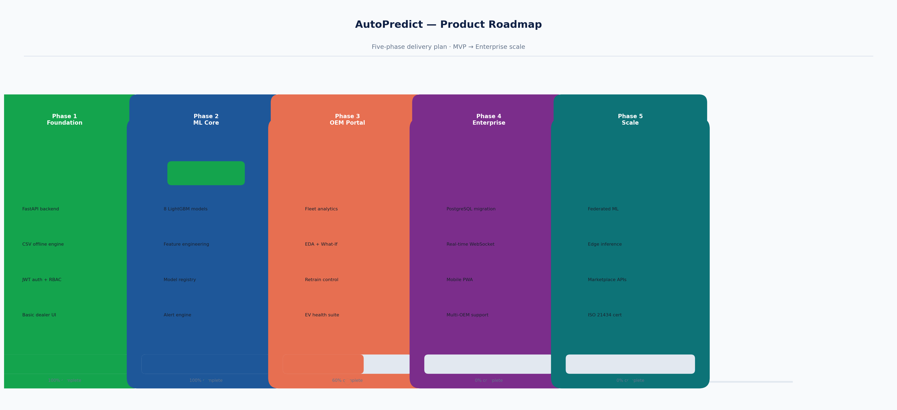
Figure 1 — Five-phase product roadmap

7. Acceptance Criteria
- Login with valid credentials returns JWT token and redirects to dashboard
- Dealer A cannot view Dealer B data even with a valid token
- OEM user can access fleet analytics; dealer cannot (403 response)
- All 8 predictive models return a risk score for every vehicle in the fleet
- Alert table filters correctly by severity and time window
- All pages pass axe-core WCAG 2.1 AA scan with zero critical/serious violations
- Model retrain completes successfully and logs entry in retrain history
- Admin can create a new user who can immediately log in

