MG MOTOR INDIA
AutoPredict — Predictive Maintenance Platform

User Journey Document

Three-persona journey maps with touchpoints, emotions, and pain points

Version: v1.0
Date: July 2025
Status: Confidential — Internal Use
Platform: AutoPredict v2.0

1. Overview
This document maps the end-to-end journeys of the three primary AutoPredict user personas. Each journey covers the complete flow from initial system access through to the key value-generating action, including emotional states and system touchpoints.
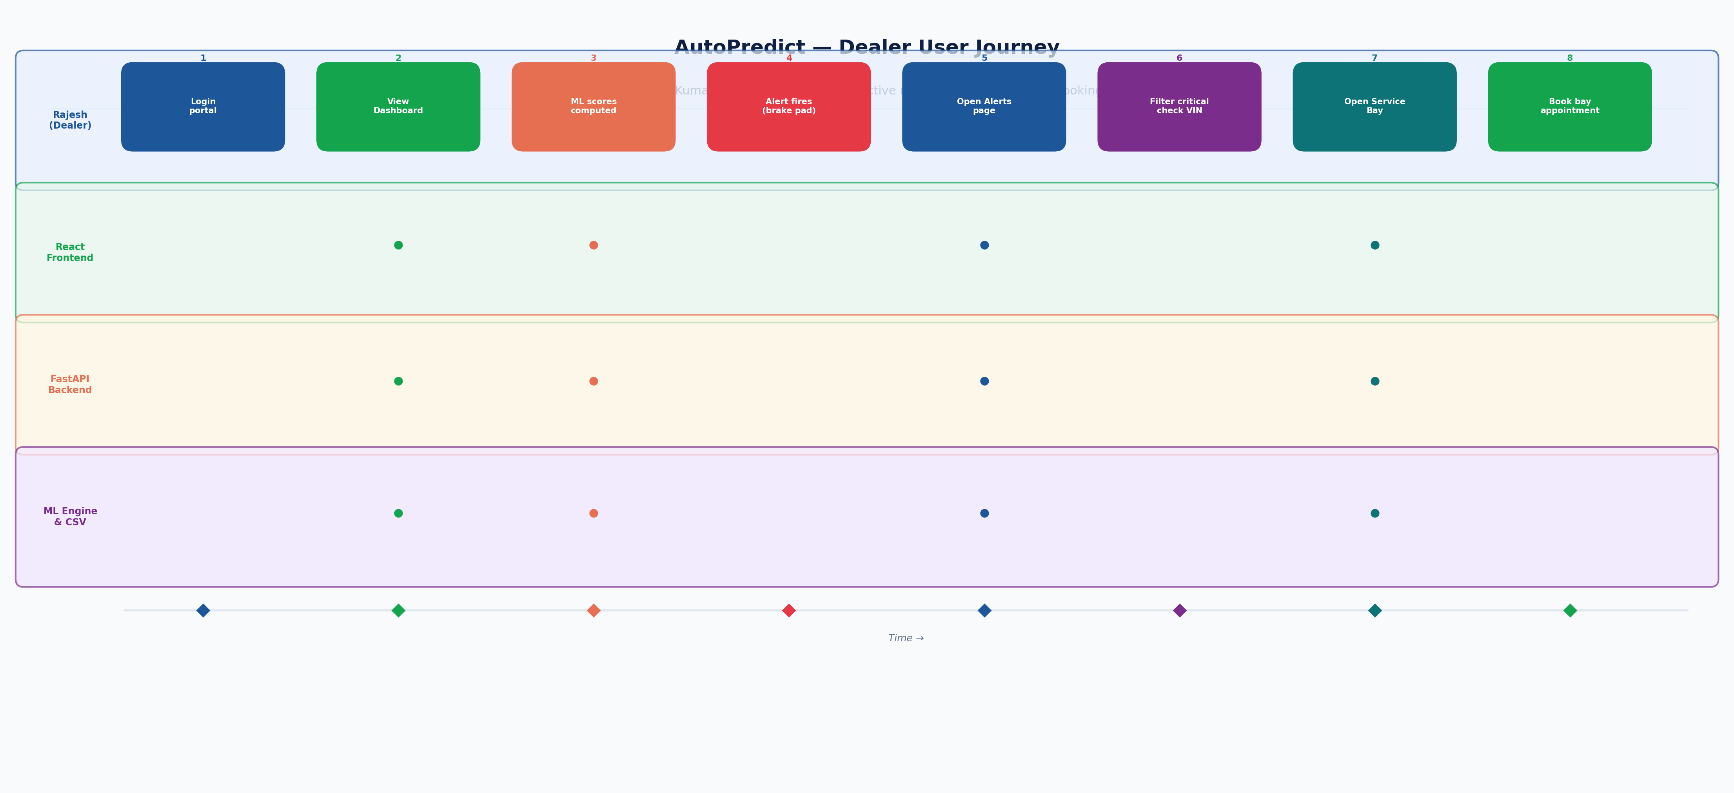
Figure 1 — Dealer user journey swimlane (Rajesh Kumar)

2. Persona 1 — Rajesh Kumar (Dealer Service Manager)

Journey: From morning login to proactive service booking
Step 1 — Login: Rajesh opens the AutoPredict portal URL and enters credentials.
Emotion: Curious | System: Login page loads instantly; branded MG Motor layout
Step 2 — Dashboard Review: Dashboard shows 4 KPI cards. Rajesh sees "3 Critical Alerts" in red.
Emotion: Focused | System: Fleet Health Score at 87/100; vehicle table sorted by risk
Step 3 — Alert Investigation: Rajesh clicks to Alerts page; filters to Critical severity.
Emotion: Concerned | System: Table shows VIN MH01AB1234 — brake pad failure in 12 days
Step 4 — Vehicle Detail: Rajesh inspects the vehicle record and sees brake pad RUL = 980 km.
Emotion: Informed | System: Model confidence 91%; last service 8 months ago
Step 5 — Service Bay Booking: Rajesh opens Service Bay and books Bay 3 for the vehicle.
Emotion: Confident | System: Booking confirmed; customer notification queued
Step 6 — Confirmation: Bay occupancy grid reflects the new booking.
Emotion: Satisfied | System: Proactive appointment booked 12 days before predicted failure

3. Persona 2 — Priya Sharma (OEM Fleet Engineer)

Journey: Monthly model health review and retraining
Step 1 — OEM Login: Priya logs in with OEM credentials; sees expanded navigation including OEM sections.
Emotion: Prepared
Step 2 — Fleet Overview: Priya views fleet-wide stats grouped by vehicle model. Sees ZS EV has higher alert rate.
Emotion: Analytical
Step 3 — Model Health: Priya opens Model Health page. Sees hv_battery_soh PSI = 0.28 (threshold: 0.25) in red.
Emotion: Alert
Step 4 — EDA Investigation: Priya runs EDA on HV battery features. Distribution shift visible in cell_temp histogram.
Emotion: Investigating
Step 5 — What-If Analysis: Priya tests model with edge-case feature values to understand sensitivity.
Emotion: Exploring
Step 6 — Trigger Retrain: Priya selects hv_battery_soh and ev_battery_12v, adds training notes, submits retrain.
Emotion: Decisive
Step 7 — Verify Results: Retrain history shows new AUROC 0.94 (up from 0.87). Priya promotes to champion.
Emotion: Satisfied

4. Persona 3 — Arjun Mehta (System Admin)

Journey: Onboarding a new dealer
Step 1 — Admin Login: Arjun logs in with admin credentials.
Step 2 — User List: Admin panel shows all registered users. Arjun searches for the new dealership.
Step 3 — Create User: Arjun fills: username, password, role=DEALER, dealer_code=DL099.
Step 4 — Confirmation: New user appears in list with status Active. Arjun sends credentials to new dealer.
Step 5 — Verify Access: Arjun logs out and logs in as new dealer to verify correct scoping.

5. Pain Points & Opportunities
Persona | Pain Point | AutoPredict Solution
Rajesh | No warning until customer complains | ML alerts 30 days before failure
Rajesh | Bay scheduling is ad hoc | Service Bay booking linked to predicted alerts
Rajesh | Parts often out of stock | Inventory demand forecast enables pre-stocking
Priya | No central model quality view | Model Health dashboard with AUROC, PSI per model
Priya | Retraining requires data science team | One-click retrain from OEM portal
Arjun | User management is manual | Admin panel with create/list/deactivate

