MG MOTOR INDIA
AutoPredict — Predictive Maintenance Platform

Product, Process & Roadmap Document

Core process flows, information architecture, and five-phase delivery plan

Version: v1.0
Date: July 2025
Status: Confidential — Internal Use
Platform: AutoPredict v2.0

1. Core Process Flows
AutoPredict implements four primary operational processes. Each is described below with inputs, actors, system steps, and outputs.

1.1 Telemetry-to-Alert Process
Stage | Actor | Action | Output
Signal Emission | TBox ECU | Emits 200+ signals at 5 Hz over MQTT | Raw telemetry stream
Ingestion | MQTT Broker | Receives and queues messages | Buffered signal packets
Persistence | CSV Writer | Appends signals to vehicle-partitioned CSV | Structured telemetry CSV
Feature Engineering | FastAPI backend | Computes rolling windows, lag features, ratios | Feature vector per VIN
ML Inference | LightGBM models | Predicts RUL for 8 components | Risk scores + confidence
Alert Generation | Alert engine | Fires alert when RUL < threshold | Alert record in alerts CSV
UI Display | React frontend | Fetches and renders alerts table | Dealer sees actionable alert

1.2 Dealer Predictive Maintenance Process
- Dealer logs in; dashboard loads with fleet risk overview
- Dealer identifies high-risk vehicles from KPI cards or vehicle table
- Dealer navigates to Alerts to see component-level failure predictions
- Dealer opens Service Bay; selects bay; creates appointment for vehicle
- Dealer verifies parts availability in Inventory before confirming appointment
- On appointment day, technician performs service using predicted component data
- Service record updated; ML model receives new ground truth for future training

1.3 OEM Model Retraining Process
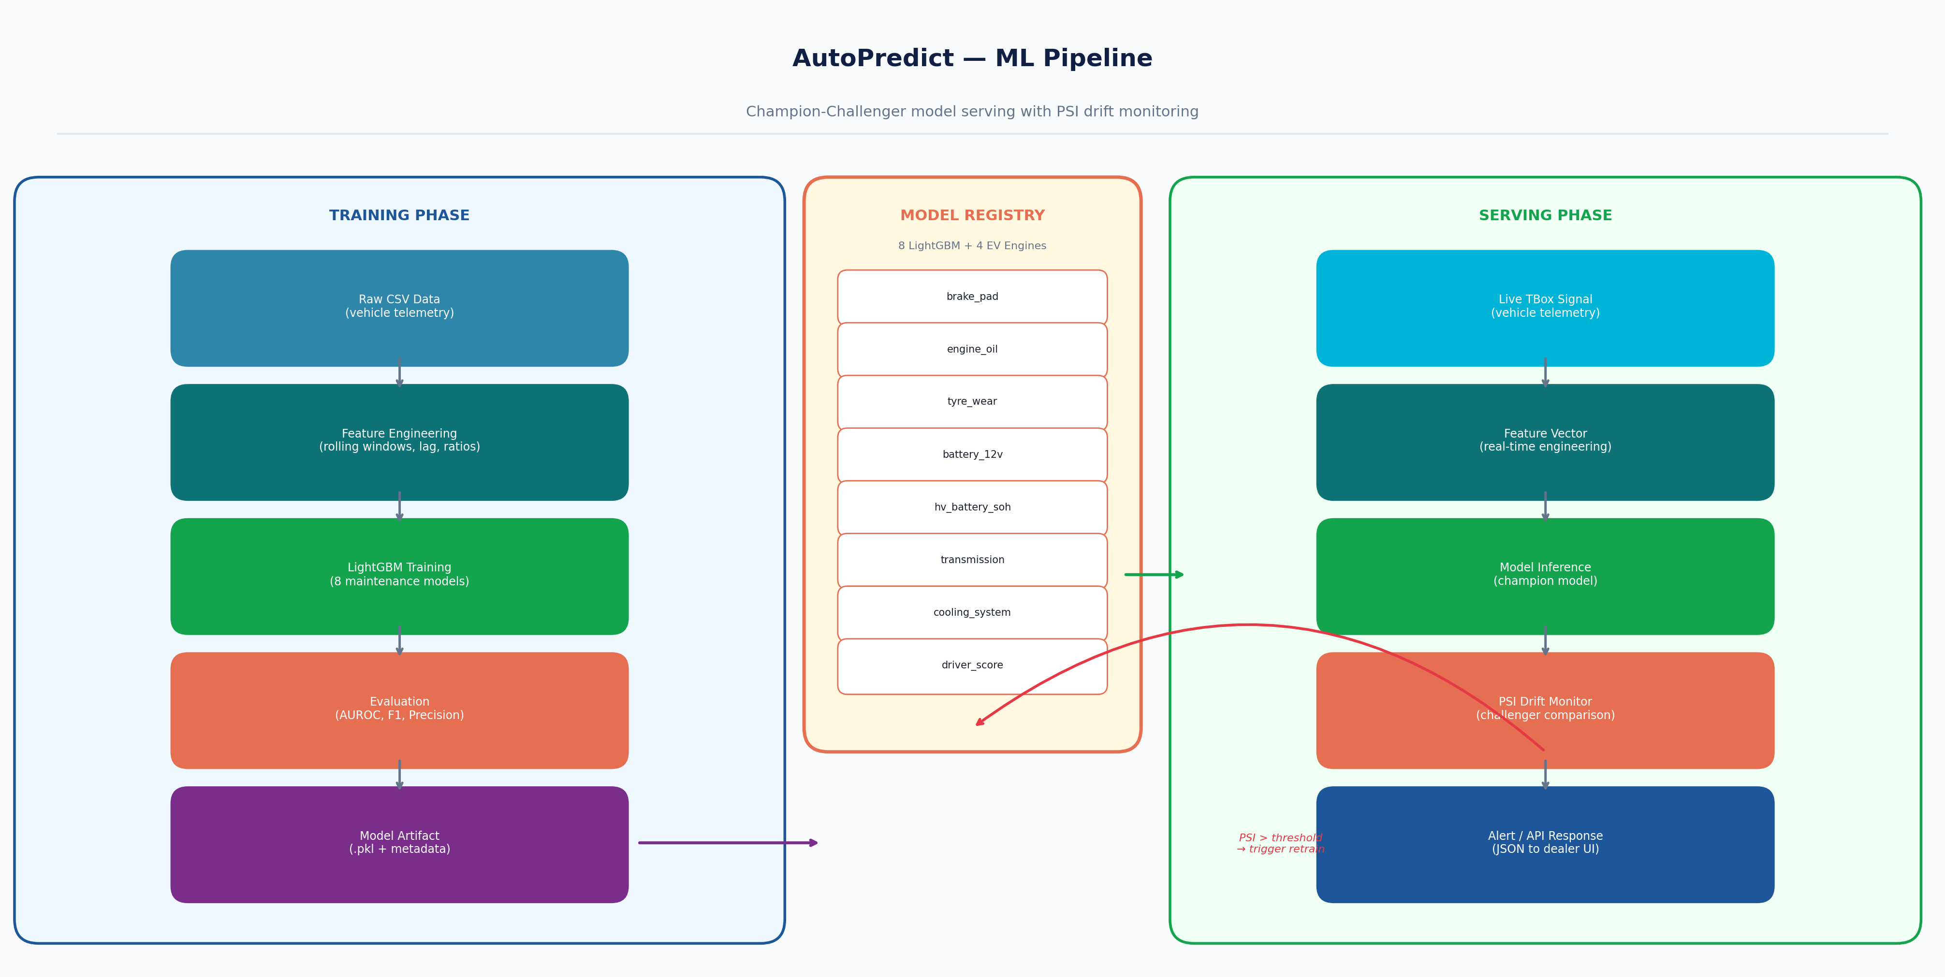
Figure 1 — ML pipeline with champion-challenger model promotion

1.4 Admin User Onboarding Process
- Admin logs in to admin panel
- Admin creates new dealer user with dealer_code
- System generates credentials and stores user record
- Admin communicates credentials to new dealer contact
- Dealer logs in; system applies dealer_code scope to all queries
- Admin monitors user list for activity

2. Product Roadmap
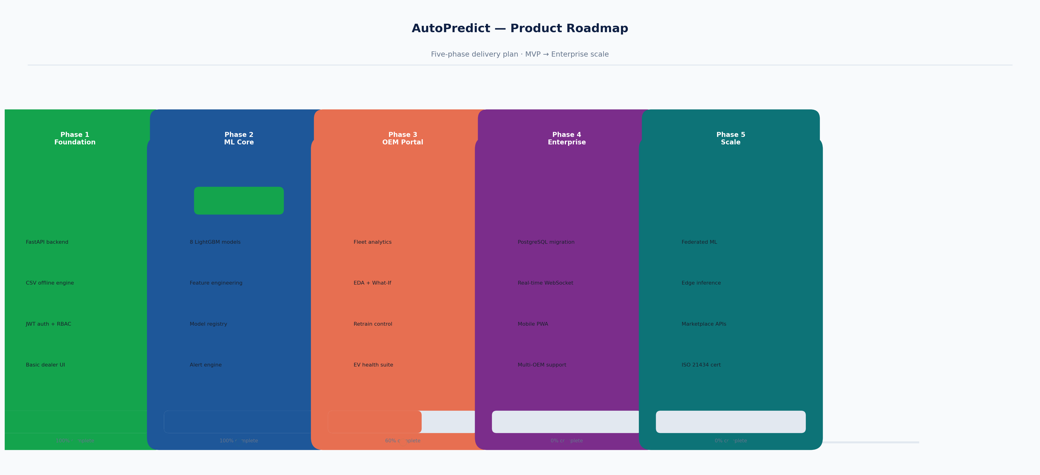
Figure 2 — Five-phase product delivery roadmap
Phase 1 — Foundation (Q1 2024) — COMPLETE
- FastAPI backend with 6 routers and 36 endpoints
- JWT authentication with DEALER/OEM/ADMIN roles
- CSV-based offline-first data storage
- Basic dealer dashboard and alert views
- React + TypeScript + Vite frontend scaffold
Phase 2 — ML Core (Q2 2024) — COMPLETE
- 8 LightGBM maintenance prediction models
- Feature engineering pipeline (rolling windows, lag features)
- Champion-Challenger model registry with PSI monitoring
- Alert generation engine with severity thresholds
- Automated model evaluation (AUROC, F1, Precision)
Phase 3 — OEM Portal (Q3 2024) — IN PROGRESS
- OEM Fleet Overview with multi-dimensional grouping
- Model Health dashboard with drift indicators
- EDA tools (feature distributions, heatmaps)
- What-If analysis interface
- EV/PHEV health physics engines (DCDC, motor, thermal)
- Inventory management with demand forecasting
Phase 4 — Enterprise (Q4 2024) — PLANNED
- PostgreSQL migration (replace CSV with proper database)
- Real-time WebSocket push notifications
- Multi-worker Uvicorn (horizontal scaling)
- Mobile PWA for dealer technicians
- Security hardening (bcrypt passwords, rotation key, CORS fix)
Phase 5 — Scale (Q1 2025) — V2
- Federated ML across multiple OEM brands
- Edge inference on TBox hardware
- Third-party DMS integration APIs
- ISO 21434 cybersecurity certification
- Multi-language UI support

3. KPI Framework
Metric | Baseline | Phase 3 Target | Phase 4 Target
Unplanned breakdowns per 1,000 vehicles | 42/month | 30/month (-29%) | 20/month (-52%)
Service bay utilisation | 64% | 75% | 82%
Alert-to-booking conversion rate | N/A | 45% | 65%
ML model AUROC (average) | 0.81 | 0.88 | 0.92
Dealer portal adoption | 0% | 80% of dealers | 95% of dealers
Mean time to detect failure | 0 days (reactive) | 30 days | 45 days

