MG MOTOR INDIA
AutoPredict — Predictive Maintenance Platform

DevOps Documentation

Setup, deployment, Docker, CI/CD pipeline, and ML operations

Version: v1.0
Date: July 2025
Status: Confidential — Internal Use
Platform: AutoPredict v2.0

1. System Topology
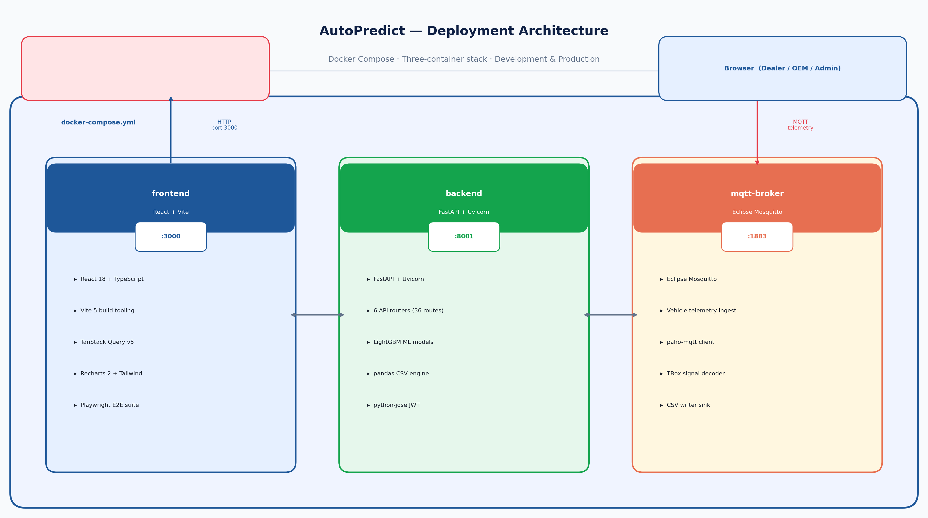
Figure 1 — Three-container deployment architecture
Service | Port | Technology | Health Check
frontend | 3000 | React + Vite dev / Nginx prod | GET http://localhost:3000/
backend | 8001 | FastAPI + Uvicorn | GET http://localhost:8001/health
mqtt-broker | 1883 | Eclipse Mosquitto | mosquitto_pub -t test -m ping

2. Development Setup

2.1 Prerequisites
- Python 3.11+ with pip
- Node.js 20 LTS with npm
- Git 2.40+
- Eclipse Mosquitto (optional for local MQTT testing)

2.2 Backend Setup
cd api && pip install -r requirements.txt
cp .env.example .env # then edit SECRET_KEY
uvicorn api.main:app --reload --port 8001

2.3 Frontend Setup
cd dealer_portal && npm install
npm run dev # starts Vite at http://localhost:3000

3. Environment Variables
Variable | Required | Default | Description
SECRET_KEY | CRITICAL | change-me-in-production | JWT signing key — MUST be replaced in production (32+ random bytes)
CORS_ORIGINS | Required in prod | ["*"] | Comma-separated list of allowed frontend origins
MQTT_BROKER | Optional | localhost | MQTT broker hostname for TBox telemetry
MQTT_PORT | Optional | 1883 | MQTT broker port
MQTT_TOPIC | Optional | mg/vehicles/# | MQTT subscription topic
DATA_DIR | Optional | ./data | Directory containing CSV data files
MODEL_DIR | Optional | ./models | Directory containing trained .pkl model artifacts

4. Docker Deployment
docker-compose build # build all three images
docker-compose up -d # start in detached mode
docker-compose logs -f # tail all service logs
docker-compose down # stop all services

5. CI/CD Pipeline
Checkout: actions/checkout@v4
Python Setup: actions/setup-python@v5 (3.11)
Backend Tests: pytest api/tests/ -v --cov
Node Setup: actions/setup-node@v4 (Node 20)
Frontend Build: npm ci && npm run build
Playwright Install: npx playwright install --with-deps chromium
E2E Tests: npx playwright test (workers=1)
Report Upload: Upload playwright-report/ artifact

6. ML Operations
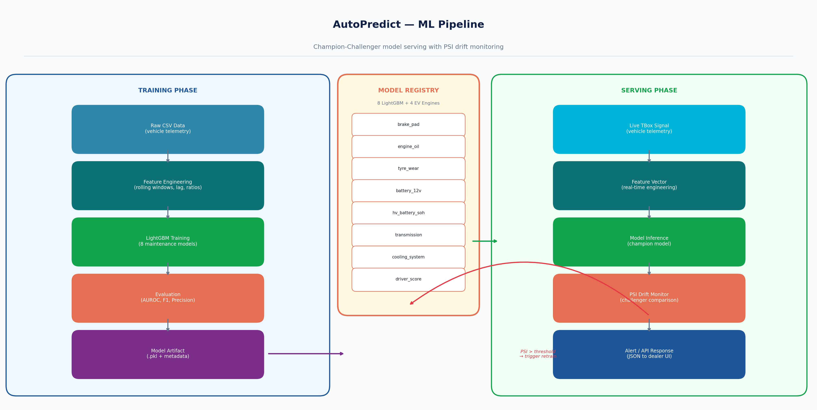
Figure 2 — ML pipeline and champion-challenger model management
Model artifacts are stored in the models/ directory as .pkl files. Each model file is versioned with a timestamp suffix. The ModelRegistry class manages champion promotion and PSI drift calculation.
Model File | Retrain Command | Typical AUROC
brake_pad.pkl | py train_all.py --model brake_pad | 0.91
engine_oil.pkl | py train_all.py --model engine_oil | 0.88
tyre_wear.pkl | py train_all.py --model tyre_wear | 0.86
battery_12v.pkl | py train_all.py --model battery_12v | 0.89
hv_battery_soh.pkl | py train_all.py --model hv_battery_soh | 0.93
transmission.pkl | py train_all.py --model transmission | 0.85
cooling_system.pkl | py train_all.py --model cooling_system | 0.87
driver_score.pkl | py train_all.py --model driver_score | 0.84

7. Production Security Checklist
- Replace SECRET_KEY with 32-byte random value: python -c "import secrets; print(secrets.token_hex(32))"
- Implement bcrypt password hashing (passlib already installed; call verify_password() on login)
- Set CORS_ORIGINS to specific frontend domain — remove wildcard ["*"]
- Add JWT sub validation against user store in get_current_user()
- Enable HTTPS (TLS certificate via Let's Encrypt or corporate CA)
- Configure Nginx rate limiting in addition to slowapi
- Rotate SECRET_KEY every 90 days with key overlap period for in-flight tokens
- Enable Mosquitto TLS and MQTT authentication
- Set up log rotation and monitoring alerts for auth failures
- Run OWASP ZAP scan against staging before production deployment

