MG MOTOR INDIA
AutoPredict — Predictive Maintenance Platform

Frontend Documentation

React architecture, component structure, routing, state management, and accessibility

Version: v1.0
Date: July 2025
Status: Confidential — Internal Use
Platform: AutoPredict v2.0

1. Technology Stack
Technology | Version | Role | Key Decision
React | 18 | UI framework | Concurrent features; large ecosystem
TypeScript | 5 | Type safety | Catches prop/API contract errors at compile time
Vite | 5 | Build tool | Sub-second HMR; native ESM; faster than Webpack
Tailwind CSS | 3 | Styling | Utility-first; zero runtime; PurgeCSS in prod
TanStack Query | v5 | Server state | Auto-caching; background refetch; stale-while-revalidate
Axios | 1.x | HTTP client | Interceptors for token injection and 401 handling
React Router | v6 | Routing | PrivateRoute + OemRoute guards; nested routes
Recharts | 2 | Charts | SVG-based; props passed to path elements for aria-label

2. Application Routing
Route | Component | Auth Required | Description
/login | LoginPage | Public | Redirects to / if already authenticated
/ | DashboardPage | DEALER | Fleet health overview with vehicle table
/alerts | AlertsPage | DEALER | Predictive alerts with severity and time filters
/service | ServiceBayPage | DEALER | Bay grid and appointment booking
/inventory | InventoryPage | DEALER | 7-tab inventory management
/oem/fleet | OemFleetOverview | OEM | Fleet-wide analytics with group-by controls
/oem/models | OemModelHealth | OEM | AUROC/PSI model quality dashboard
/oem/eda | OemEda | OEM | Exploratory data analysis tools
/oem/whatif | OemWhatIf | OEM | Scenario analysis for model predictions
/oem/retrain | OemRetrain | OEM | Model retrain trigger and history
/admin | AdminPanel | ADMIN | User management (CRUD)

3. Authentication Flow
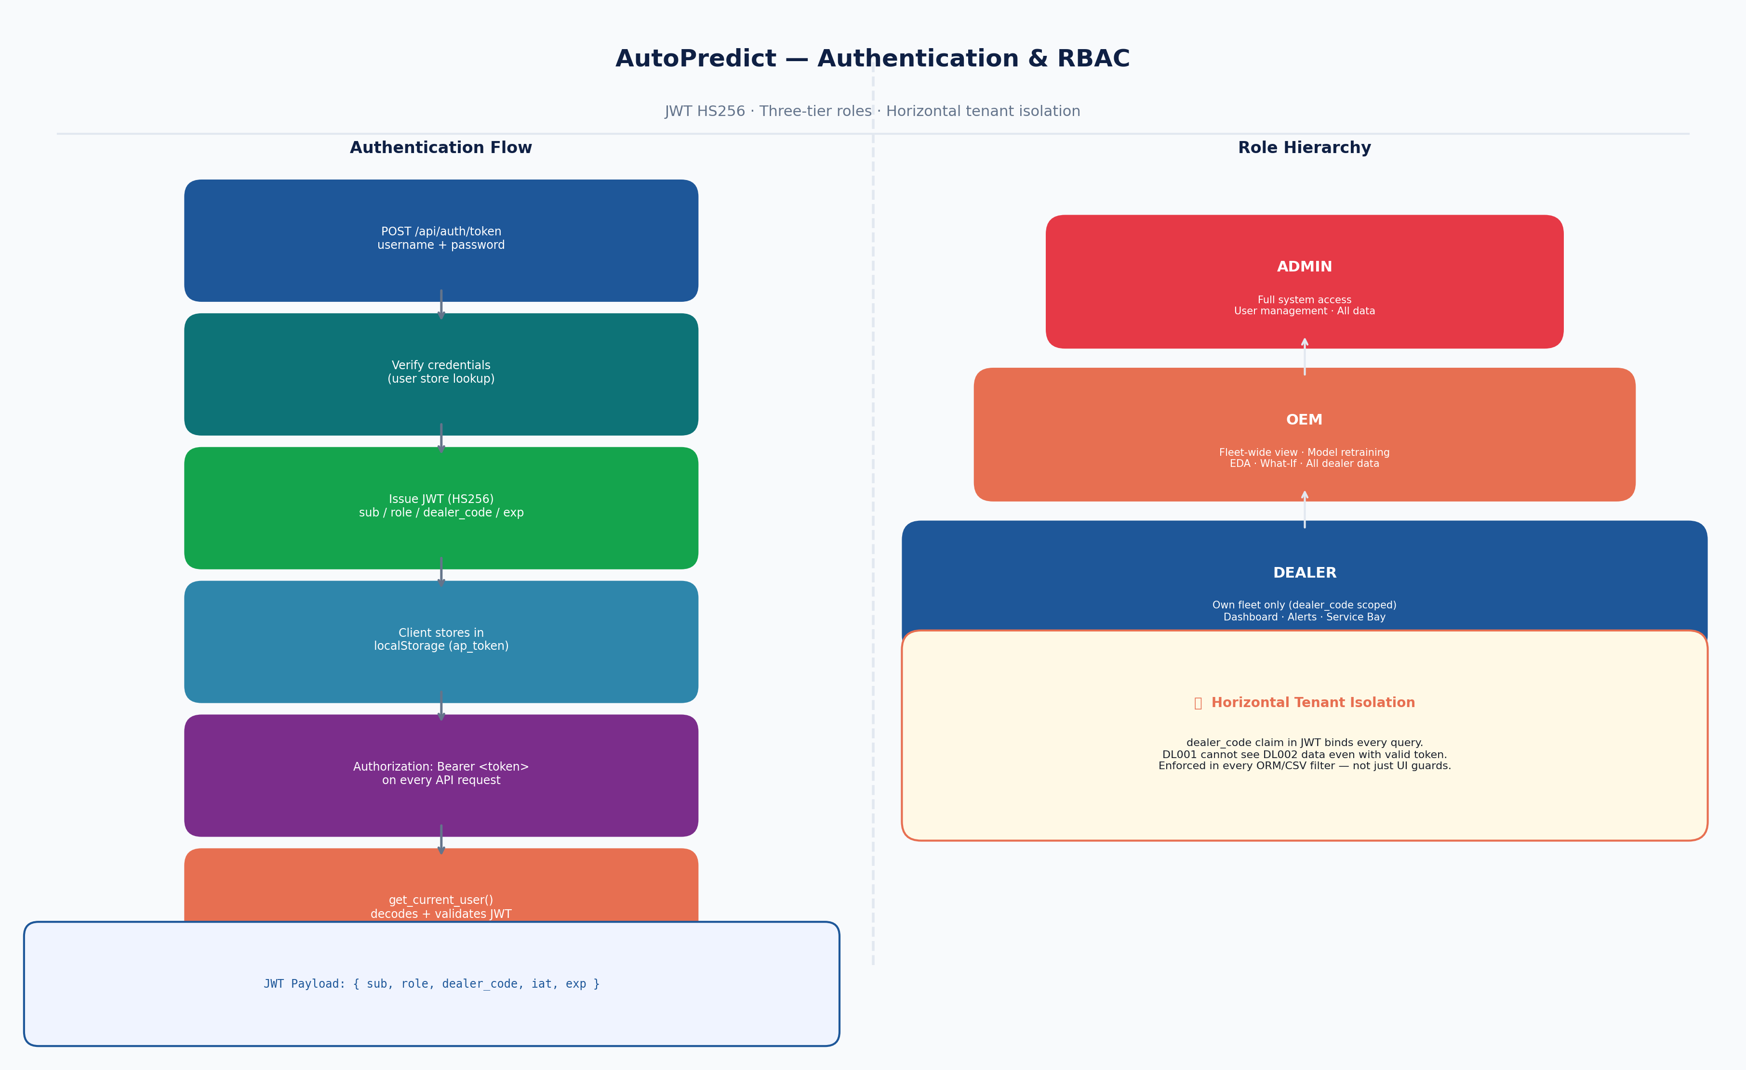
Figure 1 — Auth flow and RBAC hierarchy
Auth state is stored in localStorage with four keys:
Key | Value | Purpose
ap_token | JWT string | Sent as Authorization: Bearer header
ap_role | dealer / oem / admin | Controls route access and sidebar items
ap_dealer_code | DL001, DL002 … | Scopes all API queries to this dealer
ap_user | username string | Displayed in sidebar

4. State Management
State is divided into two clear categories:
- Server state (API data): TanStack Query — caching, background refetch, loading/error states
- Client state (UI state): React useState and Context — sidebar toggle, filter selections, modal open/close
No Redux or global state manager is used. The separation of concerns is enforced at the component level: components use useQuery() for data and useState() for UI.

5. Key Pages

DashboardPage (src/pages/Dashboard.tsx)
- 4 KPI stat cards (Total Vehicles, Active Alerts, Due Service, Health Score)
- Searchable, sortable vehicle table (VIN, Model, Year, Mileage, Risk, Status)
- Upcoming service panel (next 7 days)
- Real-time refresh via TanStack Query (5 min stale time)

AlertsPage (src/pages/Alerts.tsx)
- Severity filter buttons (All/Critical/High/Medium/Low) with active state highlighting
- Time window selector (24h/7d/30d/90d)
- Manual refresh with loading spinner
- Empty state illustration when no alerts match

OemFleetOverview (src/pages/OemFleetOverview.tsx)
- Group-by selector: Model / Region / Year / Fuel Type
- Bar chart of fleet health by group (Recharts)
- Pie chart of alert severity distribution
- Summary KPI cards with fleet-wide totals

OemRetrain (src/pages/OemRetrain.tsx)
- Checkbox list for 8 LightGBM models + 4 EV engines
- Select All / Clear All buttons
- Training notes textarea
- Retrain history table with AUROC before/after

6. Accessibility (WCAG 2.1 AA)
Issue | Component | Fix Applied
svg-img-alt | OemFleetOverview Recharts PieChart | Added aria-label to each <Cell>: "{name}: {value} vehicles"
scrollable-region-focusable | OemModelHealth heatmap div | Added tabIndex={0} to overflow-auto container
All 8 pages pass axe-core automated scans with zero critical or serious violations. The Playwright test suite (10-accessibility.spec.ts) runs these scans on every CI run.

