MG MOTOR INDIA
AutoPredict — Predictive Maintenance Platform

Backend API Documentation

FastAPI endpoints, authentication, request/response schemas, and error codes

Version: v1.0
Date: July 2025
Status: Confidential — Internal Use
Platform: AutoPredict v2.0

1. API Overview
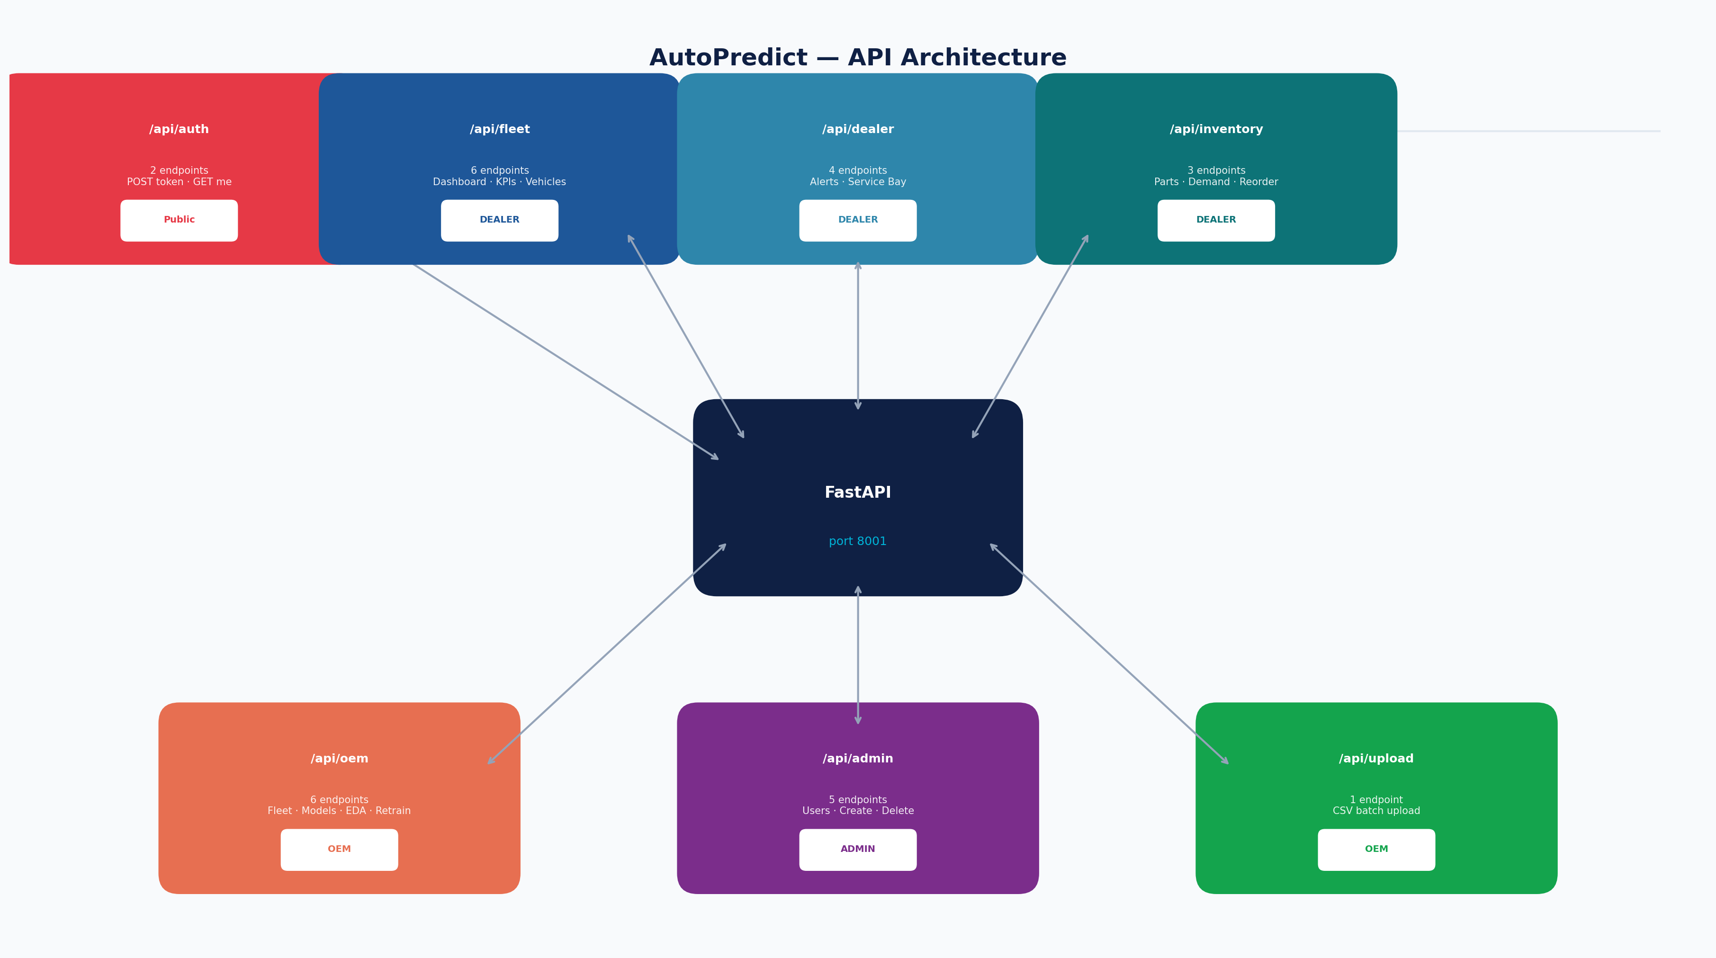
Figure 1 — API router map: 36 endpoints across 6 routers
The AutoPredict backend is a FastAPI application exposing 36 REST endpoints across 6 routers. All non-public endpoints require JWT Bearer authentication. The base URL is http://localhost:8001 in development.

2. Authentication
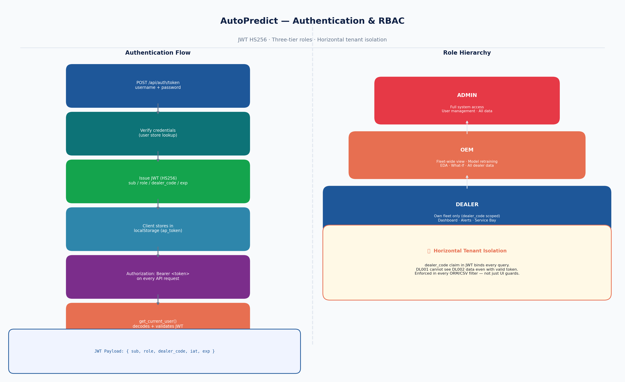
Figure 2 — Authentication and RBAC flow

2.1 Obtain Token
POST /api/auth/token
Field | Request Body | Response
username | string (required) | —
password | string (required) | —
access_token | — | JWT string
role | — | dealer / oem / admin
dealer_code | — | DL001 / null
token_type | — | "bearer"

3. Routers & Endpoints

/api/auth (Role: Public)
Method | Path | Description
POST | /token | Authenticate user; returns JWT token
GET | /me | Returns current user info from JWT claims

/api/fleet (Role: DEALER)
Method | Path | Description
GET | /dashboard | Fleet KPI summary (total vehicles, alerts, health score)
GET | /vehicles | Paginated vehicle list with risk scores (scoped to dealer_code)
GET | /vehicles/{vin} | Single vehicle detail with all ML predictions
GET | /alerts | Alert records with severity filter and time window
GET | /upcoming-service | Vehicles due for service in next N days
GET | /health-trend | Fleet health score time series

/api/dealer (Role: DEALER)
Method | Path | Description
GET | /service-bay | Bay grid status and appointment list
POST | /service-bay/book | Create bay appointment (VIN, bay, date, type)
GET | /demand-forecast | ML-driven parts demand forecast
GET | /inventory | Stock levels with reorder flags

/api/oem (Role: OEM)
Method | Path | Description
GET | /fleet-overview | Fleet-wide stats grouped by model/region/year/fuel
GET | /model-health | AUROC, PSI, precision, recall per model per region
GET | /eda | Feature distributions and correlation for EDA
POST | /whatif | What-if prediction: POST feature values, GET prediction
POST | /retrain | Trigger model retraining for selected models
GET | /retrain/history | Retrain log with AUROC before/after

/api/admin (Role: ADMIN)
Method | Path | Description
GET | /users | List all registered users
POST | /users | Create new user (username, password, role, dealer_code)
DELETE | /users/{username} | Deactivate user account
PUT | /users/{username} | Update user role or dealer_code
GET | /audit-log | Admin action audit trail

4. Error Codes
HTTP Code | Condition | Response Body
200 | Success | {"data": ...}
400 | Invalid request body (Pydantic validation) | {"detail": "field required"}
401 | Missing or malformed Authorization header | {"detail": "Not authenticated"}
403 | Valid token; insufficient role | {"detail": "Forbidden"}
404 | Resource not found (VIN, user, etc.) | {"detail": "Not found"}
422 | Unprocessable entity (FastAPI Pydantic error) | {"detail": [{...}]}
429 | Rate limit exceeded (auth endpoints) | {"detail": "Rate limit exceeded"}
500 | Internal server error (CSV parse failure, model error) | {"detail": "Internal error"}

5. Data Models
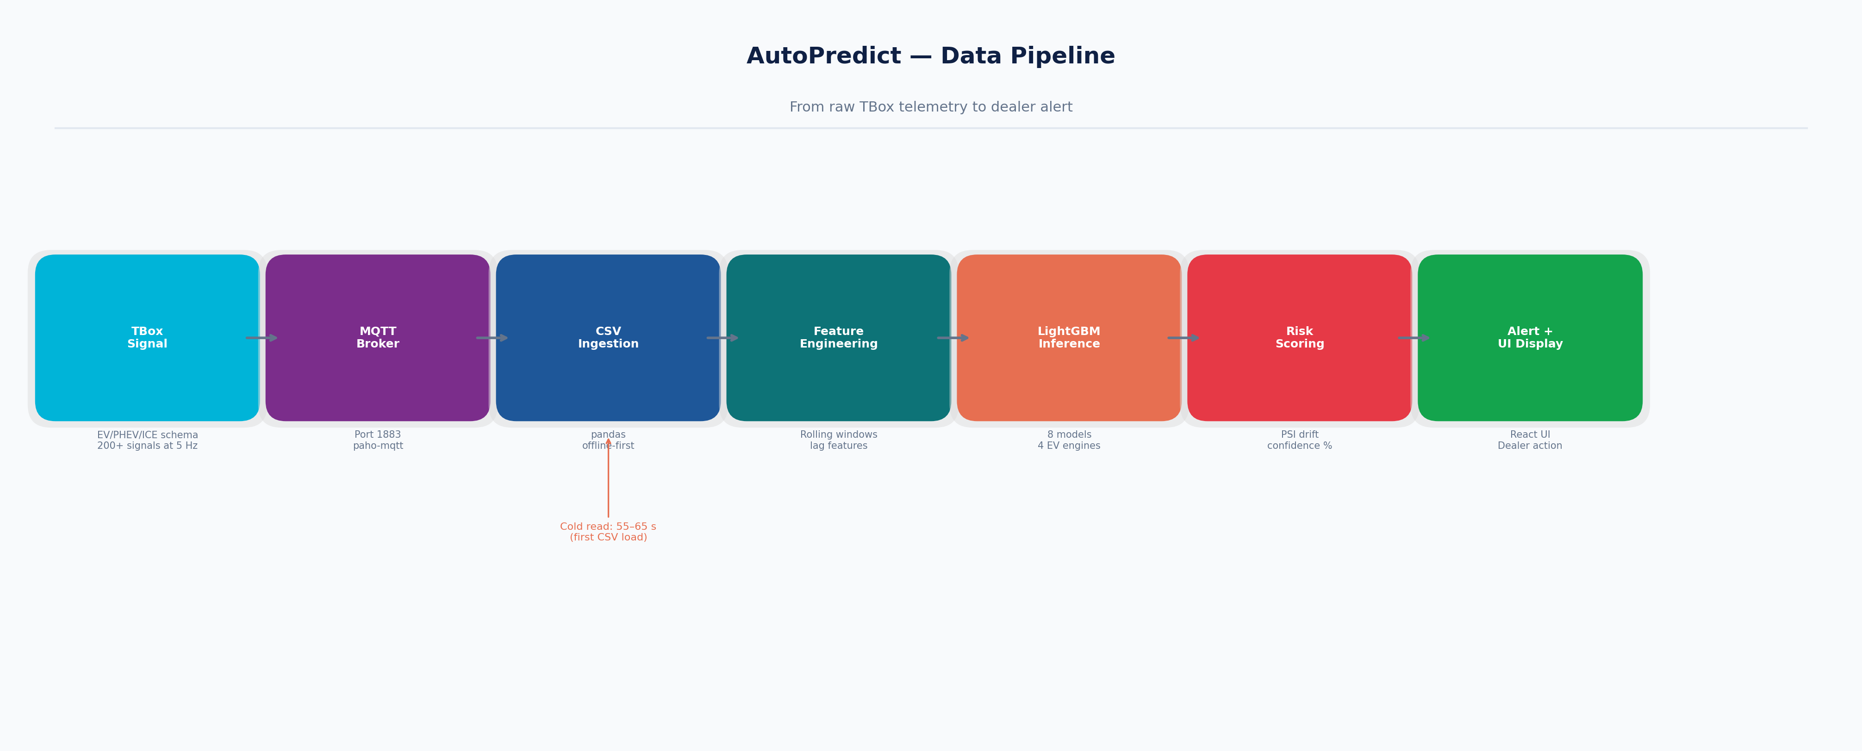
Figure 3 — Data flow from TBox signal to API response

