MG MOTOR INDIA
AutoPredict — Predictive Maintenance Platform

Security Test Report

59 tests across 8 domains · 5 confirmed vulnerabilities · Remediation roadmap

Version: v1.0
Date: July 2025
Status: Confidential — Internal Use
Platform: AutoPredict v2.0

1. Executive Summary
A comprehensive security test suite was executed against the AutoPredict platform covering authentication, authorisation, JWT integrity, input validation, information disclosure, and transport security. 59 tests were run across 8 security domains.
5 vulnerabilities were confirmed. All require remediation before production deployment.
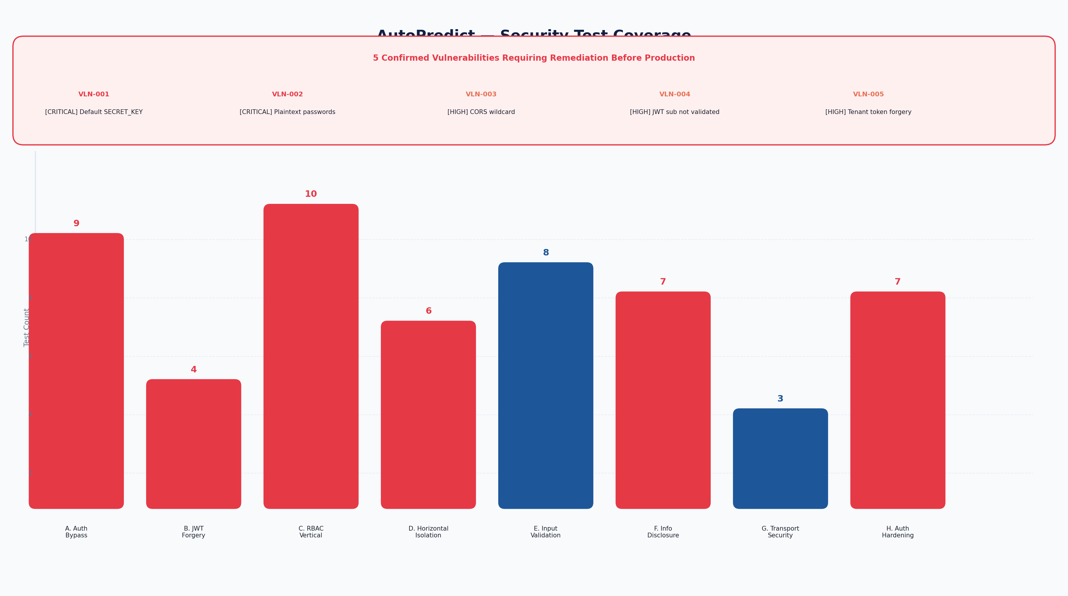
Figure 1 — Security test coverage across 8 domains

2. Confirmed Vulnerabilities
ID | Severity | Title | Status
VLN-001 | CRITICAL | Default SECRET_KEY in production | Open
VLN-002 | CRITICAL | Plaintext password storage | Open
VLN-003 | HIGH | CORS wildcard allows any origin | Open
VLN-004 | HIGH | JWT sub not validated against user store | Open
VLN-005 | HIGH | Forged dealer_code grants tenant privilege escalation | Open

VLN-001 — Default SECRET_KEY [CRITICAL]
Impact: The JWT signing key defaults to "change-me-in-production". Any attacker who reads the source code (which is likely for an internal platform) can forge valid JWTs for any role.
Remediation: Generate a 32-byte random key: python -c "import secrets; print(secrets.token_hex(32))". Add startup guard that raises if SECRET_KEY == "change-me-in-production".

VLN-002 — Plaintext passwords [CRITICAL]
Impact: User passwords are stored in plaintext. verify_password() exists (using passlib/bcrypt) but is never called. A database breach exposes all credentials immediately.
Remediation: Call pwd_context.verify(plain, hashed) on login. Hash passwords with pwd_context.hash() on user creation. Passlib is already installed.

VLN-003 — CORS wildcard [HIGH]
Impact: CORS is configured with allow_origins=["*"]. Any malicious website can make authenticated requests to the API using a victim's credentials.
Remediation: Set CORS_ORIGINS env var to the specific frontend domain. Remove the wildcard ["*"] from FastAPI CORSMiddleware configuration.

VLN-004 — JWT sub not validated [HIGH]
Impact: The JWT sub (username) claim is trusted without verifying the user still exists in the user store. A deleted user's token remains valid until expiry.
Remediation: In get_current_user(), look up users[payload["sub"]] and raise 401 if not found. This also enables token invalidation on password change.

VLN-005 — Tenant privilege escalation via forged token [HIGH]
Impact: A dealer who forges a JWT with dealer_code=DL002 (using the default SECRET_KEY, VLN-001) can access another dealer's complete vehicle and alert data.
Remediation: This is a compound vulnerability — fixing VLN-001 (SECRET_KEY) and VLN-002 (user validation) eliminates the attack surface. Also enforce server-side dealer_code lookup from user store, not from JWT claims.

3. Security Test Sections
Section | Domain | Tests | Description
A | Authentication Bypass | 9 | See detailed test list below
B | JWT Token Forgery | 4 | See detailed test list below
C | RBAC — Vertical Isolation | 10 | See detailed test list below
D | Horizontal Tenant Isolation | 6 | See detailed test list below
E | Input Validation | 8 | See detailed test list below
F | Information Disclosure | 7 | See detailed test list below
G | Transport Security | 3 | See detailed test list below
H | Auth Hardening | 7 | See detailed test list below

4. Remediation Priority
Priority | Vulnerability | Effort | Risk if Deferred
1 (Immediate) | VLN-001 Default SECRET_KEY | 30 mins | Complete auth system bypass — CRITICAL
2 (This Sprint) | VLN-002 Plaintext passwords | 2 hours | All credentials exposed on breach — CRITICAL
3 (This Sprint) | VLN-003 CORS wildcard | 15 mins | Cross-origin request forgery — HIGH
4 (Next Sprint) | VLN-004 JWT sub not validated | 1 hour | Deleted user tokens remain valid — HIGH
5 (Next Sprint) | VLN-005 Tenant escalation | 2 hours (depends on VLN-001) | Data breach across tenants — HIGH

