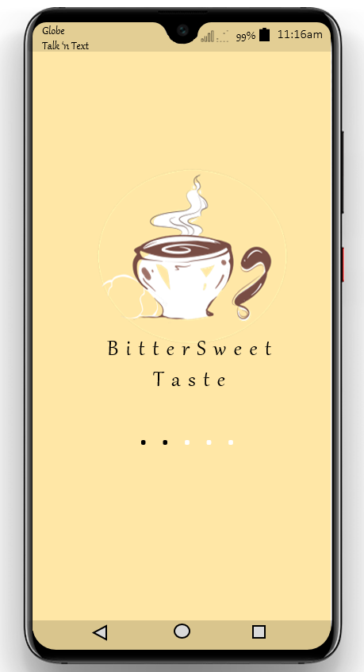

**Task Performance:** Mobile Application’s User Interface. *(Explanations only)*

By developing this mobile application, I follow some of the HCI principle which are know the user, understand the task, reduce memory load, strive for consistency, and remind the user. First, it is important for an app to know who its users. In this case, my users are all food and coffee lover. Next, is to understand the task. Its task is to offer food and beverages, that is why its main function is to display the menu of the food, and it has an interaction with the user by asking to check out or add it on cart. Then, the strive for consistency and reduced memory load. I placed all the icons and images on the app according to what’s most important. I limit the content of the page so that it can only show what is needed. Lastly, is to remind the user. Every time the user is going to check out, the app will ask them if they will really be going to, or will cancel the order. Also, to remind some restrictions and policy.