**A**

**PROJECT REPORT**

**ON**

**IOT Based Smart Agriculture System Using LoRa**

SUBMITTED TOWARDS THE

PARTIAL FULFILLMENT OF THE REQUIREMENTS OF

**BACHELOR OF ENGINEERING**

In

**Instrumentation & Control Engineering**

By

Ajit Ganpat Padule Exam No:

Student name Exam No:

Student name Exam No:

Student name Exam No:

**Under The Guidance of**

Prof. Name



Submitted to

**DEPARTMENT OF INSTRUMENTATION & CONTROL ENGINEERING**

Government College Of Engineering & Research

Avasari khurd

2021-2022

**CERTIFICATE**

This is to certify that the project entitled

**IOT Based Smart Agriculture System Using LoRa**

Submitted by

Ajit Ganpat Padule Exam No:

Student name Exam No:

Student name Exam No:

Student name Exam No:

Is a bonafide work carried out by Students under the supervision of Prof. name and it is submitted towards the partial fulfillment of the requirement of **Savitribai Phule Pune University** for the project in final year of Instrumentation and Control Engineering.

This project report has not been earlier submitted to any other institute or University for the award of any degree or diploma.

Prof. name Prof. HOD Name Principal name

**Internal Guide H.O.D Principal**

Dept. Instru & Control Engg. Dept. Instru& Control Engg. GCOE, Avasari khurd

Signature of Internal Examiner Signature of External Examiner

**Acknowledgment**

It gives us great pleasure in presenting the preliminary project report on **IOT Based Smart Agriculture System Using LoRa**

I would like to take this opportunity to thank my internal guide **Prof. name** for giving me all the help and guidance I needed. I am really grateful to them for their kind support. Their valuable suggestions were very helpful.

I am also grateful to **Prof. HOD Name**, Head of Dept. Instrumentation & Control Engg, Government college of engineering and research, avsari. for his indispensable support, suggestions.

In the end our special thanks to **Other Person Name** for providing various resources such as laboratory with all needed software platforms, continuous Internet connection, for Our Project.

Ajit Ganpat Padule Exam No:

Student name Exam No:

Student name Exam No:

Student name Exam No:

**Abstract**

Technology has become more advanced from past few years and becoming more advanced day by day. Today, we have so called IOT Internet Of Technology which is used in almost every department from healthcare, army, agriculture, industrial domains etc.

Problems in agriculture domain can be solved with this technology for high efficiency and best agri produce. Quality of agri produce can be increased with this technology.

So we have decided to use this technology in agriculture automation. As IOT need active source of internet but in remote area active internet is not present. So we have added LoRa technology to overcome this problem.

With more advanced tech Blynk also used to have more readable dashboard to show data and control things.

Table Of Contents

|  |  |  |
| --- | --- | --- |
|  | Acknowledgement |  |
|  | Abstract |  |
|  | List Of Figures |  |
|  | List Of Abbreviations |  |
|  |  |  |
| Chapter 1 | Introduction |  |
| 1.1 | Prelude |  |
| 1.2 | Motivation |  |
| 1.3 | Problem Statement |  |
| 1.4 | Objective of proposed work |  |
|  |  |  |
| Chapter 2 | Literature Review |  |
| 2.1 | Introduction |  |
| 2.2 | Microcontroller Based Agriculture Automation System |  |
| 2.3 | IOT based agriculture automation system |  |
| 2.4 | Conclusion |  |
|  |  |  |
| Chapter 3 | Block Diagram and flowchart |  |
| 3.1 | Introduction |  |
| 3.2 | Block diagran |  |
| 3.3 | Flowchart |  |
|  |  |  |
| Chapter 4 | System Design |  |
| 4.1 | DHT11 temperature and humidity sensor |  |
| 4.2 | Moisture Sensor |  |
| 4.3 | ESP-12E ESP8266 WiFi module |  |
| 4.4 | LoRa module LoRa- RA_01 SX1278 |  |
| 4.5 | Atmega328p Dev. Board [Arduino Nano] |  |
| 4.6 | GUI |  |
|  |  |  |
| Chapter 5 | Softwares and IDEs |  |
| 5.1 | Arduino IDE |  |
| 5.2 | LoRa Library |  |
| 5.3 |  |  |
| 5.4 |  |  |
|  |  |  |
| Chapter 6 | Results |  |
|  |  |  |
| Chapter 7 |  |  |
| 7.1 | Application |  |
| 7.2 | Advantages |  |
| 7.3 | Future scope |  |
|  |  |  |
| Chapter 8 | Conclusion |  |
|  |  |  |
| Chapter 9 | Bill Of material |  |
|  |  |  |
| Chapter 10 | References |  |
|  |  |  |
|  |  |  |

**Chapter 1**

**Introduction**

* 1. **Prelude:**

Now a days wireless communication is more popular than wired communication.

Wired communication has major disadvantages like requirement of long connecting wire and lots of hardware. Wireless communication is cheaper than wired communication. In Agriculture field various wireless technologies were used to improve farming technologies. Over past few years technology has changed rapidly. The low cost wireless devices like wearables, remote controls etc are made with wirelss device.

In agriculture field latest wireless technology used is Internet Of Things i.e IOT. Iot is term related to internet means data is sent over internet to control and analyze various connected device. Weather stations are best example of IOT technology. But internet is compulsory.

In remote area there is no internet available. In this IOT over internet will not work.

* 1. **Motivation**

We have seen in many agriculture automation systems there is problem with sending data and controlling wireless. They are either wired systems or incomplete wireless systems with compulsory internet requirement. To overcome this issues we have decided to develope a sytem which is not totally depend on internet.

* 1. **Problem Statement**

In remote areas internet is not available so the IOT based agriculture automation system will not work properly. As IoT system require wifi connection.

To overcome this problem we have used LoRa technology.

* 1. **Objective of proposed work**

1.To replace current agriculture automation system with latest IOT based and LoRa technolgy

2. To help farmers to monitor their fields and crops remotely and wirelessly without need of internet.

3.

**Chapter 2**

**Literature Review**

**2.1 Introduction**

Nowadays the world is facing many challenges in reducing energy consumption, water consumption and global warming. In the same time there are many technologies that can be used to resolve this problems and moreever support a better living. High accuracy and low power consumption with low cost is the main parameters of any project.

Literature survey gives us an idea about previous work done on perticular project, so that we can implement system better and flexible. There are various systems available for monitoring and controlling smart agri parameters.

**2.2 Microcontroller Based Agriculture Automation System:**

Microcontroller is the heart of any embedded system. Pic18F4520 is an 8 bit microntroller of pic family. It can work on different internal and external clock sources. Signal coming from sensors circuit are processed by the microcontroller and devices will be controlled accordingly.

Water Pump

LEDs

r

r

5V DC power

Supply

LCD Display

Soil Moisture Sensor

PIC18F4520

Microcontroller

Fig. Agriculture automation system using PIC18F4520

In above agriculture automation system moisture sensor used to sense soil moisture. PIC18F4520 8 bit microcontroller used to read sensor value and control water pump connected to it. This system need to be installed at the actual location and has no user control over it.

2.3 IOT based agriculture automation system:

In this Internet is used to send and receive sensors data and contrl it from remote location.

2.4 Conclusion:

There are various type of systems available for agriculture automation using wireless technologies like BLE, WIFI, RF etc. But still some systems has few advantages like BLE, WIFI RF cannot be used for long range control. Internet can be used to long range automation and control. But there is also a problem remote areas has no internet availabel.

**Chapter 3**

**Block diagram and flowchart:**

3.1 Introduction:

The sensor like DHT11 a humidity and temperature sensor, moisture sensors are connected to atmega328p development board. A LoRa module is connected to arduino uno i.e atmega328p developement board. This becomes whole transmitter circuit.

Receiver circuit has LoRa module connected with ESP8266 wifi module. LoRa module receives data and ESP8266 wifi module send this data to cloud. In this case we are using Blynk IoT cloud. It has best features and a beutiful dashboard to control and analyze data.

3.2 Block Diagram:

Power Supply

DHT11 sensor

LoRa Module

RA-01

Atmega328p Dev. Board

Arduino Nano

Moisture Sensor

Water Pump

Motor

Fig. Transmitter block diagram.

Power Supply

LoRa Module

RA-01

ESP8266

WiFI module

NodeMCU

Fig. Receiver block diagram.

3.3 Flowchart

3.3.1 Transmitter

Send data to LoRa Module

Read Sensor Data

No

No

Yes

Yes

LoRa ?

sensor connecteded ?

Init LoRa Module

Initialize Sensors and initial parameters

If control signal is

Get Control Signal from LoRa

Turn OFF water pump

Turn OFF motor

Turn ON motor

Turn ON water pump

Init LoRa Module

LoRa ?

No

Yes

Read and Parse received Data

Send parsed data to Blynk

Display received data on Blynk dashboard

If moisture is < 30%

Send turn on motor command

Yes

No

Send turn Off motor command

**Chapter 4**

**System Design**

**4.1 DHT 11 temperature and humidity Sensor:**

The DHT11 is a basic, ultra low-cost digital temperature and humidity sensor. It uses a capacitive humidity sensor and a thermistor to measure the surrounding air and spits out a digital signal on the data pin (no analog input pins needed). It's fairly simple to use but requires careful timing to grab data. The only real downside of this sensor is you can only get new data from it once every 2 seconds, so when using our library, sensor readings can be up to 2 seconds old.

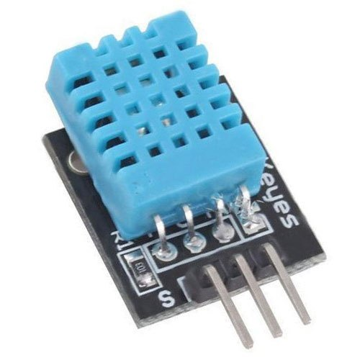

* Low cost
* 3 to 5V power and I/O
* 2.5mA max current use during conversion (while requesting data)
* Good for 20-80% humidity readings with 5% accuracy
* Good for 0-50°C temperature readings ±2°C accuracy
* No more than 1 Hz sampling rate (once every second)
* Body size 15.5mm x 12mm x 5.5mm
* 4 pins with 0.1" spacing

**4.2 Moisture sensor:**

This**Capacitive soil moisture** sensor measures soil moisture levels by capacitive sensing rather than resistive sensing like other sensors on the market. It is made of corrosion-resistant material which gives it excellent service life. Insert it into the soil around your plants and impress your friends with real-time soil moisture data!

This module includes an onboard voltage regulator which gives it an operating voltage range of **3.3 ~ 5.5**V. It is perfect for low-voltage **MCUs**, both **3.3V**, and**5V**. For compatibility with a **Raspberry Pi**, it will need an **ADC converter**.

This soil moisture sensor is compatible with our **3-pin** “**Gravity**” interface, which we can connect to the **Gravity I/O**

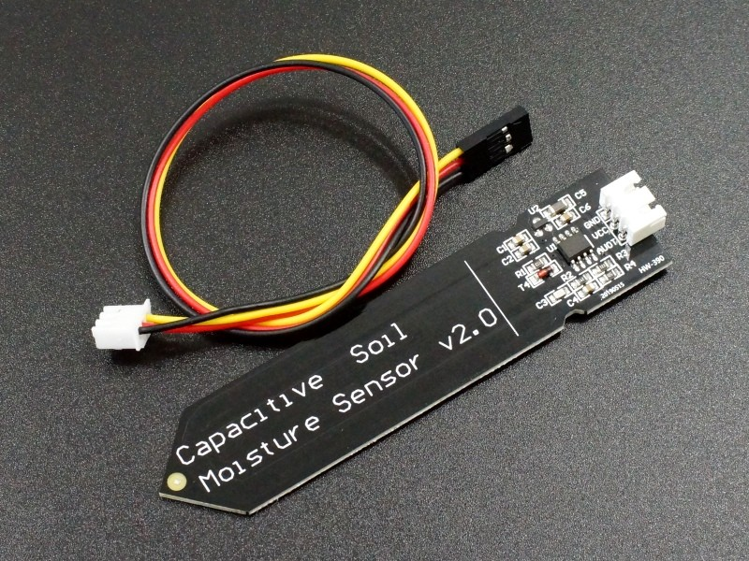

1. Operating Voltage: 3.3 ~ 5.5 VDC.
2. Operating Current: 5mA.
3. Interface: PH2.54-3P.
4. Dimensions mm(LxWxH): 98 x 23 x 4.
5. Supports 3-Pin Gravity Sensor interface
6. Analog output.
7. Weight (gm): 15

**4.3 ESP-12E ESP8266 WiFi module:**

This is ESP-12E: ESP8266 Serial Port WIFI Wireless Transceiver Module For Arduino.

This small WIFI transceiver is the perfect solution for home Automation and IoT applications. It can be the replacement of your NRF24L01, it can talk to your WIFI router directly through the UART MCU’s (Rx, Tx).

The ESP-12 module is one of the most complete of the ESP family as it allows you to use the biggest amount of pins of all of them. You can program this module to work stand alone with the Arduino IDE or with LUA as NodeMCU.

The system is equipped with ESP8266 manifested leading features are: energy saving VoIP quickly switch between the sleep/wake patterns, with low-power operation adaptive radio bias, front-end signal processing functions.

The ESP8266-03 is one of the smallest versions of this module. It includes a built-in ceramic antenna.



1. WS2812 Led on board.
2. 802.11 b/g/n
3. Wi-Fi Direct (P2P), soft-AP
4. Integrated TCP/IP protocol stack
5. Integrated TR switch, balun, LNA, power amplifier and matching network
6. Integrated PLL, regulators, DCXO and power management units
7. 802.11 b/g/n
8. Wi-Fi Direct (P2P), soft-AP
9. Integrated TCP/IP protocol stack
10. Integrated TR switch, balun, LNA, power amplifier and matching network
11. Integrated PLL, regulators, DCXO and power management units
12. +19.5dBm output power in 802.11b mode
13. Power down leakage current of <10uA

**4.4 LoRa module LoRa- RA_01 SX1278:**

This LoRa 433MHz module designed by AI-THINKER, which based on the chip SX1278. The SX1278 RF module is mainly used for long-range spread spectrum communication. It can resist Minimize current consumption. Thanks to SEMTECH’s patented LoRa™ modulation technology, the SX1278 has a high sensitivity of -148 dBm with a power output of +20 dBm, a long transmission distance and high reliability. At the same time, compared with the traditional modulation technology, LoRa™ Modulation technology in anti-blocking and selection also has obvious advantages, to solve the traditional design can not take into account the distance, interference and power consumption.

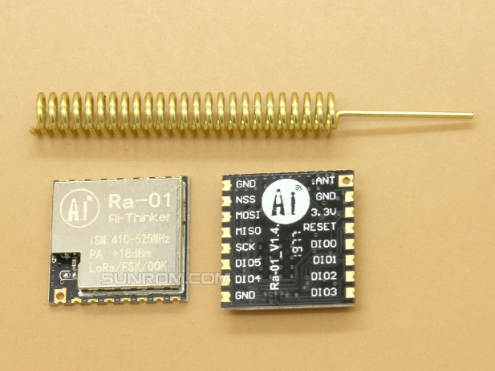

1. LoRaTM spread spectrum communication
2. +18dBm – 10mW. Stable RF output power when the input voltage changed
3. Half-duplex SPI communication
4. Programmable bit rate can reach to 300kbps
5. Support FSK, GFSK, MSK, GMSK, LoRaTM and OOK Modulation Mode
6. 127dB RSSI wave range.
7. Automatically detect RF signal, CAD mode, and super high-speed AFC
8. With CRC 256 bytes data engine
9. Half hole (castellated hole)  SMD package
10. With metal shielding case
11. Spring antenna

**4.5 Atmega328p Dev. Board [Arduino Nano]:**

The Arduino Nano is a small, complete, and breadboard-friendly board based on the ATmega328 (Arduino Nano 3.x). It has more or less the same functionality of the Arduino Duemilanove, but in a different package. It lacks only a DC power jack, and works with a Mini-B USB cable instead of a standard one



### Power

The Arduino Nano can be powered via the Mini-B USB connection, 6-20V unregulated external power supply (pin 30), or 5V regulated external power supply (pin 27). The power source is automatically selected to the highest voltage source.

### Memory

The ATmega328 has 32 KB, (also with 2 KB used for the bootloader. The ATmega328 has 2 KB of SRAM and 1 KB of EEPROM.

### Input and Output

Each of the 14 digital pins on the Nano can be used as an input or output, using pinMode(), digitalWrite(), and digitalRead() functions. They operate at 5 volts. Each pin can provide or receive a maximum of 40 mA and has an internal pull-up resistor (disconnected by default) of 20-50 kOhms. In addition, some pins have specialized functions:

* Serial: 0 (RX) and 1 (TX). Used to receive (RX) and transmit (TX) TTL serial data. These pins are connected to the corresponding pins of the FTDI USB-to-TTL Serial chip.
* External Interrupts: 2 and 3. These pins can be configured to trigger an interrupt on a low value, a rising or falling edge, or a change in value. See the attachInterrupt() function for details.
* PWM: 3, 5, 6, 9, 10, and 11. Provide 8-bit PWM output with the analogWrite() function.
* SPI: 10 (SS), 11 (MOSI), 12 (MISO), 13 (SCK). These pins support SPI communication, which, although provided by the underlying hardware, is not currently included in the Arduino language.
* LED: 13. There is a built-in LED connected to digital pin 13. When the pin is HIGH value, the LED is on, when the pin is LOW, it's off.

The Nano has 8 analog inputs, each of which provide 10 bits of resolution (i.e. 1024 different values). By default they measure from ground to 5 volts, though is it possible to change the upper end of their range using the analogReference() function. Analog pins 6 and 7 cannot be used as digital pins. Additionally, some pins have specialized functionality:

* I2C: A4 (SDA) and A5 (SCL). Support I2C (TWI) communication using the Wire library (documentation on the Wiring website).

There are a couple of other pins on the board:

* AREF. Reference voltage for the analog inputs. Used with analogReference().
* Reset. Bring this line LOW to reset the microcontroller. Typically used to add a reset button to shields which block the one on the board.

### Communication

The Arduino Nano has a number of facilities for communicating with a computer, another Arduino, or other microcontrollers. The ATmega328 provide UART TTL (5V) serial communication, which is available on digital pins 0 (RX) and 1 (TX). An FTDI FT232RL on the board channels this serial communication over USB and the FTDI drivers (included with the Arduino software) provide a virtual com port to software on the computer. The Arduino software includes a serial monitor which allows simple textual data to be sent to and from the Arduino board. The RX and TX LEDs on the board will flash when data is being transmitted via the FTDI chip and USB connection to the computer (but not for serial communication on pins 0 and 1). A SoftwareSerial library allows for serial communication on any of the Nano's digital pins. The ATmega328 also support I2C (TWI) and SPI communication. The Arduino software includes a Wire library to simplify use of the I2C bus. To use the SPI communication, please see ATmega328 datasheet.

### Programming

The Arduino Nano can be programmed with the Arduino software ([download](https://www.arduino.cc/en/main/software)). Select "Arduino Duemilanove or Nano w/ ATmega328" from the Tools > Board menu (according to the microcontroller on your board). The ATmega328 on the Arduino Nano comes preburned with a bootloader that allows you to upload new code to it without the use of an external hardware programmer.

**4.6 GUI :**

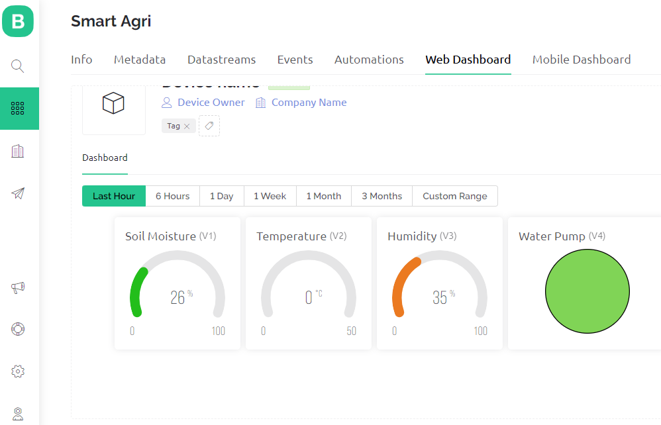

**Fig. Web dashboard**

**Chapter 5**

**Softwares and IDEs used:**

**5.1.Arduino IDE:**

The open source Arduino Software makes it easy to write code and upload it to the board.

This software can be used with any arduino board.



5.2 LoRa library



**Chapter 6**

**Results**

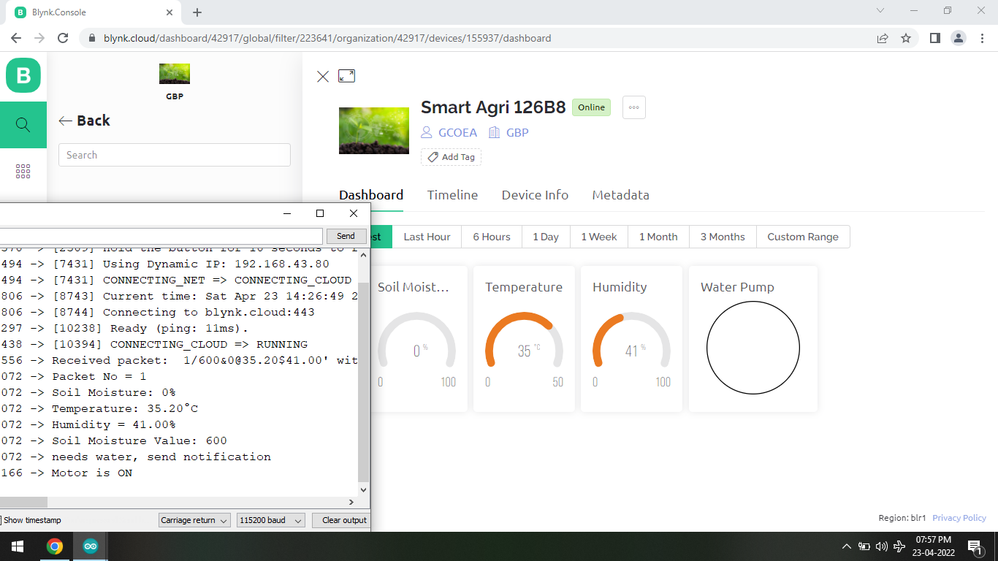

**Fig.** Data reception on Blynk dashboard

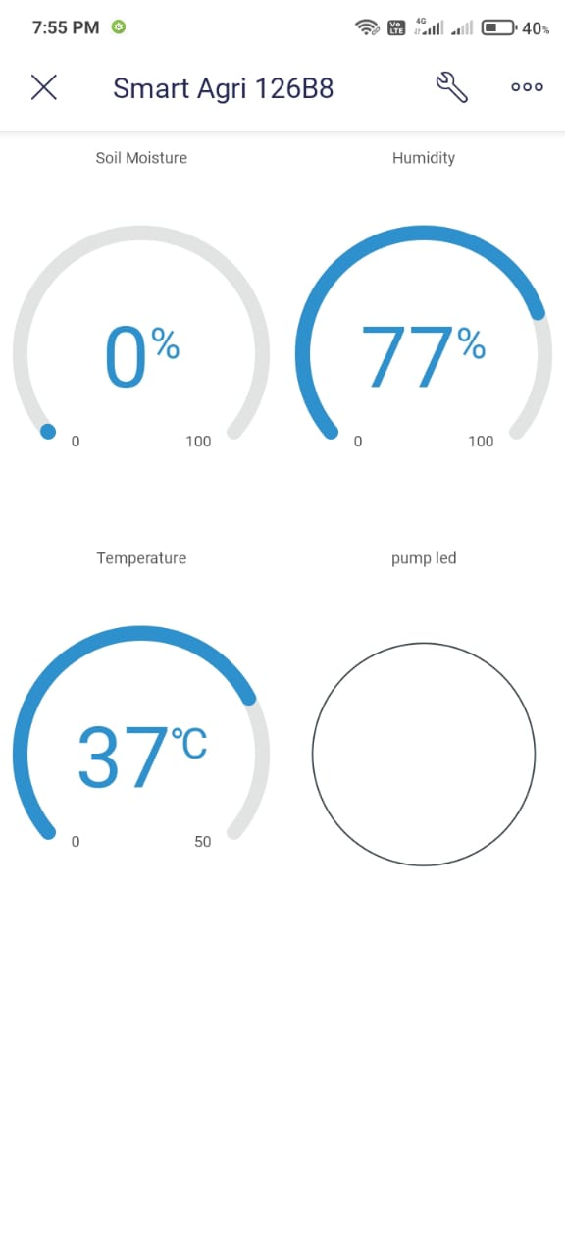

Fig. Android app dashboard view

**Chapter 7**

**7.1 Applications**

1. Smart Agriculture
2. Hospital automation(for large hospitals)
3. Can also be used in Army for long range data transmission without internet

**7.2 Advantages**

**7.3 Future scope**

**Chapter 8**

**Conclusion**

There are lots of systems available for agriculture automation using GSM technique, using internet. We have studied all this techniques but they have some drawbacks like Internet based system cant work in remote area. To overcome this issue we have developed a system which can work upto 10km range without internet.

**Chapter 9**

**Bill Of Material**

|  |  |  |  |  |
| --- | --- | --- | --- | --- |
| **Sr No** | **Component Description** | **Quantity** | **Price** | **Cost(INR)** |
| 1 | ESP8266 Wifi module | 1 | 620 | 620 |
| 2 | LoRa Module RA-01 | 2 | 398 | 796 |
| 3 | Atmega328p dev. board | 1 | 650 | 650 |
| 4 | DHT 11 sensor | 1 | 275 | 275 |
| 5 | Capacitive Soil Moisture Sensor | 1 | 264 | 264 |
| 6 | 9V Dc battery connector | 2 | 15 | 30 |
| 7 | 9V dc batteries | 4 | 25 | 100 |
| 8 | 3.3V dc voltage regulator | 1 | 195 | 195 |
| 9 | Jumper wires | 30 | 2 | 60 |
| 10 | Double side tape | 1 | 25 | 25 |
| 11 | Water pump | 1 | 250 | 250 |
|  |  |  |  |  |
| 12 | LoRa-module | 1 | 398 | 398 |
| 11 | ESP-12E | 1 | 475 | 475 |
|  |  |  |  |  |
|  |  |  | Total | 4138 INR |
|  | Total including 18% GST (CGST 9% + SGST 9%) | | | 4882 INR |

**Chapter 10**

**References**

# 1.Performance Analysis of LPWAN Using LoRa Technology for IoT Application October 2018 [International Journal of Engineering & Technology](https://www.researchgate.net/journal/International-Journal-of-Engineering-Technology-2227-524X) 7(4.11):252 DOI:[10.14419/ijet.v7i4.11.21387](http://dx.doi.org/10.14419/ijet.v7i4.11.21387)

# 2.Internet of Things (IoT) Reference Architecture by [Chris Haddad](https://dzone.com/users/1008231/cobiacomm.html) Jun. 18, 14 · [IoT Zone](https://dzone.com/iot-developer-tutorials-tools-news-reviews)· Interview

# 3. Reference Architectures for the Internet of Things

**Publisher: IEEE**

4. LoRa Blynk app Interfacing Sending The Data From The LoRa Modules To Blynk Servers Using Ai-Thinker LoRa Modules Published December 13, 2020

# 5.Blynk App And Lora Transreceiver Interfacing