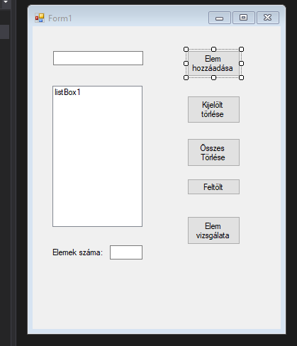
2 db textBox
1 db label
1 db listBox
5 db button

