Package ni nomi doim eng birinchi yozilishi kerak, aks holda error beradi:

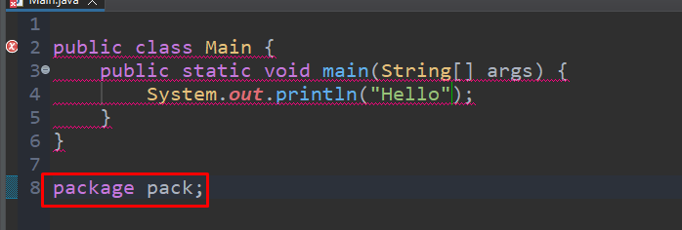

Endi esa xatolik yo’qoldi:

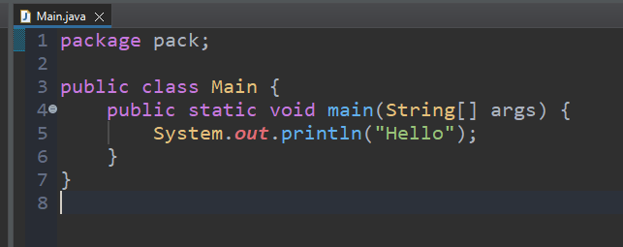

Packageni class ni ichida ham yoza olmaymiz:

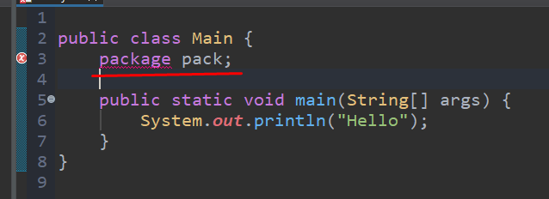

Bundan tashqari bitta class faqat bitta package ga tegishlidir, 2 yoki undan ortiq packagega emas:

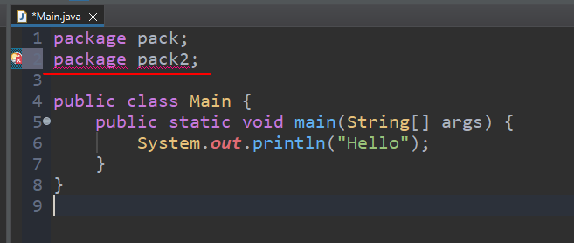

**Import** statementini package dan oldin yoza olmaymiz, aks hola error beradi:

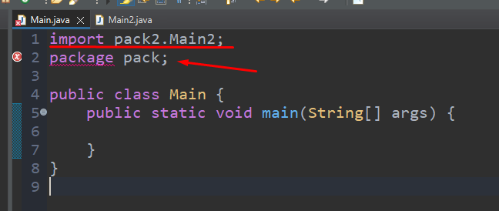

**Import** statement **package** dan keyin yozilishi kerak, shunda xatolik bermaydi:

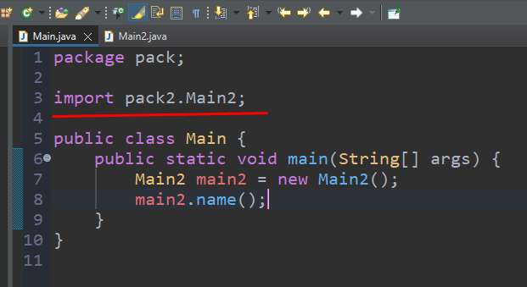

**Package** dan oldin yoki keyin comment yozish mumkin:

