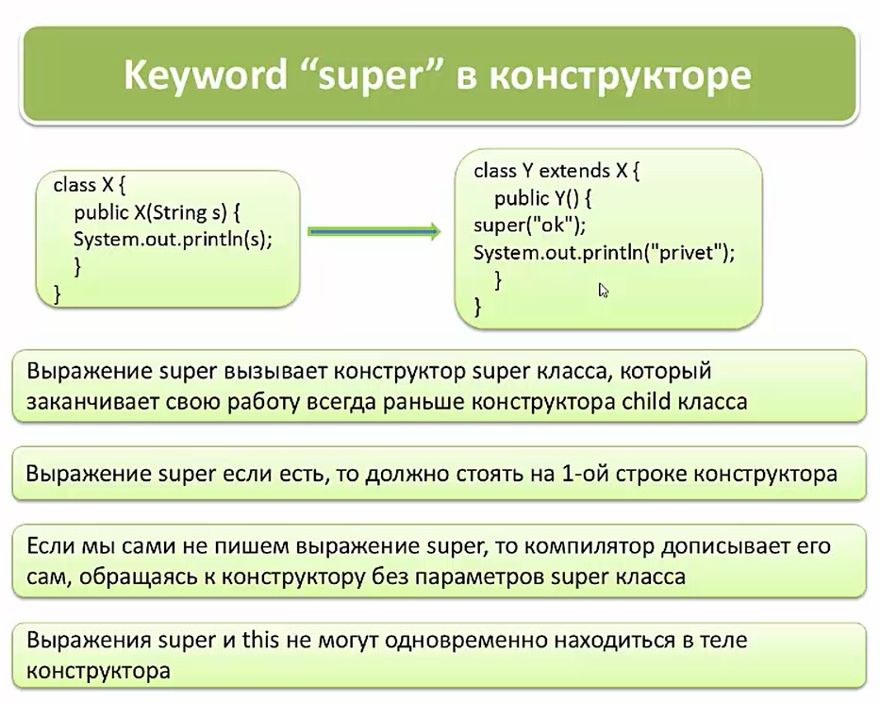

Pastdagi misolda xatolikni sababi, bu Paper ota class da private modifier bilan constructor yaratilyapti. Private constructorlar o’zidan tashqaridagi classlarda ko’rinmaydi. Bola class book esa eng avval ota class dagi no-arg constructorni super() orqali chairishga harakat qiladi, lekin topa olmaydi private bo’lgani uchun. Shunda bola class nima qilib bo’lsa ham ota classni constructorini chaqirishi shart. Lekin boshqa constructor yo’q. Shuning uchun xatolik beradi:

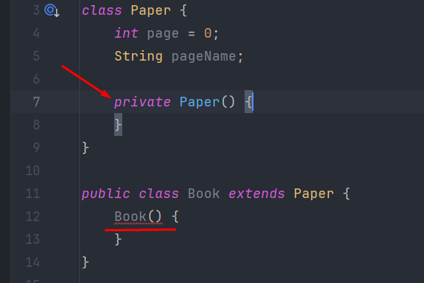

Lekin boshqa private bo’lmagan constructor yasab, uni bola classda chaqirsak, u holda xatolik yo’qoladi:

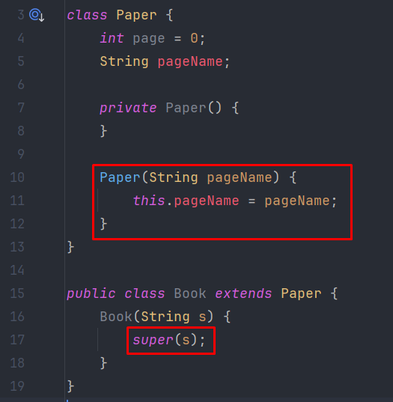

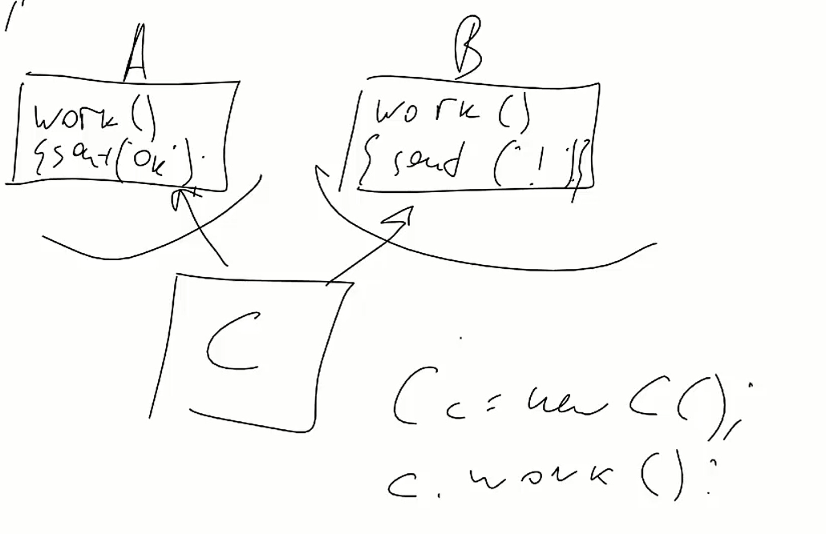

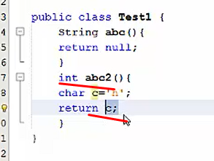

Bizga ma’lumki child class ni constructori albatta parent classni constructorini supe() keyword orqali chaqirishi shart. Bunda bir narsani bilish kerak. Agar parent class ni constructori parameterli constructor bo’lsa, u holda child class ni constructori albatta ota classni constructorini chaqrishi shart. Agar ota classda bir nechta parameterli constructor bo’ladigan bo’lsa, bola class ni constructorida super() orqali o’sha constructorlardan bittasini chaqirishi shart:

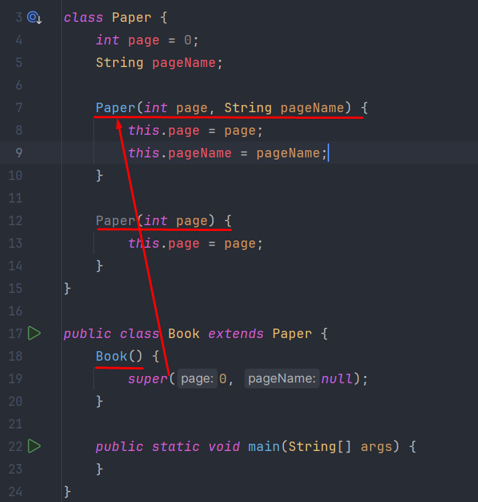

Agar bola classda nechta constructor bo’lsa, u holda ota class da faqat parameterli constructor bo’ladigan bo’lsa, u holda bola class ni har bir constructorida ota class ni parameterli constructorlaridan birini chaqirish shart. Bunda ota class ni parameterli constructorlaridan qaysi birini chaqirishni farqi yo’q, lekin bola class ni har bir constructorida albatta chaqirilishi shart:

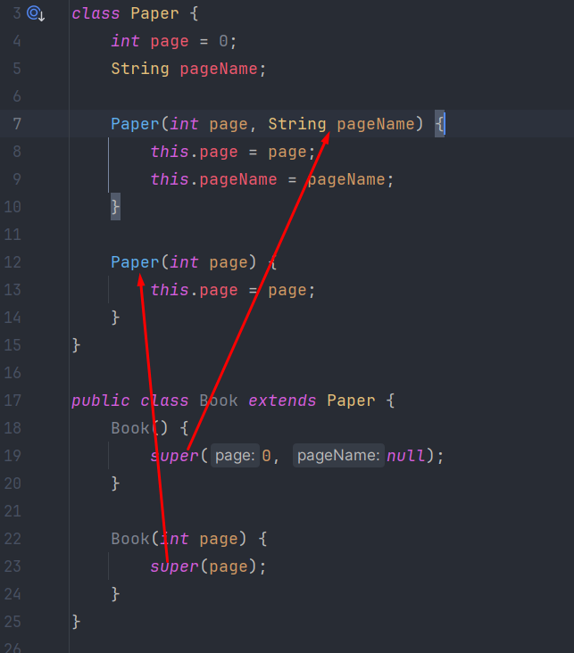

Agar ota class da faqat no-argument constructor bo’ladigan bo’lsa, u holda bola classdagi constructorlar, o’sha constructorni avtomatik ravishda super() ni qo’yib chaqiradi:

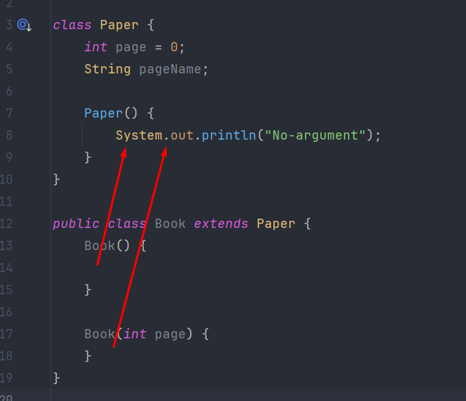

Agar ota class da no-argument constructor va parameterli constructor bo’ladigan bo’lsa, u holda bola classdagi constructorlarda super() ni yozmasak, avtomatik ota classdagi no-arg constructoni chaqiradi: 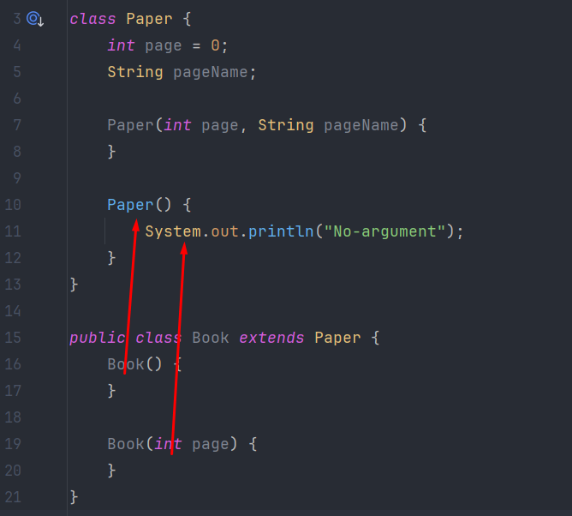

Agar ota class da faqat parameterli constructor bo’lsa, u holda bola classda albatta constructorda ulardan aqalli bittasini yozish shart, aks holda xatolik beradi. Masalan pastdagi misolda ham ota class Paper da faqat parameterli constructor bor bo’lib, bola class da hali constructor yozilmagan bo’lsa hamki, aslida default constructor bor va shu constructorda super() yozilgan, lekin bu supe() faqat ota classni no-arg constructorini chaqiradi. Ota class da esa no-arg constructor yo’q. Shuning uchun bizni Java majburlaydi, bola classda constructorni yozgin va unda ota classni istalgan bitta constructorini chaqirgin deb:

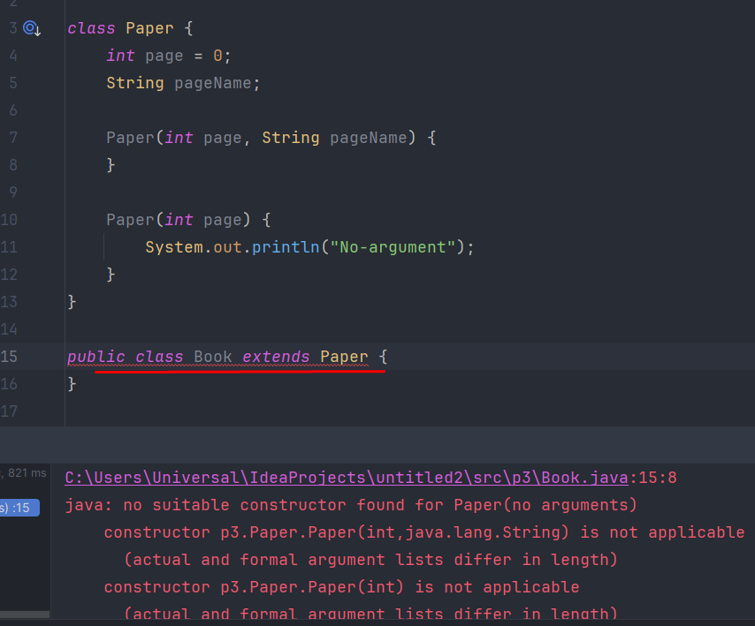

Lekin agar ota class da no-arg constructor bor bo’lsa, u holda bola class da constructor yaratish shart emas, orqa fonda java bola classda default constructorni yaratib, ota classdagi no-arg constructorni super() orqali chaqiradi:

