Documentation of the Comprehensive Analysis of the Technology Industry (Power BI Dashboard)
José Eduardo Zárate Aranda
Introduction
In this analysis, I studied the impact of the COVID-19 pandemic and the subsequent recovery period on the workforce, specifically focusing on layoffs within the technology industry. The pandemic has undoubtedly reshaped the business landscape, with companies worldwide having to make tough decisions to ensure their survival. One of these decisions has been to reduce their workforce, a measure that has affected millions of employees around the world.
My study is based on three comprehensive datasets. The first one, titled 'Layoffs 2022', provides a detailed account of layoffs in various industries during the pandemic and post-pandemic periods. The second dataset, 'Top 50 US Tech Companies 2022 – 2023', offers information on the leading US technology companies during the same period. The third dataset, 'Tech migrations', provides information on technology movement during and after the pandemic.
The dashboard is presented in English because my plan at the end of the course is to publish the analysis on Kaggle as a thread for the already published data.
My analysis begins with an overview of layoffs during the pandemic and post-pandemic periods, highlighting the sectors that were most affected and the companies that had to make significant staff reductions. Then, I delved into the technology industry, examining layoffs over time and geographically. Additionally, I analyzed the top 50 US technology companies and technology migration patterns during this period.
Main Objectives
The main objective is to implement an interactive dashboard that encompasses a comprehensive analysis since the limited graphs included in the Layoffs.fyi website fall short in representing the amount of information present. This is done to complement and enhance the analysis of data on layoffs in the information technology industry.
Hypothesis
It is of vital importance to carry out a comprehensive data analysis of the massive layoffs in the technology industry during the years 2019-2023. This analysis will allow for a better understanding of the magnitude and distribution of these layoffs, as well as possible underlying factors causing them. With the results of this analysis, informed decisions can be made, taking into account the current economic situation of the sector. It will be determined that the behavior of layoffs is not trivial and, at the same time, allows anticipating future possibilities in the industry.
Types of Analysis
• Descriptive: Visualize the periods with the most observed layoffs, as well as the most affected sectors. Analyze the density of layoffs in large companies compared to small ones and study the frequency with which layoffs are executed in large and small companies.
• Diagnostic: Implementation of an interactive dashboard to better understand which companies and geographical regions have been most affected and observe the evolution of the crisis from the beginning of the post-pandemic phase.

Calendar Table
A table named 'Dates' was created to facilitate data visualization. Not all columns were used in the analysis; however, they were generated for future work.
Measurement Table
The data was slightly transformed for analysis purposes. Layoff locations were converted into latitude and longitude using the Google Geocoding API, and the resulting locations in that format were written into the 'Geocode' table. Additionally, the income per employee in each company was calculated, and a relative performance was shown with a total income rate calculated. The formula for such calculations is a simple division between the two elements under study, the size of employees, and the company's income. The calculations can be found in the 'CalculatedTable'.
Database
Below is the diagram of the model, the tables used, and the existing relationships in general.
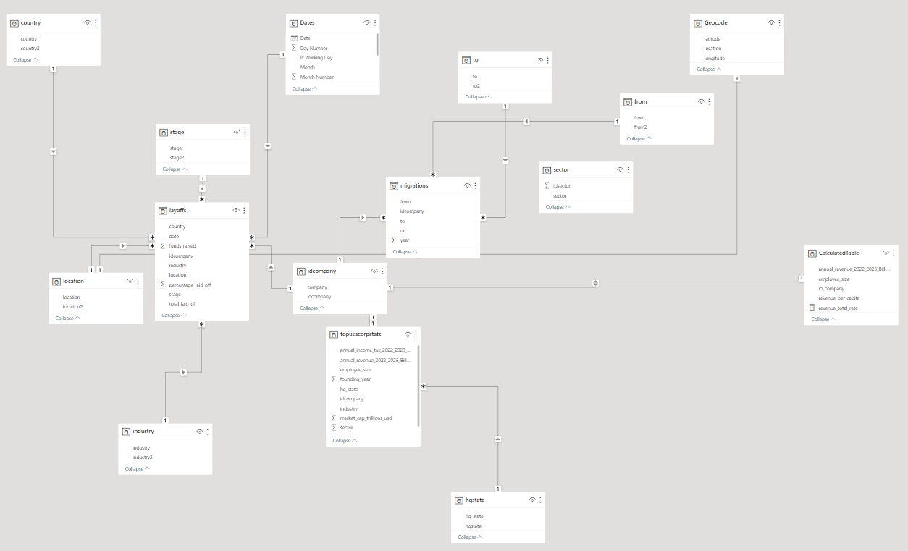
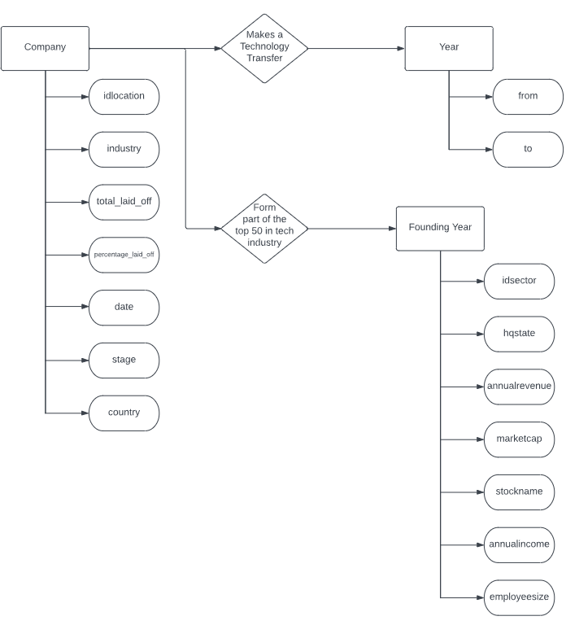

The database has 9 columns, of which 5 contain qualitative information, and the other 4 are quantitative. The records contain information about the company, such as the corporate name, country, office location, industry or sector, company stage or level, date of layoffs, the number of people laid off in that company, the percentage of layoffs relative to the total active employees in the company, and the funds raised.
These records add up to a total of 2508 rows, and each day, new data is accumulated on Layoffs.fyi - Tech Layoff Tracker and Startup Layoff Lists link. However, for the preparation of this analysis, the compiled data in a comma-separated file was obtained through a dataset on the Layoffs Dataset | Kaggle, created by Roger Lee with the username SWAPTR. He curated the Airtable table published on the Layoffs.fyi website. This CSV file is available on Kaggle under the Open Data Commons Open Database License 1.0, http://opendatacommons.org/licenses/odbl/1.0/ but it does not receive daily updates like the primary source on Layoffs.fyi. Here are the details about each table:

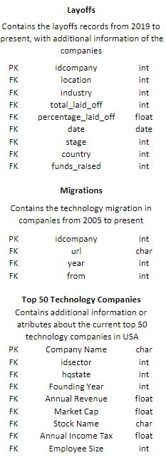

Here is a brief visualization of the dashboard with their respective descriptions:


