ANGULAR PROJECT GUIDELINES

## HOMECOMPONENT:

The home screen upon successful build should be looking as follows:



## LOGIN CREDENTIALS:

* Log in as ADMIN through credentials as follows:

User Name: “admin”

Pwd: “admin”

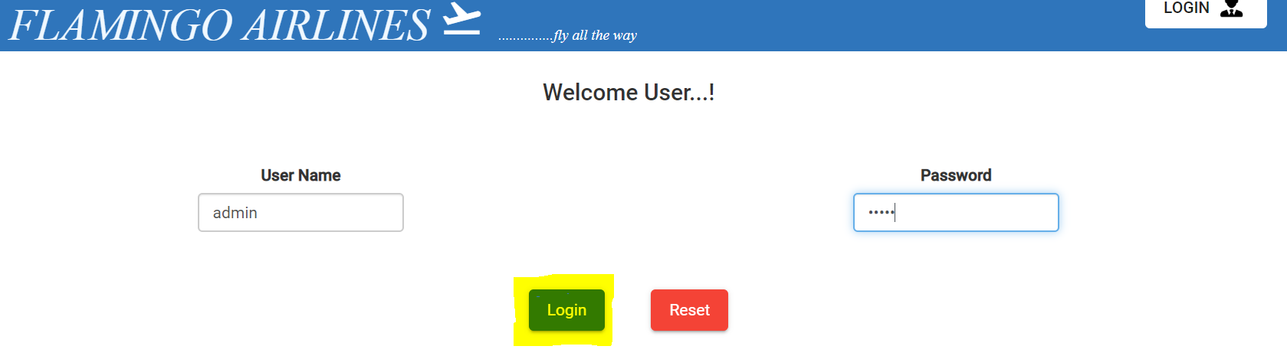

* Log in as STAFF through credentials as follows:

User Name: “staff”

Pwd: “staff”

Select the type as : “Check-in to flight” or “In-flight purpose” based on the requirement

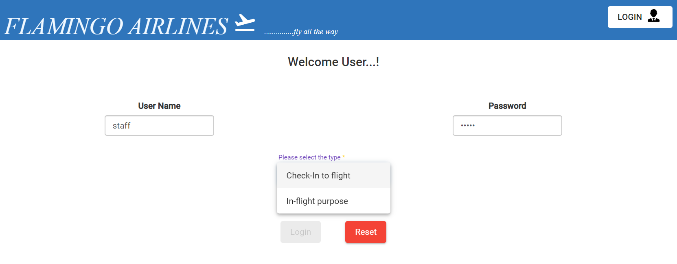

## ADMIN DASHBOARD

Upon successful login as admin and selecting the flights, the admin dashboard should look as follows:



## CHECK-IN TO FLIGHT:

The Check-in screen should be looking as follows upon successful login and selection of one of flights that are yet to depart based on local time to check-in:

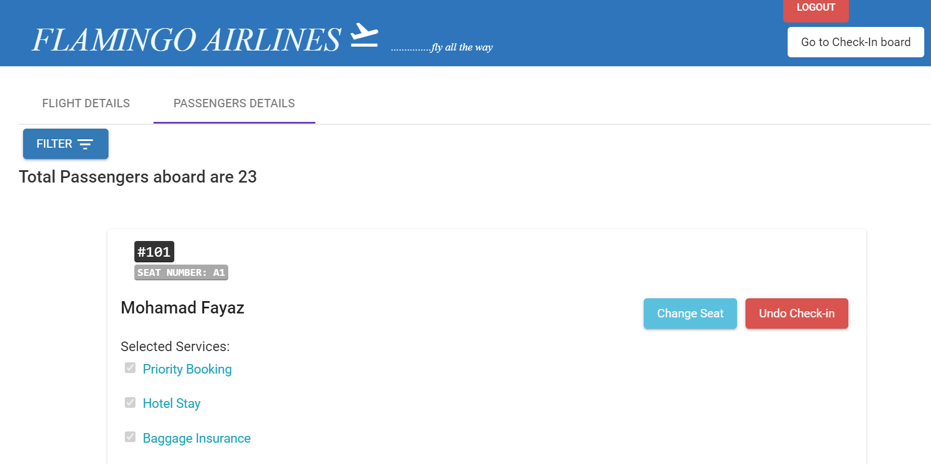

## IN-FLIGHT PURPOSE

The In-flight purpose screen should be looking as follows upon successful login and selection of flights that are already departed based on local time:

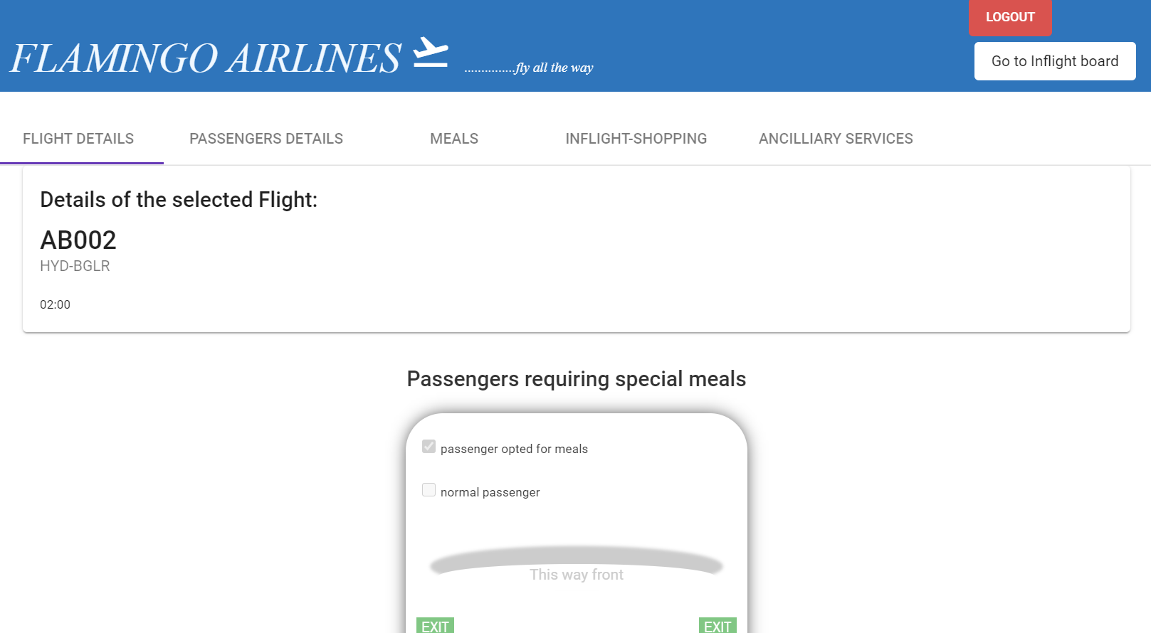

## DETAILS OF THE STORED DATA

Instead of using a JsonServer or any other apps to suffice for mocking the database, I have used the input data through the json files. The input data is fetched using json files stored in the “assets” folder of the project, from which the input data is called through services using httpclient. You can find the json files as follows:

