LAB 6:

**Task 01:-**

Write a PHP code for the following and print their outputs (where applicable) on the browser

1. To get the PHP version and configuration information.

**Code:**

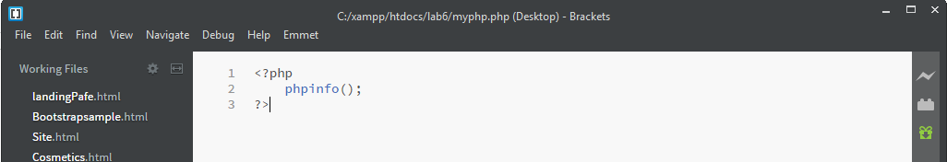

**Output:**

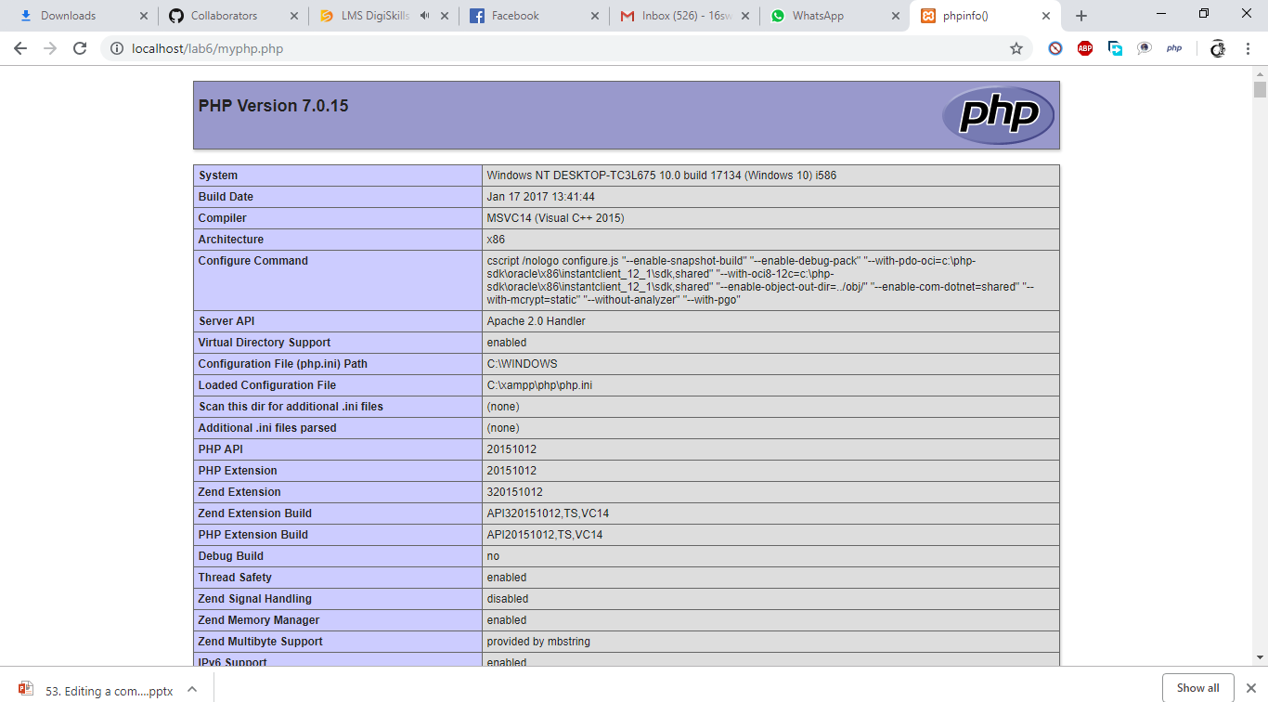

1. To get the name of the owner of the current PHP script, document root directory under which the current script is running and the operating system PHP is running on.

**Code&Output:**

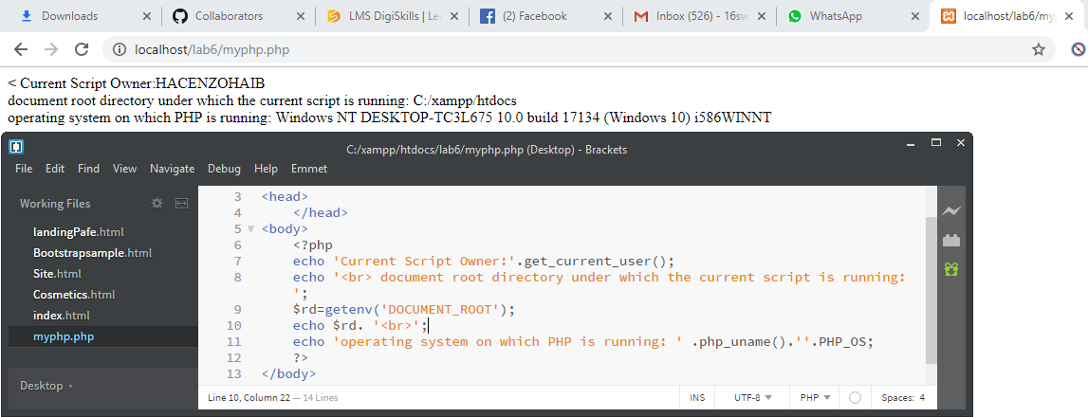

1. To swap two variables and print their values before and after swapping.

**Code&Output:**

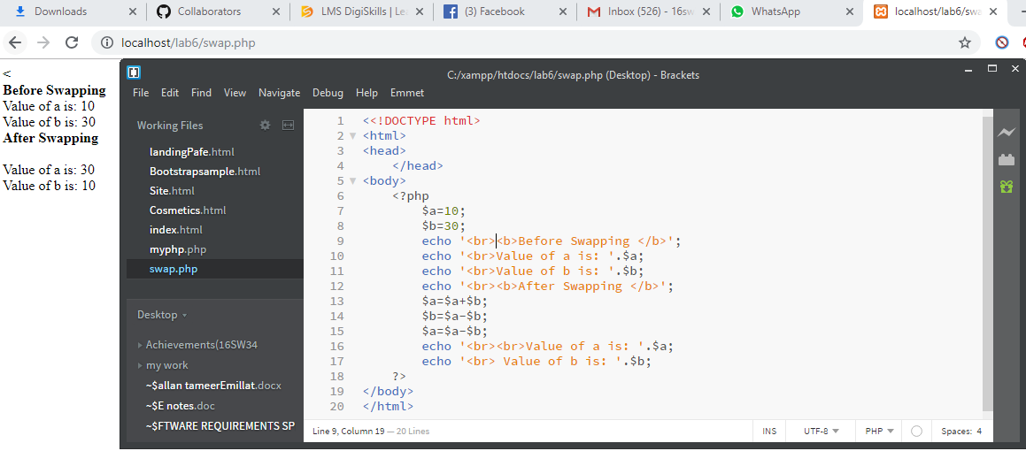

1. To redirect a user to a different web page (for example:

<http://sw.muet.edu.pk>).

**Code:**

**Output:**

1. To display the following strings:

Tomorrow I’ll learn something new.

This is a bad command: del c:\*.*\$.

**Code & Output:**

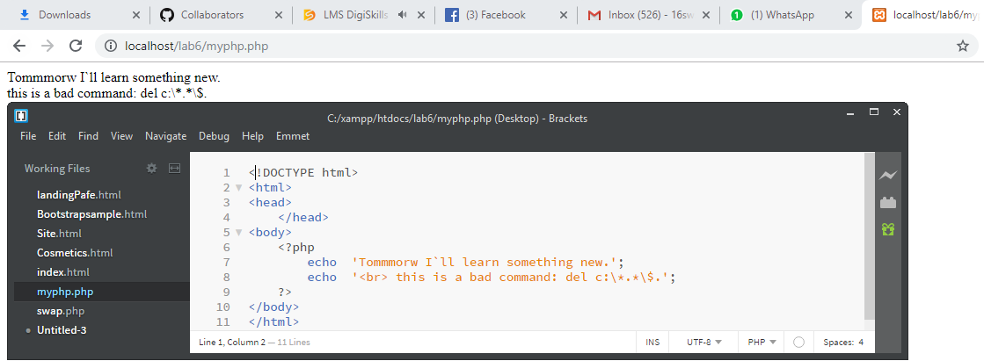

1. To test whether a number is greater than 30, 20 or 10 using ternary operator and print the result.

**Code&Output:**

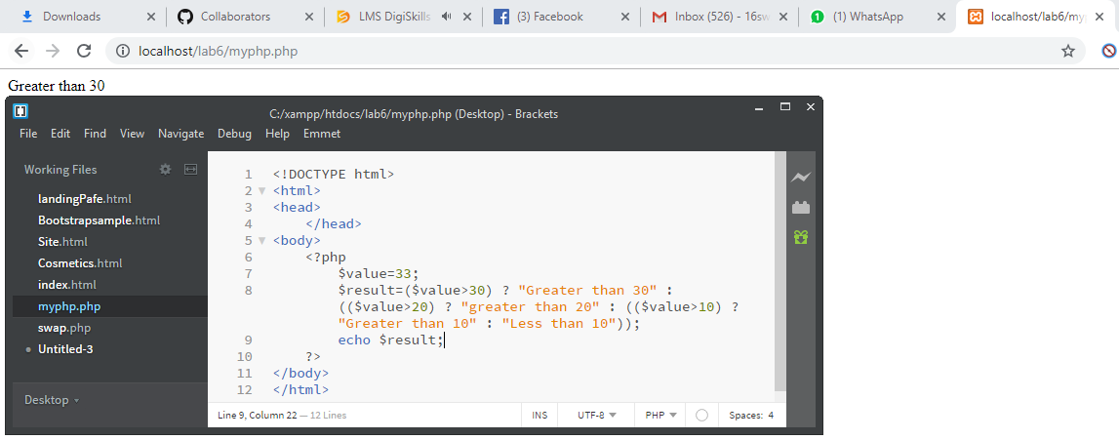

1. To return the following components of any url stored in a variable such as:

url: <http://sw.muet.edu.pk/faculty/cvs/sample.pdf>

Scheme : http  
Host : www.sw.muet.edu.pk  
Path : /faculty/cvs/sample.pdf

Hint: Use string functions to extract various components from the url

**Code & Output:**

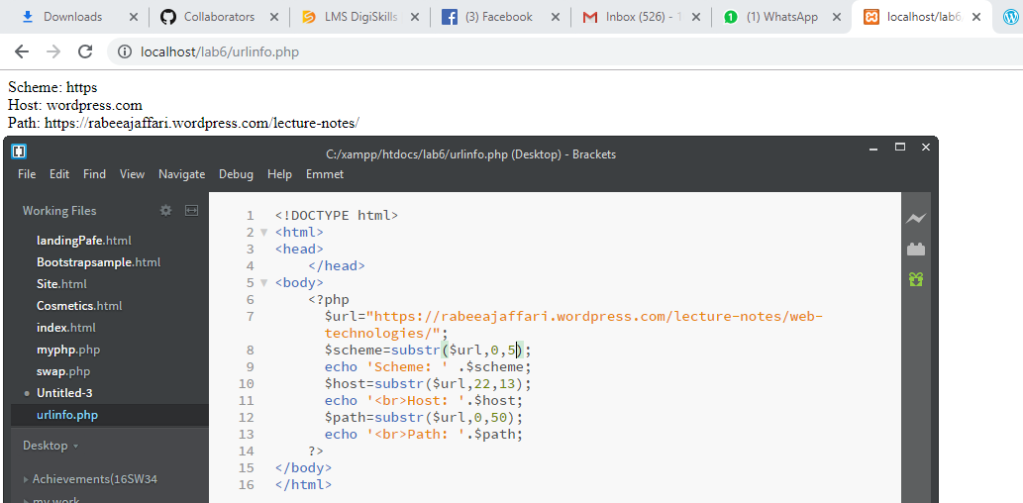

**Task 02:-**

Write PHP code inside HTML for the following:

Create a variable $var = 'PHP Lab 6'. Put this variable into the title section, h3 tag and as an anchor text within an HTML document to print its value in all of them i.e. in title, h3 tag and anchor tag text.

Hint: Save the file with .php extension and run according to PHP basics in the browser. Use echo function between HTML tags to print the value of PHP variable.

**Code & Output:**

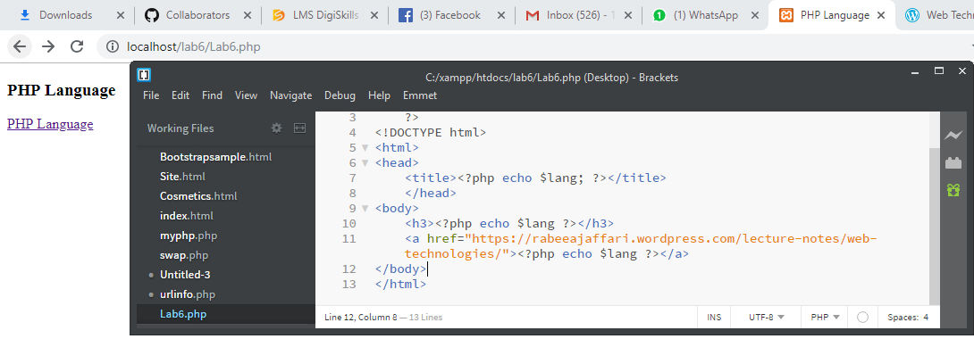

**Task 03:-**

Write HTML code inside PHP to display string, values within a table given below:

Hint: Use HTML table tag inside PHP echo statement.

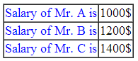

**Code:**

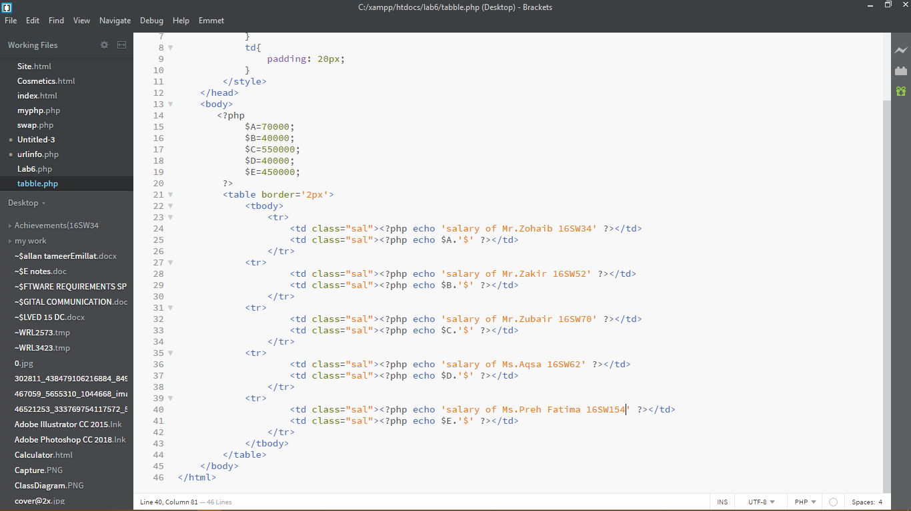

**Output:**

