

**1. Roll Numbers & Student Name:**

Hammad Ashraf – 21L6275  
Nareen Waseem – 21L6270

**2. Name of the Project:**

**Smart Inventory Forecasting System for Retailers**

**3. Overview:**

The Smart Inventory Forecasting System is designed to solve a crucial problem for retailers of good and products. Every year, poor planning causes great loss to retailers most of the losses incurred due to products with shorter lifespan, or significant storage overheads or both. Our project aims to save these stores from majority of their losses by smartly analysing their own past sales data and predict future sales of individual products. This will greatly assist in planning inventory and grow their profit.

**4. Key Features:**

* **Demand Forecasting:** With help of past inventory sales data, we plan to help the store forecast future sales of individual products. Data needs to be sufficient for accurate market trend analysis. ✅

* **Real-Time Stock Monitoring:** Providing managers and owners ability to track inventory in real time. We will alert them for stock shortages or excessive situations. ✅

* **Supplier & Order Management:** Manages records of suppliers and estimation of orders to be placed as per the trends. ✅

* **Store Integration:** Supports multiple retail outlets, synchronizing inventory levels across all locations. ✅

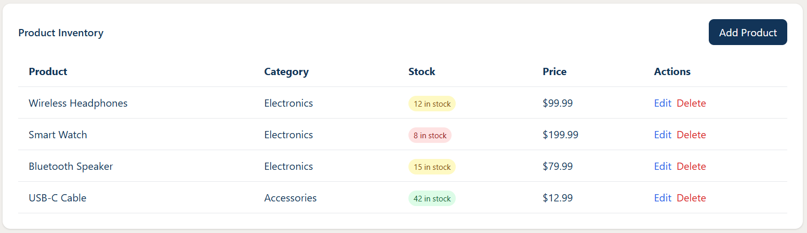

* **Data Analytics & Reporting Dashboard:** An interactive dashboard which provides insights on sales trends, slow-moving products, and restocking recommendations will hook retailers to use our application. ✅

* **Role Based Access:**  
  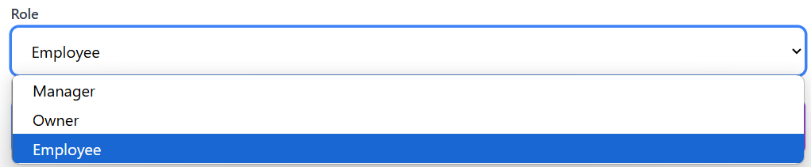
* **Automated Restocking Alerts:** Sends notifications when stock levels reach a predefined threshold. Visualization of the trends for a better idea. ✅

* **Mobile & Web Accessibility:** A responsive interface is a must for every application. Retailers can monitor and manage their inventory from any device of their choice. ✅

