In the name of Allah, the Most Gracious and The Merciful


Department of Computer Science
Rachna College of Engineering and Technology, Gujranwala
(A Constituent College of UET Lahore)

Project: Grocery Management System
SOFTWARE ENGINEERING

Submitted By:
23-CS-455 EMAN FATIMA
23-CS-486 HAMMAD
Submitted To:
Dr. Mam Tayybah Kiran

Semester: Fall 2024
B.Sc. Computer Science

 | Rachna College of Engineering and Technology, Gujranwala  (A Constituent College of UET, Lahore)  Department of Computer Science
BS (Hons.) Computer Science |  |  | Semester Fall 2024

Grocery Management System - Documentation

Acknowledgement
We express our sincere gratitude to everyone who contributed to the successful development of the Grocery Management System. Special thanks to our mentors, who guided us throughout the project, and to the development team for their dedication and hard work. We are also grateful to the users whose valuable feedback helped us refine the system.

Abstract
The Grocery Management System (GMS) is a desktop application designed to facilitate efficient management of a grocery store's operations. The system provides modules for inventory management, customer management, sales, purchase tracking, and reporting. The primary aim is to enhance productivity and reduce manual workload through automation. Developed using C# and Oracle Database, this system follows a structured Software Development Life Cycle (SDLC) approach, ensuring scalability, reliability, and user-friendly interfaces.

1. Introduction
The Grocery Management System aims to streamline the operations of a grocery store by automating routine tasks such as billing, inventory management, and customer tracking. This document provides comprehensive details about the system, covering all stages of its development life cycle.

1.1 Problem Statement
Manual grocery management is prone to errors, time-consuming, and lacks efficiency. There is a need for a system that automates these tasks and provides real-time data.

1.2 Purpose
The purpose of this project is to create a reliable and efficient system that simplifies grocery store operations.

1.3 Objective
To develop software application that reduces manual effort, enhances productivity, and provides robust inventory and sales management.

1.4 Overview
The system is designed to handle multiple modules, including inventory, sales, customer management, and reporting.

1.5 Scope
The application is intended for standalone grocery stores and is adaptable to larger businesses with modifications.

1.6 Tools & Technology
- Development: Microsoft Visual Studio, C#
- Backend: Oracle Database
- Framework: .NET Framework

2. Feasibility Study

2.1 Operational Feasibility
The system is user-friendly and requires minimal training for employees.

2.2 Technical Feasibility
Developed using established technologies, ensuring compatibility and support.

2.3 Financial Feasibility
Cost-effective development with scalable architecture.

2.4 Economic Feasibility
Improves efficiency, reducing long-term operational costs.

2.5 Study of Current System
Manual operations are inefficient and error-prone.

2.6 Proposed System
An automated solution that manages inventory, sales, and customer data efficiently.

2.7 Problem and Weakness of Current System
- Time-consuming
- Error-prone
- Lack of data centralization

2.8 Features of New System
- Automated inventory updates
- Secure user authentication
- Real-time reporting

2.9 Literature Survey
Existing systems were reviewed to identify best practices and features for implementation.

3. Study of the System

3.1 Modules
- Login Module
- Dashboard
- Inventory Management
- Sales Module
- Customer Management
- Reporting

4. Software Requirement Study

4.1 Product Description
A desktop application for grocery store management.

4.2 User Characteristics
Designed for store managers and staff with basic computer knowledge.

4.3 Functional Requirements
Secure Login System The system includes a robust authentication mechanism, ensuring that only authorized personnel can access its features. It uses encrypted passwords stored in the database and restricts access based on user roles.
Inventory and Sales Tracking The system provides real-time inventory management, allowing users to add, update, or delete items. It tracks sales transactions, ensuring accurate stock counts and timely reordering of products.
Reporting A comprehensive reporting module generates detailed reports on sales, inventory levels, and revenue. Reports can be exported in various formats, aiding in decision-making and performance analysis.

4.4 Non-Functional Requirements
Scalability The system is designed to handle an increasing number of users, products, and transactions without significant performance degradation. It can be adapted to multi-store operations in the future.
Reliability Built with reliable technologies, the system ensures minimal downtime and consistent performance. It includes error-handling mechanisms and regular backups to prevent data loss.
User-Friendly Interface The application features an intuitive interface with clear navigation. It includes tooltips, dropdown menus, and context-sensitive help to enhance user experience and reduce training time.

4.5 Tools and Technology
- Development: C#
- Database: Oracle 11g or higher

5. System Design

5.1 Requirement Analysis
Detailed user requirements were gathered.

5.2 System Analysis
Analyzed existing systems and identified improvement areas.

5.3 System Architecture
Designed a multi-tier architecture.

5.4 UML Diagram
Includes the following diagrams:
- Use Case Diagram: Represents the interaction between users and the system.
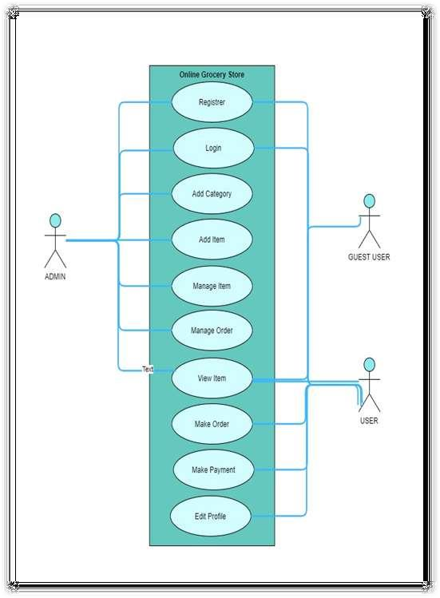
Fig 1. Use Case Diagram
- Class Diagram: Outlines the system's structure through classes and relationships.
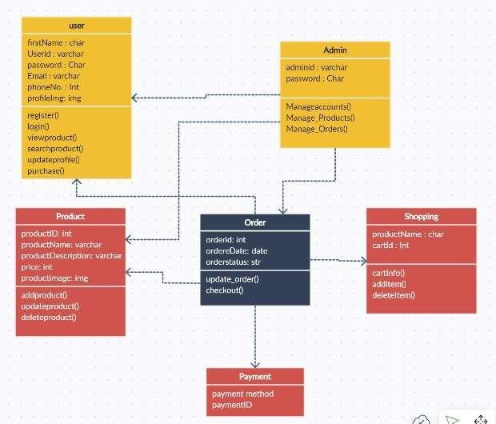
Fig 2. Class Diagram

- Activity Diagram: Shows the flow of activities within the system.
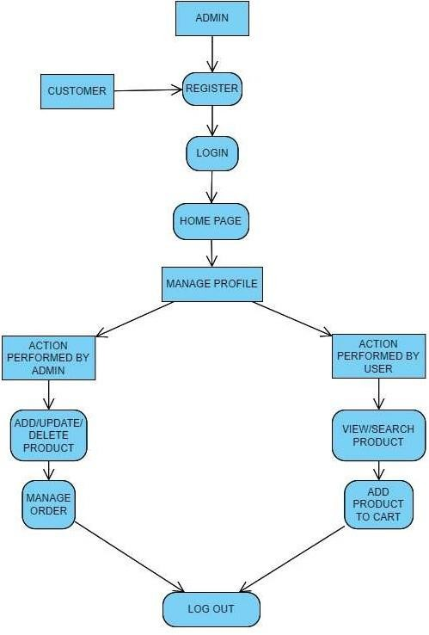
Fig 3. Activity Diagram
- Sequence Diagram: Visualizes the sequence of messages between objects in the system.
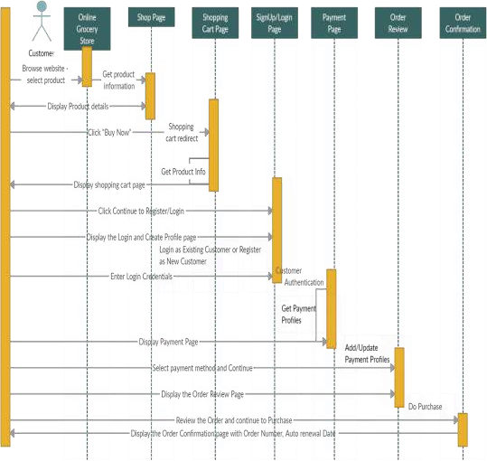Fig 4. Sequence Diagram

5.5 Data Flow Diagram
Includes the following levels:
- Level-0 DFD: High-level representation of the system's major processes.
- Level-1 DFD: Breaks down major processes into sub-processes.
- Level-2 DFD: Provides a detailed view of data flow and interactions.
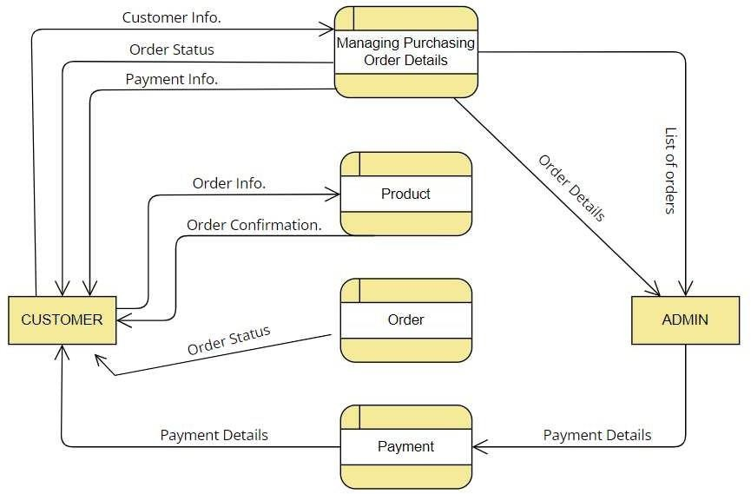
Fig 5: Data Flow Diagram System

6. Database Design

Schema
- Users: Stores user credentials.
- Items: Stores inventory details.
- Sales: Tracks transactions.
- Invoice: Records customer invoices.

DATABASE TABLE DESIGN

USER LOGIN TABLE:

Column | Type | Index | Description
Id | int(100) | Primary Key | User ID
Name | varchar(100) | Not null | User Name
Email | varchar(100) | Not null | User Email
Password | varchar(100) | Not null | User Password
User type | varchar(20) | Not null | User/Admin
Image | varchar(100) | Not null | User Profile Image

Table 1: User Login Database Table
PRODUCT TABLE:

Column | Type | Index | Description
Id | int(100) | Primary Key | Product ID
Name | varchar(100) | Not null | Product Name
Category | varchar(20) | Not null | Product Category
Details | varchar(500) | Not null | Product Details
Price | int(100) | Not null | Product Price
Image | varchar(100) | Not null | Product Image

Table 2: Product Details Database Table
ORDER TABLE:

Column | Type | Index | Description
Id | int(100) | Primary Key | Order Id
User Id | int(100) | Not null | User Id
Name | varchar(100) | Not null | User Name
Mo. Number | varchar(12) | Not null | User Mo. Number
Email | varchar(100) | Not null | User Email
Method | varchar(50) | Not null | Payment Method
Address | varchar(500) | Not null | Delivery Address
Total Products | varchar(1000) | Not null | Total Available  Products
Total Price | int(100) | Not null | Total Price
Table 3: Order Details Database Table
CART TABLE:
Column | Type | Index | Description
Id | int(100) | Primary Key | Cart ID
User Id | int(100) | Not null | User Id
P_id | int(100) | Not null | Product Id
Name | varchar(100) | Not null | Product Name
Price | int(100) | Not null | Total Cart Price
Quantity | int(100) | Not null | Total Quantity in Cart
Table 4: Cart Details Database Table

7. Implementation
Code implemented in C# with Oracle Database for backend.
REGISTER PAGE: New User can register here
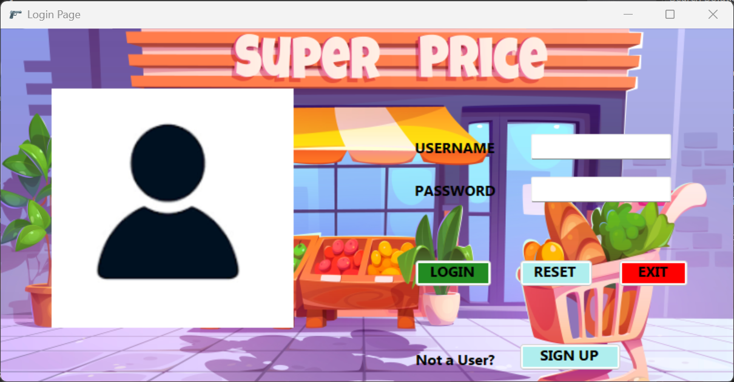
DASHBOARD: The home screen will consist of screen were one can browse through the products which we have on our website.
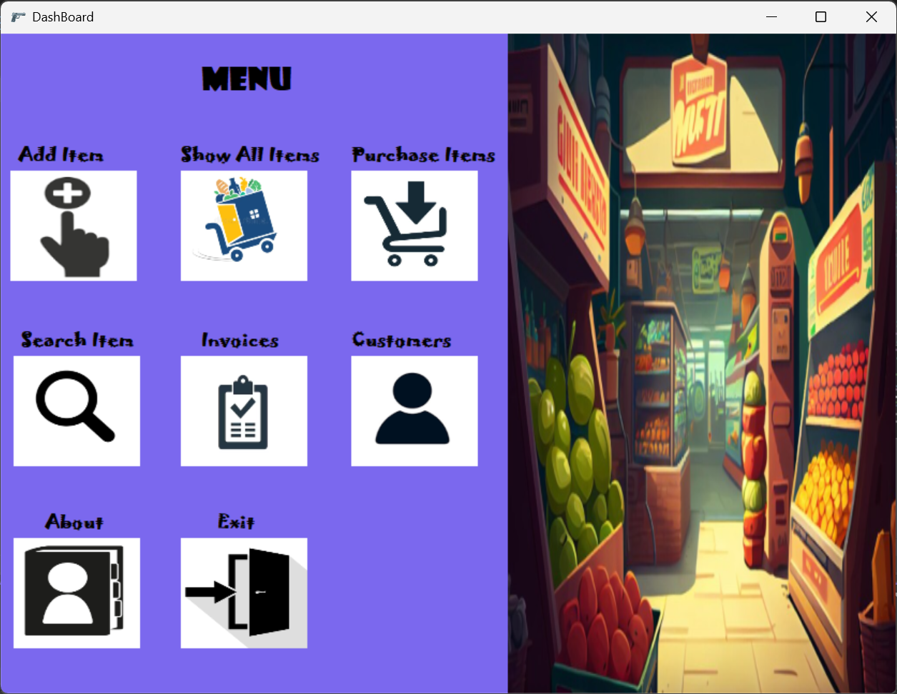

- User Authentication (Login Function):
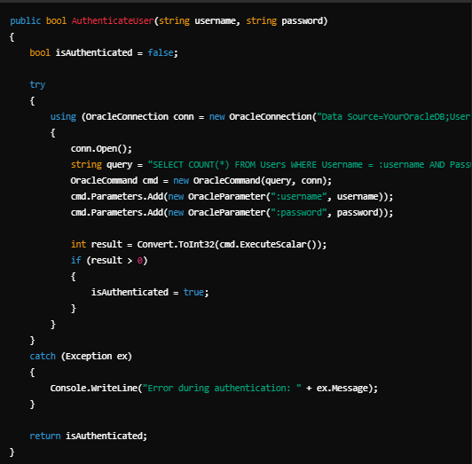
- Add Item to Inventory:
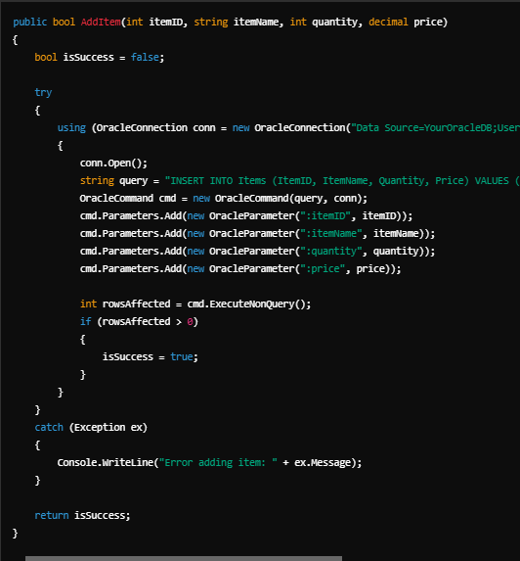

3. Record Sale Transaction
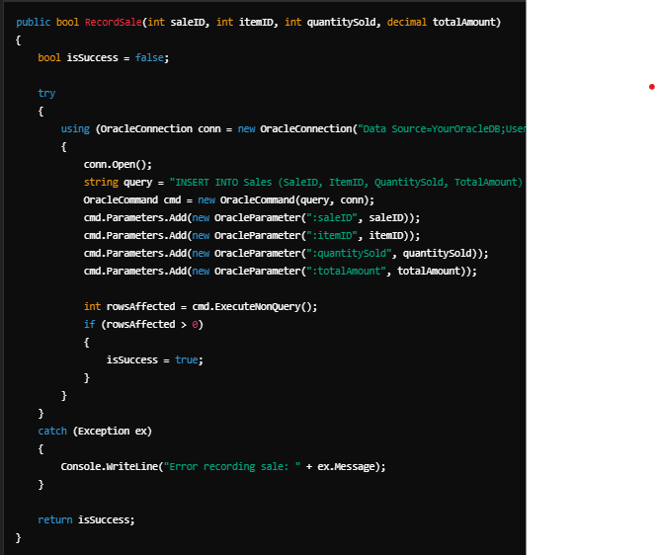

8. Limitations
- Limited to standalone application
- Requires Oracle Database setup

9. Testing

9.1 Introduction
Testing ensures the system meets user requirements.

9.2 Levels of Testing
- Unit Testing
- Integration Testing
- System Testing

9.3 Testing Report
All test cases passed with no critical issues.

10. Conclusion
The Grocery Management System simplifies store operations, providing a reliable and efficient solution for inventory and sales management. The project demonstrates the successful application of software engineering principles in a real-world scenario.

