**Lab manual**

**Lab 01:**

**Outline:**

1. Installation of CISCO Packet Tracer
2. Understand layout of CISCO Packet Tracer
3. Find IP address of a node using ipconfig
4. P2P configuration and communication

**Task 01:**

Find the IP address of your system using ipconfig command.

**Sol:**

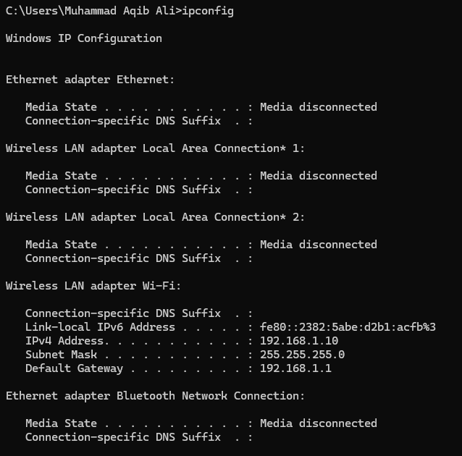

**Task 02:**

Add 2 PCs and connect them with cross over cable. Assign IP addresses and test the connection using ping command.

**Sol:**

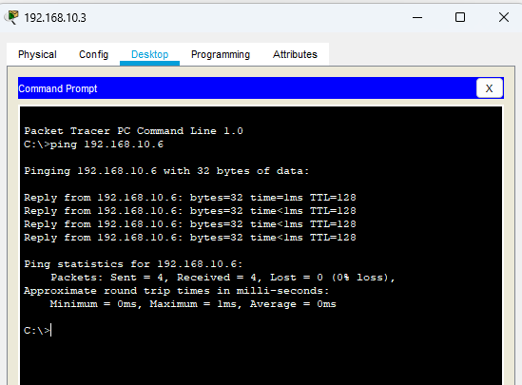 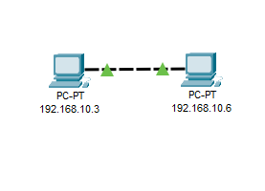

**Task 03:**

Create a simple LAN using a switch, assign IP addresses to the nodes and test the connection using ping command.

**Sol:**

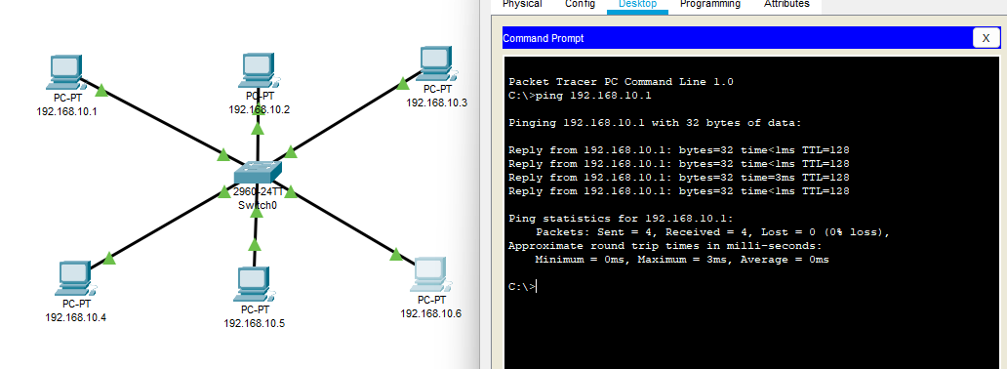

**Task 05:**

Toggle to Simulation mode and analyze the working of ping command. Understand the working of a switch broadcasting technique and dealing with MAC addresses.

**Sol:**

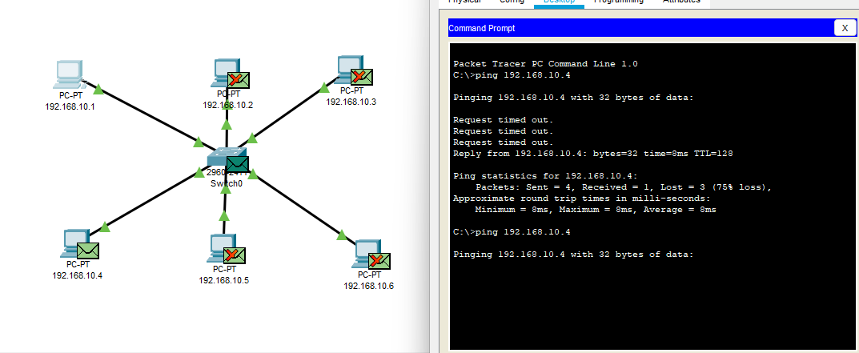

**Lab 02:**

**Outline:**

1. Creating a Simple Network with a switch and observe MAC address table working.
2. Understanding various switch modes
3. Basic Cisco Switch Configurations

**Task 01:**

Create a network with one switch and four PCs.

Connect each PC to the switch using copper straight-through cables.

Assign IP addresses to the PCs within the same subnet (e.g., 192.168.1.2, 192.168.1.3, 192.168.1.4, 192.168.1.5).

Use ping command to test the connections by pinging different nodes over the LAN.

**Sol:**

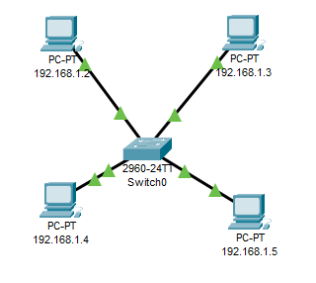

**Task 02:**

Open switch CLI and use show mac-address-table command to view the mac address table and observe its behaviour after each ping.

**Sol:**

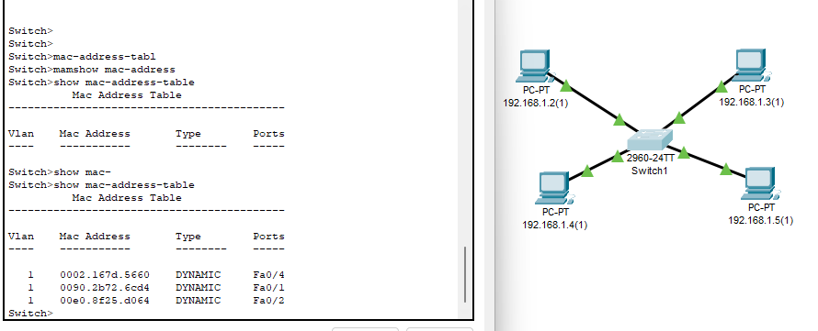

**Task 03:**

1. Use switch CLI and above stated commands to move from one mode to another.
2. Change the hostname of switch to “SystemsLab”.
3. Assign IP address to the switch

**Sol:**

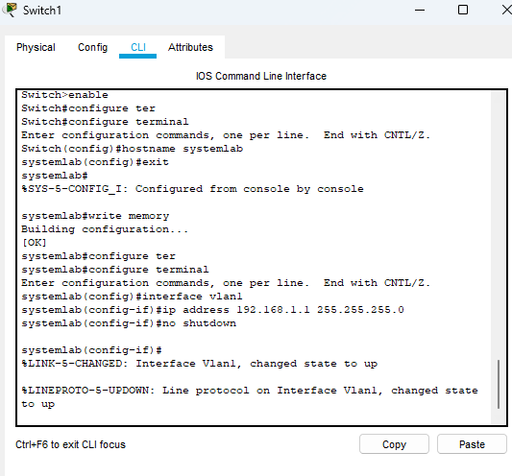

**Task 04:**

Set the password to the console port and configuration mode of switch.

**Sol:**

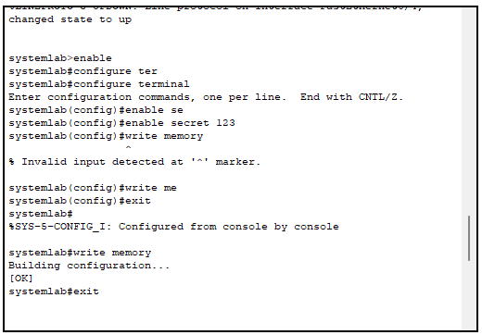

**Lab 03:**

**Outline:**

Introducing a router for communication outside the network

Basic router configurations

Viewing routing table

Default Gateway implementation

**Task 01:**

Create two networks each with one switch and five PCs. Name switch 1 as “SystemsLabSwitch” and switch 2 as “ProgrammingLabSwitch”.

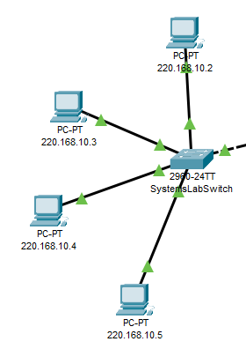**Sol:**

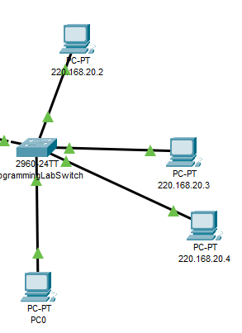

**Task 02:**

Take a router and connect the switches with its ethernet ports using suitable cables. Configure the router: hostname “RCET”, setup password for configuration mode, assign IP addresses to the used ports for both switches. Save the configurations as: *Router# copy running-config startup-config.* Current interfaces status can be viewed using: *Router# show ip interface brief* and running configurations using: *Router# show running-config.*

**Sol:**

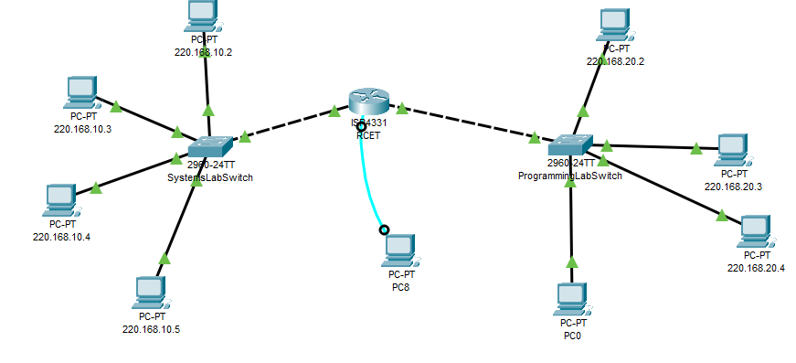 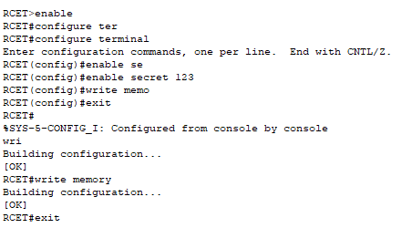

**Task 03:**

Setup the networks with following configurations.

|  |  |  |  |
| --- | --- | --- | --- |
| Networks | Gateway | Switch Ids | Host Ids |
| ProgrammingLabSwitch | 220.168.10.1 (255.255.255.0) | 220.168.10.2 (255.255.255.0) | 220.168.10.3 and onward |
| SystemsLabSwitch | 220.168.20.1 (255.255.255.0) | 220.168.20.2 (255.255.255.0) | 220.168.10.3 and onward |

**Sol:**

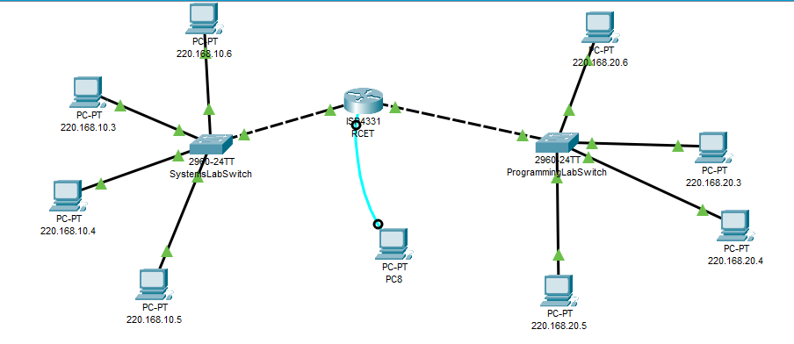 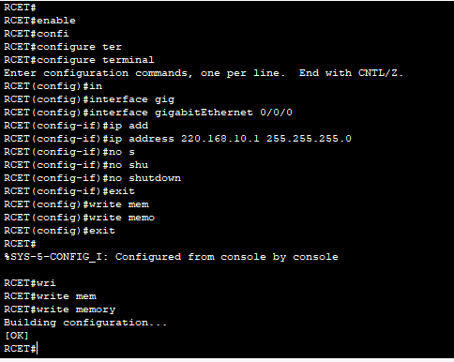

**Task 04:**

Use *show ip route* command to view routing table in router.

**Sol:**

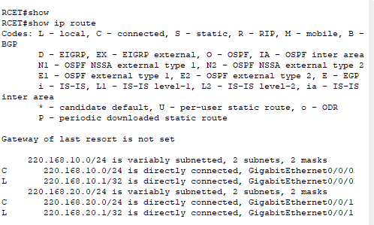

**Task 05:**

Use ping command to test the connections by pinging different nodes over the LAN as well as WAN

**Sol:**

