COMSATS University Islamabad

Final Project of Web Technologies

**Title:**

Infinix Computers

**Niche:**

An e-commerce site

**Group Members:**  
Haseeb Ahmed Saeed

(SP18-BCS-063 / 5B)

Muhammad Ameen

(SP18-BCS-098 / 5B)

**Date of Submission:**August 11, 2020

**Important Instruction to Read**

Our main project consists of 3 different folders i.e.

1) eCommerceSite Folder

2) Database Folder

3) Screenshots Folder

**eCommerceSite** folder consists of all the files/assets that are somewhere somehow used inside the project. It also includes styles, images, CMS etc.

**Database** folder consists of infinity.sql file that is a db file used to import all the data on any pc having phpmyadmin installed.

**Screenshots** folder consists of some of the screenshots of our working project that shows the basic layout/styles/colors etc.

**How to run the Project?**

In order to run the project on your PC, all you need to do is copy the folder (eCommerceSite) and paste it inside the www in the wamp/Xampp directory.

Then go to your browser, and open localhost/phpmyadmin where you can log into the mySql database. Use username as ‘root’ and password is ‘’ means empty.

Now headover to import and import our database file from Database folder so that our site can work properly.

**How to manage all Posts?**

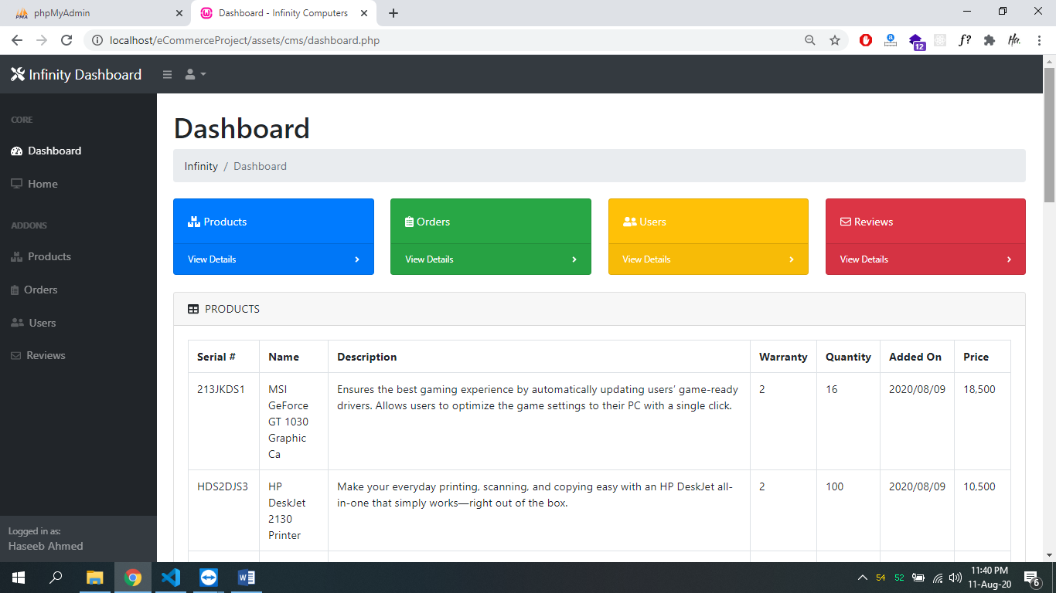

Our CMS for Admin/Manager

In order to manage all posts/products, we have created a very basic but working CMS (content management system) that allows the admin/manager to upload/delete posts of products from website.

Inside CMS, Admin/Managers can:

* Add a new Product.
* Delete a Product.
* Read the reviews of Customers/Users.
* Access all the Customer details.
* Can checkout the details of all given Orders from Customers.

**Screenshots:**

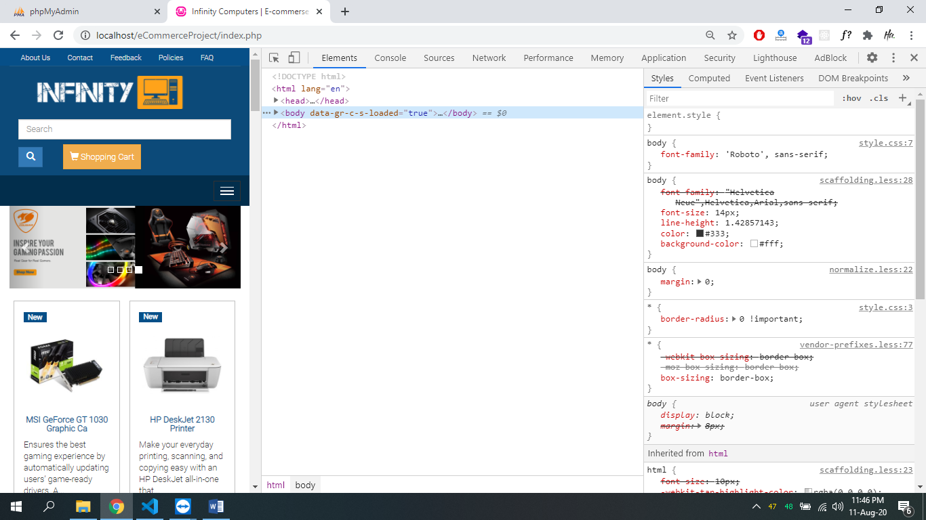

Mobile View

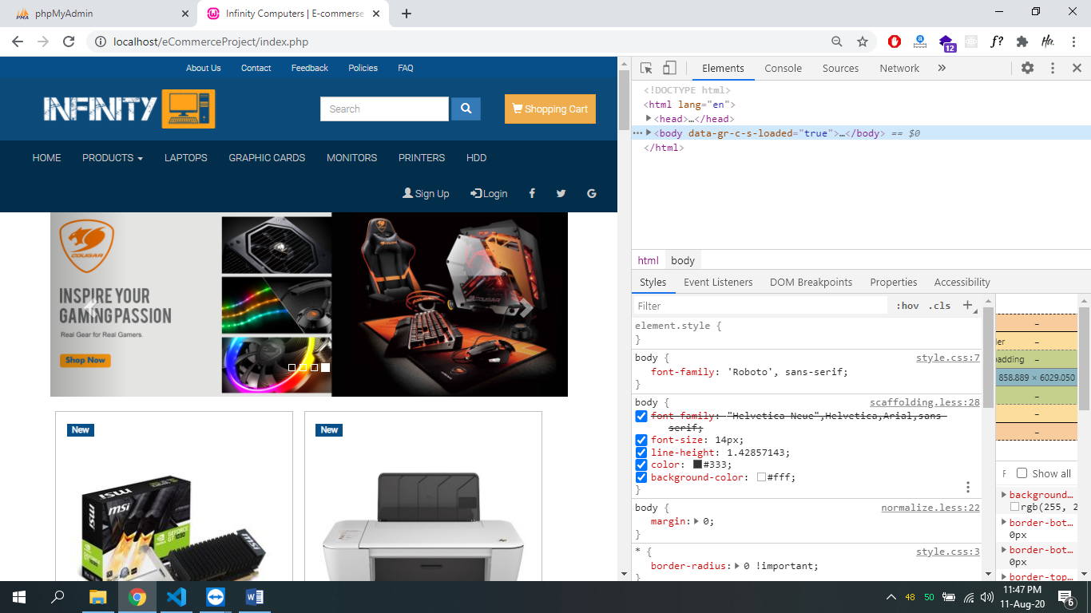

Tablet View

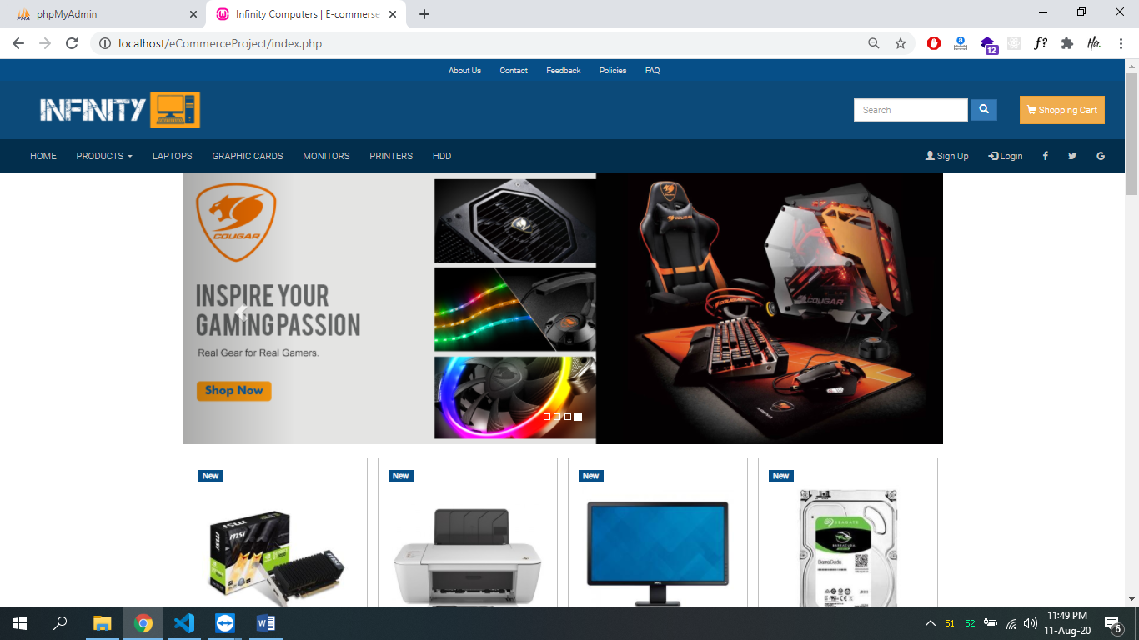

Desktop View