**LetsConnect - Django Social Media Project**

**Project Overview**

LetsConnect is a Django-based social media platform that allows users to register, log in, create posts, comment on posts, and manage their content. This project utilizes Django's built-in authentication system and follows a Model-View-Template (MVT) architecture.

**Models**

**Category**

Defines the categories for posts.

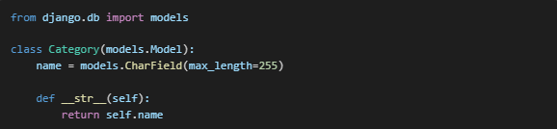

**Post**

Represents a social media post with a title, content, category, author, and timestamp.

**Comment**

Stores user comments on posts.

**CustomUser**

Extends Django's AbstractUser model to require unique emails for authentication.

**Forms**

**PostForm**

Used for creating and updating posts.

**CommentForm**

Handles user comments on posts.

**CustomUserCreationForm**

Extends Django's UserCreationForm to include email.

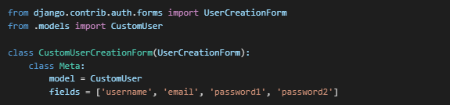

**Views**

**User Authentication Views**

**Register View**

Handles user registration and authentication.

**Login View**

Handles user authentication.

**Logout View**

Logs out the user.

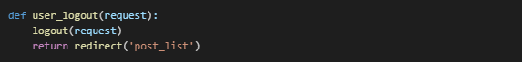

**Post & Comment Views**

**Create Post View**

Allows authenticated users to create a post.

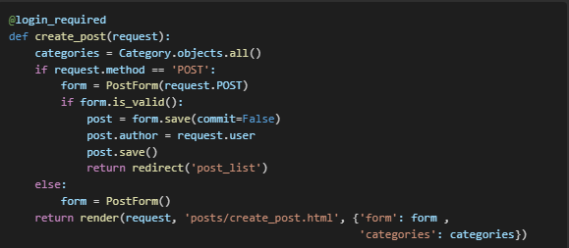

**Post List View**

Displays all posts with search functionality.

**Post Detail View**

Displays a single post with comments.

**Settings.py**

**URLs**

**Project URLs**

**Commands to Run the Project**

