**CAR RENTAL WEBSITE**

A MINI-PROJECT REPORT

Submitted by

Jenish R E 200701102

***in partial fulfillment of the award of the degree***

***of***

**BACHELOR OF ENGINEERING**

**IN**

**COMPUTER SCIENCE AND ENGINEERING**

**RAJALAKSHMI ENGINEERING COLLEGE, CHENNAI**



**DECEMBER-2022**

**ANNA UNIVERSITY**

**CHENNAI**

**BONAFIDE CERTIFICATE**

Certified that this project **“CAR RENTAL WEBSITE”** is the bonafide work of **“ JENISH R E ”** who carried out the project work under my supervision.

|  |  |
| --- | --- |
| **SIGNATURE** | **SIGNATURE** |
| **DR. DR. KUMAR P M.E., PH.D.,** | **MR. MURUGANANDAM S M.E,PH.D.,** |
| **HEAD OF THE DEPARTMENT** | **ASSISTANT PROFESSOR(SG)** |
| **PROFESSOR** | Dept. of Computer Science and Engg, |
| Dept. of Computer Science and Engg,  Rajalakshmi Engineering College, Chennai | Rajalakshmi Engineering College, Chennai |
|  |  |

Submitted for the **ANNA UNIVERSITY** practical examination Mini-Project work viva voce held on __________

**INTERNAL EXAMINER** **EXTERNAL EXAMINER**

**ABSTRACT**

Our Aim is to design and create a data management System for a car rental company .This enables admin can rent a vehicle that can be used by a customer This system increases customer retention and simplify vehicle and staff Management in an efficient way.

This software car Rental System has a very user friendly interface. Thus the users will feel very easy to work on it. By using this system admin can manage customer confirm and cancel booking request, customer Testimonials, customer issues. The car information can be added to the system. Or existed car information can be edited or deleted too by Administrator .There is no delay in the availability of any car information, whenever needed, car information can be Captured very quickly and easily.

The customers can also use the system to get car rent. The customer should create a new account before logging in or he / she can log into the System with his/her created account. Then he/she can book the available cars and can book this car .This system will helpful to the admin as well as to the customer also

ACKNOWLEDGEMENT

We thank the almighty God for the successful completion of the project. We would like to extend our sincere thanks to our Chairman, **Mr.S. MEGANATHAN, B.E, F.I.E,** for his sincere endeavor in educating us in his premier institution.

We express our gratitude to our beloved and respected Chairperson, **Dr. (Mrs.) THANGAM MEGANATHAN, M.A., M.Phil.,Ph.D.,** and our Vice-Chairman **Mr. M. ABHAY SHANKAR, B.E., M.S,** for their enthusiastic motivation which inspired us a lot towards completing this project.

Our sincere thanks to **Dr. S.N. MURUGESAN, M.E., Ph.D.,** our beloved Principal for his kind support and facilities provided to complete our work in time.

We thank our Head of the Department, **Dr. Kumar P M.E., Ph.D.,** for his invaluable guidance and encouragement for the successful completion of this project.

We convey our sincere and deepest gratitude to our internal guide, **Mr. MURUGANANDAM S , M.E.,Ph.D.,**for her valuable guidance, ideas and advice throughout the course of the project.

Finally, we express our gratitude to our parents and friends for extending their full supporters.

STUDENT NAME

JENISH R E

**TABLE OF CONTENTS**

CHAPTER NO. TITLE PAGE

**ABSTRACT iv**

**1 INTRODUCTION 2**

1.1 introduction 2

1.2 SCOPE OF THE WORK 2

1.3 PROBLEM STATEMENT 3

1.4 AIM AND OBJECTIVES OF THE PROJECT 3

**2 SYSTEM SPECIFICATIONS 4**

2.1 HARDWARE SPECIFICATIONS 4

2.2 SOFTWARE SPECIFICATIONS 4

**3 MODULE DESCRIPTION 5**

**4 SYSTEM DESIGN 6**

4.1 FLOW CHART 6

**5 CODING 7**

**6 SCREEN SHOTS 16**

**7 CONCLUSION AND FUTURE ENHANCEMENT 23**

**8** **REFERENCES 24**

**LIST OF FIGURES**

|  |  |  |
| --- | --- | --- |
| **FIGURE NO** | **FIGURE NAME** | **PAGE NO.** |

**4.1 Flow diagram 6**

**6.1 Index page 16**

**6.2 About us page 11**

**6.3 Services page**

**6.4 Login page**

**6.5 COntact us page**

**LIST OF SYMBOLS AND ABBREVIATIONS**

HTML - HyperText Markup Language

CSS - Cascading Style Sheets

XAMPP - X-operating system, Apache, MySQL, PHP, Perl.

HTTP - Hypertext transfer protocol

PHP - Hypertext Preprocessor

SQL - Structured Query Language

UI - User Interface

**CHAPTER 1**

**INTRODUCTION**

* 1. INTRODUCTION

The CAR RENTAL SYSTEM (CRS) was one of the earliest changes to improve efficiency. CRS eventually evolved into the [Computer Reservations System](http://en.wikipedia.org/wiki/Computer_Reservations_System) . A Computer Reservation System is used for the reservations of a particular car and interfaces with a [Global Distribution System](http://en.wikipedia.org/wiki/Global_Distribution_System) (GDS) which supports travel agencies and other distribution channels in making reservations for most major user in a single system. Car Rental Systems contain airline , fare tariffs, passenger Info and Booking Records , Vehicle Info . An car direct distribution works within their own reservation system, as well as pushing out information to the GDS.

* 1. **SCOPE OF THE WORK**

This project traverses a lot of areas ranging from business concept to computing fields , and required to perform several researches to be able to achieve the project objectives. The area cover include

* Car rental industry: This includes study on how the car rental business is being done, process involved and opportunity to improvement.
* PHP Technology used for the development of the application.

Web-platform so the system will available for 24/7 except when there is any temporary server issue.

* The user can use the system more efficient way.
  1. **PROBLEM STATEMENT**

A car rental is a vehicle that can be used temporarily for a fee during a specified period. Getting a rental car helps people get around despite the fact they do not have access to their own personal vehicle or don't own a vehicle at all. The individual who needs a car must contact a rental car company and contract out for a vehicle. This system increases customer retention and simplify vehicle and staff management.

**1.4 AIM AND OBJECTIVES OF THE PROJECT**

Specific goals are –

• To produce a web-based system that allow customer to register and reserve car online and for the company to effectively manage their car rental business.

• To ease customers task whenever they need to rent a car.

**CHAPTER 2**

**SYSTEM SPECIFICATIONS**

**2.1 HARDWARE SPECIFICATIONS**

|  |  |  |
| --- | --- | --- |
| Processor | **:** | Intel core i5 |
| Memory Size | **:** | 256 GB (Minimum) |
| HDD | **:** | 40 GB (Minimum) |

**2.2 SOFTWARE SPECIFICATIONS**

|  |  |  |
| --- | --- | --- |
| Operating System | **:** | WINDOWS 10 Or 11 |
| Front – End | **:** | HTML,CSS,JS |
| Back - End | **:** | PHP, MYSQL 5.1,XAMPP |
| Language | **:** | HTML,CSS,Javascript,jQuery,PHP |

**CHAPTER 3**

**MODULE DESCRIPTION**

This application consists of five main modules. When the programs runs, it will ask for a confirmation to login window. The person who interacts can login as an User. The description of the modules are as follows:

1. User Registration

When the person wants to access or view contents, information of places, car and bookings, they have to register using their name, email, password etc.,

2. User login

When the person tries to login as a user then he/she will be directed to enter the home page only if they are already registered.

3. Services

They can view the information of the respective car, the rental fee for the journey.

4. Booking

If the user like the place and willing to visit they can book the car according to the information.

5. Logout

When user completed viewing they can logout from there account, it will direct to the login page.

**CHAPTER 4**

**SYSTEM DESIGN**

**4.1 FLOW CHART**

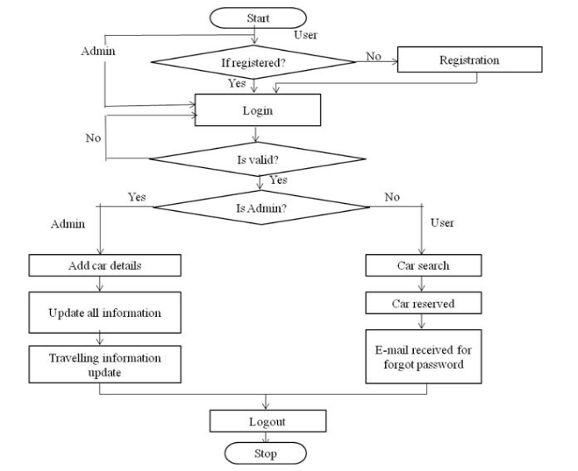

**CHAPTER 5**

**SAMPLE CODING**

**Index.html**

<!DOCTYPE html>

<html lang="en">

<head>

<meta charset="UTF-8" />

<meta http-equiv="X-UA-Compatible" content="IE=edge" />

<meta name="viewport" content="width=device-width, initial-scale=1.0" />

<title>Navbar 1</title>

<link rel="preconnect" href="https://fonts.googleapis.com" />

<link rel="preconnect" href="https://fonts.gstatic.com" crossorigin />

<link

href="https://fonts.googleapis.com/css2?family=Poppins:wght@300;400;500&display=swap"

rel="stylesheet"

/>

<link

href="https://fonts.googleapis.com/css2?family=Material+Symbols+Outlined"

rel="stylesheet"

/>

<link href="./homecss.css" rel="stylesheet" />

</head>

<body class="background">

<div>

<div style='position: absolute; top: 130px; left: 10px; color:aliceblue; padding-top:133px; padding-left: 100px;' >

<div style="height:4px;width:60%;background-color:#f4581f"></div>

<h1>Book a Car Near You<br> and Drive in<br> Minutes! </h1>

<div style="height:4px;width:15%;background-color:#f4581f"></div><br>

<div class="sub-text">Book the selected car effortlessly, pay for driving only.<br>

Join our service instantly by installing our app.</div>

</div>

<nav class="navbar">

<div style="width:350px;">

<img class="navbar-logo" src="./Images/logo.jpg" align="right">

</div>

<input type="text" placeholder="Search" class="navbar-search" />

</nav>

<button class="navbar-burger" onclick="toggleMenu()"></button>

<nav class="menu">

<a href="index.html" style="animation-delay: 0.1s">Home</a>

<a href="about.html" style="animation-delay: 0.2s">About</a>

<a href="car-index.html" style="animation-delay: 0.3s">Services</a>

<a href="login.html" style="animation-delay: 0.4s">Login</a>

<a href="contact.html" style="animation-delay: 0.5s">Contact</a>

</nav>

<script type="text/javascript">

const toggleMenu = () => {

document.body.classList.toggle("open");

};

</script>

</div>

<div class="second-phase">

<div style="position: absolute; top: 1000px; left: 590px; padding-top:133px; padding-left: 100px;color:grey;">HOW IT WORKS</div>

<div style="position: absolute; top: 1050px; left: 370px; padding-top:133px; padding-left: 100px;font-size: 40px;">Carsharing Has Never Been That Easy</div>

<div style="height:4px;width:120px;background-color:#f4581f;top:1250px;position: absolute;left:690px;"></div>

<div style="position: absolute; top: 1150px; left: 385px; padding-top:133px; padding-left: 100px;font-size: 18px;">Book a car when you need to drive, save greatly, and enjoy freedom of movement.</div>

</div>

<div class="third-phase">

<div class="inline">

<div class="span-image">

<img src="images/icon1.svg" class="img">

</div>

<div class="img-text">

<h3>&nbsp;&nbsp;&nbsp;Visit Our Website</h3>

</div>

</div>

<div class="inline">

<div class="span-image">

<img src="images/icon2.svg" class="img">

<div class="img-text">

<h3>&nbsp;Book a Car</h3>

</div>

</div>

</div>

<div class="inline">

<div class="span-image">

<img src="images/icon3.svg" class="img">

<div class="img-text">

<h3>Enjoy Your Ride</h3>

</div>

</div>

</div>

<div class="inline">

<div class="span-image">

<img src="images/icon4.svg" class="img">

<div class="img-text">

<h3>&nbsp;Return Car</h3>

</div>

</div>

</div>

</div>

<div style="height:100px;width:100%;position:absolute;top:1700px;"></div>

<div class="final">

<div style="position: absolute; top: 200px; left: 590px; padding-top:133px; padding-left: 100px;color:white;">FAQ</div>

<div style="position: absolute; top: 250px;font-family:sans-serif;font-weight:bold;color:#ff8c00; left: 380px; padding-top:133px; padding-left: 100px;font-size: 40px;">Answering Your Questions</div>

<div style="height:4px;width:120px;background-color:#4166f5;position: absolute;top:450px;left:650px;"></div>

<div style="position: absolute; top: 350px; left: 305px; padding-top:133px; padding-left: 100px;font-size: 18px;color:#ff8c00;font-family:sans-serif;">We have made the conditions for using our carsharing service as simple as possible. <br>&nbsp;&nbsp;&nbsp;&nbsp;&nbsp;&nbsp;&nbsp;&nbsp;&nbsp;If you still have any questions, please contact us in any convenient way.</div>

<div style="position:relative;top:600px;left:200px;" >

<div style="position:absolute">

<div>

<div class="one faq">

<h2>What cars can I rent?</h2><br>You can book cars of any class for short-term rent,<br> from compact city coupes to minivans.

</div>

<div class="one faq">

<h2>What if I need extra time?</h2><br>

When booking a car, you specify the duration of your rental.<br> If you need some extra time, a special tariff will be applied.

</div>

</div>

<div>

<div class="two faq">

<h2>Can I increase the mileage limit?</h2><br>

Yes, in this case, select the appropriate option <br>when booking a car.

</div>

<div class="two faq">

<h2>How much does carsharing cost?</h2><br>

We have different tariffs based on the class of the car you select<br> and on the trip length. The minimum cost is $ 1 per minute.

</div>

</div>

<div>

<div class="three faq">

<h2>Are the cars insured?</h2><br>

Yes, we provide secondary insurance for all trips.<br><br><br>

</div>

<div class="three faq">

<h2>What cities do you cover?</h2><br>We cover the majority of US cities, including New York,

Washington, Miami, Boston, etc.

</div>

</div>

</div>

</div>

</div>

</body>

</html>

**Login.html**

<!DOCTYPE html>

<html lang="en">

<head>

<title>Login 1</title>

<link rel="stylesheet" href="login.css" />

<link rel="stylesheet" href="signup.css">

</head>

<body>

<div class="background"></div>

<div class="login-card">

<h2>Sign-In</h2>

<h3>Enter your credentials</h3>

<form class="login-form" method="get" action="http://localhost/Home/accountverification.php">

<input type="text" placeholder="Username" name="cname" />

<input type="password" placeholder="Password" name="pass"/>

<span><a href="https://website.com" style="position:absolute;left:30px;">Forgot your password?</a>

<a href="http://localhost/Home/signup.php" style="position:absolute;left:220px;">Create a new account</a></span><br>

<button type="submit">LOGIN</button>

</form></div> </body></html>

**CHAPTER 6**

**SCREEN SHOTS**

**Index.html**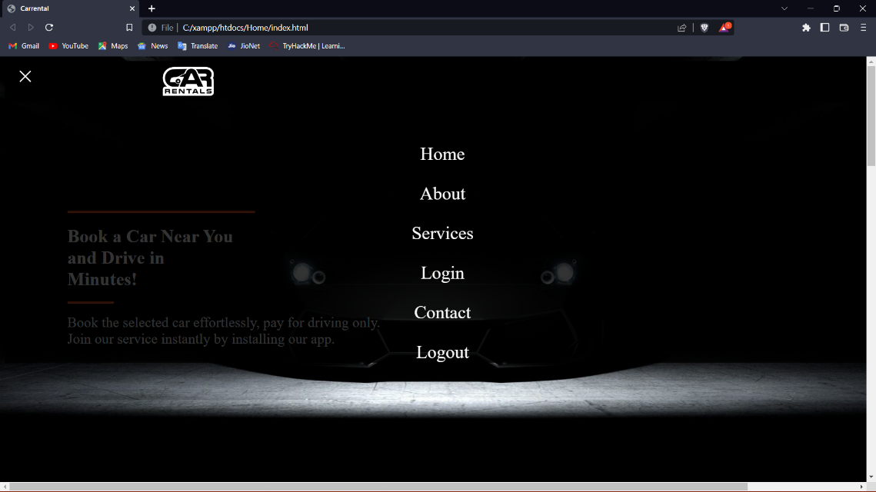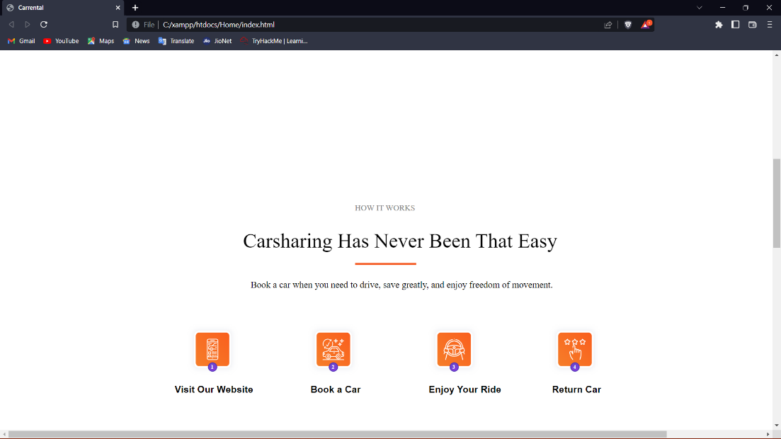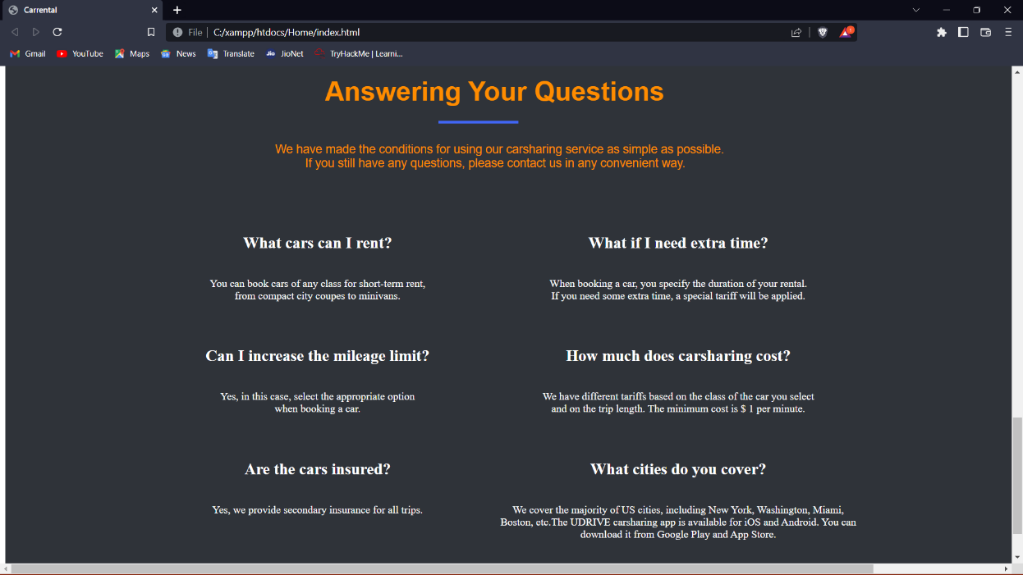

**About us page**

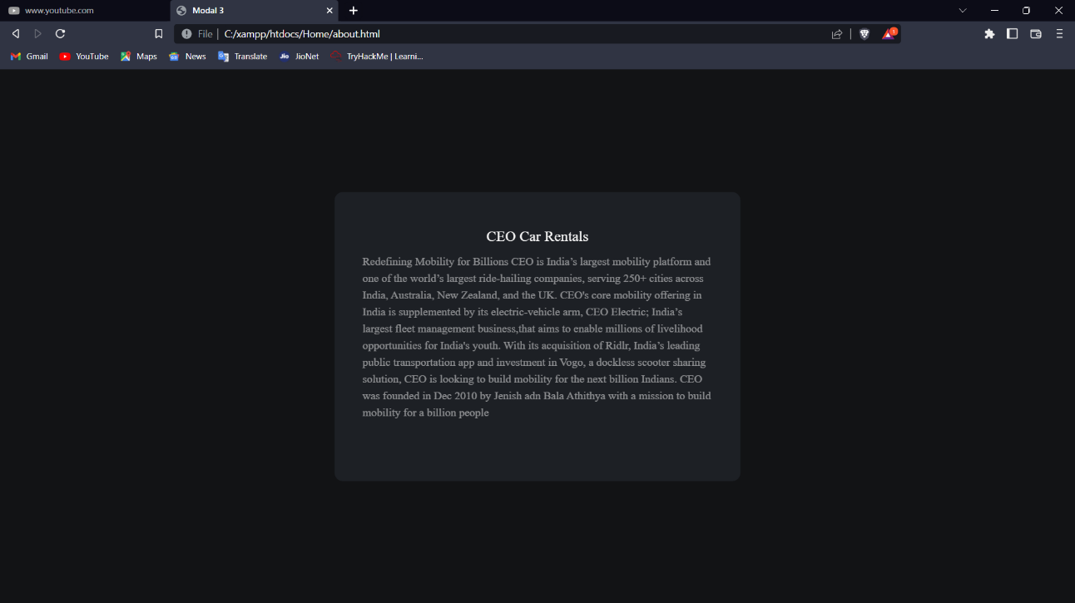

**Services page**

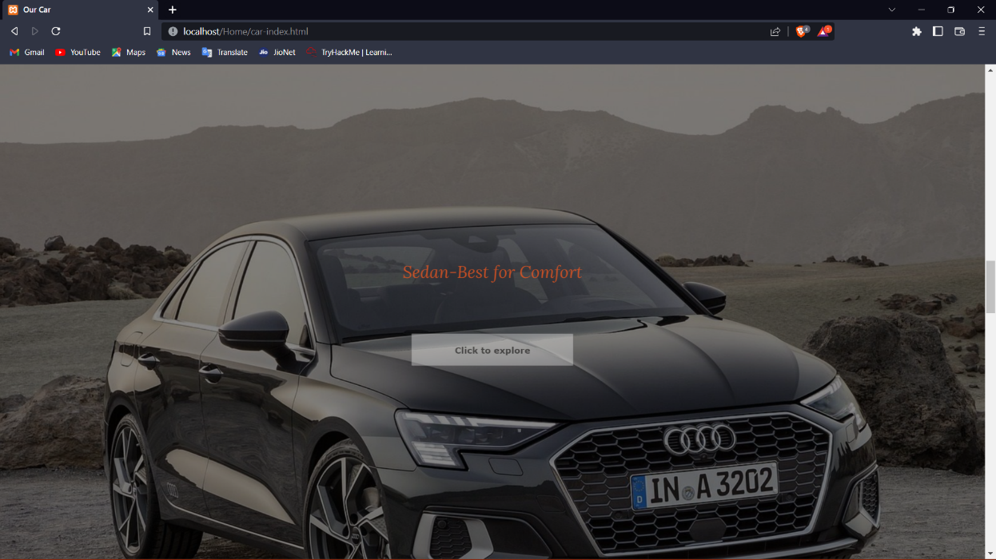

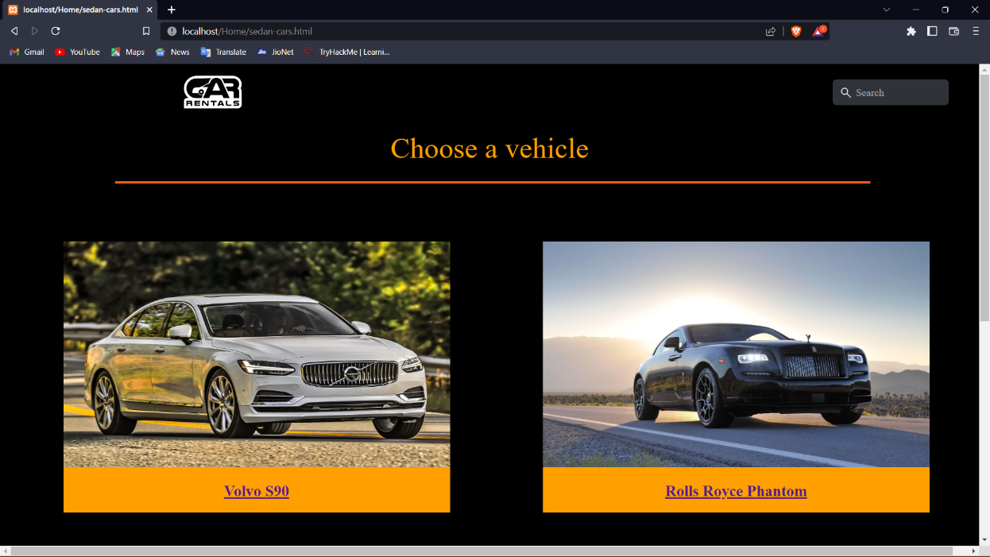

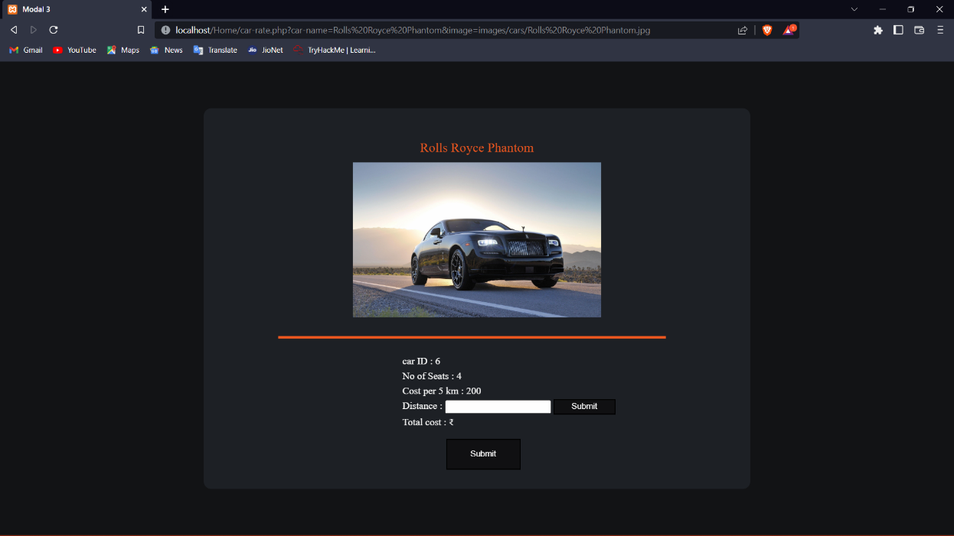

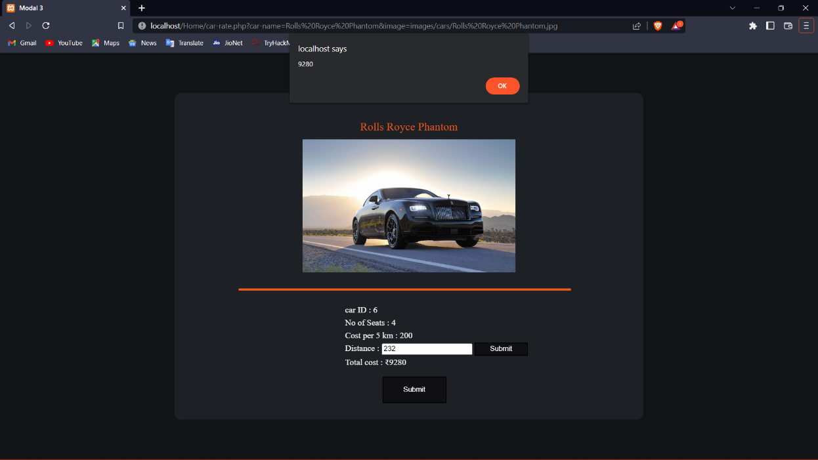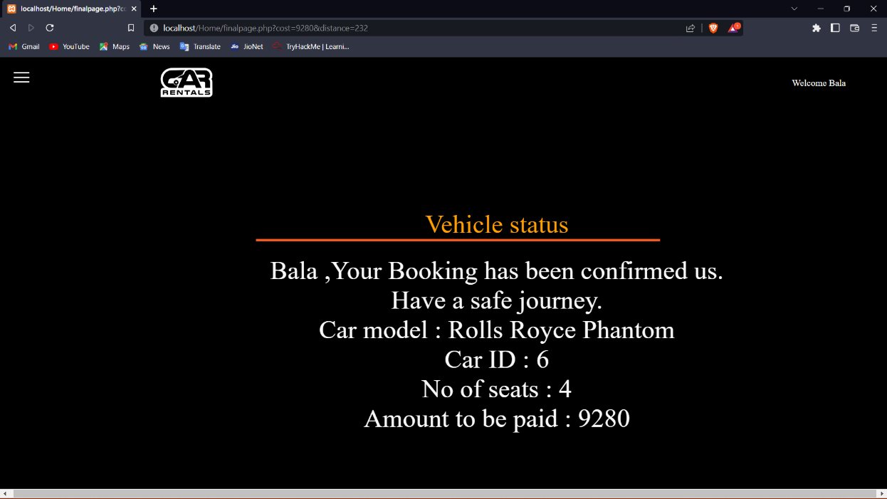

**Login page**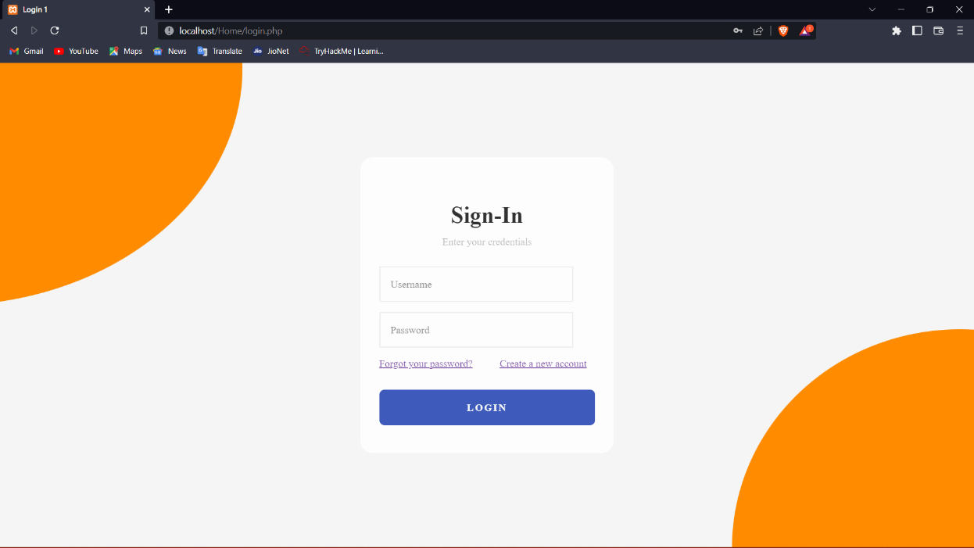 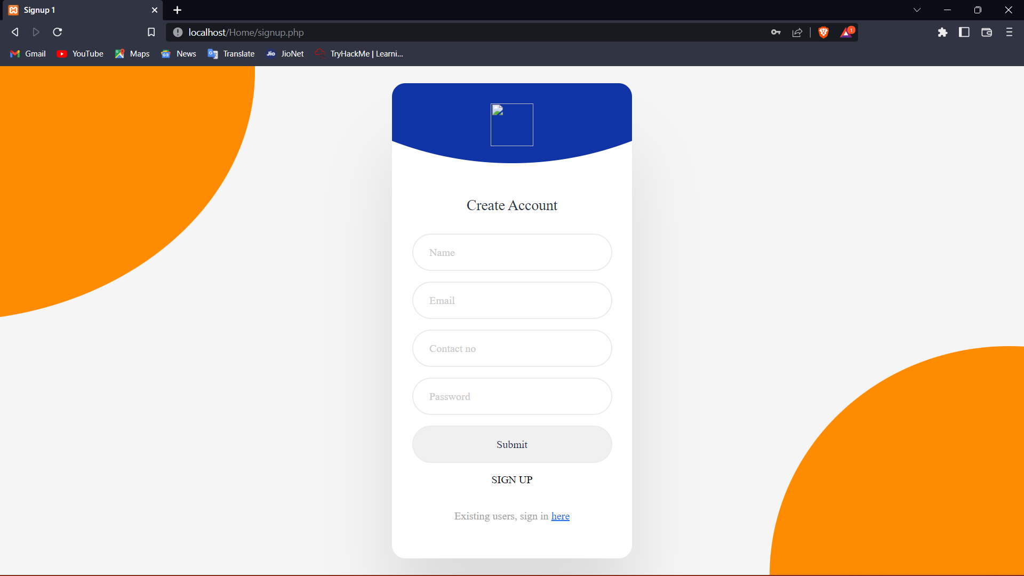

**Contact us page**

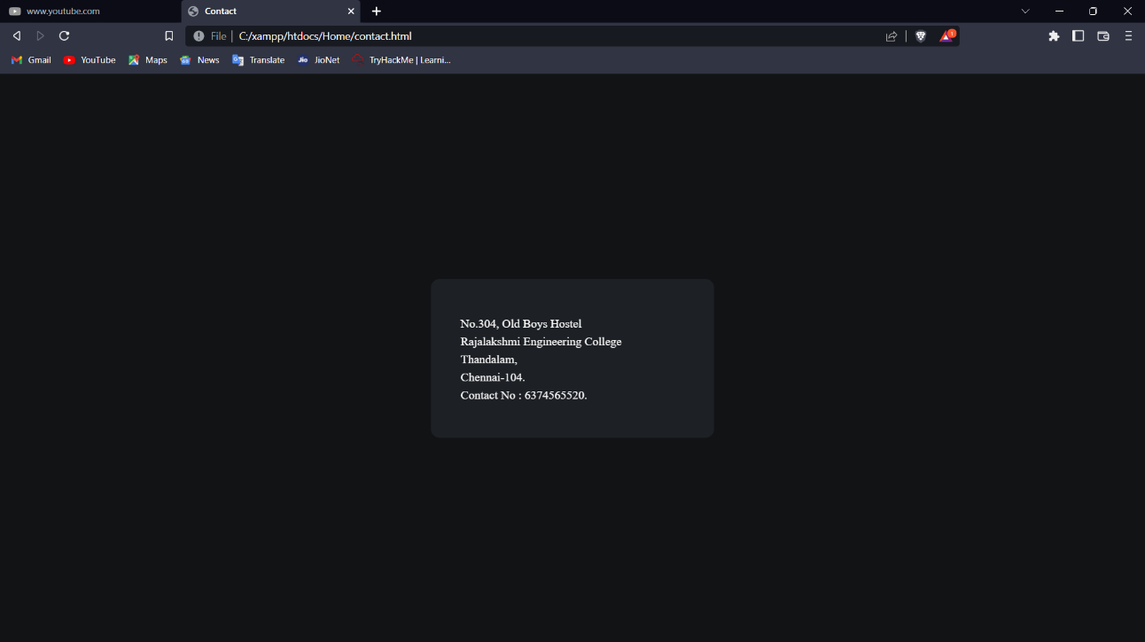

**CHAPTER 7**

**CONCLUSION AND FUTURE ENHANCEMENT**

Therefore, the Car rental system has been a way of minimizing the clerical work, which is almost a routine and consumes the most precious time. This Car Rental System has been an attempt to help the user to minimize his workload along with minimizing the paper works and saving of time .The system has been developed in a way to make it very user friendly. It provides an on-line message and an error detection and error messages every time the user needs. Any person having a little bit of window based can run this system without any pain.

**REFERENCES**

1. https://www.researchgate.net/publication/333812517_AIRLINE_RESERVATION_SYSTEMS
2. http://www.w3schools.com/
3. <https://www.academia.edu/35009581/Airline_Reservation_System_Project_Documentation>