The app is secured with Proguard which is a tool that shrinks, optimizes and obfuscates code.

When the application starts, the user has to log in 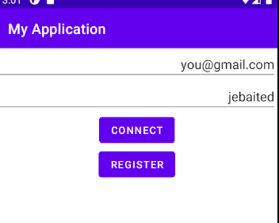

If the user is new, he can register a new account by clicking on the button.

He has to write the email and the password to log in. 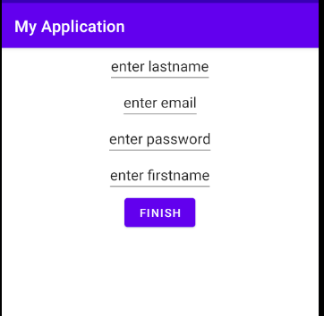

Email has to respect the email syntax with @ and . otherwise it doesn’t allow the user to create an account.

I’m using an API called Firebase, which needs internet connection to store the users, I must apologize for that because I read the instruction as “This application must be available Online.” instead of “Offline.” But I don’t think that should be that much of an issue as I’m using databases with SQLITE later for the accounts information.

Once the user has created an account, he can log in. 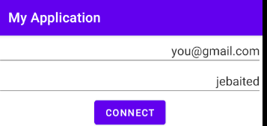

If he is indeed in the firebase, the access is allowed. 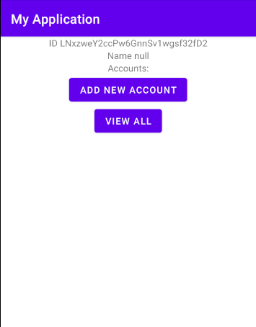

Here, we are in a new page, where his ID is shown (randomly generated). He can either look at his accounts or add new accounts.

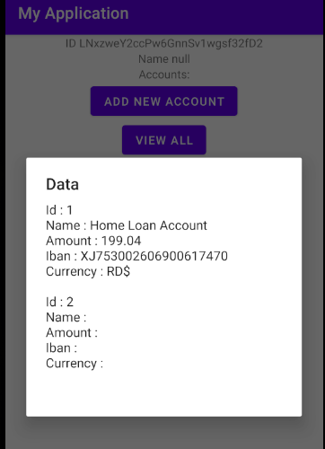

If he wants to view his accounts, a popup window appears.

If he wants to add a new account, we redirect him to a new activity.

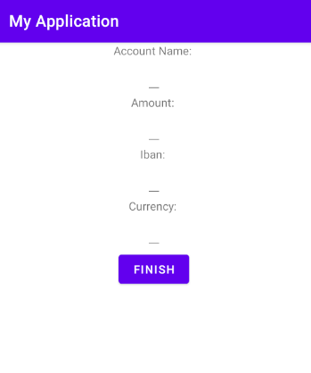

The ID is autoincremented and the data is stored locally in a sqlite server.

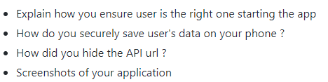

I ensure the user is the right one starting the app by asking him to identify himself with email and password.

The user data is secured with Proguard with encrypts the datas.