Nathan Robinson

System Modeling and Simulation

Dr. Cooper

5/2/2018

Assignment 3: Bifurcation

Question 1

* Consider the following discrete-time dynamical system: $x_{t}=(1-a)x_{t-1} + ax_{t-1}^{3}$

This equation has xeq = 0 as an equilibrium point.  Obtain a value of *a* at which the equilibrium point undergoes a first period-doubling bifurcation.

Given discrete time dynamical system $x_{t}=\left(1-a\right)x_{t-1} + ax_{t-1}^{3}$ a pitchfork bifurcation is expected. A two period fixed point is a point that repeats itself after two periods:

Equilibrium point xeq = 0 means that the equilibrium point will first double the period at $x_{t+1}=x_{t-1}$ OR $x_{t+1}=\left(1-a\right)x_{t}+ ax_{t}^{3}$ and

$$x_{t-1}=\left(1-a\right)\left[\left(1-a\right)x_{t-1}+ax_{t-1}^{3}\right]+a{[\left(1-a\right)x_{t-1}+ax_{t-1}^{3}]}^{3}$$

Substitute $b=x_{t-1}$ and we get $b=\left(1-a\right){[b\left(1-a\right)+ab^{3}\left(1-a\right)+a(ab^{3}+b\left(1-a\right))]}^{3}$ and $b'=\left(1-a\right)b'+a{b'}^{3}$ => 1 $=1-a+a{b'}^{2}$ => $0=a(-1+{b^{'}}^{2})$

Therefore *a* = 0 (from ${-∞<x}_{t-1}< ∞$) is where the first period-doubling bifurcation occurs.

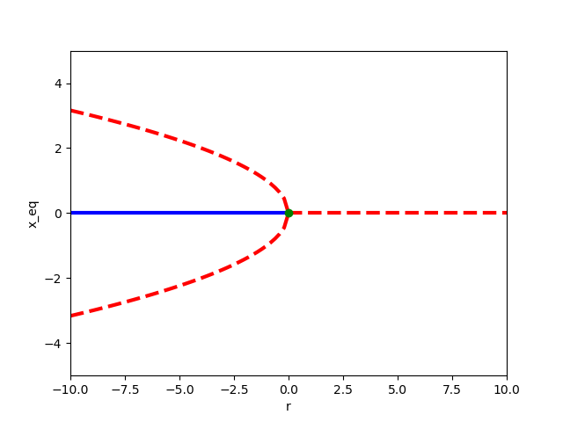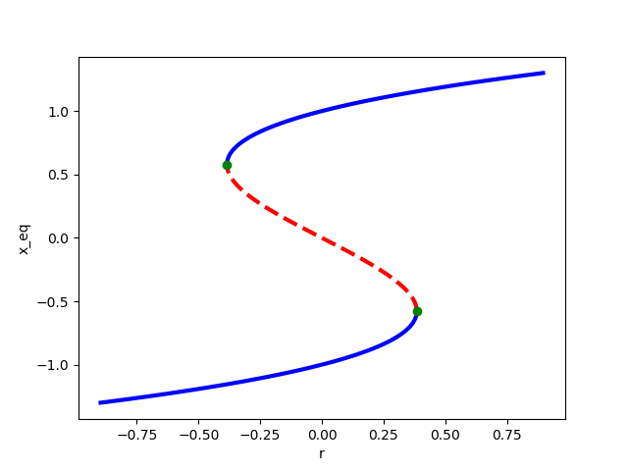

Question 2

We first introduced the logistic map earlier in the semester: $x_{t}=rx_{t-1}\left(1-x_{t-1}\right)$.

* Conduct a bifurcation analysis of this model to find the critical thresholds of *r* at which bifurcation occurs

Fixed points: x* = 0 and x* = (1-r) / r

Bifurcation value: r =1, thus a transcritical bifurcation

To check stability let x` = f(x) so that f `(x*) = 1 - 2 r x* - r

f ` (0) = 1- r and f ` ((1-r) / r) = 1 -2 r ((1-r) / r ) = r – 1

x* = 0 is stable for r > 1 and x* = (1-r) / r is stable for r < 1

* Study the stability of each equilibrium point in each parameter range and summarize the results in a table

|  |  |  |
| --- | --- | --- |
| Equilibrium point | Parameter range | Stability |
| x* = 0 | r > 1 | stable |
| x* = 0 | r = 1 | stable |
| x* = (1-r) / r | 0 < r < 1 | stable |
| none | r < 0 | unstable |

* Simulate the model with several selected values of *r* to confirm the results of the analysis
* Plot a bifurcation diagram of this model to 0<r<4.

