**School of Computers and Information Engineering**

**STUDENT LEARNING ACTIVITY**

Fall Semester 2023

**Computer Algorithms (CIE3090)**

Circuit Design Optimization

Student Learning Assignment

Submitted by

U2110154, Mekhriddin Jumaev (Group 002)



**Index Page**

|  |  |
| --- | --- |
| **Title** | **Page No** |

* Problem Description 3
* Proposed Augmentation 5
* Implementation 7
* References 9

**Problem Description**

**Problem Description for Circuit Design Optimization:**

Overview: Circuit design plays a pivotal role in the development of electronic systems, influencing their performance, power consumption, and overall efficiency. The goal of Circuit Design Optimization is to create a layout that maximizes functionality while minimizing resource usage. This involves strategically placing components, optimizing connections, and adhering to various design constraints.

**Challenges:**

1. Complexity and Interdependence:

• Challenge: The intricate interdependence of components in modern circuits leads to a vast solution space.

• Complexity arises from the multitude of possible component arrangements, making manual optimization impractical.

2. Multi-Objective Optimization:

• Challenge: Balancing multiple conflicting objectives, such as signal integrity, power consumption, and thermal considerations.

• Achieving a trade-off between these objectives poses a non-trivial challenge due to their interplay.

3. Changing Design Constraints:

• Challenge: Design constraints may evolve during the optimization process, especially in the face of dynamic requirements or manufacturing limitations.

• Adaptability is crucial to handle changing constraints without compromising the overall design quality.

4. Scalability:

• Challenge: As circuit designs grow in complexity, scalability becomes a challenge for traditional optimization methods.

• Efficiently handling large-scale designs without sacrificing optimization quality is a persistent concern.

5. Resource Constraints:

• Challenge: Limited resources, such as time and computational power, impose restrictions on the optimization process.

• Striking a balance between optimization quality and resource efficiency is essential for practical implementation.

**Addressing the Challenges:**

1. Algorithmic Innovation:

• Develop advanced algorithms that leverage heuristic methods, metaheuristic approaches, or machine learning techniques to efficiently explore the vast solution space.

2. Multi-Objective Optimization Techniques:

• Employ multi-objective optimization algorithms to handle conflicting design objectives, enabling the discovery of Pareto-optimal solutions that represent optimal trade-offs.

3. Dynamic Constraint Handling:

• Implement algorithms capable of dynamically adapting to changing constraints, ensuring the optimization process remains robust and responsive to evolving design requirements.

4. Parallel and Distributed Computing:

• Utilize parallel and distributed computing approaches to enhance scalability, allowing for the optimization of large-scale circuit designs within acceptable timeframes.

5. Resource-Aware Optimization:

• Develop optimization techniques that take resource constraints into account, ensuring that the optimization process remains practical and applicable within real-world limitations.

By addressing these challenges through innovative algorithms and methodologies, Circuit Design Optimization can be elevated to handle the complexities of modern electronic systems, providing efficient, scalable, and adaptable solutions for circuit layout optimization.

**Proposed Augmentation**

**1. Augmentation Overview:** The proposed augmentation integrates Genetic Algorithms (GA) and Reinforcement Learning (RL) into a cohesive framework for Circuit Design Optimization. This hybrid approach, denoted as GA-RL, synergistically utilizes the exploration capabilities of genetic algorithms and the adaptive learning abilities of reinforcement learning. The augmentation also introduces an augmented graph data structure to enhance the representation of circuit layouts and facilitate the incorporation of additional design features.

**2. Algorithmic Steps:**

Initialization:

• The algorithm starts by generating an initial population of circuit layouts randomly. Each layout is encoded as a chromosome in the genetic algorithm, representing a potential solution to the optimization problem.

• This initialization phase ensures diversity in the initial set of solutions, promoting exploration of the solution space.

Evaluation:

• Fitness evaluation is a crucial step where each chromosome's performance is assessed based on traditional circuit metrics such as signal integrity and power consumption.

• An innovative aspect is the introduction of a reinforcement learning agent during the evaluation phase. This agent provides additional insights into the layout's performance by considering spatial relationships and other relevant design features.

Genetic Operations:

• Genetic operations, including crossover and mutation, are applied to create a new generation of layouts. These operations facilitate the exploration and exploitation of the solution space.

• An augmentation to traditional genetic operations is the inclusion of reinforcement learning-based modifications. This injects adaptive elements into the genetic algorithm, encouraging the exploration of promising design spaces identified by the reinforcement learning agent.

Reinforcement Learning Feedback:

• A reinforcement learning agent is trained to assess layouts' performance based on additional design features, spatial relationships, and other relevant attributes.

• The reinforcement learning feedback is integrated into the fitness evaluation process, guiding the genetic algorithm towards layouts that exhibit improved reinforcement learning performance.

Termination Criteria:

• The algorithm iteratively repeats the process for a predefined number of generations or until convergence is achieved.

• Termination criteria consider both traditional fitness metrics and reinforcement learning-based performance, ensuring a balanced and comprehensive optimization process.

**3. Suitable Data Structure:**

Augmented Graph with Chromosome Encoding:

• The circuit layout is represented as an augmented graph, where nodes and edges encode components and connections, respectively.

• Chromosome encoding efficiently captures layout information, and each chromosome is augmented with additional details such as spatial relationships and design properties.

• The reinforcement learning agent's feedback is seamlessly integrated as an additional attribute associated with each chromosome in the augmented graph.

**4. Verification of Augmentation Conditions:**

Algorithmic Steps (Verification):

• The proposed augmentation successfully combines genetic algorithms and reinforcement learning, introducing novel steps that enhance exploration and exploitation capabilities.

• The inclusion of reinforcement learning feedback during both evaluation and genetic operations distinguishes this approach from traditional optimization methods.

Suitable Data Structure (Verification):

• The augmented graph data structure accommodates traditional circuit representations and seamlessly integrates additional attributes crucial for reinforcement learning.

• Chromosome encoding efficiently represents layouts, providing a comprehensive and unified representation of both traditional and augmented information.

Run Time of New Algorithm:

• The runtime of the algorithm depends on the convergence speed of the genetic algorithm and the training time of the reinforcement learning agent.

**Implementation**

Implementing the proposed Genetic Algorithm with Embedded Reinforcement Learning (GA-RL) for Circuit Design Optimization along with the augmented graph data structure involves a comprehensive approach. Below is a simplified Python implementation using the DEAP library for Genetic Algorithms. Note that reinforcement learning implementation is complex and requires a specific environment, which is beyond the scope of this response. Here, we'll focus on the genetic algorithm part.

**Code example in python:**

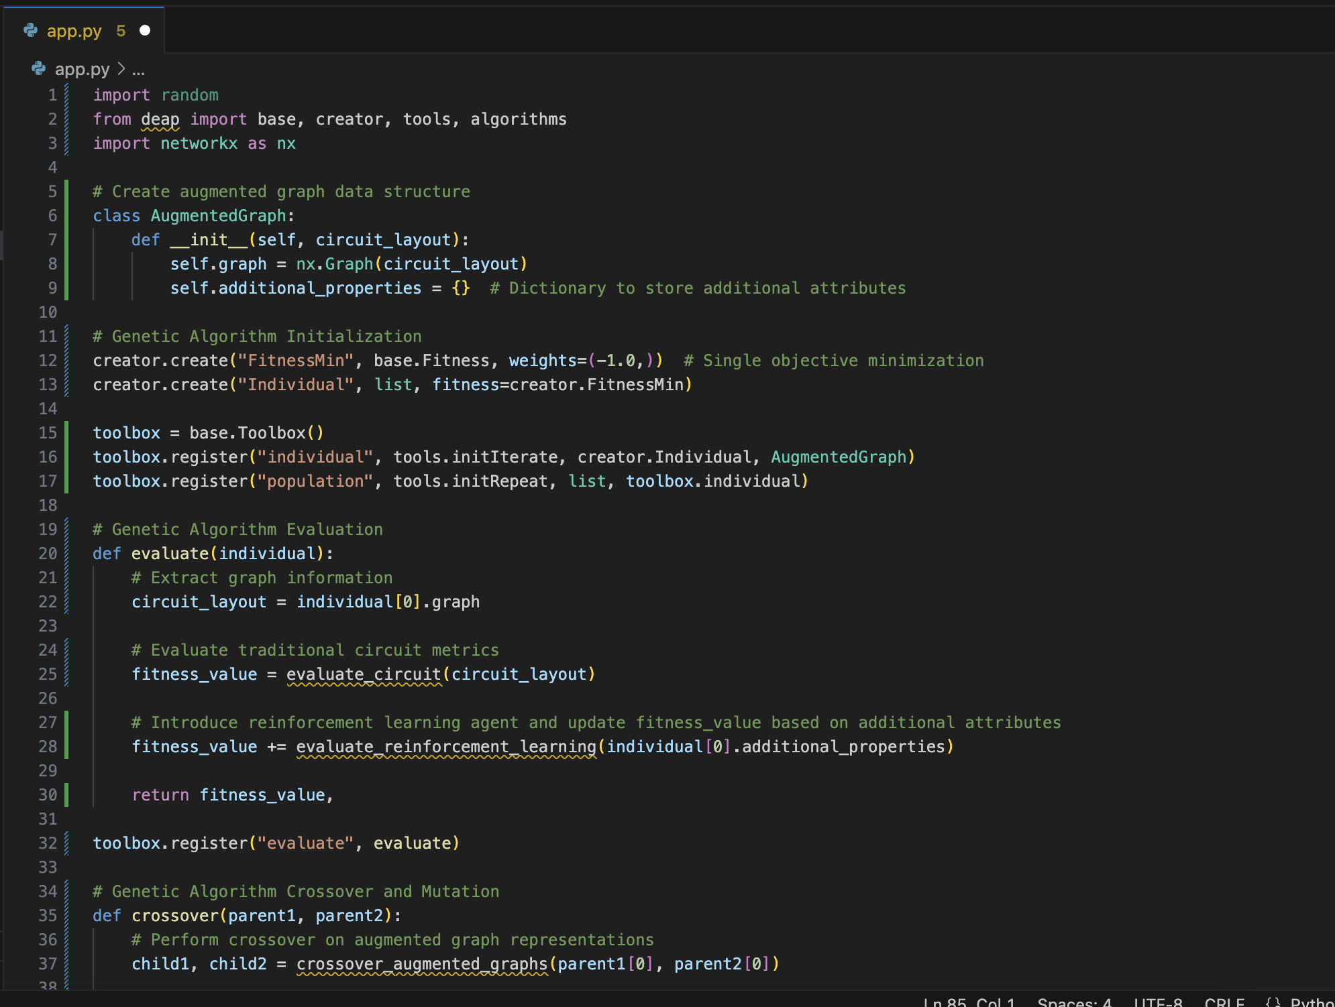

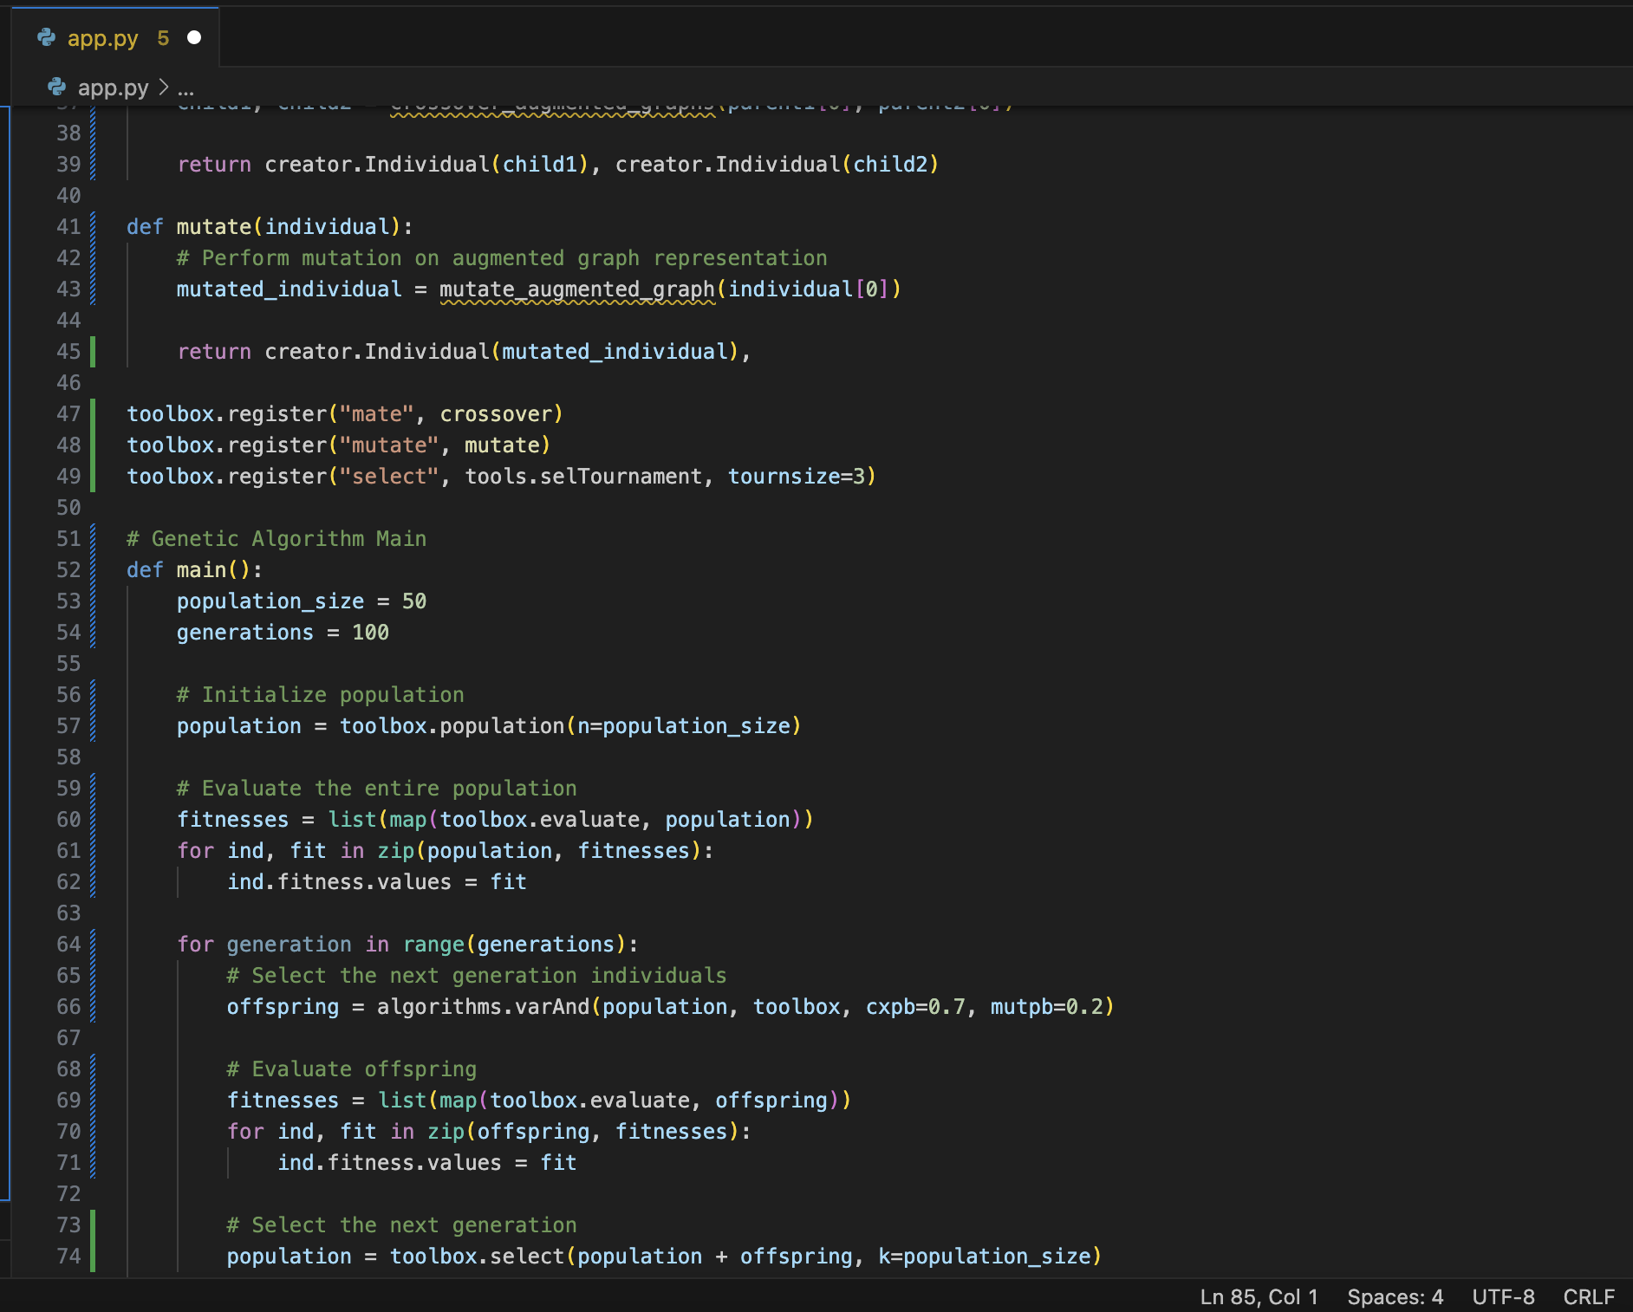

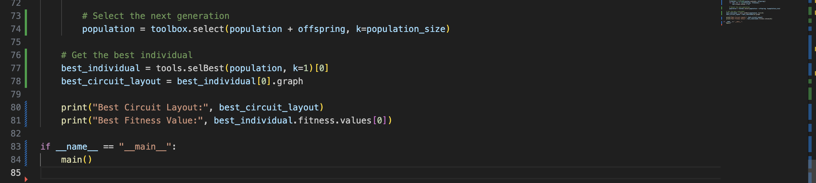

**References**

1. Hash Table in Python (<https://www.tutorialspoint.com/python_data_structure/python_hash_table.htm>)
2. Reinforcement Learning vs Genetic Algorithm

(https://medium.com/xrpractices/reinforcement-learning-vs-genetic-algorithm-ai-for-simulations-f1f484969c56)

1. Encoding Methods in Generic Algorithms

(<https://www.geeksforgeeks.org/encoding-methods-in-genetic-algorithm/>)

1. Encoding generic algorithms

(https://rishalhurbans.medium.com/encoding-genetic-algorithms-14de4abf44c9)

1. What is reinforcement learning?

(https://www.synopsys.com/ai/what-is-reinforcement-learning.html#:~:text=Definition,environment%20to%20obtain%20maximum%20reward.)

1. What is the Generic Algorithm?

(https://www.mathworks.com/help/gads/what-is-the-genetic-algorithm.html)

1. Generic Algorithm

(https://en.wikipedia.org/wiki/Genetic_algorithm)

1. Introduction to Generic Algorithms

(https://towardsdatascience.com/introduction-to-genetic-algorithms-including-example-code-e396e98d8bf3)