Hi!

Thank you for buying my asset. This is a lite version.

This asset contains only borders of the countries and points. All geometry is already built. If you want to change something in the code and get new map with your changes you need to delete old map using context menu. Select “EarthXRotation” object in hierarchy and press right mouse button on the EarthMapBuilder component in the inspector. Then press “DeleteMap”:

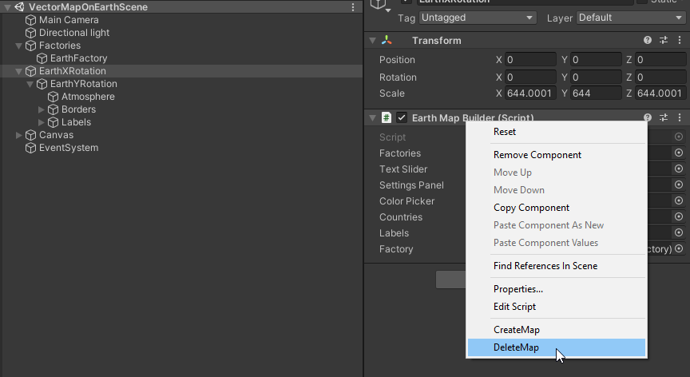

Then you can use “CreateMap” of context menu:

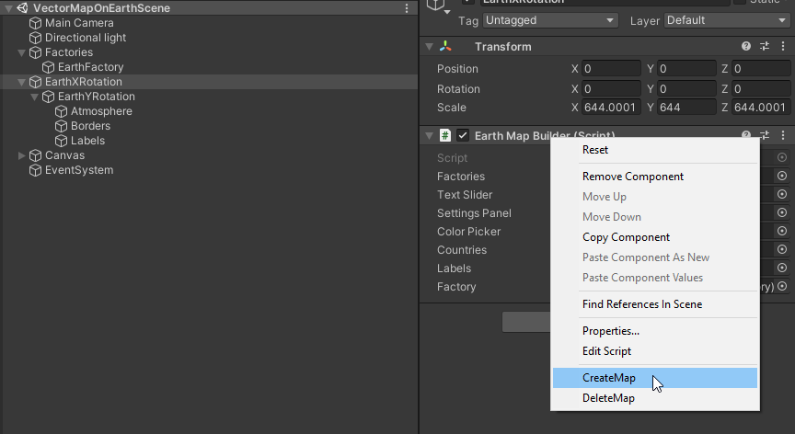

You can change color of borders, size of labels or switch labels off.

Launch the scene in the project to see how it works.

Left mouse button to rotate the planet in horizontal plane, right mouse button to control the light, middle mouse button to rotate the planet in vertical plane.

If you have any question contact me anytime and I’ll be happy to help you ☺

If you bought this asset and want to get a full version with selectable countries, just contact me and we will figure it out.

If you like this asset you can leave a review. It will be very helpful for me. Thank you again!